**Experiment Title-3.2**

**Student Name: Nitesh Sharma UID: 20BCS1600**

**Branch: CSE Section/Group-ON20BCS_NTPP_WM_702 {B}**

**Semester: 5th Date of Performance: 28/10/2022**

**Subject Name: java lab Subject Code: 20CSP-321**

**Subject Teacher: Reshma mam**

**1. Aim/Overview of the practical:**

Create an application for Online Auction using HTML and Servlet. Use the database to store and retrieve records.

**2. Task to be done/ Which logistics used:**

To create an application for Online Auction using HTML and Servlet. Use the database to store and retrieve records.

**4. Steps for experiment/practical/Code:**

Auction.html

<!DOCTYPE html>

<html>

<head>

<meta charset="ISO-8859-1">

<title>HTML CSS auction Form</title>

<style>

{

margin: 0;

padding: 0;

background-color:lightblue;

font-family: 'Arial';

}</style>

</head>

<body>

<form action="Auction_data" method="post">

Name:<input type="text" name="userName"/><br/><br/>

Product:

<select name="productName">

<option>Dell</option>

<option>HP</option>

<option>Sony</option>

<option>Lenevo</option>

</select>

<br/><br/>

Bid Value:<input type="text" name="bidValue"/><br/><br/>

<input type="submit" value="register"/>

</form>

</body>

</html>

Auction_data.java

import java.io.IOException;

import java.io.PrintWriter;

import java.sql.Connection;

import java.sql.DriverManager;

import java.sql.PreparedStatement;

import java.sql.ResultSet;

import java.sql.Statement;

import javax.servlet.ServletException;

import javax.servlet.http.HttpServlet;

import javax.servlet.http.HttpServletRequest;

import javax.servlet.http.HttpServletResponse;

public class Auction_data extends HttpServlet {

private static final long serialVersionUID = 1L;

protected void doPost(HttpServletRequest request, HttpServletResponse response) throws ServletException,

IOException

{

response.setContentType("text/html");

PrintWriter out = response.getWriter();

String n=request.getParameter("userName");

String p=request.getParameter("productName");

int e=Integer.parseInt(request.getParameter("bidValue"));

try{

Class.forName("com.mysql.jdbc.Driver");

Connection con=DriverManager.getConnection("jdbc:mysql://localhost:3306/Auction","root","");

Statement stmt=con.createStatement();

PreparedStatement ps=con.prepareStatement("insert into user

values(?,?,?)");

ps.setString(1,n);

ps.setString(2,p);

ps.setInt(3,e);

int i=ps.executeUpdate();

if(i>0)

out.print("You are successfully registered...");

ResultSet rs=stmt.executeQuery("select *from user where UName='"+n+"'");

while(rs.next())

out.println("<br>Your data is:"+rs.getString(1)+" "+rs.getString(2)+"

"+rs.getInt(3));

con.close();

}catch (Exception e2)

{System.out.println(e2);}

out.close();

}

}

**5. Screenshot of code with output:**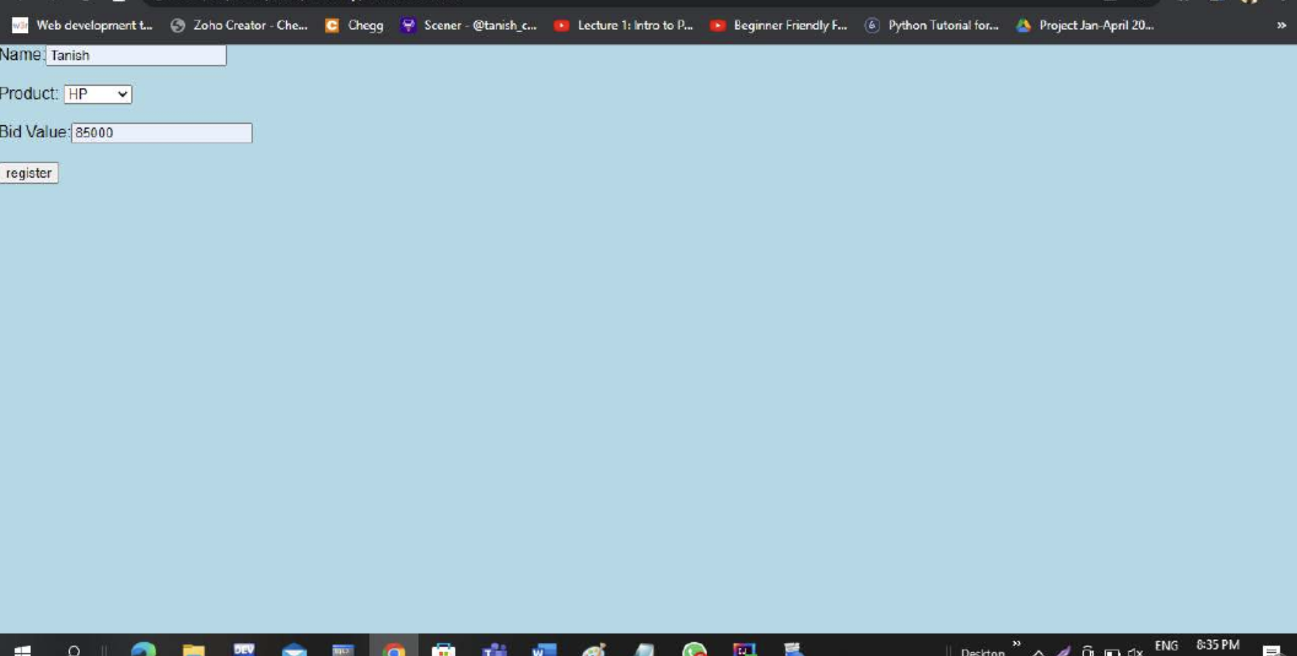

**Learning outcomes (What I have learnt):**

**1.We have learnt about the basic syntax of java**

**2.We have learnt about html and servlet and the database to retrieve the records.**

**Evaluation Grid (To be created as per the SOP and Assessment guidelines by the faculty):**

| Sr. No. | Parameters | Marks Obtained | Maximum Marks |
| --- | --- | --- | --- |
| 1. |  |  |  |
| 2. |  |  |  |
| 3. |  |  |  |
|  |  |  |  |