**Experiment Title-3.3**

**Student Name: Nitesh Sharma UID: 20BCS1600**

**Branch: CSE Section/Group-ON20BCS_NTPP_WM_702 {B}**

**Semester: 5th Date of Performance: 3/10/2022**

**Subject Name: java lab Subject Code: 20CSP-321**

**Subject Teacher: Reshma mam**

**1. Aim/Overview of the practical:**

**Write a JSP application to demonstrate the expression tag by**

**using mathematical operations.**

There are multiple checkboxes in the html page to perform different mathematical operations.

By default, Addition is checked and it’s added to the given number in the text box. At the time of

division operation when we enter any invalid data in text box, it generates error message

from the "error.jsp" page.

**2. Task to be done/ Which logistics used:**

To make one calculator and to perform mathematical operations by using that calculator with the help of jsp.

**4. Steps for experiment/practical/Code:**

Input.html

<html>

<title>Sample Example </title>

<body>

<form method="post" action="index.jsp">

<fieldset style="width:30%; background-color:#b3d1ff">

<h2><center> Mathematical Operation</center></h2>

<hr>

<font size=5 face="Times New Roman">

<input type="radio" name="a1"value="add checked>Addition</input><br>

<input type="radio" name="a1" value="sub">Subtraction</input><br>

<input type="radio" name="a1" value="mul" >Multiplication</input><br>

<input type="radio" name="a1" value="div" >Division</input><br>

</font>

<table>

<tr>

<td>Enter first Value:</td>

<td> <input type="text" name="t1" value=""></td>

</tr>

<tr>

<td>Enter second Value: </td>

<td><input type="text" name="t2" value=""></td>

</tr><br>

<tr>

<td></td>

<td><input type="submit" name="result" value="Check result!"></td>

</tr>

</table>

</fieldset>

</form>

</body>

</html>

Index.jsp

<%@ page errorPage="error.jsp" %>

<html>

<body>

<H1><center>Result for <%=request.getParameter("a1")%></center></H1>

<%

String num1=request.getParameter("t1");

String num2=request.getParameter("t2");

int i=Integer.parseInt(num1);

int j=Integer.parseInt(num2);

int k=0;

String str=request.getParameter("a1");

if(str.equals("add"))

k=i+j;

if(str.equals("sub"))

k=i-j;

if(str.equals("mul"))

k=i*j;

if(str.equals("div"))

k=i/j;

%>

Result is: <%=k%>

</body>

</html>

Error.jsp

<%@ page isErrorPage="true" %>

<h3>Sorry an exception occured!</h3>

Exception is: <%= exception %>

Web.xml

<web-app>

<servlet>

<servlet-name>xyz</servlet-name>

<jsp-file>/input.html</jsp-file>

</servlet>

<servlet-mapping>

<servlet-name>xyz</servlet-name>

<url-pattern>/test</url-pattern>

</servlet-mapping>

</web-app>

**5. Screenshot of code with output:**

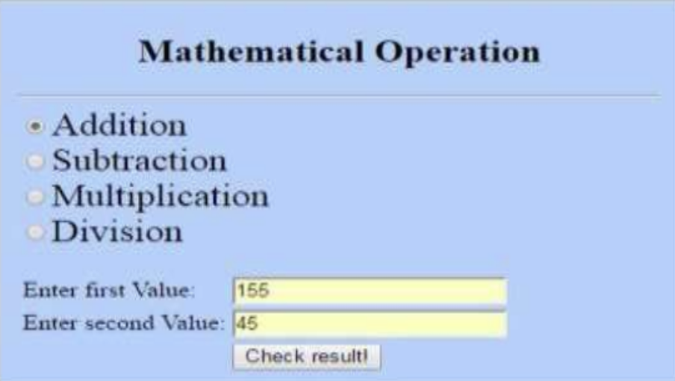

**Learning outcomes (What I have learnt):**

**1.We have learnt about the basic syntax of java**

**2.We have learnt about html and servlet and the database to retrieve the records.**

**Evaluation Grid (To be created as per the SOP and Assessment guidelines by the faculty):**

| Sr. No. | Parameters | Marks Obtained | Maximum Marks |
| --- | --- | --- | --- |
| 1. |  |  |  |
| 2. |  |  |  |
| 3. |  |  |  |
|  |  |  |  |