**Experiment Title-3**

**Student Name: Nitesh Sharma UID: 20BCS1600**

**Branch: CSE Section/Group-ON20BCS_NTPP_WM_702 {B}**

**Semester: 5th Date of Performance: 18/8/2022**

**Subject Name: java lab Subject Code: 20CSP-321**

**Subject Teacher: Reshma mam**

**1. Aim/Overview of the practical:** Calculate interest based on the type of the account and the status of the account holder. The rates of interest changes according to the amount (greater than or less than 1 crore), age of account holder (General or Senior citizen) and number of days if the type of account is FD or RD.

**2. Task to be done/ Which logistics used:** To make a calculator of interest based on type of account.

**4. Steps for experiment/practical/Code:**

**import java.util.Scanner;**

**abstract class Account {**

**double interestRate;**

**double amount;**

**abstract double calculateInterest(double amount)**

**throws InvalidMonthsException, InvalidAgeException, InvalidAmountException, InvalidDaysException;**

**}**

**class FDaccount extends Account {**

**double FDinterestRate;**

**double FDAmount;**

**int noOfDays;**

**int ageOfACHolder;**

**double General, SCitizen;**

**Scanner FDScanner = new Scanner(System.in);**

**@Override**

**double calculateInterest(double amount)**

**throws InvalidAgeException, InvalidAmountException, InvalidDaysException {**

**this.FDAmount = amount;**

**System.out.println("Enter FD days");**

**noOfDays = FDScanner.nextInt();**

**System.out.println("Enter FD age holder ");**

**ageOfACHolder = FDScanner.nextInt();**

**if (amount < 0) {**

**throw new InvalidAmountException();**

**}**

**if (noOfDays < 0) {**

**throw new InvalidDaysException();**

**}**

**if (ageOfACHolder < 0) {**

**throw new InvalidAgeException();**

**}**

**if (amount < 10000000) {**

**if (noOfDays >= 7 && noOfDays <= 14) {**

**General = 0.0450;**

**SCitizen = 0.0500;**

**} else if (noOfDays >= 15 && noOfDays <= 29) {**

**General = 0.0470;**

**SCitizen = 0.0525;**

**} else if (noOfDays >= 30 && noOfDays <= 45) {**

**General = 0.0550;**

**SCitizen = 0.0600;**

**} else if (noOfDays >= 45 && noOfDays <= 60) {**

**General = 0.0700;**

**SCitizen = 0.0750;**

**} else if (noOfDays >= 61 && noOfDays <= 184) {**

**General = 0.0750;**

**SCitizen = 0.0800;**

**} else if (noOfDays >= 185 && noOfDays <= 365) {**

**General = 0.0800;**

**SCitizen = 0.0850;**

**}**

**FDinterestRate = (ageOfACHolder < 50) ? General : SCitizen;**

**} else {**

**if (noOfDays >= 7 && noOfDays <= 14) {**

**interestRate = 0.065;**

**} else if (noOfDays >= 15 && noOfDays <= 29) {**

**interestRate = 0.0675;**

**} else if (noOfDays >= 30 && noOfDays <= 45) {**

**interestRate = 0.00675;**

**} else if (noOfDays >= 45 && noOfDays <= 60) {**

**interestRate = 0.080;**

**} else if (noOfDays >= 61 && noOfDays <= 184) {**

**interestRate = 0.0850;**

**} else if (noOfDays >= 185 && noOfDays <= 365) {**

**interestRate = 0.10;**

**}**

**}**

**return FDAmount * FDinterestRate;**

**}**

**}**

**class InterestCalculator {**

**public static void main(String[] args) {**

**// TODO code application logic here**

**Scanner sc = new Scanner(System.in);**

**System.out.println(**

**"SELECT THE OPTIONS " +**

**"\n1." +**

**" Interest Calculator-SB" +**

**" \n2." +**

**" Interest Calculator-FD" +**

**"\n3." +**

**" InterestCalculator-RD" +**

**"\n4 " +**

**" Exit"**

**);**

**int choice = sc.nextInt();**

**switch (choice) {**

**case 1:**

**SBaccount sb = new SBaccount();**

**try {**

**System.out.println("Enter the Average SB amount ");**

**double amount = sc.nextDouble();**

**System.out.println(**

**"Interest gained is : $ " + sb.calculateInterest(amount)**

**);**

**} catch (InvalidAmountException e) {**

**System.out.println("Exception : Invalid amount");**

**}**

**break;**

**case 2:**

**try {**

**FDaccount fd = new FDaccount();**

**System.out.println("Enter the FD Amount");**

**double fAmount = sc.nextDouble();**

**System.out.println(**

**"Interest gained is: $ " + fd.calculateInterest(fAmount)**

**);**

**} catch (InvalidAgeException e) {**

**System.out.println("Invalid Age Entered");**

**} catch (InvalidAmountException e) {**

**System.out.println("Invalid Amount Entered");**

**} catch (InvalidDaysException e) {**

**System.out.println("Invalid Days Entered");**

**}**

**break;**

**case 3:**

**try {**

**RDaccount rd = new RDaccount();**

**System.out.println("Enter the RD amount");**

**double Ramount = sc.nextDouble();**

**System.out.println(**

**"Interest gained is: $ " + rd.calculateInterest(Ramount)**

**);**

**} catch (InvalidAgeException e) {**

**System.out.println("Invalid Age Entered");**

**} catch (InvalidAmountException e) {**

**System.out.println("Invalid Amount Entered");**

**} catch (InvalidMonthsException e) {**

**System.out.println("Invalid Days Entered");**

**}**

**break;**

**case 4:**

**System.out.println(**

**"DO YOU WANT TO CALCULATE AGAIN ????" + " " + "RUN AGAIN THE PROGRAM"**

**);**

**default:**

**System.out.println("Wrong choice");**

**}**

**}**

**}**

**class InvalidAgeException extends Exception {}**

**class InvalidAmountException extends Exception {}**

**class InvalidDaysException extends Exception {}**

**class InvalidMonthsException extends Exception {}**

**class RDaccount extends Account {**

**double RDInterestRate;**

**double RDamount;**

**int noOfMonths;**

**double monthlyAmount;**

**double General, SCitizen;**

**Scanner RDScanner = new Scanner(System.in);**

**@Override**

**double calculateInterest(double Ramount)**

**throws InvalidMonthsException, InvalidAmountException, InvalidAgeException {**

**this.RDamount = Ramount;**

**System.out.println("Enter RD months");**

**noOfMonths = RDScanner.nextInt();**

**System.out.println("Enter RD holder age");**

**int age = RDScanner.nextInt();**

**if (RDamount < 0) {**

**throw new InvalidAmountException();**

**}**

**if (noOfMonths < 0) {**

**throw new InvalidMonthsException();**

**}**

**if (age < 0) {**

**throw new InvalidAgeException();**

**}**

**if (noOfMonths >= 0 && noOfMonths <= 6) {**

**General = .0750;**

**SCitizen = 0.080;**

**} else if (noOfMonths >= 7 && noOfMonths <= 9) {**

**General = .0775;**

**SCitizen = 0.0825;**

**} else if (noOfMonths >= 10 && noOfMonths <= 12) {**

**General = .0800;**

**SCitizen = 0.0850;**

**} else if (noOfMonths >= 13 && noOfMonths <= 15) {**

**General = .0825;**

**SCitizen = 0.0875;**

**} else if (noOfMonths >= 16 && noOfMonths <= 18) {**

**General = .0850;**

**SCitizen = 0.0900;**

**} else if (noOfMonths >= 22) {**

**General = .0875;**

**SCitizen = 0.0925;**

**}**

**RDInterestRate = (age < 50) ? General : SCitizen;**

**return RDamount * RDInterestRate;**

**}**

**}**

**class SBaccount extends Account {**

**double SBamount, SbInterestRate, interest;**

**Scanner SBScanner = new Scanner(System.in);**

**@Override**

**double calculateInterest(double amount) throws InvalidAmountException {**

**this.SBamount = amount;**

**if (SBamount < 0) {**

**throw new InvalidAmountException();**

**}**

**System.out.println("Select account type \n1. NRI \n2. Normal ");**

**int accountChoice = SBScanner.nextInt();**

**switch (accountChoice) {**

**case 1:**

**SbInterestRate = .06;**

**break;**

**case 2:**

**SbInterestRate = .04;**

**break;**

**default:**

**System.out.println("Please choose right account again");**

**}**

**return amount * SbInterestRate;**

**}**

**}**

**5. Screenshot of code with output:**

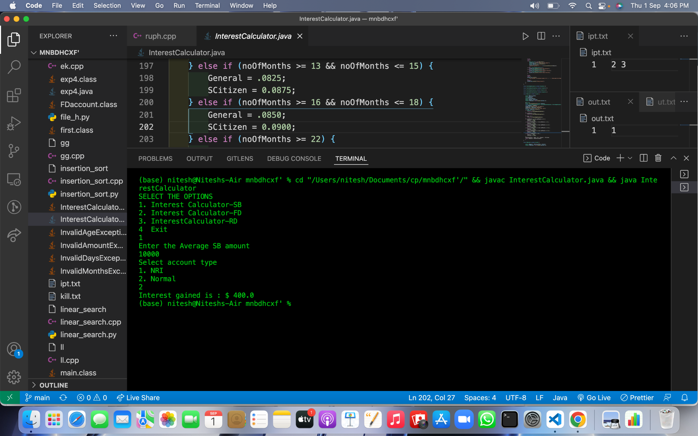

**Learning outcomes (What I have learnt):**

**1.We have learnt about the basic syntax of java**

**2.We have learnt about the inheritance concept of java.**

**Evaluation Grid (To be created as per the SOP and Assessment guidelines by the faculty):**

| Sr. No. | Parameters | Marks Obtained | Maximum Marks |
| --- | --- | --- | --- |
| 1. |  |  |  |
| 2. |  |  |  |
| 3. |  |  |  |
|  |  |  |  |