Image Encryption Using Chaos-Based Cryptography

What is Image Encryption?
Image encryption is a method to protect digital images from unauthorized access. It involves transforming the image into an unrecognizable format using a specific encryption method, and only those with the correct key can decrypt and view the original image.

What is Chaos-Based Cryptography?
Chaos-based cryptography uses mathematical chaotic systems that exhibit unpredictable behavior and are highly sensitive to initial conditions. These properties are useful for encrypting images by shuffling pixel positions and modifying pixel values.

Step-by-Step: Image Encryption Using Chaos

Step 1: Choose a Chaotic Map
Example: Logistic Map
Formula:
xₙ₊₁ = r * xₙ * (1 - xₙ)
Where:
- xₙ is the current value (between 0 and 1)
- r is a parameter (between 3.5 and 4)
- x₀ is the initial value (secret key)
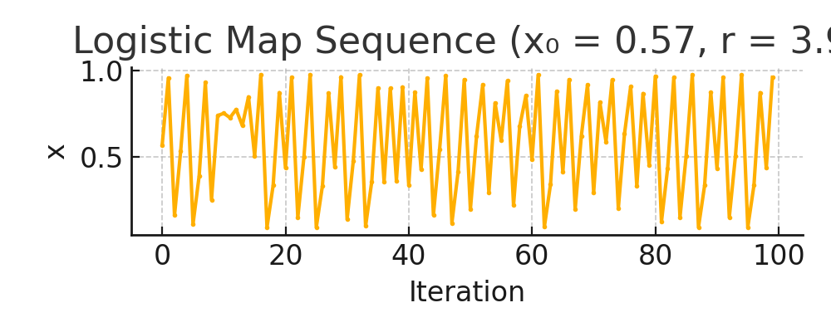
Figure: Chaotic sequence generated using Logistic Map.

Step 2: Generate a Chaotic Sequence
Using the logistic map, we generate a sequence of values that appear random. These values are used to decide how we shuffle and modify the pixels.

Step 3: Shuffle Pixels
The generated chaotic values help to rearrange the position of pixels in the image. This step changes the visual structure of the image, making it look scrambled like a puzzle.

Step 4: Modify Pixel Values
The pixel values are altered using the chaotic values. For example:
new_pixel_value = original_value XOR int(chaotic_value * 255)
This makes the pixel values completely different from the original.

Step 5: Decryption
To recover the original image, the exact initial value (x₀) and parameter (r) are needed. The receiver regenerates the chaotic sequence and reverses the pixel shuffling and value modifications.

Simple Example
Original Pixel Values: [120, 90, 200, 45]
Chaotic Values: [0.31, 0.74, 0.12, 0.85]
Converted to integers: [79, 188, 30, 217]
Encrypted (XOR): [120^79, 90^188, 200^30, 45^217] = [55, 230, 222, 252]
Decrypted (XOR again): [55^79, 230^188, 222^30, 252^217] = [120, 90, 200, 45]

