**VISVESVARAYA TECHNOLOGICAL UNIVERSITY JNANSANGAMA, BELAGAVI – 590018**

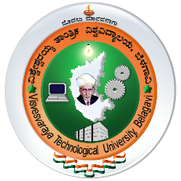

A Report on

**“MUTEX OS”**

Submitted in partial fulfilment of the requirement for the award

of the Degree of Bachelor of Engineering in

Infromation Science & Engineering

Submitted by

**NITESH B R**

Carried Out At

**ATRIA INSTITUTE OF TECHNOLOGY**

**Guide**

**Prof. Shruthi Anil**

**Assistant Faculty**

**Atria Institute of Technology**



**ATRIA INSTITUTE OF TECHNOLOGY**

**Department of Information Science & Engineering**

**Ananda Nagar, Bangalore-560024**