Week 3: Advanced Data Analysis and Visualization in Logistics
Hypothetical Logistics Dataset | Python-based EDA | Visualization | Insights & Recommendations

1. Executive Summary
This report presents an advanced exploratory data analysis of a simulated logistics dataset containing 500 shipments. The analysis focuses on delivery time, shipment volume, distance, weight, transport cost, transport mode, region, priority, and delays. Python was used to simulate realistic operational data, calculate descriptive statistics and correlations, and generate visualizations. The results show clear operational trade-offs: air transport provides the fastest delivery but at a substantially higher cost, while rail is generally more economical but slower. Distance is a major cost and delivery-time driver, and some regions exhibit higher delay rates. These findings demonstrate how visualization can support route planning, mode selection, service-level management, and cost control.

2. Data Simulation and Structure
Because the task specifies a hypothetical dataset, 500 shipment records were simulated using NumPy and Pandas. A fixed random seed (42) was used so the analysis is reproducible. The variables were designed to represent common logistics performance factors.
Variable | Type | Purpose
Shipment_ID | Categorical | Unique shipment identifier
Region | Categorical | North, South, East, West operating regions
Transport_Mode | Categorical | Road, Rail, or Air
Priority | Categorical | Standard or Express
Distance_km | Numeric | Shipment distance
Shipment_Volume_units | Numeric | Approximate shipment volume
Weight_kg | Numeric | Shipment weight
Delivery_Time_days | Numeric | End-to-end delivery duration
Transport_Cost_INR | Numeric | Estimated transportation cost
Delayed | Categorical | Whether the shipment was delayed
Delay_Days | Numeric | Number of days delayed

3. Exploratory Data Analysis
The dataset was checked using descriptive statistics, group-level summaries, and a correlation matrix. Central tendency and dispersion were examined through the mean, median, minimum, maximum, and standard deviation. The distributions were then visualized to identify skewness, outliers, and operational differences.
Metric | Value
Average delivery time (days) | 5.32
Median delivery time (days) | 5.45
Average transport cost (INR) | 2,727.83
Median transport cost (INR) | 2,271.00
Average distance (km) | 477.71
Overall delay rate (%) | 64.20

4. Visualizations and Interpretation

Figure 1. Distribution of Delivery Time
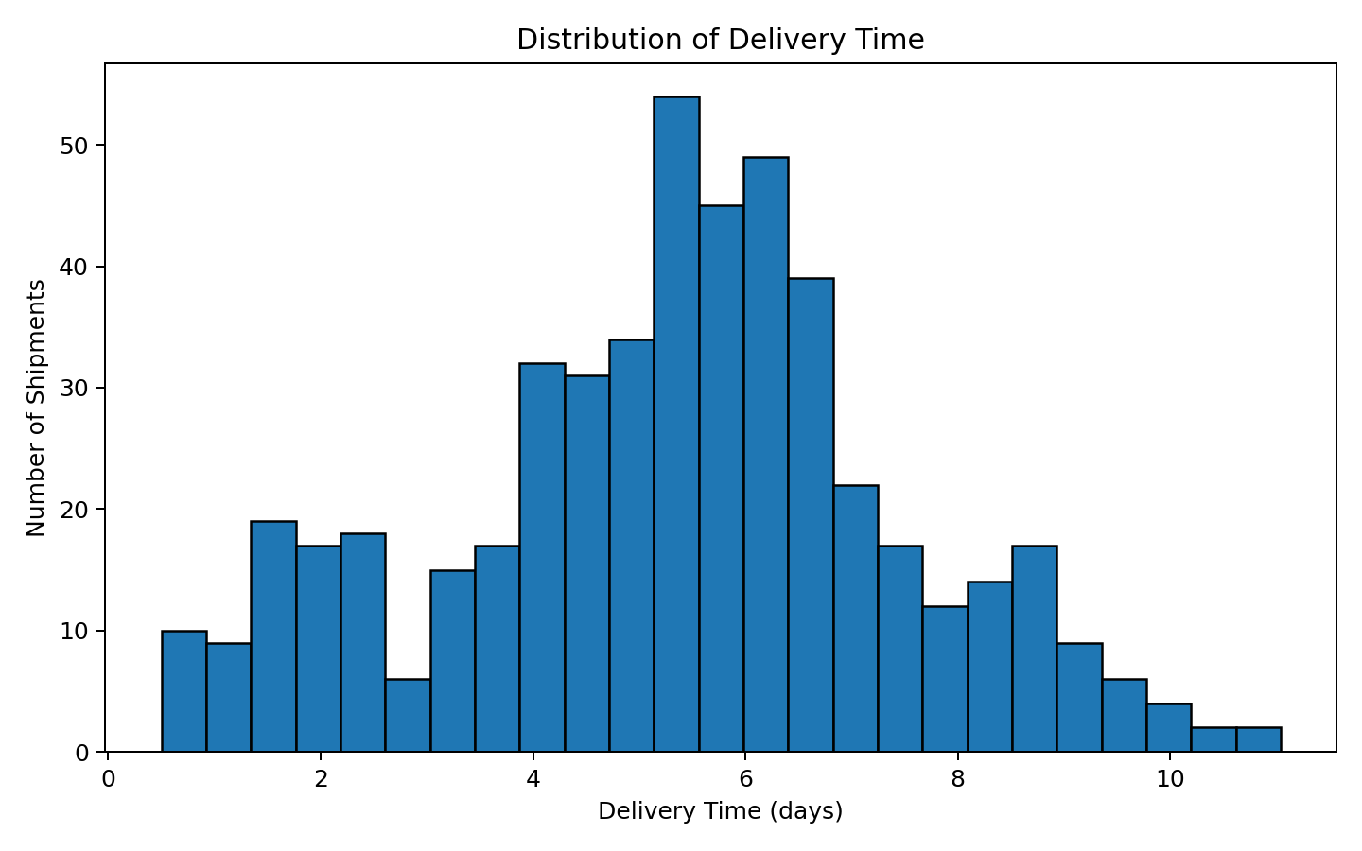
The delivery-time histogram shows the typical service duration and the spread of shipment lead times. A right tail indicates that a smaller group of shipments takes substantially longer than the central range. This type of distribution is useful for setting realistic service-level targets and identifying unusually slow shipments.

Figure 2. Transport Cost by Mode
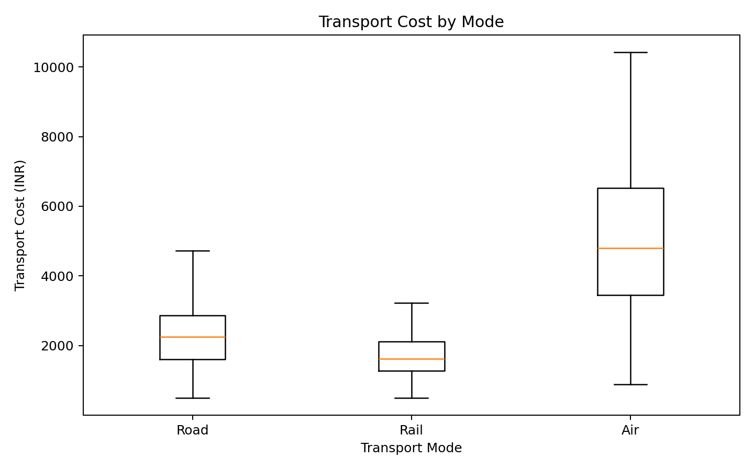
The boxplot compares the cost distributions for road, rail, and air. Air shipments have the highest cost profile, reflecting their speed premium. Rail generally provides a lower-cost alternative for suitable long-distance movements, while road provides operational flexibility and a broad range of shipment distances.

Figure 3. Distance vs Transport Cost
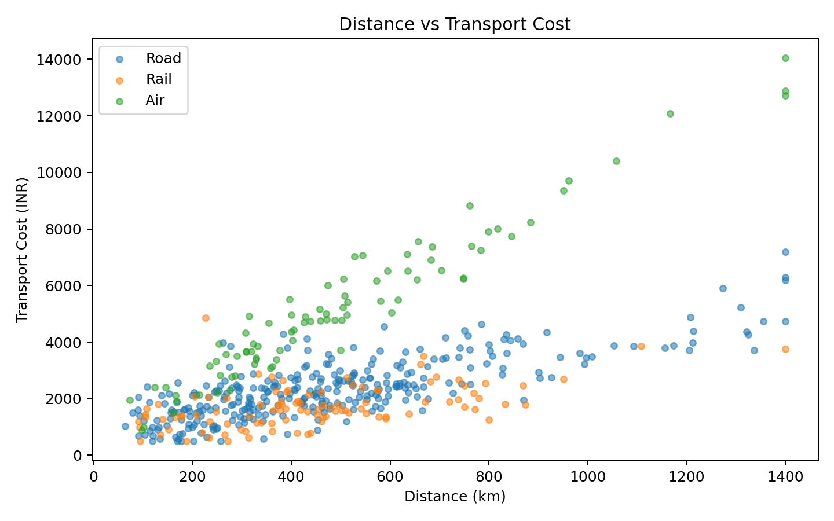
The scatter plot demonstrates a positive relationship between shipment distance and transportation cost. The slope and spread differ by mode because each mode has a different cost structure. This supports using distance as a key variable in transportation budgeting and route-level cost forecasting.

Figure 4. Transport Mode Performance
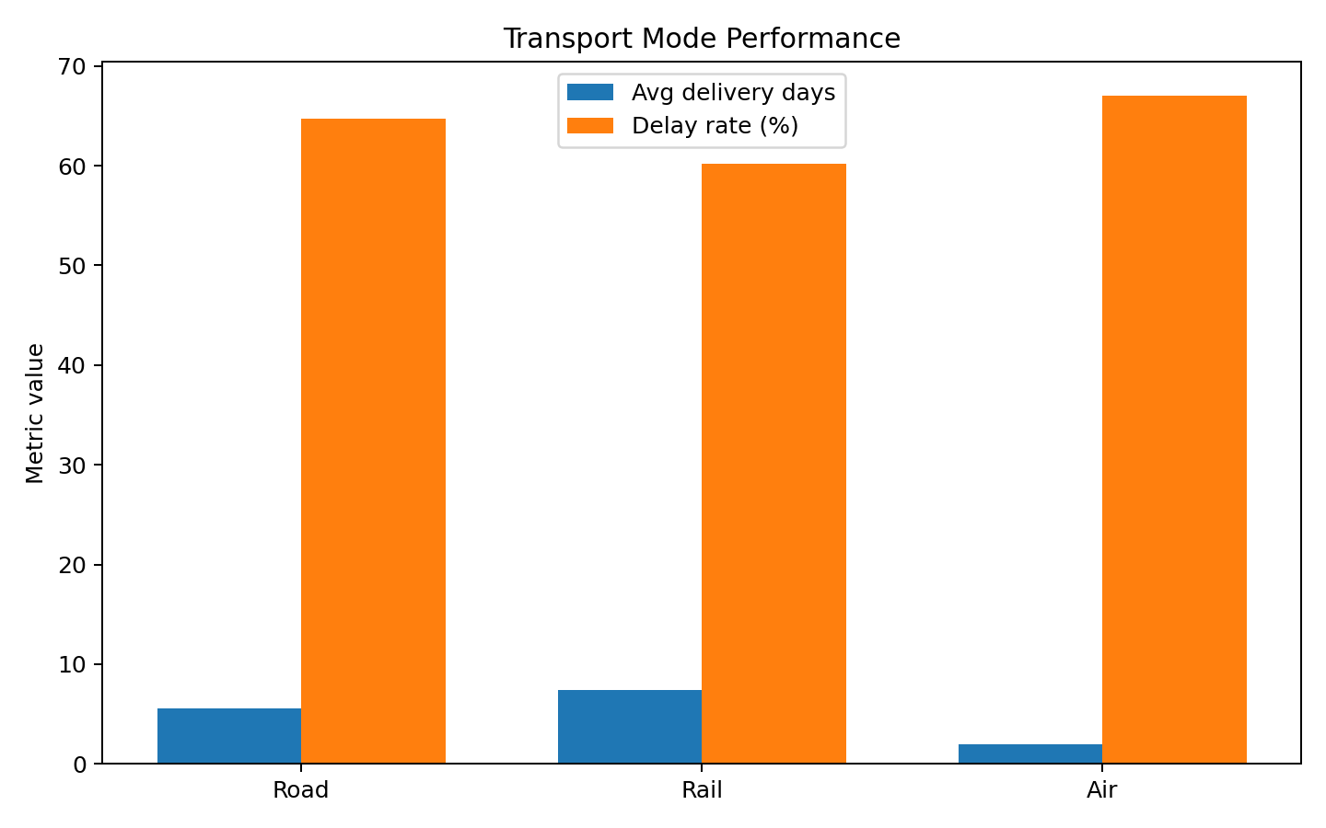
The combined bar chart compares average delivery time and delay rate by transport mode. It highlights the core logistics trade-off between speed, reliability, and cost. Managers should not select a mode using cost alone; service requirements and delay exposure also matter.

Figure 5. Correlation Matrix
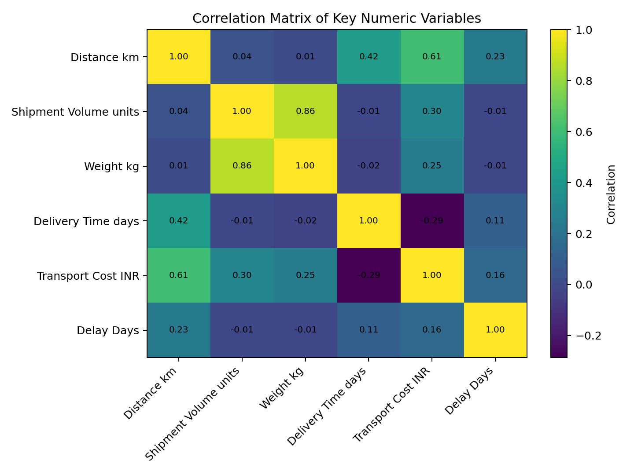
The correlation matrix summarizes linear relationships among the major numeric variables. Strong positive associations between distance, delivery time, and cost indicate that longer routes can create both cost pressure and longer lead times. Correlation is not proof of causation, but it is useful for prioritizing further analysis.

Figure 6. Delay Rate by Region
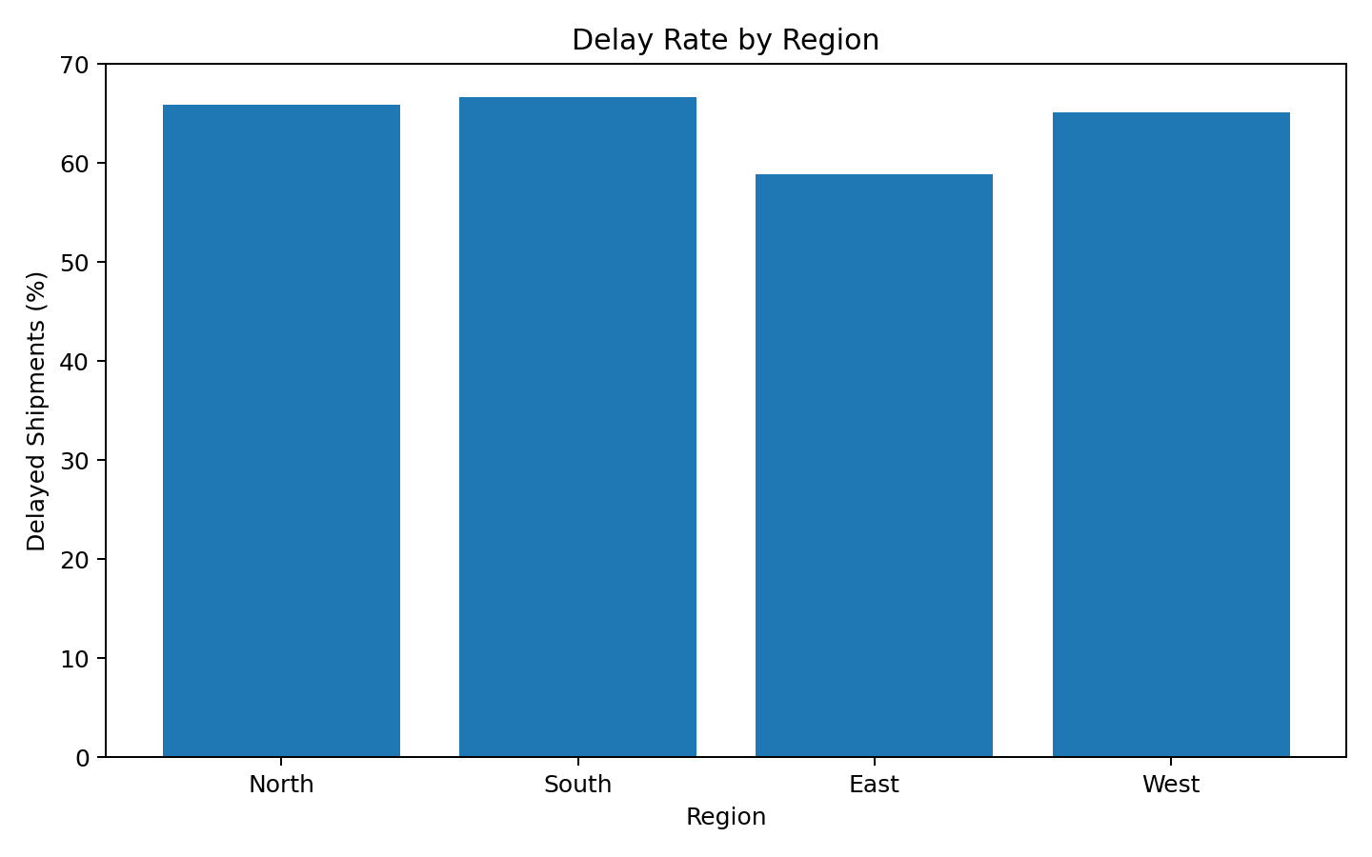
The regional delay-rate chart identifies locations where service performance may need attention. A region with a higher delay percentage can be investigated for route congestion, carrier performance, handling delays, weather exposure, or scheduling constraints.

5. Analytical Insights
1. Air is the fastest transport mode on average, making it appropriate for time-sensitive or high-priority shipments. However, its cost level is also the highest, so it should be used selectively.
2. Rail has the lowest average transportation cost in the simulation. It can be considered for shipments where delivery speed is less critical and the route is operationally suitable.
3. Air shows the highest simulated delay rate among transport modes. This suggests that mode-specific planning and carrier/service-level monitoring could reduce delivery risk.
4. The South region has the highest simulated delay rate. Regional investigation should focus on route conditions, handoff points, capacity constraints, and carrier performance rather than assuming the issue is purely distance-related.
5. Distance is an important cost and lead-time driver. Long-distance shipments should therefore receive more structured route planning, realistic delivery estimates, and mode-selection rules.

6. Logistics Recommendations
- Use a cost-versus-service framework for transport-mode selection instead of optimizing only for the lowest price.
- Reserve air transport primarily for express, high-value, or service-critical shipments because its speed comes with a cost premium.
- Evaluate rail for suitable long-distance shipments where lower cost is more important than minimum transit time.
- Create regional delay dashboards and investigate the highest-delay locations for recurring operational bottlenecks.
- Use distance and shipment characteristics in cost forecasting models to improve transportation budgets.
- Track delivery-time percentiles, not only averages, because long-tail delays can materially affect customer service.
- Repeat the analysis with real historical data and add carrier, origin, destination, fuel price, weather, and warehouse processing variables for stronger root-cause analysis.

7. Python Tools and Methodology
NumPy was used for controlled simulation and random-variable generation. Pandas was used for data-frame creation, aggregation, descriptive statistics, and correlation analysis. Matplotlib was used to create the charts. The analysis script is included separately as week3_logistics_analysis.py so that the workflow can be reproduced.
# Example EDA
print(df.describe())
# Grouped logistics performance
mode_summary = df.groupby("Transport_Mode").agg(
Avg_Delivery_Days=("Delivery_Time_days", "mean"),
Avg_Cost_INR=("Transport_Cost_INR", "mean"),
Delay_Rate=("Delayed", lambda x: (x == "Yes").mean() * 100)
)
# Example visualization
plt.hist(df["Delivery_Time_days"], bins=25, edgecolor="black")
plt.title("Distribution of Delivery Time")
plt.xlabel("Delivery Time (days)")
plt.ylabel("Number of Shipments")
plt.show()

8. Conclusion
The simulated analysis demonstrates the role of data visualization in logistics decision-making. Delivery time, cost, distance, transport mode, and regional delay performance can be analyzed together to reveal trade-offs that are difficult to identify from raw records alone. The visualizations convert operational data into actionable evidence for transportation planning, service-level improvement, and cost management. The next step would be to replace the simulated dataset with real shipment records and validate whether the same relationships and bottlenecks exist.

9. Deliverables Included
- DOCX report with methodology, EDA, visualizations, interpretations, insights, and recommendations.
- Python script used to simulate the dataset and generate analysis/visualizations.
- CSV file containing the 500-row hypothetical logistics dataset.
- Six PNG visualization outputs embedded in the report and provided separately.

