Practical No : 01

Aim :-

Write a servlet to determine whether the number is prime or not.

Solution :-

<html>

<head>

<title>TODO supply a title</title>

<meta charset="UTF-8">

<meta name="viewport" content="width=device-width, initial-scale=1.0">

</head>

<body>

<form action="prime" method="post">

Enter the Number :- <input type="text" name="txt1" size="20">

<br>

<br>

<input type="submit" value="submit" name="submit">

</form>

</body>

</html>

/*

* To change this license header, choose License Headers in Project Properties.

* To change this template file, choose Tools | Templates

* and open the template in the editor.

*/

package prime;

import java.io.IOException;

import java.io.PrintWriter;

import javax.servlet.ServletException;

import javax.servlet.http.HttpServlet;

import javax.servlet.http.HttpServletRequest;

import javax.servlet.http.HttpServletResponse;

/**

*

* @author DELL

*/

public class prime extends HttpServlet {

/**

* Processes requests for both HTTP <code>GET</code> and <code>POST</code>

* methods.

*

* @param request servlet request

* @param response servlet response

* @throws ServletException if a servlet-specific error occurs

* @throws IOException if an I/O error occurs

*/

@Override

protected void doPost(HttpServletRequest request, HttpServletResponse response)

throws ServletException, IOException {

String n=request.getParameter("txt1");

int number=Integer.parseInt(n);

response.setContentType("text/html;charset=UTF-8");

try (PrintWriter out = response.getWriter()) {

int flag=0;

for(int i=2;i<=(number-1);i++)

{

if(number%2==0)

{

flag=1;

break;

}

}

if(flag==0)

{

out.println("Number is Prime");

}

else

{

out.println("Number is not prime");

}

/* TODO output your page here. You may use following sample code. */

out.println("<!DOCTYPE html>");

out.println("<html>");

out.println("<head>");

out.println("<title>Servlet prime</title>");

out.println("</head>");

out.println("<body>");

out.println("<h1>Servlet prime at " + request.getContextPath() + "</h1>");

out.println("</body>");

out.println("</html>");

}

}

}

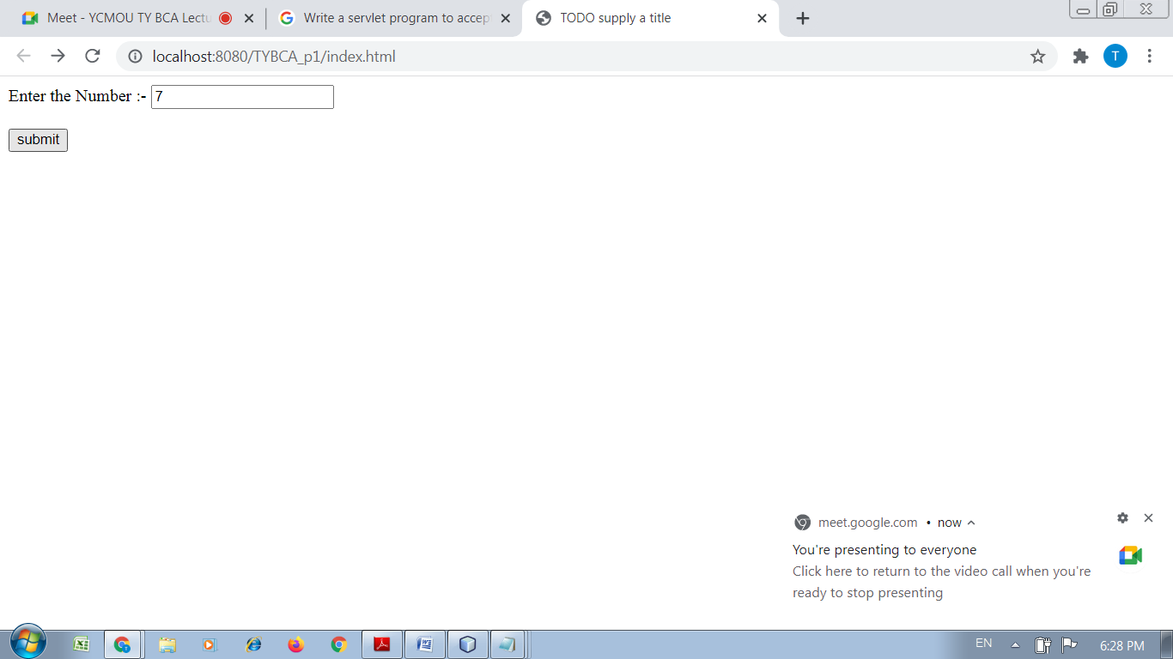

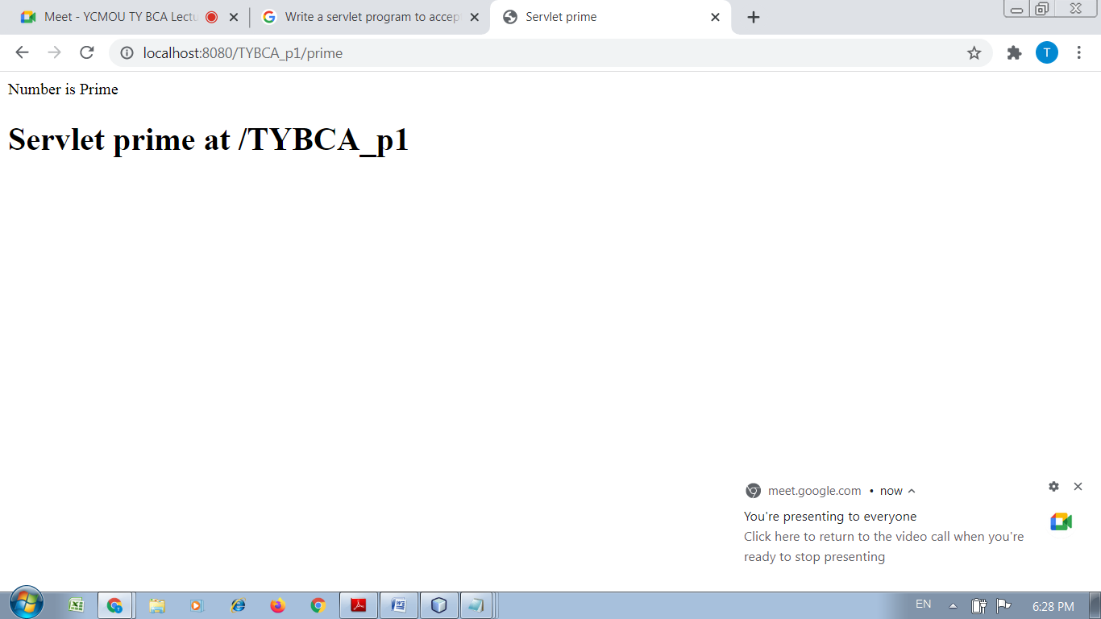

Practical No : 02

Aim :-

Write a servlet to determine whether the entered name from the html form is palindrome or not.

Solution :-

<html>

<head>

<title>TODO supply a title</title>

<meta charset="UTF-8">

<meta name="viewport" content="width=device-width, initial-scale=1.0">

</head>

<body>

<form action="palin" method="post">

Enter the String :- <input type="text" name="txt1" size="20">

<br>

<br>

<input type="submit" value="submit" name="submit">

</form>

</body>

</html>

/*

* To change this license header, choose License Headers in Project Properties.

* To change this template file, choose Tools | Templates

* and open the template in the editor.

*/

package palin;

import java.io.IOException;

import java.io.PrintWriter;

import javax.servlet.ServletException;

import javax.servlet.http.HttpServlet;

import javax.servlet.http.HttpServletRequest;

import javax.servlet.http.HttpServletResponse;

/**

*

* @author DELL

*/

public class palin extends HttpServlet {

/**

* Processes requests for both HTTP <code>GET</code> and <code>POST</code>

* methods.

*

* @param request servlet request

* @param response servlet response

* @throws ServletException if a servlet-specific error occurs

* @throws IOException if an I/O error occurs

*/

@Override

protected void doPost(HttpServletRequest request, HttpServletResponse response)

throws ServletException, IOException {

String name=request.getParameter("txt1");

response.setContentType("text/html;charset=UTF-8");

try (PrintWriter out = response.getWriter()) {

StringBuffer sb=new StringBuffer(name);

String reverse=sb.reverse().toString();

if(name.equalsIgnoreCase(reverse))

{

out.println("It is a palindrome");

}

else

{

out.println("It is not a palindrome");

}

/* TODO output your page here. You may use following sample code. */

out.println("<!DOCTYPE html>");

out.println("<html>");

out.println("<head>");

out.println("<title>Servlet palin</title>");

out.println("</head>");

out.println("<body>");

out.println("<h1>Servlet palin at " + request.getContextPath() + "</h1>");

out.println("</body>");

out.println("</html>");

}

}}

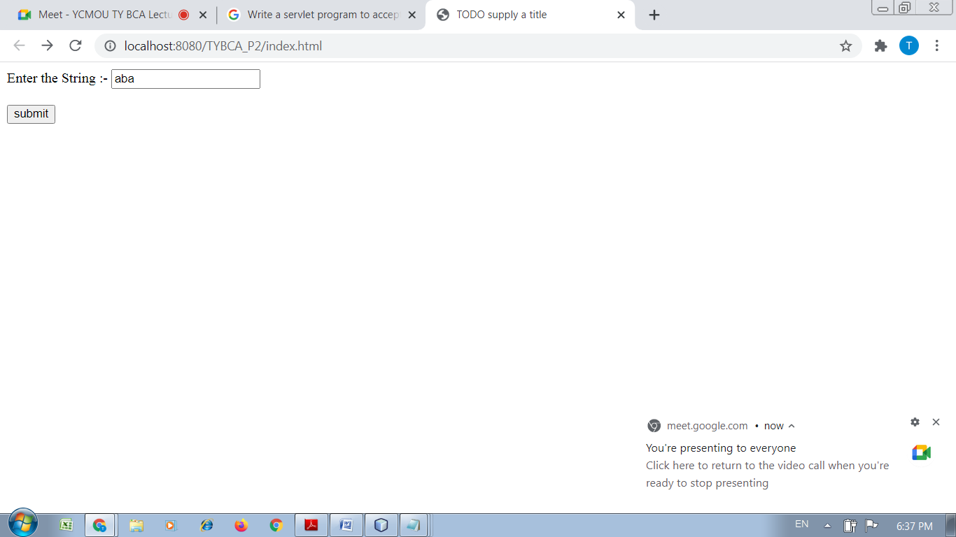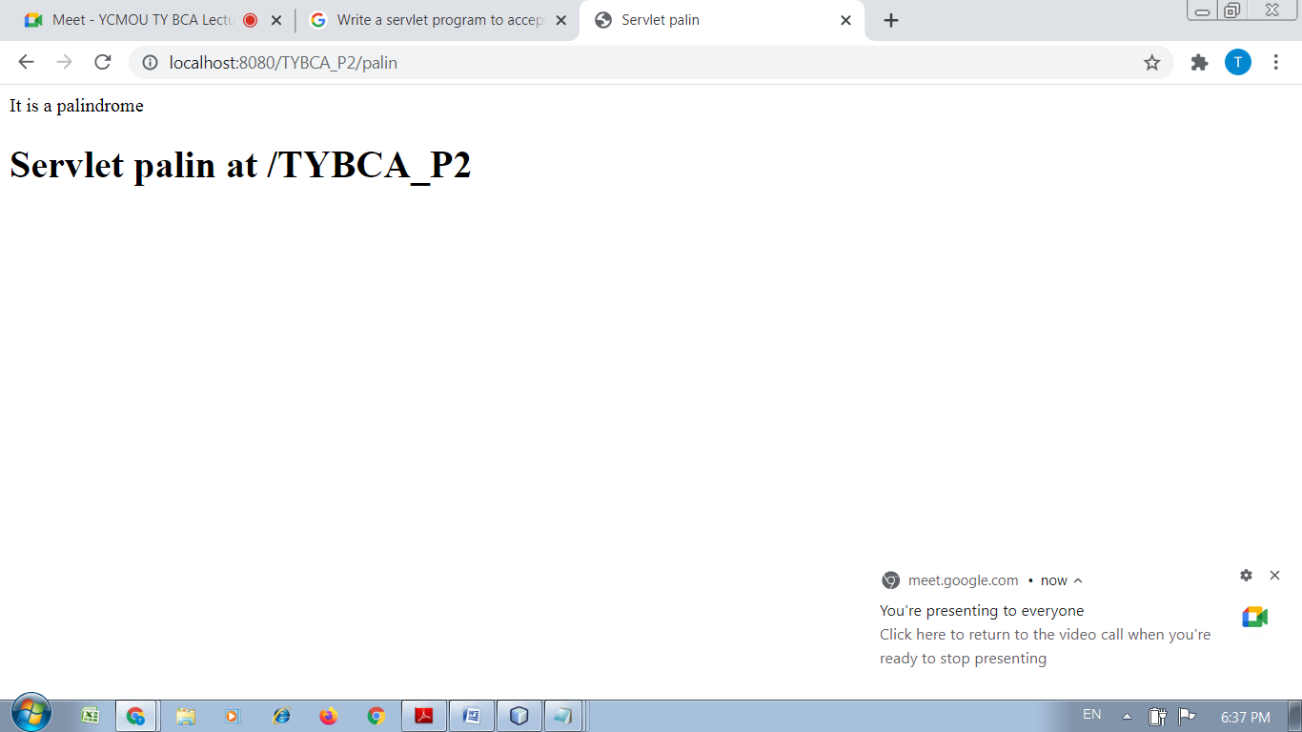

Practical No : 03

Aim :-

Write a Servlet program to print all the even numbers between the two entered numbers by the user, let say user enters 5 and 500 , so print the even numbers between 5 and 500

Solution :-

<html>

<head>

<title>TODO supply a title</title>

<meta charset="UTF-8">

<meta name="viewport" content="width=device-width, initial-scale=1.0">

</head>

<body>

<form action="prime" method="post">

Enter the 1st No :- <input type="text" name="txt1" size="20">

<br>

<br>

Enter the 2nd No :- <input type="text" name="txt2" size="20">

<br>

<br>

<input type="submit" value="submit" name="submit">

</form>

</body>

</html>

/*

* To change this license header, choose License Headers in Project Properties.

* To change this template file, choose Tools | Templates

* and open the template in the editor.

*/

package prime;

import java.io.IOException;

import java.io.PrintWriter;

import javax.servlet.ServletException;

import javax.servlet.http.HttpServlet;

import javax.servlet.http.HttpServletRequest;

import javax.servlet.http.HttpServletResponse;

/**

*

* @author DELL

*/

public class prime extends HttpServlet {

/**

* Processes requests for both HTTP <code>GET</code> and <code>POST</code>

* methods.

*

* @param request servlet request

* @param response servlet response

* @throws ServletException if a servlet-specific error occurs

* @throws IOException if an I/O error occurs

*/

@Override

protected void doPost(HttpServletRequest request, HttpServletResponse response)

throws ServletException, IOException {

String s=request.getParameter("txt1");

int start=Integer.parseInt(s);

String s1=request.getParameter("txt2");

int end=Integer.parseInt(s1);

response.setContentType("text/html;charset=UTF-8");

try (PrintWriter out = response.getWriter()) {

for(int i=start;i<=end;i++)

{

if(i%2==0)

{

out.println(i+"<br>");

}

else

{

}

}

/* TODO output your page here. You may use following sample code. */

out.println("<!DOCTYPE html>");

out.println("<html>");

out.println("<head>");

out.println("<title>Servlet prime</title>");

out.println("</head>");

out.println("<body>");

out.println("<h1>Servlet prime at " + request.getContextPath() + "</h1>");

out.println("</body>");

out.println("</html>");

}

}}

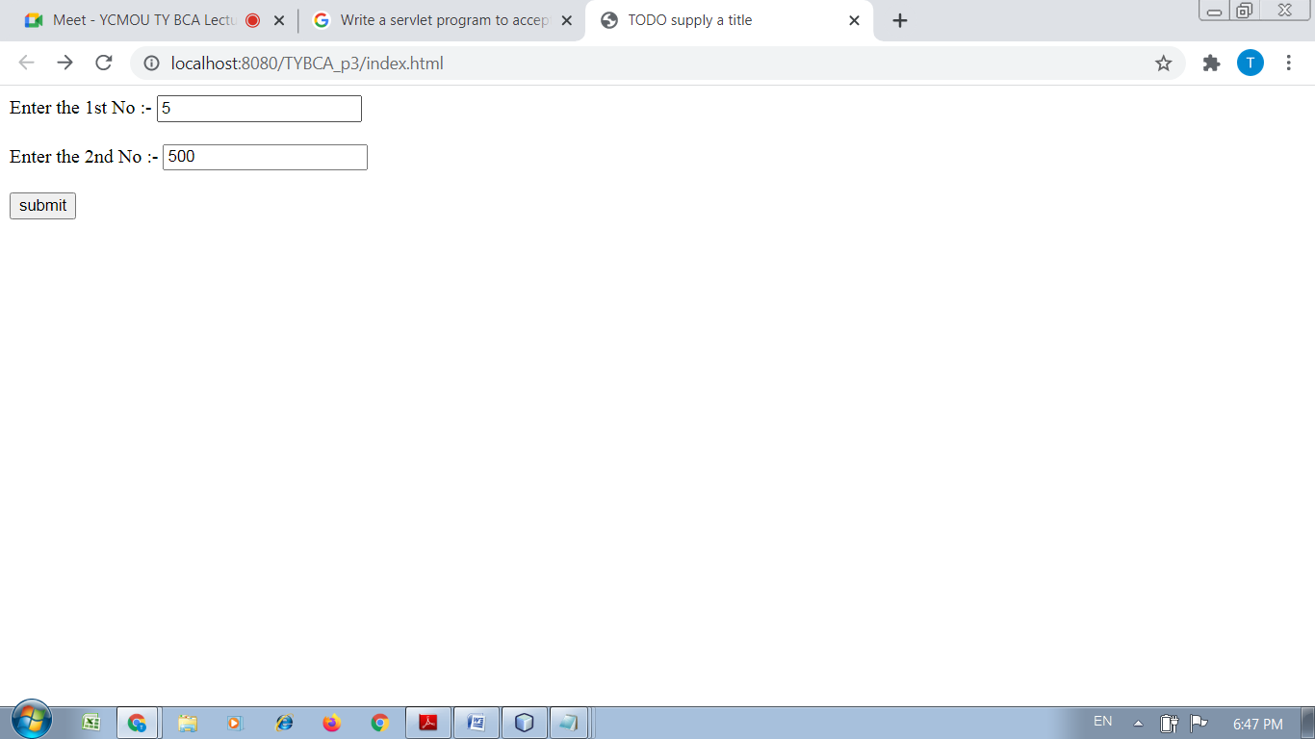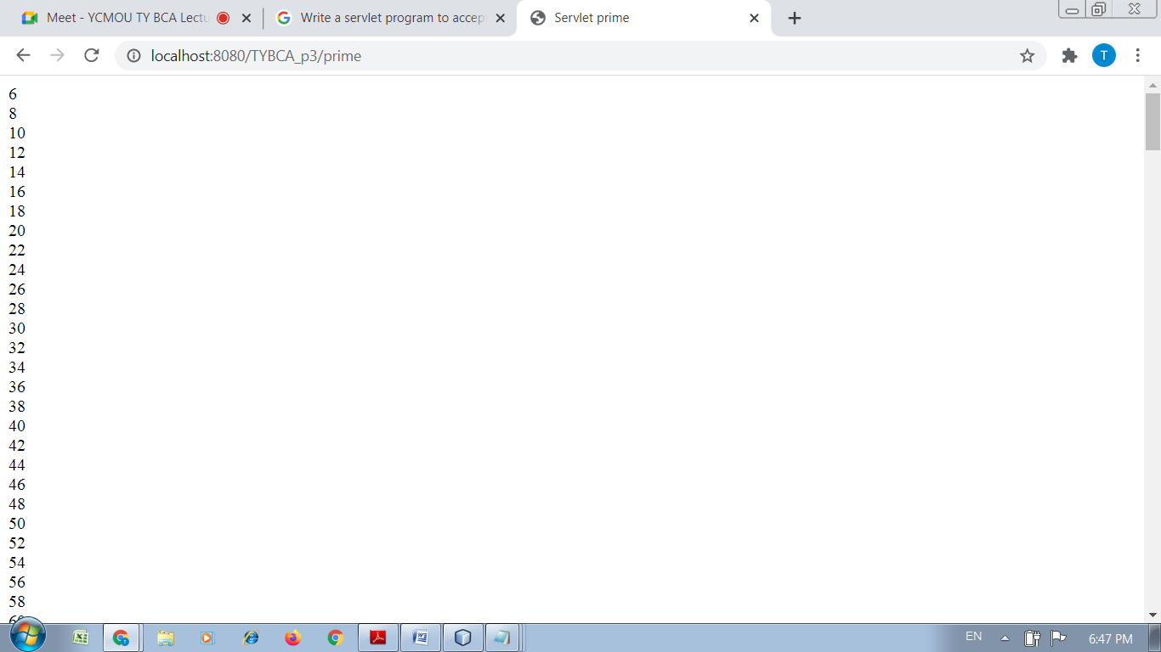

Practical No : 04

Aim :-

Write a servlet program to accept a number, if number is even redirect to purplesq.com if number is odd redirect to google.com

Solution :-

<html>

<head>

<title>TODO supply a title</title>

<meta charset="UTF-8">

<meta name="viewport" content="width=device-width, initial-scale=1.0">

</head>

<body>

<form action="evenodd" method="post">

Enter the Number :- <input type="text" name="txt1" size="20">

<br>

<br>

<input type="submit" value="submit" name="submit">

</form>

</body>

</html>

/*

* To change this license header, choose License Headers in Project Properties.

* To change this template file, choose Tools | Templates

* and open the template in the editor.

*/

package evenodd;

import java.io.IOException;

import java.io.PrintWriter;

import javax.servlet.RequestDispatcher;

import javax.servlet.ServletException;

import javax.servlet.http.HttpServlet;

import javax.servlet.http.HttpServletRequest;

import javax.servlet.http.HttpServletResponse;

/**

*

* @author DELL

*/

public class evenodd extends HttpServlet {

/**

* Processes requests for both HTTP <code>GET</code> and <code>POST</code>

* methods.

*

* @param request servlet request

* @param response servlet response

* @throws ServletException if a servlet-specific error occurs

* @throws IOException if an I/O error occurs

*/

@Override

protected void doPost(HttpServletRequest request, HttpServletResponse response)

throws ServletException, IOException {

String s=request.getParameter("txt1");

int n=Integer.parseInt(s);

response.setContentType("text/html;charset=UTF-8");

try (PrintWriter out = response.getWriter()) {

if(n%2==0)

{

out.println(n+"<br>"+"is a even number");

RequestDispatcher rd = request.getRequestDispatcher("www.purplesq.com");

rd.include(request, response);

}

else

{

out.println(n+"<br>"+"is a odd number");

RequestDispatcher rd = request.getRequestDispatcher("www.google.com");

rd.include(request, response);

}

/* TODO output your page here. You may use following sample code. */

out.println("<!DOCTYPE html>");

out.println("<html>");

out.println("<head>");

out.println("<title>Servlet evenodd</title>");

out.println("</head>");

out.println("<body>");

out.println("<h1>Servlet evenodd at " + request.getContextPath() + "</h1>");

out.println("</body>");

out.println("</html>");

}

}

}

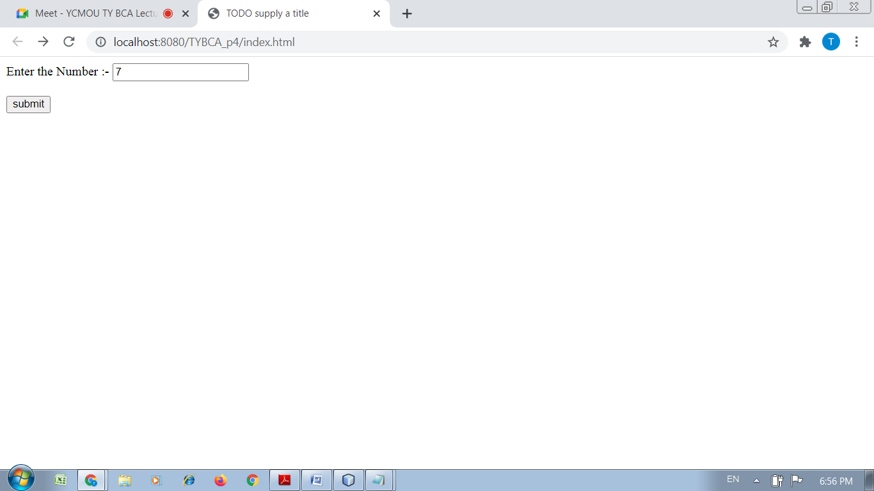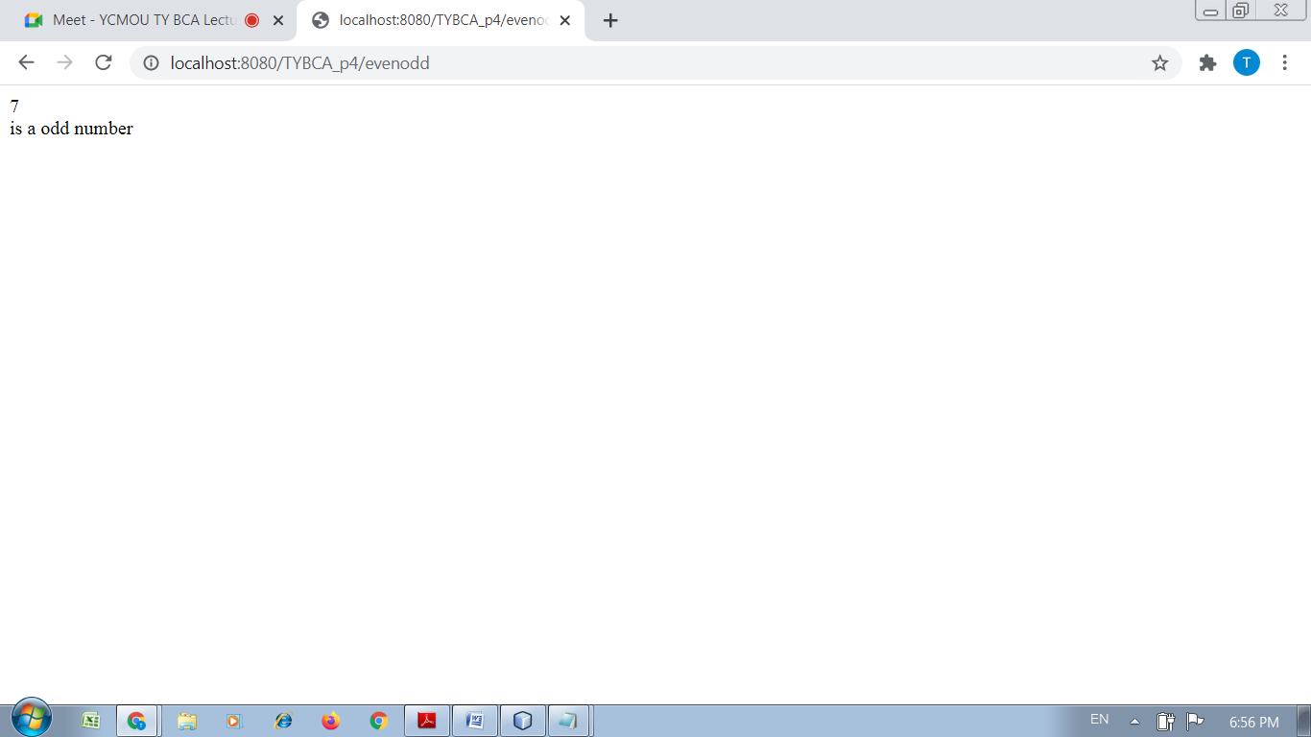

Practical No : 05

Aim :-

Write a servlet program to redirect the request to another servlet which requires a String as the parameter and the other servlet converts the string to lower case.

Solution :-

<html>

<head>

<title>TODO supply a title</title>

<meta charset="UTF-8">

<meta name="viewport" content="width=device-width, initial-scale=1.0">

</head>

<body>

<form action="conv" method="post">

Enter the String :- <input type="text" name="txt1" size="20">

<br>

<br>

<input type="submit" value="submit" name="submit">

</form>

</body>

</html>

/*

* To change this license header, choose License Headers in Project Properties.

* To change this template file, choose Tools | Templates

* and open the template in the editor.

*/

package conv;

import java.io.IOException;

import java.io.PrintWriter;

import javax.servlet.ServletException;

import javax.servlet.http.HttpServlet;

import javax.servlet.http.HttpServletRequest;

import javax.servlet.http.HttpServletResponse;

/**

*

* @author DELL

*/

public class conv extends HttpServlet {

/**

* Processes requests for both HTTP <code>GET</code> and <code>POST</code>

* methods.

*

* @param request servlet request

* @param response servlet response

* @throws ServletException if a servlet-specific error occurs

* @throws IOException if an I/O error occurs

*/

@Override

protected void doPost(HttpServletRequest request, HttpServletResponse response)

throws ServletException, IOException {

String s=request.getParameter("txt1");

response.setContentType("text/html;charset=UTF-8");

try (PrintWriter out = response.getWriter()) {

out.println(s.toLowerCase());

/* TODO output your page here. You may use following sample code. */

out.println("<!DOCTYPE html>");

out.println("<html>");

out.println("<head>");

out.println("<title>Servlet conv</title>");

out.println("</head>");

out.println("<body>");

out.println("<h1>Servlet conv at " + request.getContextPath() + "</h1>");

out.println("</body>");

out.println("</html>");

}

}

}

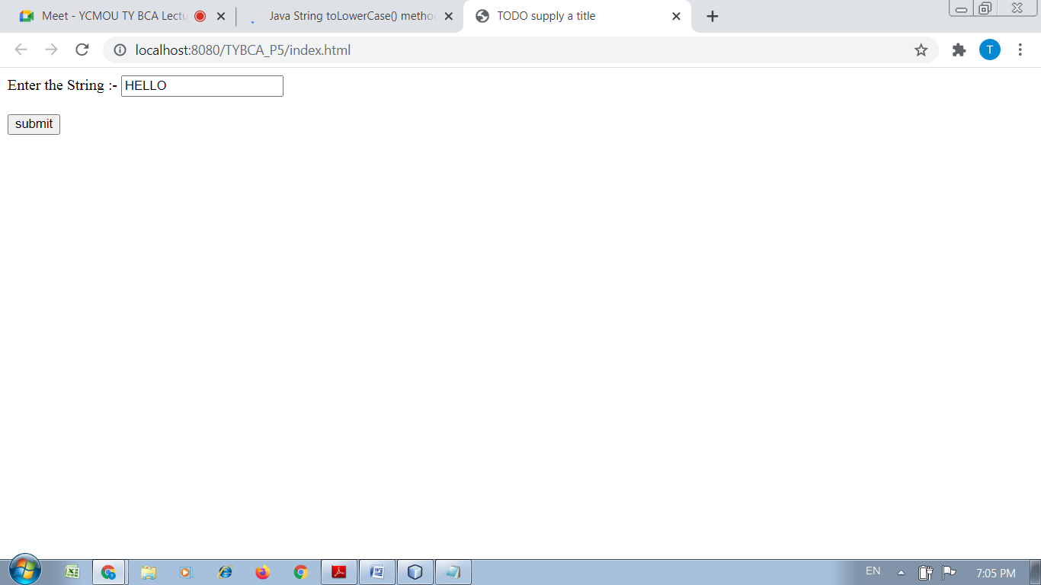

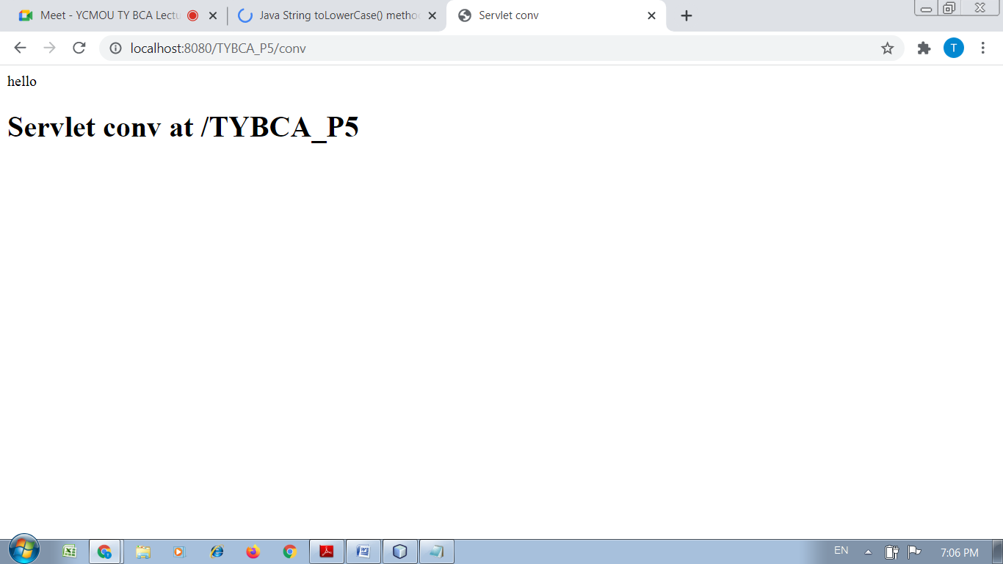

Practical No : 06

Aim :-

Write a Java program to get the name from a html form, put the name in session and redirect the flow to another servlet and the other servlet displays the name put into the session.

Solution :-

<html>

<head>

<title>TODO supply a title</title>

<meta charset="UTF-8">

<meta name="viewport" content="width=device-width, initial-scale=1.0">

</head>

<body>

<form action="session1" method="post">

Enter the Name :- <input type="text" name="txt1" size="20">

<br>

<br>

<input type="submit" value="submit" name="submit">

</form>

</body>

</html>

/*

* To change this license header, choose License Headers in Project Properties.

* To change this template file, choose Tools | Templates

* and open the template in the editor.

*/

package session1;

import java.io.IOException;

import java.io.PrintWriter;

import javax.servlet.ServletException;

import javax.servlet.http.HttpServlet;

import javax.servlet.http.HttpServletRequest;

import javax.servlet.http.HttpServletResponse;

/**

*

* @author DELL

*/

public class session1 extends HttpServlet {

/**

* Processes requests for both HTTP <code>GET</code> and <code>POST</code>

* methods.

*

* @param request servlet request

* @param response servlet response

* @throws ServletException if a servlet-specific error occurs

* @throws IOException if an I/O error occurs

*/

@Override

protected void doPost(HttpServletRequest request, HttpServletResponse response)

throws ServletException, IOException {

String s=request.getParameter("txt1");

response.setContentType("text/html;charset=UTF-8");

try (PrintWriter out = response.getWriter()) {

out.println("Welcome"+s);

/* TODO output your page here. You may use following sample code. */

out.println("<!DOCTYPE html>");

out.println("<html>");

out.println("<head>");

out.println("<title>Servlet session1</title>");

out.println("</head>");

out.println("<body>");

out.println("<h1>Servlet session1 at " + request.getContextPath() + "</h1>");

out.println("</body>");

out.println("</html>");

}

}

}

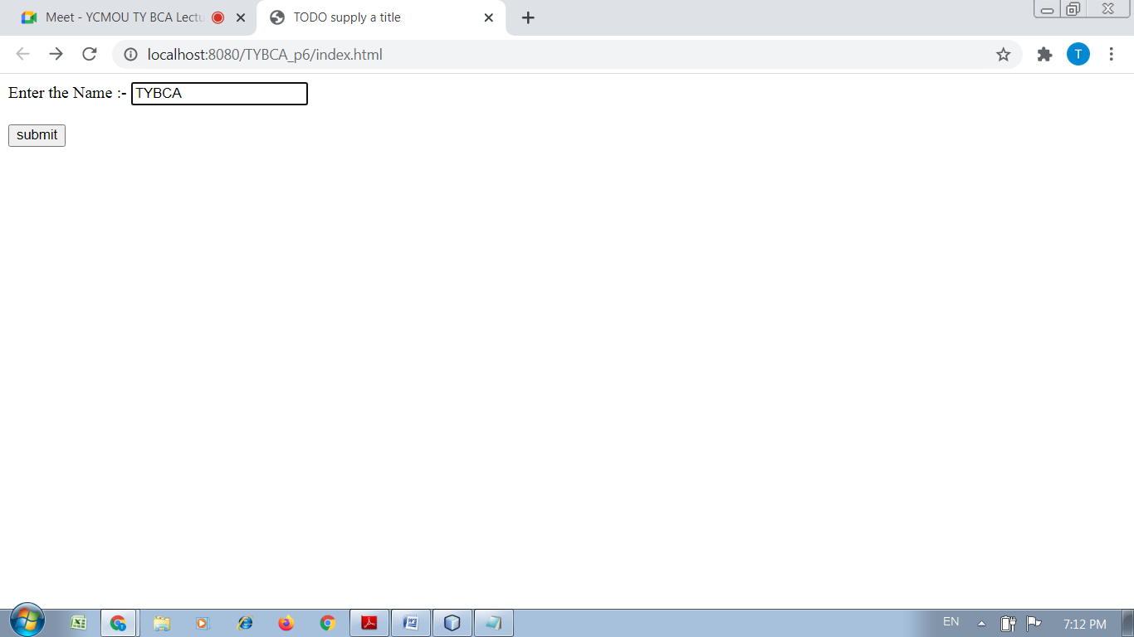

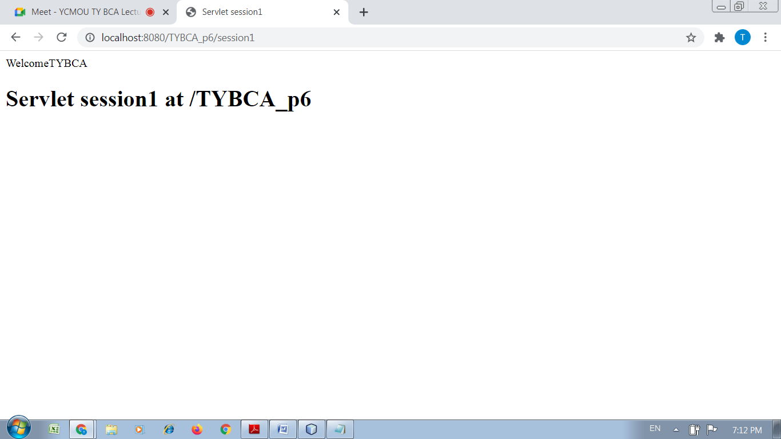

Practical No : 07

Aim :-

Write a JSP code to accept a number and revert whether the number is prime or not.

Solution :-

<html>

<head>

<title>TODO supply a title</title>

<meta charset="UTF-8">

<meta name="viewport" content="width=device-width, initial-scale=1.0">

</head>

<body>

<form action="prime.jsp" method="post">

Enter the Number :- <input type="text" name="txt1" size="20">

<br>

<br>

<input type="submit" value="submit" name="submit">

</form>

</body>

</html>

<%--

Document : prime

Created on : Nov 11, 2021, 7:17:37 PM

Author : DELL

--%>

<%@page contentType="text/html" pageEncoding="UTF-8"%>

<!DOCTYPE html>

<html>

<head>

<meta http-equiv="Content-Type" content="text/html; charset=UTF-8">

<title>JSP Page</title>

</head>

<body>

<%

String n=request.getParameter("txt1");

int number=Integer.parseInt(n);

int flag=0;

for(int i=2;i<=(number-1);i++)

{

if(number%2==0)

{

flag=1;

break;

}

}

if(flag==0)

{

out.println("Number is Prime");

}

else

{

out.println("Number is not prime");

}

%>

</body>

</html>

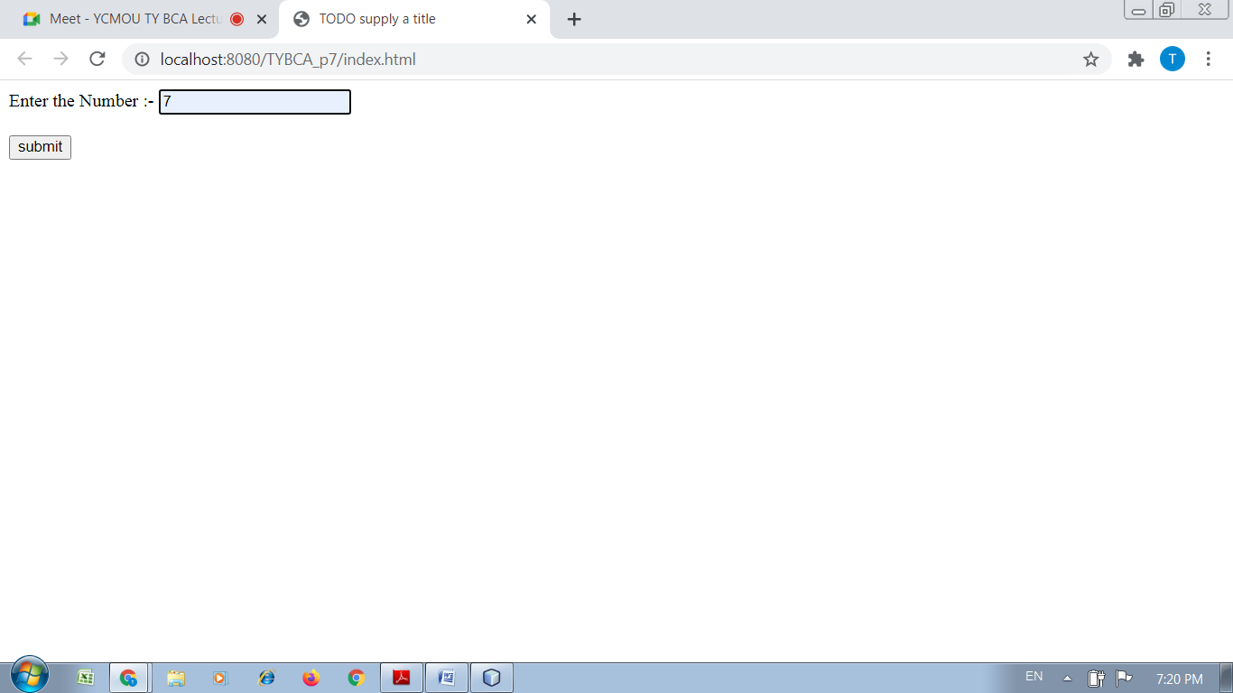

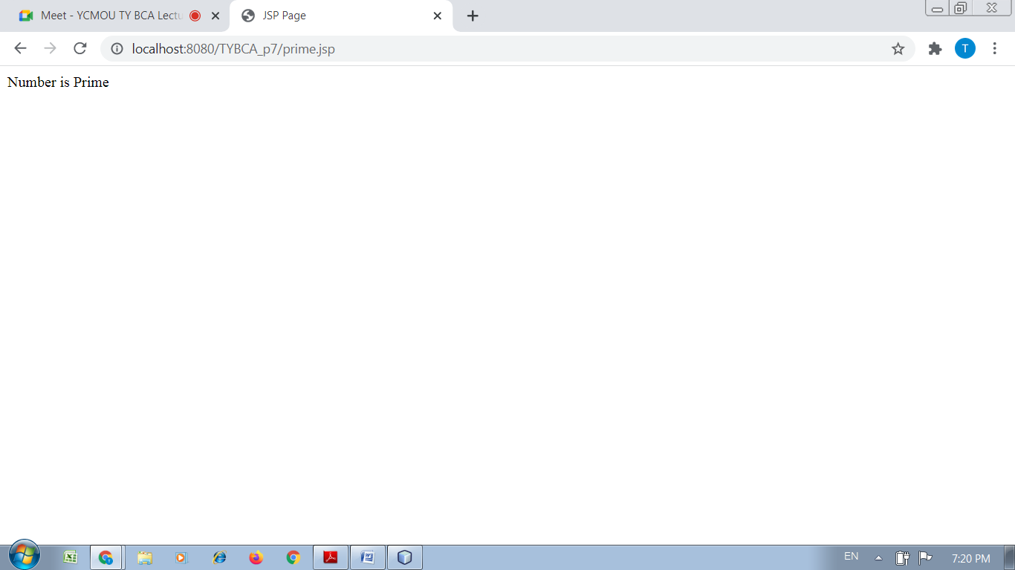

Practical No : 08

Aim :-

Write a servlet Program to accept a String and determine whether the String‟s length is greater than 6.

Solution :-

<html>

<head>

<title>TODO supply a title</title>

<meta charset="UTF-8">

<meta name="viewport" content="width=device-width, initial-scale=1.0">

</head>

<body>

<form action="len" method="post">

Enter the String :- <input type="text" name="txt1" size="20">

<br>

<br>

<input type="submit" value="submit" name="submit">

</form>

</body>

</html>

<%--

Document : len

Created on : Nov 11, 2021, 7:24:17 PM

Author : DELL

--%>

<%@page contentType="text/html" pageEncoding="UTF-8"%>

<!DOCTYPE html>

<html>

<head>

<meta http-equiv="Content-Type" content="text/html; charset=UTF-8">

<title>JSP Page</title>

</head>

<body>

<%

String s=request.getParameter("txt1");

int l=s.length();

if(l>=6)

{

out.println("Length of the string is:"+l);

}

else

{

out.println("Length of the String is not equals or more than 6. Length :"+l);

}

%>

</body>

</html>

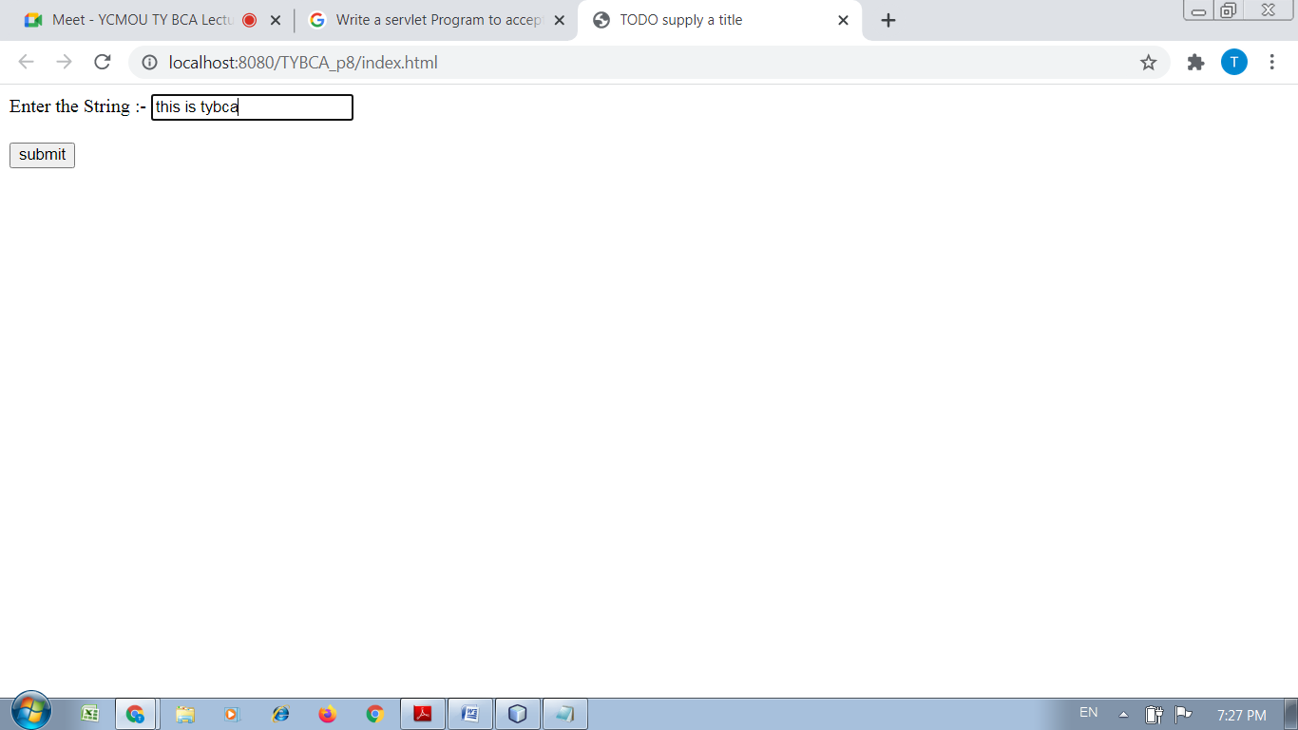

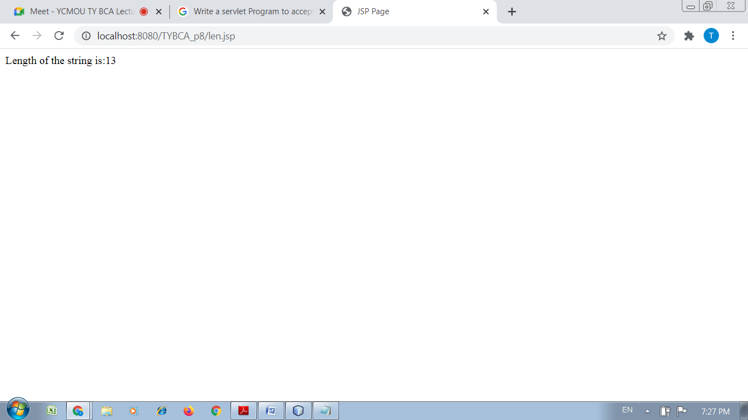

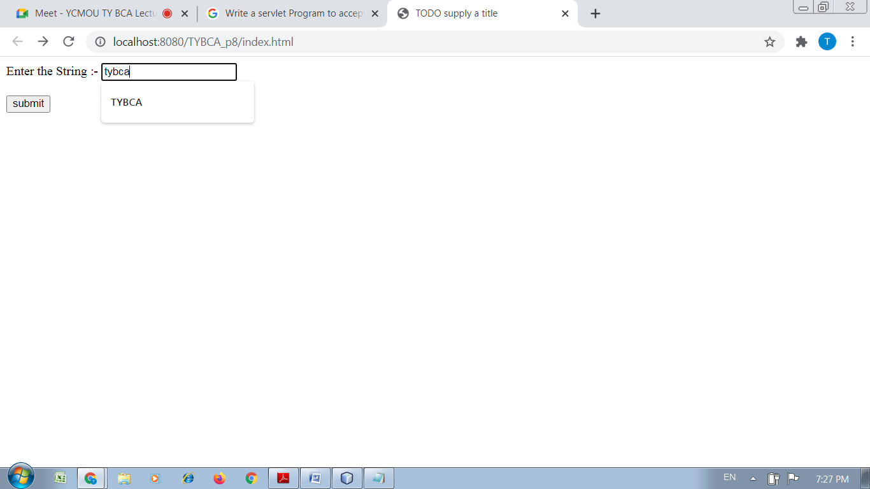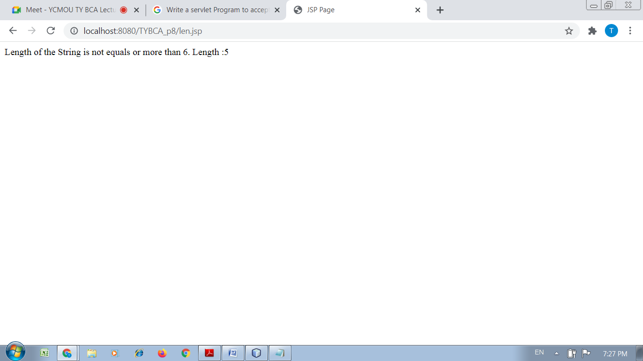

Practical No : 08

Aim :-

Write a JSP Program to redirect to Google.com

Solution :-

<%--

Document : redirect

Created on : Nov 11, 2021, 7:31:28 PM

Author : DELL

--%>

<%@page contentType="text/html" pageEncoding="UTF-8"%>

<!DOCTYPE html>

<html>

<head>

<meta http-equiv="Content-Type" content="text/html; charset=UTF-8">

<title>JSP Page</title>

</head>

<body>

<%

// New location to be redirected

String site = new String("http://www.google.com");

response.setStatus(response.SC_MOVED_TEMPORARILY);

response.setHeader("Location", site);

%>

</body>

</html>

