**Practical No: 01**

**Aim**:- Design a Home page for a Business to Consumer website

**Solution** :-

//homepage.html

<html>

<head>

<title>

</title>

</head>

<body>

<img src=”C:\Users\DELL\Desktop\test1.jpg” height=400 width=400>

</body>

</html>

<https://www.optimonk.com/best-ecommerce-homepage-design/>

**Practical No : 02**

**Aim** :- Design a page to enter customer details such as name address phone number etc.

**Solution** :-

<html>

<head>

<title>

</title>

</head>

<body>

<form>  
  <label for="name">Name:</label><br>  
  <input type="text" id="name" name="name"><br>  
  <label for="Address">Address:</label><br>  
  <input type="text" id="add" name="add"><br>

  <label for="Contact"> Contact:</label><br>  
  <input type="number" id=" Contact " name=" Contact "><br>  
</form>

</body>

</html>

**Practical No : 03**

**Aim** :- Explain with diagram working of e Payment System (Debit, Credit Card, Smart Card)

**Solution** :-

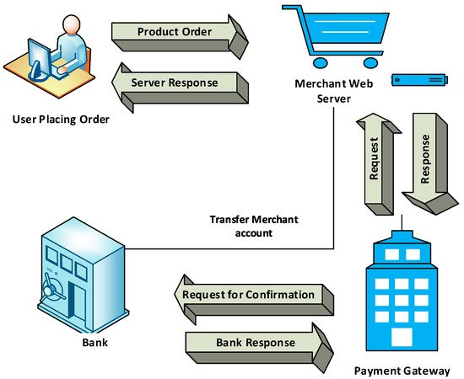

E-commerce sites use electronic payment, where electronic payment refers to paperless monetary transactions. Electronic payment has revolutionized the business processing by reducing the paperwork, transaction costs, and labor cost. Being user friendly and less time-consuming than manual processing, it helps business organization to expand its market reach/expansion. Listed below are some of the modes of electronic payments −

* Credit Card
* Debit Card
* Smart Card

Credit Card

Payment using credit card is one of most common mode of electronic payment. Credit card is small plastic card with a unique number attached with an account. It has also a magnetic strip embedded in it which is used to read credit card via card readers. When a customer purchases a product via credit card, credit card issuer bank pays on behalf of the customer and customer has a certain time period after which he/she can pay the credit card bill. It is usually credit card monthly payment cycle. Following are the actors in the credit card system.

* **The card holder** − Customer
* **The merchant** − seller of product who can accept credit card payments.
* **The card issuer bank** − card holder's bank
* **The acquirer bank** − the merchant's bank
* **The card brand** − for example , visa or Mastercard.

Credit Card Payment Proces

|  |  |
| --- | --- |
| **Step** | **Description** |
| Step 1 | Bank issues and activates a credit card to the customer on his/her request. |
| Step 2 | The customer presents the credit card information to the merchant site or to the merchant from whom he/she wants to purchase a product/service. |
| Step 3 | Merchant validates the customer's identity by asking for approval from the card brand company. |
| Step 4 | Card brand company authenticates the credit card and pays the transaction by credit. Merchant keeps the sales slip. |
| Step 5 | Merchant submits the sales slip to acquirer banks and gets the service charges paid to him/her. |
| Step 6 | Acquirer bank requests the card brand company to clear the credit amount and gets the payment. |
| Step 6 | Now the card brand company asks to clear the amount from the issuer bank and the amount gets transferred to the card brand company. |

Debit Card

Debit card, like credit card, is a small plastic card with a unique number mapped with the bank account number. It is required to have a bank account before getting a debit card from the bank. The major difference between a debit card and a credit card is that in case of payment through debit card, the amount gets deducted from the card's bank account immediately and there should be sufficient balance in the bank account for the transaction to get completed; whereas in case of a credit card transaction, there is no such compulsion.

Debit cards free the customer to carry cash and cheques. Even merchants accept a debit card readily. Having a restriction on the amount that can be withdrawn in a day using a debit card helps the customer to keep a check on his/her spending.

Smart Card

Smart card is again similar to a credit card or a debit card in appearance, but it has a small microprocessor chip embedded in it. It has the capacity to store a customer’s work-related and/or personal information. Smart cards are also used to store money and the amount gets deducted after every transaction.

Smart cards can only be accessed using a PIN that every customer is assigned with. Smart cards are secure, as they store information in encrypted format and are less expensive/provides faster processing. Mondex and Visa Cash cards are examples of smart cards.

**Practical No : 04**

Aim :- Explain types of Network and Role of Internet in eCommerce.

Solution :-

Networks can be categorized depending on size, complexity, level of security, or geographical range. We will discuss some of the most popular topologies based on geographical spread.

PAN

PAN is the acronym for Personal Area Network. PAN is the interconnection between devices within the range of a person’s private space, typically within a range of 10 metres. If you have transferred images or songs from your laptop to mobile or from mobile to your friend’s mobile using Bluetooth, you have set up and used a personal area network.

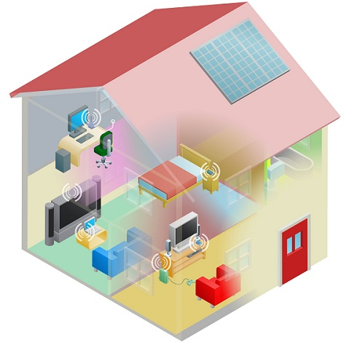

A person can connect her laptop, smart phone, personal digital assistant and portable printer in a network at home. This network could be fully Wi-Fi or a combination of wired and wireless.

LAN

LAN or Local Area Network is a wired network spread over a single site like an office, building or manufacturing unit. LAN is set up to when team members need to share software and hardware resources with each other but not with the outside world. Typical software resources include official documents, user manuals, employee handbook, etc. Hardware resources that can be easily shared over the network include printer, fax machines, modems, memory space, etc. This decreases infrastructure costs for the organization drastically.

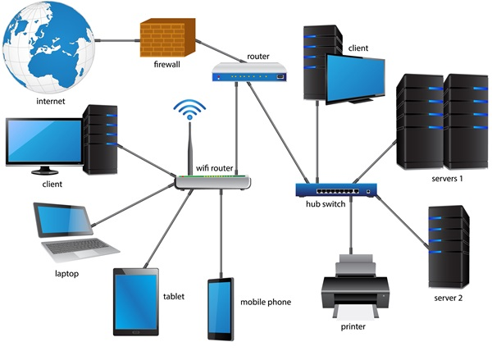

A LAN may be set up using wired or wireless connections. A LAN that is completely wireless is called Wireless LAN or WLAN.

MAN

MAN is the acronym for Metropolitan Area Network. It is a network spread over a city, college campus or a small region. MAN is larger than a LAN and typically spread over several kilometres. Objective of MAN is to share hardware and software resources, thereby decreasing infrastructure costs. MAN can be built by connecting several LANs.

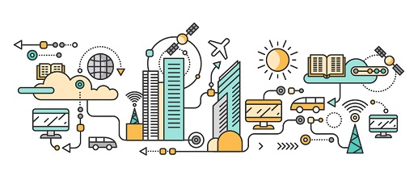

The most common example of MAN is cable TV network.

WAN

WAN or Wide Area Network is spread over a country or many countries. WAN is typically a network of many LANs, MANs and WANs. Network is set up using wired or wireless connections, depending on availability and reliability.

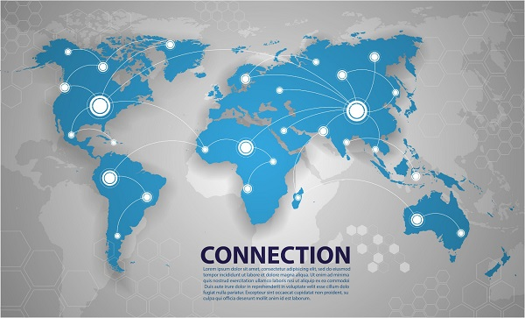

The most common example of WAN is the Internet.

Role of Internet in eCommerce.

**Analyze how Internet technology has changed value propositions and business models.**

The Internet is rapidly becoming the infrastructure of choice for electronic commerce and electronic business because it provides a universal and easy-to-use set of technologies and technology standards that can be adopted by all organizations, no matter which computer system or information technology platform they use. Internet technology provides a much lower cost and easier to use alternative for coordination activities than proprietary networks. Companies can use Internet technology to radically reduce their transaction and agency costs.

           The Internet radically reduces the cost of creating, sending, and storing information while making that information more widely available. Information is not limited to traditional physical methods of delivery. Customers can find out about products on their own on the Web and buy directly from product suppliers instead of using intermediaries such as retail stores. This unbundling of information from traditional value chain channels is having a disruptive effect on old business models, and it is creating new business models as well. Some of the traditional channels for exchanging product information have become unnecessary or uneconomical, and business models based on the coupling of information with products and services may no longer be necessary. By using the Internet and other networks for electronic commerce, organizations in some industries can exchange purchase and sale transactions directly with customers and suppliers, eliminating inefficient intermediaries.  
  
           The Internet shrinks information asymmetry and has transformed the relationship between information richness and reach. Using the Internet and Web multimedia capabilities, companies can quickly and inexpensively provide detailed product information and detailed information specific to each customer to very large numbers of people simultaneously. The Internet can help companies create and capture profit in new ways by adding extra value to existing products and services or by providing the foundation for new products and services. Many different business models for electronic commerce on the Internet have emerged, including virtual storefronts, information brokers, transaction brokers, Net marketplaces, content providers, online service providers, virtual communities, and portals.

**Practical No : 05**

Aim :- Study any popular search engine and note down the

features.

Solution :-

[**Google**](http://www.google.com/)  
Google Search Engine is the best search engine in the world and it is also one of most popular products from Google. Almost 70 percent of the Search Engine market has been acquired by Google. The tech giant is always evolving and looking to improve the search engine algorithm to provide best results to the end-user. Although Google appears to be the biggest search engine, as of 2015 YouTube is now more popular than Google (on desktop computers).

### Special interactive features

Besides the main text-based search-engine features of Google search, it also offers multiple quick, interactive experiences. These include, but are not limited to

* Calculator
* Time zone, currency, and unit conversions
* Word translations
* Flight status
* Local film showings
* Weather forecasts
* Population and unemployment rates
* Package tracking
* Word definitions
* Metronome
* Roll a die
* "Do a barrel roll" (search page spins)
* "Askew" (results show up sideways)

### "OK Google" conversational search

During Google's developer conference, [Google I/O](https://en.wikipedia.org/wiki/Google_I/O), in May 2013, the company announced that users on [Google Chrome](https://en.wikipedia.org/wiki/Google_Chrome) and [Chrome OS](https://en.wikipedia.org/wiki/Chrome_OS) would be able to have the browser initiate an audio-based search by saying "OK Google", with no button presses required. After having the answer presented, users can follow up with additional, contextual questions; an example include initially asking "OK Google, will it be sunny in Santa Cruz this weekend?", hearing a spoken answer, and reply with "how far is it from here?"[[40]](https://en.wikipedia.org/wiki/Google_Search#cite_note-40)[[41]](https://en.wikipedia.org/wiki/Google_Search#cite_note-41) An update to the Chrome browser with voice-search functionality rolled out a week later, though it required a button press on a microphone icon rather than "OK Google" voice activation.[[42]](https://en.wikipedia.org/wiki/Google_Search#cite_note-42) Google released a browser extension for the Chrome browser, named with a "[beta](https://en.wikipedia.org/wiki/Beta_software)" tag for unfinished development, shortly thereafter.[[43]](https://en.wikipedia.org/wiki/Google_Search#cite_note-43) In May 2014, the company officially added "OK Google" into the browser itself;[[44]](https://en.wikipedia.org/wiki/Google_Search" \l "cite_note-44) they removed it in October 2015, citing low usage, though the microphone icon for activation remained available.[[45]](https://en.wikipedia.org/wiki/Google_Search#cite_note-45) In May 2016, 20% of search queries on mobile devices were done through voice.[[46]](https://en.wikipedia.org/wiki/Google_Search#cite_note-46)

**Practical No : 06**

Aim :- Study session management feature of e Commerce website.

Solution :-

# 4 ways of Session management in e Commerce website

Session tracking or Session management is an important feature of modern web applications which allows the server to remember its clients. By keeping a session for each user, the Server can serve the client better. It also helps in safety, security, and personalization and must for certain kinds of web applications like e-commerce sites like Amazon or e-bay which stores items selected by the user for purchase in a shopping cart, even after the user is logged out.

Since [HTTP is a stateless protocol](http://javarevisited.blogspot.com/2015/06/how-to-create-http-server-in-java-serversocket-example.html), there are no ways to know that two HTTP requests are related to each other i.e. they are coming from the same client or they are part of the same process. Session tracking is a mechanism that Servlets and Java Web applications use to maintain a state about a series of requests from the same user across some period of time.

By keeping a session, an e-commerce site can maintain add to card facility and also keep track of how you interact with the application. Since HTTP doesn't provide a default way to track Sessions, there are some non-standard ways to manage Sessions in [Servlet JSP-based applications](http://java67.blogspot.com/2012/10/servlet-jsp-interview-questions-answer-faq-experience.html). Let's have a close look at them.

## Types of Session Tracking in Servlet

Since Session management needs to work with all web browsers and also considers user's security preferences, often an identifier i.e. a SessionId is used to keep track of requests coming from the same client during a time duration. There are four main ways to manage Session in Java Web application written using Servlet and JSP.  
  
1) URL rewriting  
2) Cookies  
3) Hidden Form fields  
4) HTTPS and SSL

**1. URL rewriting**  
URL rewriting is a method of session tracking in which some extra data (session ID) is appended at the end of each URL. This extra data identifies the session. The server can associate this session identifier with the data it has stored about that session. This method is used with browsers that do not support cookies or where the user has disabled the cookies. If you need to track Session from JSP pages, then you can [use the <c:out> tag for URL-rewriting](http://javarevisited.blogspot.com/2012/01/url-rewriting-url-encoding-in-servlet.html). It automatically encodes session identifiers in URL.  
  
  
**2. Hidden Form Fields**  
This is one of the oldest ways to do session tracking in the Servlet application. Similar to URL rewriting. The server embeds new hidden fields in every dynamically generated form page for the client. When the client submits the form to the server the hidden fields identify the client. You can further see [Head First Servlet and JSP](https://javarevisited.blogspot.com/2017/01/best-books-to-learn-servlet-and-jsp.html) for more details on how to use the hidden form field to manage sessions in Servlet JSP.  
  
  
  
**3. Cookies**  
A cookie is a small amount of information sent by a servlet to a Web browser. A cookie is saved by the browser and later sent back to the server in subsequent requests. A cookie has a name, a single value, expiration date, and optional attributes.

A cookie's value can uniquely identify a client. Since a client can disable cookies, this is not the most secure and fool-proof way to manage the session. If Cookies are disabled then you can fall back to URL rewriting to encode Session id e.g. [JSESSIOINID](http://javarevisited.blogspot.com/2012/08/what-is-jsessionid-in-j2ee-web.html) into the URL itself.

**4. Secure Socket Layer (SSL) Sessions**  
Web browsers that support Secure Socket Layer communication can use SSL's support via HTTPS for generating a unique session key as part of the encrypted conversation. Modern days online internet banking websites, ticket booking websites, e-commerce retailers like Amazon and e-bay all use HTTPS to securely transfer data and manage the session. You can also see [Murach's Java Servlets and JSP](https://medium.com/javarevisited/my-favorite-books-to-learn-servlet-and-jsp-for-java-programmers-f14fdfe5a151" \t "_blank) learn more about how HTTPS can be used with Java web applications.  
  
  
That's all about **different ways to track Session in Java Web application**. Cookie was the most popular way to manage Session with a fallback to URL rewriting when Cookies are not enabled at the client-side.

While more security-sensitive applications like online e-commerce portals like Amazon, Flipkart, eBay, online banking websites, travel booking websites, or any other websites which deal with sensitive information like personal, financial, or professional they use SSL and HTTPS to secures transfer and maintain them.

**Practical No : 07**

Aim :- State the role of ISP.

Solution :-

## What is the definition of ISP?

ISP is an acronym that stands for Internet Service Provider. An Internet Service Provider is a company that provides Internet access to organizations and home users.

## What exactly do ISPs do?

In short, an ISP provides you with Internet access, usually for a fee. Without an ISP, you wouldn’t be able to shop online, access Facebook, or read this page. Connecting to the Internet requires specific telecommunications, networking, and routing equipment. ISPs allow users access to networks that contain the required equipment, enabling users to establish Internet connectivity.

ISPs are responsible for making sure you can access the Internet, routing Internet traffic, resolving domain names, and maintaining the network infrastructure that makes Internet access possible.

While the core function of an ISP is to provide Internet access, many ISPs do much more. ISPs also offer services like web hosting, domain name registration, and email services.

The role of ISP in internet access among others:

* As a medium that provides services to connect to the internet.
* Connect customers to the nearest Internet gateway.
* Provides a modem for dial-up.
* Connecting an information service to a user of the World Wide Web (www).
* Allows a user to use the services of electronic mail (e-mail).
* Allows a user voice conversations via the internet.
* Gave place to the homepage.
* ISP do protection from the spread of the virus by applying antivirus systems for his customers.

**Practical No : 08**

Aim :- State the Importance of Digital signature in online business.

Solution :-

What are Digital Signatures?

A digital signature is a type of digital identification that can be used to validate the digital message. The digital signature’s identity validation gives information about who sent it and when, so you know whether or not there has been any tampering with the message or electronic document in transit.

[Digital signatures provide authentication](https://www.lightico.com/blog/what-is-the-difference-between-an-esignature-and-a-digital-signature/) without requiring physical access to what’s being signed, or to the signature device.

## How Do Digital Signatures Work?

Digital signatures have a high level of security. They use asymmetric encryption, which means that the key for signing is different from the one used to decrypt messages locked with a digital signature.

There are digital signatures that use public and private keys, digital certificates, and email signing. The type of digital signature you should choose depends on the needs of your online business.

## Benefits of Digital Signatures

[Digital signatures are faster](https://www.lightico.com/blog/esignature-complete-guide/) than traditional means of acquiring an important online signature. They help to simplify procedures such as document exchange among partners or customers outside a company, by reducing administrative tasks needlessly involved in manual handling.

Digital signature tools provide authentication without requiring physical access to what’s being signed or to the signature device. They are considered a digital “fingerprint” that is unique and can’t be forged without access to the original sender’s private key. Digital fingerprints also prove when data was sent, which helps detect messages or files being re-sent after an event that should have invalidated an original document.

## Using Digital Signatures in Online Businesses

Digital signatures will help digital business transactions to be carried out faster and more securely. They can also reduce the risk of fraud, for example, if a payment is made on a website, it’s possible that this could be revoked by using digital signature technology.

Customer-centric digital signing offers business owners many benefits including higher conversion rates and lower customer acquisition costs. The digital document signing process is also more secure and efficient and provides a much better user experience.

## Implementing Digital Signatures in a Business

If you’re serious about digital signatures, it’s important to have an implementation strategy in place.

**Step One:**Understand what digital signing is and how it can be implemented within your business environment.

**Step Two:**Find out if there are digital signature tools or service providers for your industry.

**Step Three:**Determine digital signing requirements, industry standards, and the workflow that is required to implement digital signatures in your business environment.

**Step Four:**Plan, pilot, and roll out a solution for yourself or your team with this information as guidance.

Digital signatures are becoming more common. Companies can enjoy the benefits digital signatures have to offer, such as being faster than traditional means of acquiring an important signature and providing authentication without requiring physical access to what’s being signed or to the signature device. The digital signing process is also more secure and efficient, which creates a better user experience for customers.

**Practical No : 09**

Aim :- Explain cookies, write steps to create a cookie.

Solution :-

Cookies are text files stored on the client computer and they are kept for various information tracking purposes. JSP transparently supports HTTP cookies using underlying servlet technology.

There are three steps involved in identifying and returning users −

* Server script sends a set of cookies to the browser. For example, name, age, or identification number, etc.
* Browser stores this information on the local machine for future use.
* When the next time the browser sends any request to the web server then it sends those cookies information to the server and server uses that information to identify the user or may be for some other purpose as well.

## Setting Cookies with JSP

Setting cookies with JSP involves three steps −

### Step 1: Creating a Cookie object

You call the Cookie constructor with a cookie name and a cookie value, both of which are strings.

Cookie cookie = new Cookie("key","value");

Keep in mind, neither the name nor the value should contain white space or any of the following characters −

[ ] ( ) = , " / ? @ : ;

### Step 2: Setting the maximum age

You use **setMaxAge** to specify how long (in seconds) the cookie should be valid. The following code will set up a cookie for 24 hours.

cookie.setMaxAge(60\*60\*24);

### Step 3: Sending the Cookie into the HTTP response headers

You use **response.addCookie** to add cookies in the HTTP response header as follows

response.addCookie(cookie);

### Example

Let us modify our [Form Example](https://www.tutorialspoint.com/jsp/jsp_form_processing.htm) to set the cookies for the first and the last name.

<%

// Create cookies for first and last names.

Cookie firstName = new Cookie("first\_name", request.getParameter("first\_name"));

Cookie lastName = new Cookie("last\_name", request.getParameter("last\_name"));

// Set expiry date after 24 Hrs for both the cookies.

firstName.setMaxAge(60\*60\*24);

lastName.setMaxAge(60\*60\*24);

// Add both the cookies in the response header.

response.addCookie( firstName );

response.addCookie( lastName );

%>

<html>

<head>

<title>Setting Cookies</title>

</head>

<body>

<center>

<h1>Setting Cookies</h1>

</center>

<ul>

<li><p><b>First Name:</b>

<%= request.getParameter("first\_name")%>

</p></li>

<li><p><b>Last Name:</b>

<%= request.getParameter("last\_name")%>

</p></li>

</ul>

</body>

</html>

Let us put the above code in **main.jsp** file and use it in the following HTML page −

<html>

<body>

<form action = "main.jsp" method = "GET">

First Name: <input type = "text" name = "first\_name">

<br />

Last Name: <input type = "text" name = "last\_name" />

<input type = "submit" value = "Submit" />

</form>

</body>

</html>

Keep the above HTML content in a file **hello.jsp** and put **hello.jsp** and **main.jsp** in **<Tomcat-installation-directory>/webapps/ROOT** directory. When you will access ***http://localhost:8080/hello.jsp***, here is the actual output of the above form.

Top of Form

First Name:   
Last Name: 

Bottom of Form

Try to enter the First Name and the Last Name and then click the submit button. This will display the first name and the last name on your screen and will also set two cookies **firstName** and **lastName**. These cookies will be passed back to the server when the next time you click the Submit button.

In the next section, we will explain how you can access these cookies back in your web application.

**Practical No : 10**

Aim :- Bitcoin

Solution :-

**Bitcoin** (**₿**) is a decentralized [digital currency](https://en.wikipedia.org/wiki/Digital_currency), without a [central bank](https://en.wikipedia.org/wiki/Central_bank) or single administrator, that can be sent from user to user on the [peer-to-peer bitcoin network](https://en.wikipedia.org/wiki/Bitcoin_network) without the need for intermediaries.[[8]](https://en.wikipedia.org/wiki/Bitcoin#cite_note-JSC-14) Transactions are verified by network [nodes](https://en.wikipedia.org/wiki/Node_(networking)) through [cryptography](https://en.wikipedia.org/wiki/Cryptography) and recorded in a public [distributed ledger](https://en.wikipedia.org/wiki/Distributed_ledger) called a [blockchain](https://en.wikipedia.org/wiki/Blockchain" \o "Blockchain). The [cryptocurrency](https://en.wikipedia.org/wiki/Cryptocurrency) was invented in 2008 by an unknown person or group of people using the name [Satoshi Nakamoto](https://en.wikipedia.org/wiki/Satoshi_Nakamoto).[[10]](https://en.wikipedia.org/wiki/Bitcoin#cite_note-whoissn-17) The currency began use in 2009[[11]](https://en.wikipedia.org/wiki/Bitcoin#cite_note-NY2011-18) when its implementation was released as [open-source software](https://en.wikipedia.org/wiki/Open-source_software).[[7]](https://en.wikipedia.org/wiki/Bitcoin#cite_note-Antonopoulos2014-12): ch. 1

Bitcoins are created as a reward for a process known as [mining](https://en.wikipedia.org/wiki/Bitcoin#Mining). They can be exchanged for other currencies, products, and services. Bitcoin has been criticized for its use in illegal transactions, the large amount of electricity (and thus [carbon footprint](https://en.wikipedia.org/wiki/Carbon_footprint)) used by mining, [price volatility](https://en.wikipedia.org/wiki/Volatility_(finance)), and thefts from exchanges. Some investors and economists have characterized it as a [speculative bubble](https://en.wikipedia.org/wiki/Speculative_bubble) at various times. Others have used it as an investment, although several regulatory agencies have issued investor alerts about bitcoin.[[12]](https://en.wikipedia.org/wiki/Bitcoin#cite_note-:1-19)[[13]](https://en.wikipedia.org/wiki/Bitcoin#cite_note-CFTC_bitcoin-20)[[14]](https://en.wikipedia.org/wiki/Bitcoin#cite_note-21) In September 2021, El Salvador officially adopted Bitcoin as legal tender, becoming the first and only nation in the world to do so.[[15]](https://en.wikipedia.org/wiki/Bitcoin#cite_note-22)

The word *bitcoin* was defined in a [white paper](https://en.wikipedia.org/wiki/White_paper) published on 31 October 2008.[[4]](https://en.wikipedia.org/wiki/Bitcoin#cite_note-paper-7)[[16]](https://en.wikipedia.org/wiki/Bitcoin#cite_note-ageofcr-23) It is a [compound](https://en.wikipedia.org/wiki/Compound_(linguistics)) of the words [*bit*](https://en.wikipedia.org/wiki/Bit) and [*coin*](https://en.wikipedia.org/wiki/Coin).[[17]](https://en.wikipedia.org/wiki/Bitcoin#cite_note-btox-24) No uniform convention for *bitcoin* capitalization exists; some sources use *Bitcoin*, capitalized, to refer to the technology and [network](https://en.wikipedia.org/wiki/Computer_network) and *bitcoin*, lowercase, for the unit of account.[[18]](https://en.wikipedia.org/wiki/Bitcoin#cite_note-capitalization-25) [*The Wall Street Journal*](https://en.wikipedia.org/wiki/The_Wall_Street_Journal),[[19]](https://en.wikipedia.org/wiki/Bitcoin#cite_note-26) [*The Chronicle of Higher Education*](https://en.wikipedia.org/wiki/The_Chronicle_of_Higher_Education),[[20]](https://en.wikipedia.org/wiki/Bitcoin#cite_note-27) and the [*Oxford English Dictionary*](https://en.wikipedia.org/wiki/Oxford_English_Dictionary)[[17]](https://en.wikipedia.org/wiki/Bitcoin#cite_note-btox-24) advocate the use of lowercase *bitcoin* in all cases.

