Practical No : 01

Aim :- Print “hello world” in PHP.

<html>

<body>

<?php

echo "Hello World !";

?>

</body>

</html>

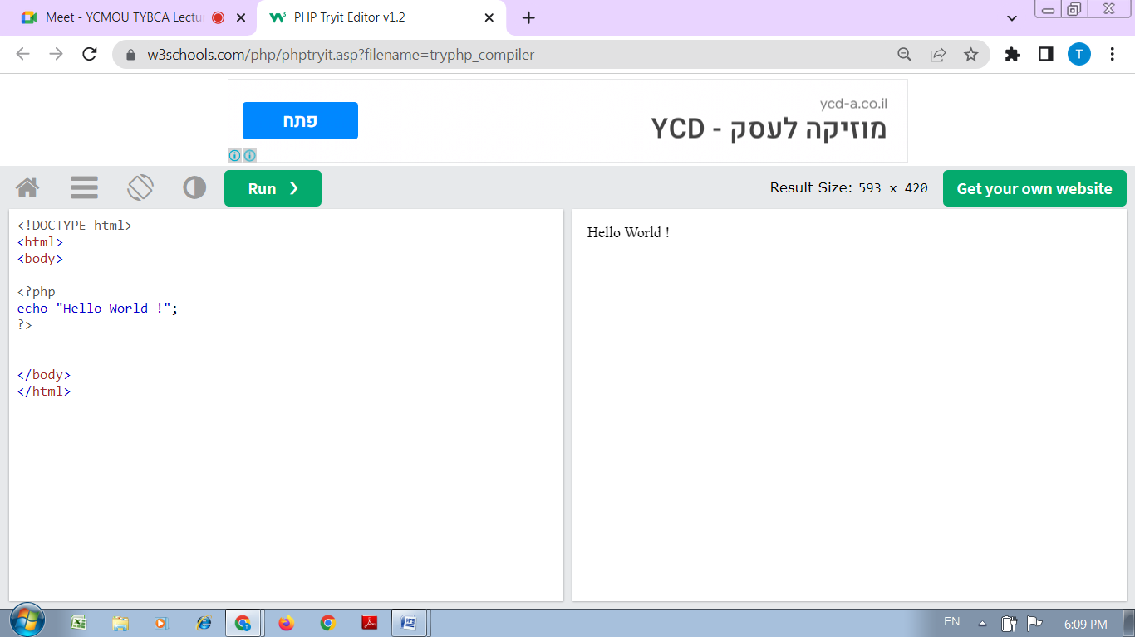

Practical No : 02

Aim :- Write a PHP program to print sum of digits.

<html>

<body>

<?php

$num = 14597;

$sum=0; $rem=0;

for ($i =0; $i<=strlen($num);$i++)

{

$rem=$num%10;

$sum = $sum + $rem;

$num=$num/10;

}

echo "Sum of digits 14597 is $sum";

?>

</body>

</html>

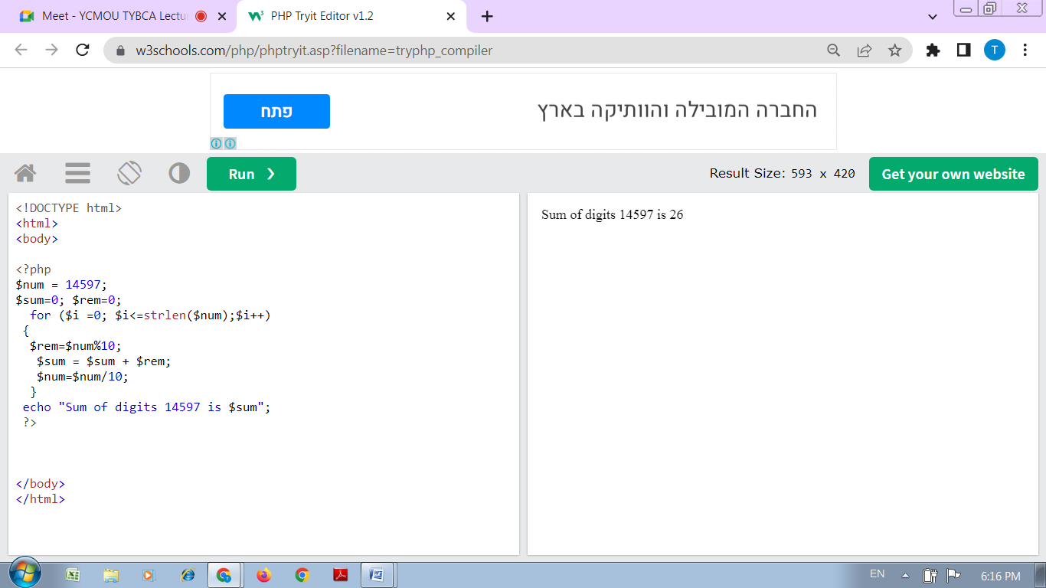

Practical No : 03

Aim :- Write a PHP program to check prime number.

<html>

<body>

<?php

function check_prime($num)

{

if ($num == 1)

return 0;

for ($i = 2; $i <= $num/2; $i++)

{

if ($num % $i == 0)

return 0;

}

return 1;

}

$num = 47;

$flag_val = check_prime($num);

if ($flag_val == 1)

echo "It is a prime number";

else

echo "It is a non-prime number"

?>

</body>

</html>

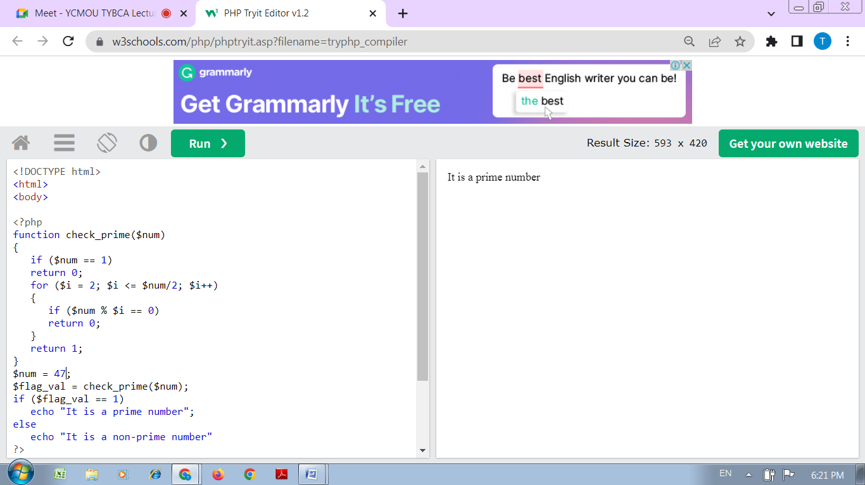

Practical No : 04

Aim :- Write a PHP program to print factorial of a number.

<html>

<body>

<?php

$num = 4;

$factorial = 1;

for ($x=$num; $x>=1; $x--)

{

$factorial = $factorial * $x;

}

echo "Factorial of $num is $factorial";

?>

</body>

</html>

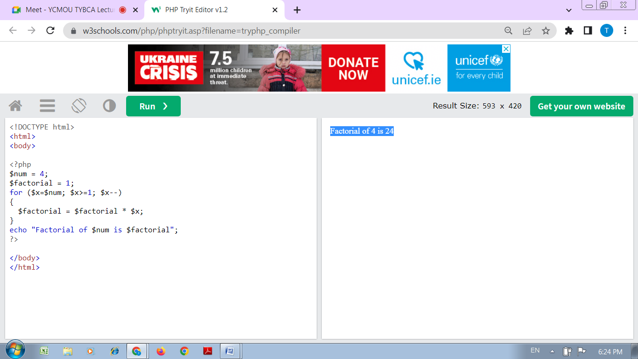

Practical No : 05

Aim :- Write a PHP program to sort elements in an array in ascending order.

<html>

<body>

<?php

$cars = array("Volvo", "BMW", "Toyota");

sort($cars);

$clength = count($cars);

for($x = 0; $x < $clength; $x++) {

echo $cars[$x];

echo "<br>";

}

?>

</body>

</html>

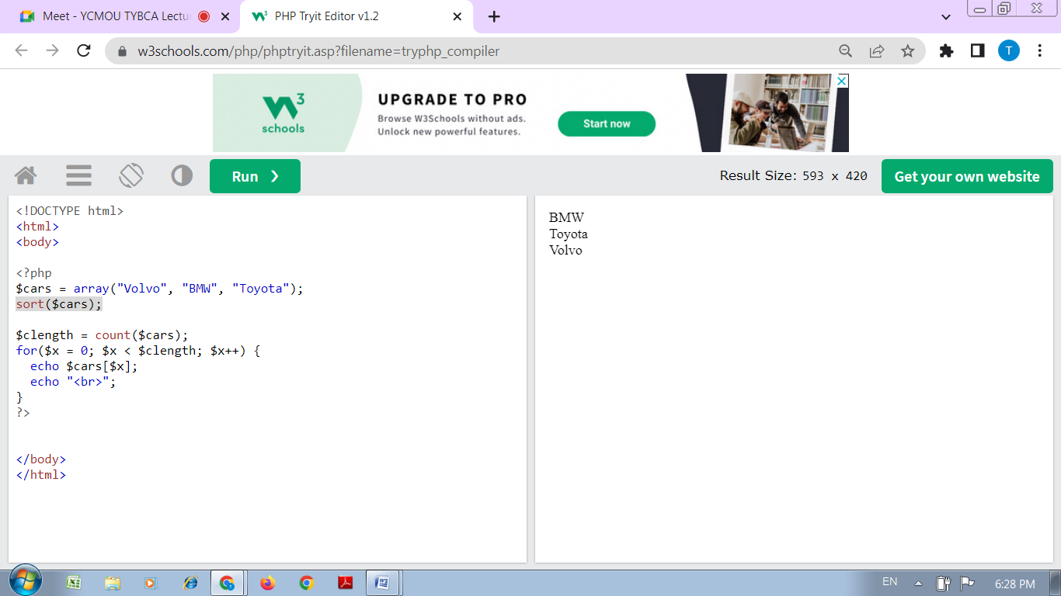

Practical No : 06

Aim :- Create a PHP program to calculate its addition, subtraction, multiplication, modulation, average and division on the same page.

<html>

<body>

<?php

$x=100;

$y=60;

echo "The sum of x and y is : ". ($x+$y) ."<br />";

echo "The difference between x and y is : ". ($x-$y) ."<br />";

echo "Multiplication of x and y : ". ($x*$y) ."<br />";

echo "Division of x and y : ". ($x/$y) ."<br />";

echo "Modulus of x and y : " . ($x%$y) ."<br />";

?>

</body>

</html>

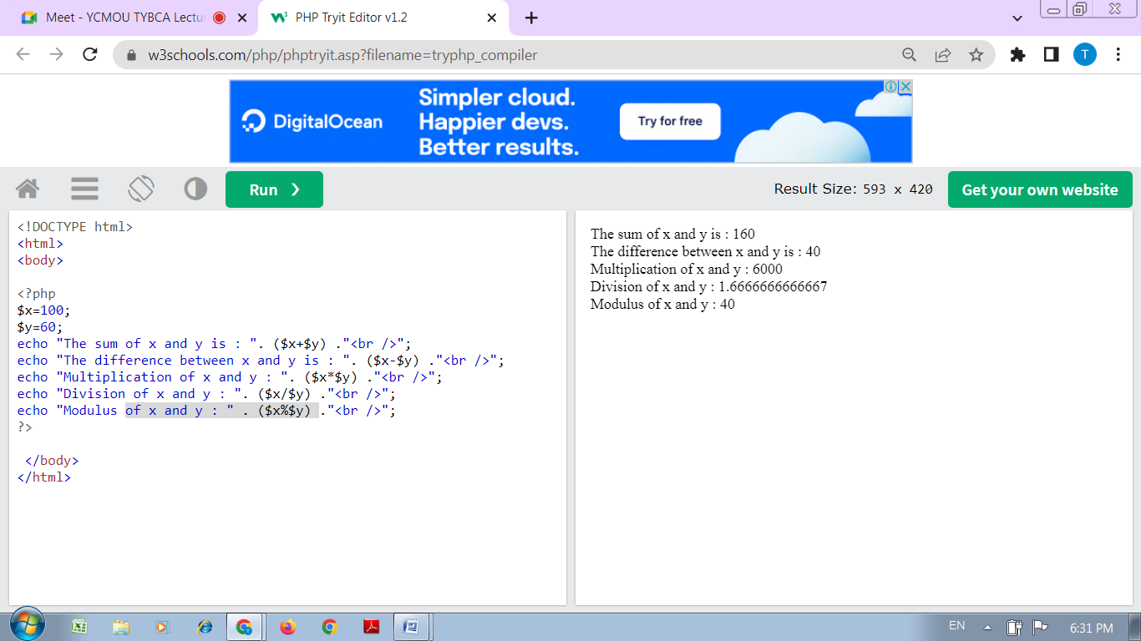

Practical No : 07

Aim :-

Write a PHP Program to create a simple Registration form.

<html>

<head>

<title>Registration Form</title>

<meta http-equiv="Content-Type" content="text/html; charset=UTF-8">

</head>

<body>

<h2>Registration Form</h2>

<form action="registration_form.php" method="POST"> First name:

<input type="text" name="firstname"> <br> Last name:

<input type="text" name="lastname">

<input type="hidden" name="form_submitted" value="1" />

<input type="submit" value="Submit">

</form>

</body>

</html>

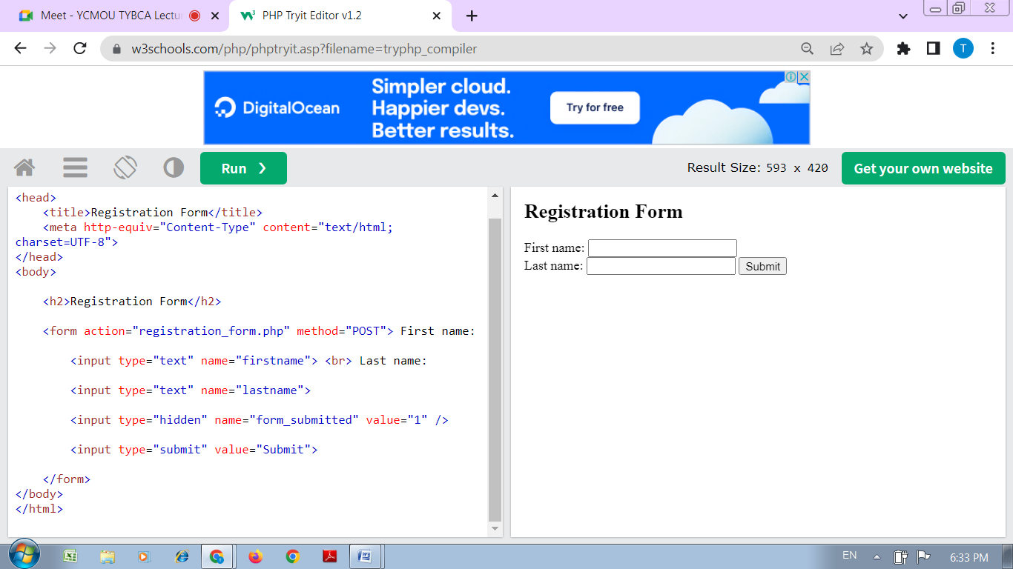

Practical No : 08

Aim :- Write a program to create a file in write mode.

<html>

<body>

<?php

$fp = fopen('data.txt', 'w');//opens file in write-only mode

fwrite($fp, 'welcome ');

fwrite($fp, 'to php file write');

fclose($fp);

echo "File written successfully";

?>

</body>

</html>

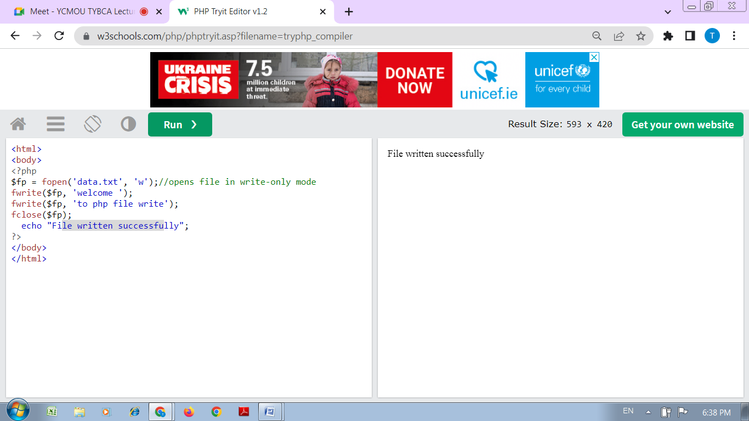

Practical No : 09

Aim :- Write a program to read and display the contents of file.

<html>

<head>

<title>Reading a file using PHP</title>

</head>

<body>

<?php

$filename = "tmp.txt";

$file = fopen( $filename, "r" );

if( $file == false ) {

echo ( "Error in opening file" );

exit();

}

$filesize = filesize( $filename );

$filetext = fread( $file, $filesize );

fclose( $file );

echo ( "File size : $filesize bytes" );

echo ( "<pre>$filetext</pre>" );

?>

</body>

</html>

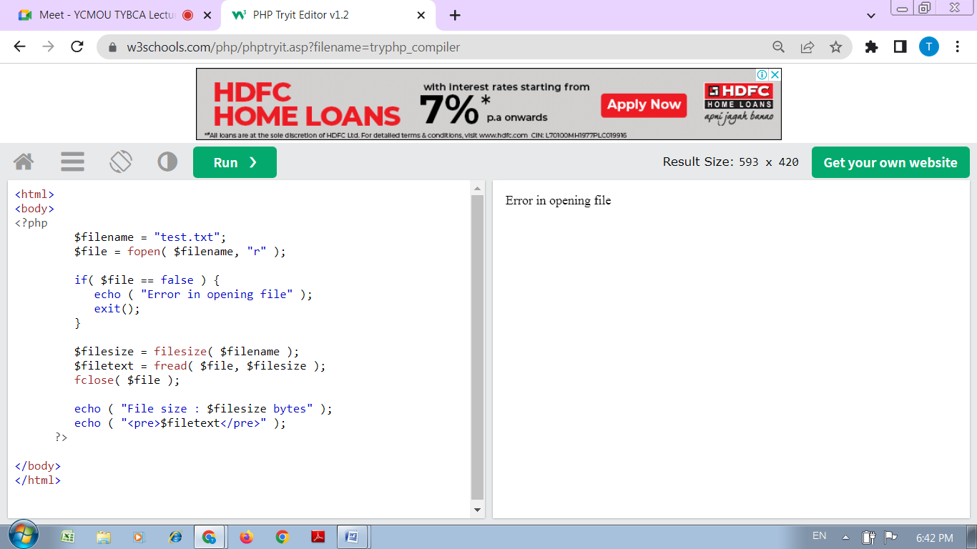

Practical No : 10

Aim :- Write a PHP script to display string, values, within a table.

<html>

<body>

<?php

$a=1000;

$b=1200;

$c=1400;

echo "<table border=1 cellspacing=0 cellpading=0>

<tr> <td><font color=blue>Salary of Mr. A is</td> <td>$a$</font></td></tr>

<tr> <td><font color=blue>Salary of Mr. B is</td> <td>$b$</font></td></tr>

<tr> <td><font color=blue>Salary of Mr. C is</td> <td>$c$</font></td></tr>

</table>";

?>

</body>

</html>

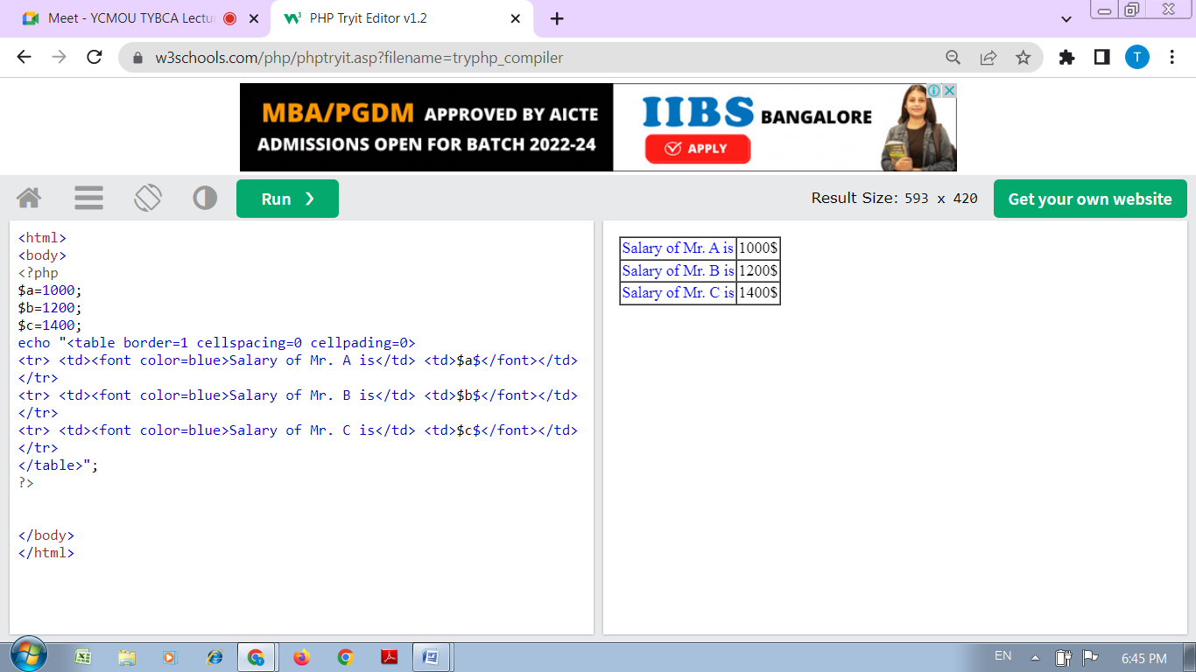

Practical No : 11

Aim :- Write a PHP Script to get Last occurred error.

<html>

<body>

<?php

echo $x;

print_r(error_get_last());

?>

</body>

</html>

