**Weather APP**

This app is developed with maven, spring boot and java 8

Application URL : http://localhost:8084/weatherDetail/{zipCode}

API Responses:

1. Success Response for zip code: 85343

URL: http://localhost:8084/weatherDetail/85343

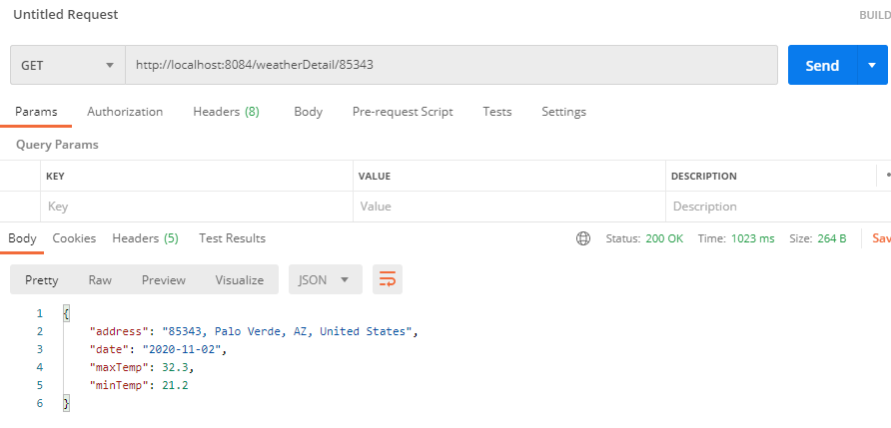

1. Failure response for zip code : 00000

URL: http://localhost:8084/weatherDetail/00000

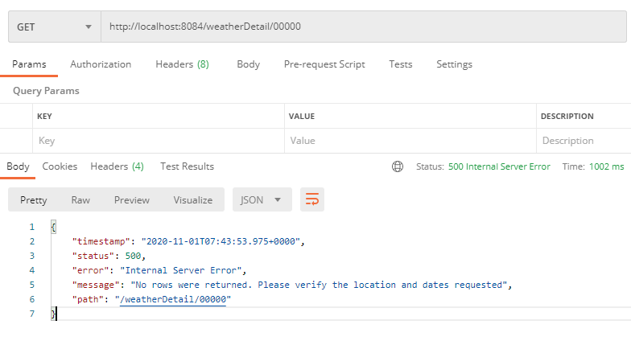

Test cases:

