Introduction Of DTMF

- The branch of robotics that utilizes the mobiles for operating a far away Robot.
- The complete system works on a signaling systems called as DTMF or “Dual Tone Multiple Frequency”.
- The systems involve the use of two mobile phones, one at the user while the other on the Robot.
- The mobile of the user is used to Signal the Robot to move in various directions.

DTMF (Dual-Tone Multi-Frequency)
- The invention of this is attributed to Western Electric and first used by the Bell System in commerce.
- DTMF signals are the superposition of 2 sine waves with different frequencies.
- It is a signaling Technology used for communicating between two far away devices.
- It uses frequency of speech signals.
- Only 12 tones are used by our mobile communication out of the 16 combination that are possible.
- The DTMF is a popular signaling method between telephones and switching centers
- The DTMF signals are Transmitted over a telephone line

HISTORY OF DTMF
Before DTMF was created, telephone networks used a dialling system called Decadic (also known as Pulse Dial). The Decadic system was used extensively in modern telephone networks to dial numbers, which were entered by the telephone companies users. The Decadic (Pulse Dialling) system used a series of clicks (which could be heard through the speaker of the phone) to dial the numbers which were dialled via a keypad or rotary dial. The clicking sounds were actually the connection of the phone line being connected, disconnected, and reconnected again in a certain pattern. The Decadic (Pulse Dialling) system was very useful, but was limited to the local exchange connections, requiring an operator to connect long distance calls.
In the late years of 1950, DTMF was being developed at Bell Labs for the purpose of allowing tone signals to dial long distance numbers, which could be potentially be dialled not only via standard wire networks, but also via radio links and or satellites.
DTMF was being developed for the future of electronic telecommunications switching systems, as opposed to the mechanical crossbar systems, which were currently in use at the time.
After DTMF was created, Decadic dialling was made pointless to continue, it made no sense to continue using that particular dialling system in the equipment circuits which the telephone exchanges were using at the time. Plans were then made to begin the manufacture of DTMF controlled switching systems in the communications exchanges and later standard customer owned telephones were upgraded to using DTMF circuits rather than Decadic (Pulse Dial). After various tests were performed on the DTMF system throughout the 1960s (when DTMF became known as Touch-Tone), DTMF was made official, and was then used as the main telecommunications dialling and switching system, and remains that way to this day.

Component Description

- ATMEGA 16
The AVR is a modified Harvard architecture 8-bit RISC single-chip microcontroller, which was developed by Atmel in 1996. The AVR was one of the first microcontroller families to use on-chip flash memory for program storage, as opposed to one-time programmable ROM,EPROM, or EEPROM used by other microcontrollers at the time.

Basic families
tinyAVR — the ATtiny series
megaAVR — the ATmega series
XMEGA — the ATxmega series
The ATmega16 is a low-power CMOS 8-bit microcontroller based on the AVR enhanced
RISC architecture. By executing powerful instructions in a single clock cycle, the
ATmega16 achieves throughputs approaching 1 MIPS per MHz allowing the system
designer to optimize power consumption versus processing speed.
Features:
Advanced RISC Architecture
– 131 Powerful Instructions – Most Single-clock Cycle Execution
– 32 x 8 General Purpose Working Registers
Up to 16 MIPS Throughput at 16 MHz
• Nonvolatile Program and Data Memories
– 16K Bytes of In-System Self-Programmable Flash
– Optional Boot Code Section with Independent Lock Bits
In-System Programming by On-chip Boot Program True Read-While-Write Operation
– 512 Bytes EEPROM
– 1K Byte Internal SRAM
– Programming Lock for Software Security

• Peripheral Features
– Two 8-bit Timer/Counters with Separate Prescalers and Compare Modes
– One 16-bit Timer/Counter with Separate Prescaler, Compare Mode, and Capture
Mode
– 8-channel, 10-bit ADC
– On-chip Analog Comparator
• Special Microcontroller Features
– Power-on Reset and Programmable Brown-out Detection
– Internal Calibrated RC Oscillator
– External and Internal Interrupt Sources
– Six Sleep Modes: Idle, ADC Noise Reduction, Power-save, Power-down, Standby and Extended Standby
• I/O and Packages
– 32 Programmable I/O Lines
– 40-pin PDIP, 44-lead TQFP, and 44-pad QFN/MLF
- Operating Voltages
– 2.7 - 5.5V for ATmega16L
– 4.5 - 5.5V for ATmega16
• Power Consumption @ 1 MHz, 3V, and 25°C for ATmega16L
– Active: 1.1 mA
– Idle Mode: 0.35 mA
– Power-down Mode: < 1 μA
Pin configuration of ATMega16:

Pin Descriptions

Pin No. | Pin name | Description | Alternate Function
1 | (XCK/T0) PB0 | I/O PORTB, Pin 0 | T0: Timer0 External Counter Input.  XCK : USART External Clock I/O
2 | (T1) PB1 | I/O PORTB, Pin 1 | T1:Timer1 External Counter Input
3 | (INT2/AIN0) PB2 | I/O PORTB, Pin 2 | AIN0: Analog Comparator Positive I/P  INT2: External Interrupt 2 Input
4 | (OC0/AIN1) PB3 | I/O PORTB, Pin 3 | AIN1: Analog Comparator Negative I/P  OC0 : Timer0 Output Compare Match Output
5 | (SS) PB4 | I/O PORTB, Pin 4 | In System Programmer (ISP)  Serial Peripheral Interface (SPI)
6 | (MOSI) PB5 | I/O PORTB, Pin 5
7 | (MISO) PB6 | I/O PORTB, Pin 6
8 | (SCK) PB7 | I/O PORTB, Pin 7
9 | RESET | Reset Pin, Active Low Reset
10 | Vcc | Vcc = +5V
11 | GND | GROUND
12 | XTAL2 | Output to Inverting Oscillator Amplifier
13 | XTAL1 | Input to Inverting Oscillator Amplifier
14 | (RXD) PD0 | I/O PORTD, Pin 0 | USART Serial Communication Interface
15 | (TXD) PD1 | I/O PORTD, Pin 1 | USART Serial Communication Interface
16 | (INT0) PD2 | I/O PORTD, Pin 2 | External Interrupt INT0
17 | (INT1) PD3 | I/O PORTD, Pin 3 | External Interrupt INT1
18 | (OC1B) PD4 | I/O PORTD, Pin 4 | PWM Channel Outputs
19 | (OC1A) PD5 | I/O PORTD, Pin 5 | PWM Channel Outputs
20 | (ICP) PD6 | I/O PORTD, Pin 6 | Timer/Counter1 Input Capture Pin
21 | PD7 (OC2) | I/O PORTD, Pin 7 | Timer/Counter2 Output Compare Match Output
22 | PC0 (SCL) | I/O PORTC, Pin 0 | TWI Interface
23 | PC1 (SDA) | I/O PORTC, Pin 1 | TWI Interface
24 | PC2 (TCK) | I/O PORTC, Pin 2 | JTAG Interface
25 | PC3 (TMS) | I/O PORTC, Pin 3 | JTAG Interface
26 | PC4 (TDO) | I/O PORTC, Pin 4 | JTAG Interface
27 | PC5 (TDI) | I/O PORTC, Pin 5 | JTAG Interface
28 | PC6 (TOSC1) | I/O PORTC, Pin 6 | Timer Oscillator Pin 1
29 | PC7 (TOSC2) | I/O PORTC, Pin 7 | Timer Oscillator Pin 2
30 | AVcc | Voltage Supply = Vcc for ADC
31 | GND | GROUND
32 | AREF | Analog Reference Pin for ADC
33 | PA7 (ADC7) | I/O PORTA, Pin 7 | ADC Channel 7
34 | PA6 (ADC6) | I/O PORTA, Pin 6 | ADC Channel 6
35 | PA5 (ADC5) | I/O PORTA, Pin 5 | ADC Channel 5
36 | PA4 (ADC4) | I/O PORTA, Pin 4 | ADC Channel 4
37 | PA3 (ADC3) | I/O PORTA, Pin 3 | ADC Channel 3
38 | PA2 (ADC2) | I/O PORTA, Pin 2 | ADC Channel 2
39 | PA1 (ADC1) | I/O PORTA, Pin 1 | ADC Channel 1
40 | PA0 (ADC0) | I/O PORTA, Pin 0 | ADC Channel 0

Memory
• ROM=Read Only Memory
– Called nonvolatile because it does not require power to retain memory
• RAM=Random Access memory

– Read and write
– Volatile=loses memory when power removed
– SRAM=Static RAM: retains data in flip flops
– DRAM=Dynamic RAM: data has to be refreshed because capacitors hold charge (i.e. values)
– Many other variations on RAM
• Battery backed up RAM
– Use a small battery (calculator size) to maintain charge to RAM after power is removed.
– The power required to maintain data in a RAM chip is incredibly small so that this little battery can easily maintain data for years (maybe 5 under optimal conditions).
• EPROM=erasable programmable ROM
– Use a special box that shines UV light into window on chip to erase contents.
– Can take up to 30 minutes. Removing too early results in only partially erased memory
– No need to ever use this, a relic of the past.
• EEPROM=electrically erasable programmable ROM
– Uses a special programming pin (usually uses higher voltage) to erase then write new program.
– Development boards often setup so EEPROM does not have to be removed (like EPROM does)
• Flash ROM
– Like EEPROM but faster and cheaper
– Limited write cycles (but in the several thousands)
How to use Memory
• RAM-this is where the program resides
• SRAM-this is your scratch pad for intermediate results or anything that you want to save during
operation (remember you lose it when power goes). It’s also the stack (discussed later).
• EEPROM
– permanent storage of data like constants
– something you save during program execution you want to be used during the next run.

Program Flow
• A special register called the program counter keeps track of the address in the Flash RAM to be executed.
• On each clock cycle, that address is decoded and the appropriate values are taken from memory and passed into the Arithmetic Logic Unit (ALU) to be processed.
• The value to be processed (operands) must come from a special set of 32 registers called the General Purpose Registers. To access SRAM or I/O, they must be brought in/out of the registers.

2. 8870 Decoder

Features:
· Low power consumption
· Adjustable acquisition and release times
· Central office quality and performance
· Power-down and inhibit modes (-02 only)
·Inexpensive 3.58 MHz time base
· Single 5 volt power supply
· Dial tone suppression
· Applications include: telephone switch equipment, remote data entry, paging systems, personal
computers, credit card systems

Pin description:

Functional Description
M-8870 operating functions (see Figure 2) include a bandsplit filter that separates the high and low tones of the received pair, and a digital decoder that verifies both the frequency and duration
of the received tones before passing the resulting 4-bit code to the output bus

Decoder
The M-8870 decoder uses a digital counting technique to determine the frequencies of the limited tones and to verify that they correspond to standard DTMF frequencies. A complex averaging algorithmis used to protect against tones imulation by extraneous signals (such as voice) while tolerating small frequency variations. The algorithm ensures an optimum combination of immunity to talk off and tolerance to interfering signals (third tones) and noise. When the detector recognizes the simultaneous presence of two valid tones(known as“signal condition”), it raises the Early Steering flag (ESt). Any subsequent loss of signal condition will cause ESt to fall.

Applications of 8870:
• Receiver system for British Telecom (BT) or CEPT Spec (MT8870D-1)
• Paging systems
• Repeater systems/mobile radio
• Credit card systems
• Remote control
• Personal computers
• Telephone answering machine

3. L293 Motor driver
L293 is atypical motor driver or Motor driver IC which allows DC motor to drive on either direction. L293D is a 16-pin IC which can control a set of two DC motors Simultaneously in any direction. It means that you can control two DC motor with a single L293D IC

Working of L293D
There are $ input pins for this 1293D, pin 2,7 on the left and pin 15,10 on the right as shown on the pin diagram. Left input pins will regulate the rotation of motor connected across left side and right side input for motor on the right hand side. The motors are rotated on the basis of the inputs provided across the input pins as logic ) or logic 1.

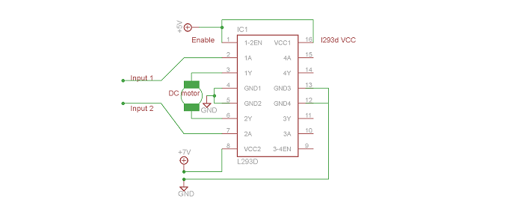L293D Logic Table
Let us consider a motor connected on left side output pins(pin 3,6). For rotating the motor in clockwise direction the input pins has to be provided with logic 1 and logic 0.
- Pin 2=logic 1 and Pin 7=Logic 0 | Clockwise Direction
- Pin 2=logic 0 and Pin 7=Logic 1 | Anticlockwise Clockwise Direction
- Pin 2=logic 0 and Pin 7=Logic 0 | Idle [no rotation] [High-impedence]
- Pin 2=logic 1 and Pin 7=Logic 1 | Idle [No rotation]

4. LM7805 (Voltage Regulator)

I. FEATURE:
• 3-Terminal Regulators
• Output Current up to 1.5 A
• Internal Thermal-Overload Protection
• High Power-Dissipation Capability
• Internal Short-Circuit Current Limiting
• Output Transistor Safe-Area Compensation
A LM7805 Voltage Regulator is a voltage regulator that outputs +5 volts.
An easy way to remember the voltage output by a LM78XX series of voltage regulators is the last two digits of the number. A LM7805 ends with "05"; thus, it outputs 5 volts. The "78" part is just the convention that the chip makers use to denote the series of regulators that output positive voltage. The other series of regulators, the LM79XX, is the series that outputs negative voltage. So:

LM78XX: Voltage regulators that output positive voltage, "XX"=voltage output.
LM79XX: Voltage regulators that output negative voltage, "XX"=voltage output
The LM7805, like most other regulators, is a three-pin IC.
Pin 1 (Input Pin): The Input pin is the pin that accepts the incoming DC voltage, which the voltage regulator will eventually regulate down to 5 volts.
Pin 2 (Ground): Ground pin establishes the ground for the regulator.
Pin 3 (Output Pin): The Output pin is the regulated 5 volts DC.
5. DC MOTOR
DC Motor has two leads. It has bidirectional motion
- If we apply +ve to one lead and ground to another motor will rotate in one direction, if we reverse the connection the motor will rotate in opposite direction.
- If we keep both leads open or both leads ground it will not rotate (but some inertia will be there).
- If we apply +ve voltage to both leads then braking will occurs.

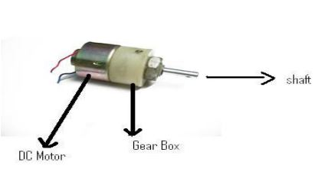

6.CAPACITORS
In a way, a capacitor is a little like a battery. Although they work in completely different ways, capacitors and batteries both store electrical energy. If you have read How Batteries Work , then you know that a battery has two terminals. Inside the battery, chemical reactions produce electrons on one terminal and absorb electrons at the other terminal.
BASIC
Like a battery, a capacitor has two terminals. Inside the capacitor, the terminals connect to two metal plates separated by a dielectric. The dielectric can be air, paper, plastic or anything else that does not conduct electricity and keeps the plates from touching each other. You can easily make a capacitor from two pieces of aluminum foil and a piece of paper. It won't be a particularly good capacitor in terms of its storage capacity, but it will work.
In an electronic circuit, a capacitor is shown:

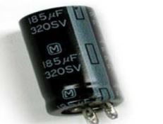

Circuit woking and its conncetions
Conventionally, wireless-controlled robots use RF circuits,which have the drawbacks of limited working range, limited frequency range and limited control. Use of a mobile phone for robotic control can overcome these limitations. It provides the advantages of robust control, working range as large as the coverage area of the service provider, no interference with other controllers and up to twelve controls. Although the appearance and capabilities of robots vary vastly, all robots share the features of a mechanical, movable structure under some form of control.
The control of robot involves three distinct phases: reception, processing and action. Generally, the preceptors are sensors mounted on the robot, processing is done by the on-board microcontroller or processor, and the task (action) is performed using motors or with some other actuators.
In this project, the robot is controlled by a mobile phone that makes a call to the mobile phone attached to the robot. In the course of a call, if any button is pressed, a tone corresponding to the button pressed is heard at the other end of the call. This tone is called ‘dual-tone multiple-frequency’ (DTMF) tone. The robot perceives this DTMF tone with the help of the phone stacked in the robot.
The received tone is processed by the ATmega16 microcontroller with the help of DTMF decoder MT8870. The decoder decodes the DTMF tone into its equivalent binary digit and this binary number is sent to the microcontroller. The microcontroller is preprogrammed to take a decision for any given input and outputs its decision to motor drivers in order to drive the motors for forward or backward motion or a turn. The mobile that makes a call to the mobile phone stacked in the robot acts as a remote. So this simple robotic project does not require the construction of receiver and transmitter units. DTMF signaling is used fr telephone signaling over the line in the voice-frequency band to the call switching centre. The version of DTMF used for telephone tone dialing is known as ‘Touch-Tone.’ DTMF assigns a specific frequency (consisting of two separate tones) to each key so that it can easily be identified by the electronic circuit.
The signal generated by the DTMF encoder is a direct algebraic summation, in real time, of the amplitudes of two sine (cosine)waves of different frequencies, i.e., pressing ‘5’ will send a tone made by adding 1336 Hz and 770 Hz to the other end of the line. The tones and assignments in a DTMF system are shown in Table I.

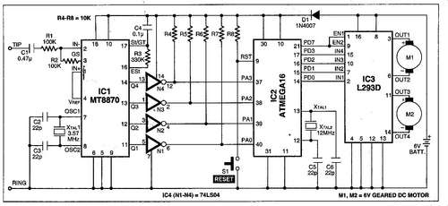

CIRCUIT DESCRIPTION
- Fig above shows the block diagram of the microcontroller-based mobile phoneoperated land rover.
- The important components of this rover are a DTMF decoder, microcontroller and motor driver.
- An MT8870 series DTMF decoder is used here. All types of the MT8870 series use digital counting techniques to detect and decode all the 16 DTMF tone pairs into a 4-bit code output.
- The built-in dial tone rejection circuit eliminates the need for pre-filtering. When the input signal given at pin 2 (IN-) in single-ended input configuration is recognized to be effective, the correct 4-bit decode signal of the DTMF tone is transferred to Q1 (pin 11) through Q4 (pin 14) outputs.
- Table II shows the DTMF data output table of MT8870. Q1 through Q4 outputs of the DTMF decoder (IC1) are connected to port pins PA0 through PA3 of ATmega16 microcontroller (IC2) after inversion by N1 through N4, respectively.
- The ATmega16 is a low-power, 8-bit, CMOS microcontroller based on the AVR enhanced RISC architecture. It provides the following features: 16 kB of in-system programmable Flash program memory with read-while-write capabilities, 512 bytes of EEPROM, 1kB SRAM, 32 general-purpose input/output (I/O) lines and 32 general-purpose working registers. All the 32 registers re directly connected to the arithmetic logic unit, allowing two independent registers to be accessed in one single instruction executed in one clock cycle. The resulting architecture is more code-efficient.
- Outputs from port pins PD0 through PD3 and PD7 of the microcontroller are fed to inputs IN1 through IN4 and enable pins (EN1 and EN2) of motor driver L293D, respectively, to drive two geared DC motors.
- Switch S1 is used for manual reset. The microcontroller output is not sufficient to drive the DC motors, so current drivers are required for motor rotation. The L293D is a quad, high-current, half-H driver designed to provide bidirectional drive currents of up to 600 mA at voltages from 4.5V to 36V. It makes it easier to drive the DC motors.

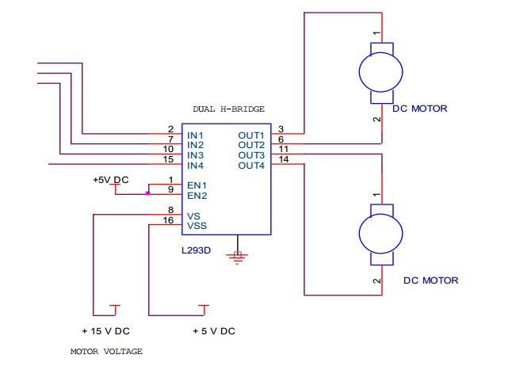
- The L293D consists of four drivers. Pin IN1 through IN4 and OUT1 through OUT4 are input and output pins, respectively, of driver 1 through driver 4. Drivers 1 and 2, and drivers 3 and 4 are enabled by enable pin 1 (EN1) and pin 9 (EN2), respectively.

- When enable input EN1 (pin 1) is high, drivers 1 and 2 are enabled and the outputs corresponding to their inputs are active. Similarly, enable input EN2 (pin 9) enables drivers 3 and 4.

Table I
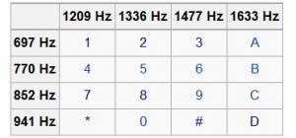

Table II
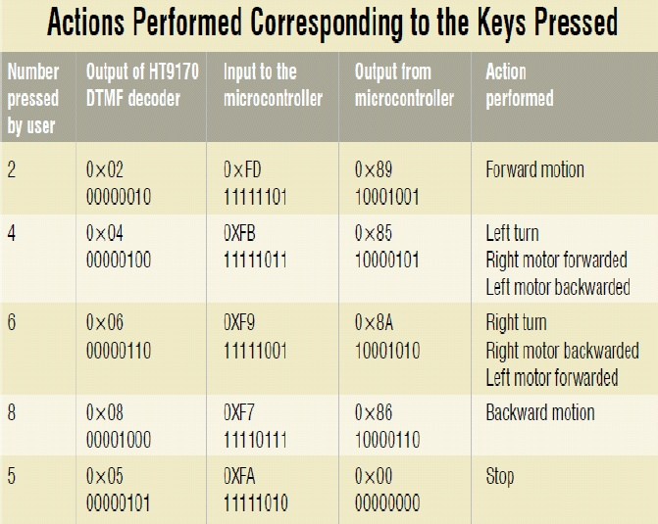

Table III
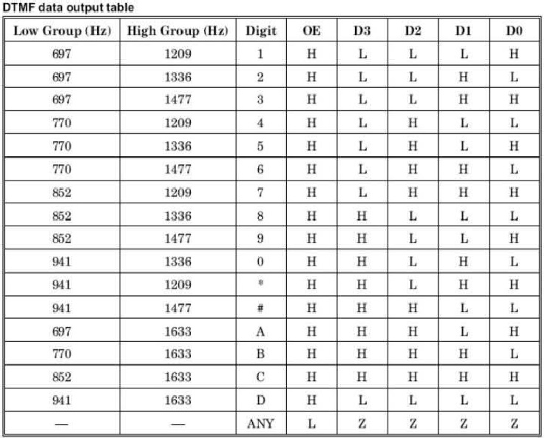
SOFTWARE DESCRIPTION
The software is written in ‘C’ language and compiled using CodeVision AVR ‘C’ compiler. The source program is converted into hex code by the compiler. Burn this hex code into ATmega16 AVR microcontroller. The source program is well commented and easy to understand.
First include the register name defined specifically for ATmega16 and also declare the variable.
Set port A as the input and port D as the output.
The program will run forever by using ‘while’ loop. Under ‘while’ loop, read port A and test the received input using ‘switch’ statement. The corresponding data will output at port D after testing of the received data.

WORKING
- In order to control the robot, you need to make a call to the cell phone attached to the robot (through head phone) from any phone, which sends DTMF tunes on pressing the numeric buttons.
- The cell phone in the robot is kept in ‘auto answer’ mode. (If the mobile does not have the auto answering facility, receive the call by ‘OK’ key on the rover-connected mobile and then made it in hands-free mode.) So after a ring, the cellphone accepts the call.

- Now you may press any button on your mobile to perform actions as listed in Table III. The DTMF tones thus produced are received by the cellphone in the robot. These tones are fed to the circuit by the headset of the cellphone.
- The MT8870 decodes the received tone and sends the equivalent binary number to the microcontroller. According to the program in the microcontroller, the robot starts moving.
- When you press key ‘2’ (binary equivalent 00000010) on your mobile phone, the microcontroller outputs ‘10001001’ binary equivalent. Port pins PD0, PD3 and PD7 are high.
- The high output at PD7 of the microcontroller drives the motor driver (L293D).
- Port pins PD0 and PD3 drive motors M1 and M2 in forward direction (as per Table III). Similarly, motors M1 and M2 move for left turn, right turn, backward motion and stop condition as per Table III.

CONSTRUCTION OF ROBOT
- When constructing any robot, one major mechanical constraint is the number there a two-wheel drive or a four-wheel drive. Though four-wheel drive is more complex than two-wheel drive, it provides more torque and good control. Two-wheel drive, on the other hand, is very easy to construct.
- The chassis of dimension 10×18cm2 sheet made up of parax may be used.
- Motors are fixed to the bottom of the sheet and the circuit is affixed firmly on top of the sheet.
- A cellphone is also mounted on the sheet.
- In the four-wheel drive system, the two motors on a side are controlled in parallel. So a single L293D driver IC can drive the rover. For the robot, beads affixed with glue act as support wheels.

To connect the hands free with the circuit
There are always two connections which come out of the phone, these connections are Tip1 andTip2.
Ring you should prefer to use handsfree which have a straight jack (similar to the ones which we use in our ipods, but a thinner one)the tip of that jack is called the "tip"and the rest part behind the tip after a black strip is the ring So connect these two connections with the circuit and you will be done.

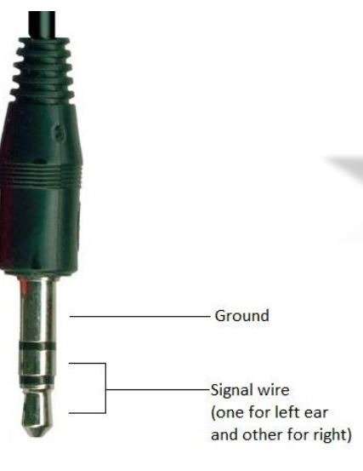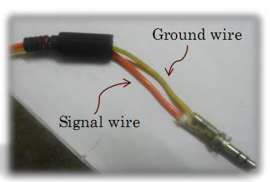

Source code Using C Language
#include <avr/io.h>
#include <util/delay.h>
void forward()
{
PORTD=0x89;
_delay_ms(40);
}
void backward()
{
PORTD=0x86;
_delay_ms(40);
}
void right()
{
PORTD=0x8A;
_delay_ms(40);
}
void left()
{
PORTD=0x85;
_delay_ms(40);
}
void stop()
{
PORTD=0x00;
_delay_ms(40);
}
void main()
{
DDRB=0xF0; // lower 4 pins are input
DDRD=0xFF; //output port (motor driver connected)
DDRC=0xFF; //output port(leds connected)
while(1)
{
if(PINA==0xFD) // press 2 for forward
{
forward();
PORTC=0x01;
}
else if(PINA==0xFB) // press 4 for left
{
left();
PORTC=0x02;
}

else if(PINA==0XF9) // press 6 for right
{
right();
PORTC=0x03;
}
else if(PINA==0XF7) // press 8 for backward

{
backward();
PORTC=0x04;
}
else
{
stop();
PORTC=0xFF;
}

APPLICATIONS OF DTMF CONTROLLED ROBOT

Scientific
Remote control vehicles have various Scientific uses including hazardous environments, working in the deep ocean , and space exploration. The majority of the probes to the other planets in our solar system have been remote control vehicles, although some of the more recent ones were partially autonomous.

Military and Law Enforcement
Military usage of remotely controlled military vehicles dates back to the first half of 20th century. Soviet Red Army used remotely controlled Teletanks during 1930s in the Winter War and early stage of World War II. There were also remotely controlled cutters and experimental remotely
controlled planes in the Red Army.

Search and Rescue
UAVs will likely play an increased role in search and rescue in the United States. This was demonstrated by the successful use of UAVs during the 2008 hurricanes that struck Louisiana and Texas.
Recreation and Hobby
Small scale remote control vehicles have long been popular among hobbyists. These remote controlled vehicles span a wide range in terms of price and sophistication. There are many types of radio controlled vehicles. These include on-road cars, off-road trucks, boats, airplanes, and even helicopters. The ’robots’ now popular in television shows such as Robot Wars, are a recent extension of this hobby (these vehicles do not meet the classical definition of a robot; they are remotely controlled by a human). Radio-controlled submarine also exist.

ADVANTAGES

1. Wireless control
2. Surveillance System.
3. Vehicle Navigation with use of 3G technology.
4. Takes in use of the mobile technology which is almost available everywhere.
5. This wireless device has no boundation of range and can be controlled as far as network of cell phone

DISADVANTAGES

1. Cell phone bill.
2. Mobile batteries drain out early so charging problem.
3. Cost of project if Cell phone cost included.
4. Not flexible with all cell phones as only a particular ,cell phone whose earpiece is attached can only be used.

FURTHER IMPROVEMENTS & FUTURE SCOPE

1. IR Sensors

IR sensors can be used to automatically detect & avoid obstacles if the robot goes beyond line of sight. This avoids damage to the vehicle if we are maneuvering it from a distant place.

2. Password Protection

Project can be modified in order to password protect the robot so that it can be operated only if correct password is entered. Either cell phone should be password protected or necessary modification should be made in the assembly language code. This introduces conditioned access &increases security to a great extent.

3. Alarm Phone Dialer

By replacing DTMF Decoder IC CM8870 by a DTMF Transceiver IC’ CM8880 , DTMF tones can be generated from the robot. So, a project called !Alarm Phone Dialer! can be built which will generate necessary alarms for something that is desired to be monitored (usually by triggering a relay). For example, a high water alarm, low temperature alarm, opening of back window, garage door, etc. When the system is activated it will call a number of programmed numbers to let the user know the alarm has been activated. This would be great to get alerts of alarm conditions from home when user is at work.

4. Adding a Camera

If the current project is interfaced with a camera(e.g. a Webcam) robot can be driven beyond line-of-sight & range becomes practically unlimited as GSM networks have a very large range.

