PREDICTIVE MODELING AND
OPTIMIZATION IN LOGISTICS SYSTEMS
Delivery Time Prediction and Operational Optimization
Task 04 • Python • Scikit-Learn • Predictive Analytics

1. Executive Summary
This project applies predictive modeling to a practical logistics problem: estimating how long an order will take to be delivered. The work builds directly on the cleaned logistics dataset prepared in the previous task. The goal was not only to produce a prediction, but also to show how predictions can support operational decisions such as delivery-risk monitoring, prioritization, and planning.
The original dataset contained 99,441 order records and 16 columns. After focusing on completed orders with a valid target value, 96,476 records were used for modeling. The target variable was actual_delivery_days. Three features were selected: purchase_year, purchase_month, and estimated_delivery_days.
Two regression models were tested: Linear Regression and Random Forest Regression. Linear Regression performed better, with MAE 5.66 days, RMSE 9.33 days, and R² 0.1307. Random Forest achieved MAE 6.15 days, RMSE 10.20 days, and R² -0.0410. Linear Regression was therefore selected as the final baseline model.
The results also show that the current feature set has limited predictive power. Random Forest feature importance assigned 89.43% importance to estimated_delivery_days. The model can still provide useful directional support, especially when predictions are converted into Low, Medium, and High delivery-risk groups.

2. Problem Definition
Delivery time is an important logistics KPI because it affects customer expectations, service performance, and operational planning. The prediction problem was defined as a supervised regression task in which the model estimates actual delivery duration in days.
- Prediction type: supervised learning – regression
- Target: actual_delivery_days
- Prediction unit: days
- Business purpose: delivery monitoring, risk identification, and operational planning

3. Dataset Overview
The predictive analysis used the logistics dataset from the previous task. The modeling data contained 96,476 records after excluding rows where actual_delivery_days could not be calculated.
Dataset Item | Value
Original dataset | 99,441 rows
Columns | 16
Modeling records | 96,476
Target | actual_delivery_days
Target missing values | 0
Training records | 77,180
Testing records | 19,296

3.1 Target Variable
The target variable had a mean of 12.56 days and a median of 10.22 days. The standard deviation was 9.55 days, with values ranging from approximately 0.53 to 209.63 days. The gap between the mean and median and the very high maximum indicate a right-skewed delivery-time distribution.
Statistic | Value
Count | 96,476
Mean | 12.5587
Median | 10.2178
Std. deviation | 9.5465
Minimum | 0.5334
75th percentile | 15.7203
Maximum | 209.6286

4. Feature Engineering and Preparation
An estimated delivery-duration feature was created from the estimated delivery date and purchase timestamp. The final modeling features were purchase_year, purchase_month, and estimated_delivery_days. All selected features and the target had zero missing values in the modeling dataset.
features = ['purchase_year', 'purchase_month', 'estimated_delivery_days']
target = 'actual_delivery_days'
X = model_data[features].copy()
y = model_data[target].copy()

5. Train-Test Split
The data was divided into training and testing subsets. The training set contained 77,180 records and the test set contained 19,296 records. The test data was kept separate so that performance could be evaluated on unseen observations.
X_train, X_test, y_train, y_test = train_test_split(
X, y, test_size=0.20, random_state=42
)

6. Model Selection and Implementation

6.1 Linear Regression
Linear Regression was selected as an interpretable baseline for the delivery-time prediction problem. It models the relationship between the selected features and actual delivery duration.
lr_model = LinearRegression()
lr_model.fit(X_train, y_train)
y_pred_lr = lr_model.predict(X_test)

6.2 Random Forest Regression
Random Forest was tested as a non-linear ensemble alternative. It can capture more complex relationships, so it was useful as a comparison model. In this experiment, however, it did not outperform Linear Regression.
rf_model = RandomForestRegressor(
n_estimators=100, random_state=42
)
rf_model.fit(X_train, y_train)
y_pred_rf = rf_model.predict(X_test)

7. Model Evaluation
The models were evaluated using MAE, RMSE, and R². MAE represents the average absolute error in days. RMSE penalizes larger errors more heavily. R² indicates how much variation in the target is explained by the model relative to a mean-based baseline.
Model | MAE (days) | RMSE (days) | R² Score
Linear Regression | 5.66 | 9.33 | 0.1307
Random Forest | 6.15 | 10.20 | -0.0410
Linear Regression achieved the best result across all three metrics. Its average absolute error was 5.66 days. The positive R² of 0.1307 shows that the model captures some useful variation, although the amount explained is limited.
Random Forest produced a higher MAE and RMSE and a negative R². In this test set, its predictions performed worse than a simple baseline based on the average target value. Therefore, greater model complexity did not translate into better performance with the current feature set.

8. Feature Importance Analysis
The Random Forest model was also used to understand which available inputs contributed most to its predictions.
Feature | Importance
estimated_delivery_days | 0.894252 (89.43%)
purchase_month | 0.082068 (8.21%)
purchase_year | 0.023680 (2.37%)
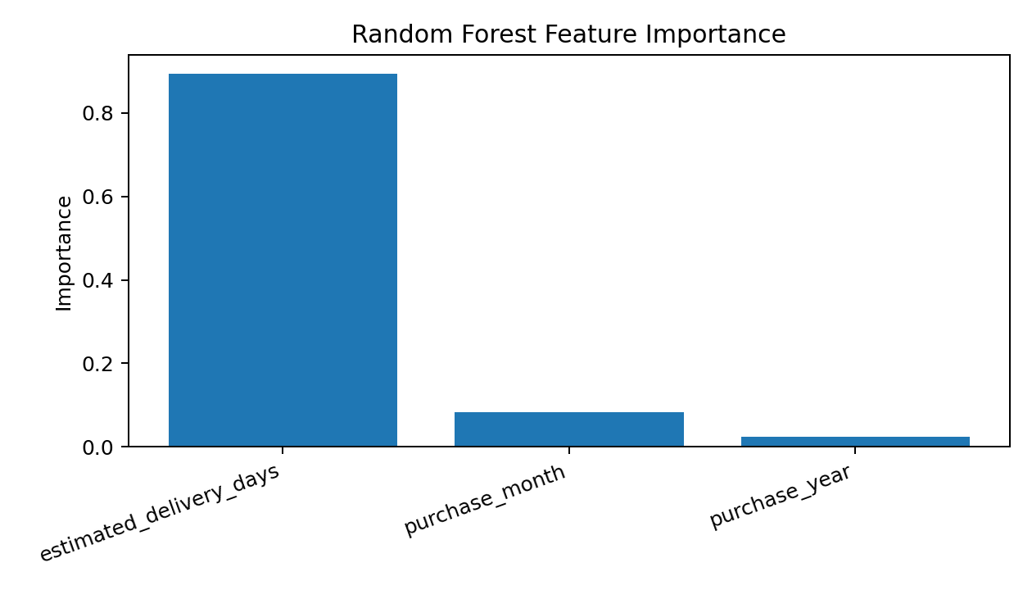
The dominant role of estimated_delivery_days suggests that the model relies heavily on the existing delivery estimate. This is useful operationally, but it also shows why richer logistics features are needed for a stronger predictive model.

9. Actual vs Predicted Delivery Time
The notebook includes an Actual vs Predicted Delivery Days plot for Linear Regression. The visualization shows predictions concentrated in a relatively narrow range while actual delivery durations have a much wider spread, including extreme cases. This visual evidence is consistent with the relatively low R² and the difference between MAE and RMSE.
The long right tail in actual delivery time means that a small number of very long deliveries can create large prediction errors. RMSE is particularly affected by these larger errors.

10. Delivery Risk Classification
To connect prediction with an operational use case, the Linear Regression predictions were grouped into three delivery-risk categories.
- Low Risk: predicted delivery time ≤ 7 days
- Medium Risk: predicted delivery time > 7 and ≤ 15 days
- High Risk: predicted delivery time > 15 days
Risk Level | Orders in Test Set
Low Risk | 943
Medium Risk | 14,244
High Risk | 4,109
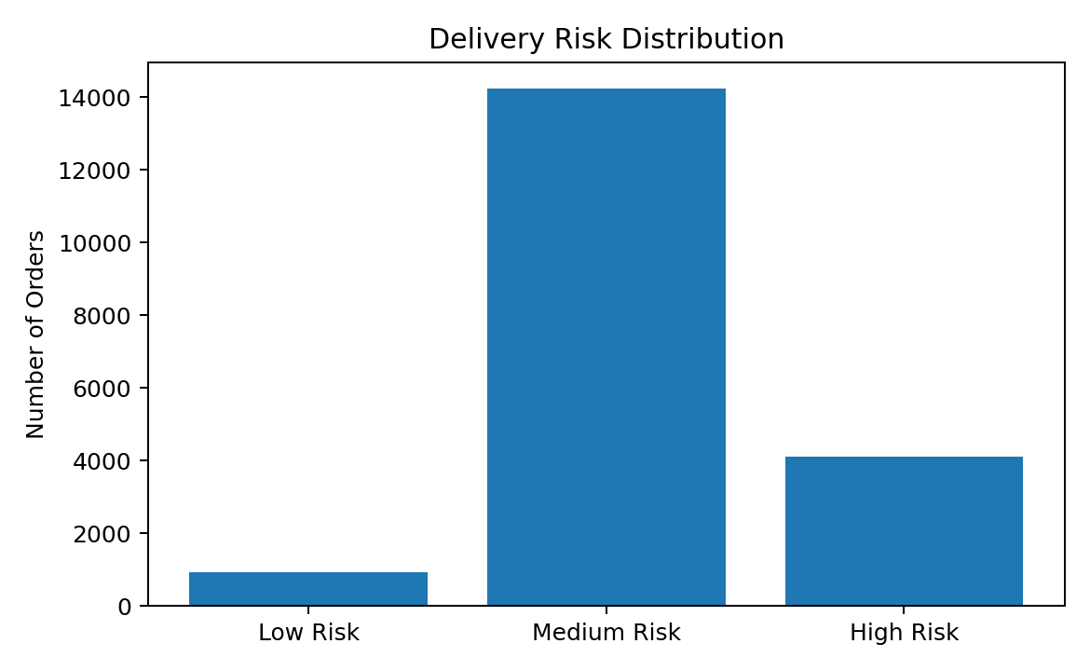
This classification is intended as an operational screening mechanism. High-risk orders can receive earlier review, medium-risk orders can receive routine monitoring, and low-risk orders can follow the standard process.
optimization_data = pd.DataFrame({
'Actual Delivery Days': y_test.values,
'Predicted Delivery Days': y_pred_lr
})
optimization_data['Risk Level'] = pd.cut(
optimization_data['Predicted Delivery Days'],
bins=[-float('inf'), 7, 15, float('inf')],
labels=['Low Risk', 'Medium Risk', 'High Risk']
)

11. Optimization Strategies

11.1 Proactive Delivery Monitoring
Orders with higher predicted delivery times can be flagged for additional monitoring. Teams can review these orders before delays become critical and investigate possible operational issues.

11.2 Resource Allocation
High-risk orders can receive priority when allocating exception-management, dispatch coordination, warehouse handling, or customer-service capacity, depending on the available operational process.

11.3 Improve Estimated Delivery Accuracy
Because estimated_delivery_days accounts for 89.43% of Random Forest importance, improving the quality of delivery estimates is an important optimization opportunity.

11.4 Exception Management
The High Risk group can act as an exception queue, allowing teams to focus limited attention on orders that are more likely to require intervention.

11.5 Seasonal and Capacity Planning
Purchase month contributes additional information. Monthly delivery patterns can be monitored to anticipate periods that may require additional capacity or operational resources.

11.6 Future Route Optimization
The current model does not contain enough route-level information to directly optimize routes. Future versions could include shipping distance, customer location, seller location, carrier performance, and other operational variables.

12. Final Recommendations
- Use Linear Regression as the current baseline because it performed better than Random Forest on MAE, RMSE, and R².
- Use predicted delivery duration to prioritize orders for operational attention.
- Review High Risk orders proactively instead of waiting for confirmed delivery failures.
- Monitor monthly patterns to support capacity and resource planning.
- Improve the accuracy of estimated delivery dates.
- Add richer logistics variables such as seller/customer location, product characteristics, freight information, shipping distance, carrier performance, and processing time.
- Investigate extreme delivery durations separately because they can strongly influence prediction error.

13. Limitations and Future Improvements
The main limitation is the relatively low R² of 0.1307. This means the current feature set explains only a limited portion of the variation in actual delivery time. The model should therefore be treated as a baseline decision-support model rather than a highly accurate forecasting system.
The feature set is also small. Delivery performance is influenced by many operational factors that are not represented by the three selected inputs. Future work should test additional available variables, apply suitable encoding for categorical data, and compare more advanced models.
Cross-validation and systematic hyperparameter tuning would also make model comparison more robust. If the model is intended for real future forecasting, time-aware validation should be considered so that future periods are not used to predict earlier periods.

14. Final Model Conclusion
Two predictive models were evaluated for forecasting actual delivery time: Linear Regression and Random Forest. Linear Regression achieved MAE 5.66 days, RMSE 9.33 days, and R² 0.1307, while Random Forest achieved MAE 6.15 days, RMSE 10.20 days, and R² -0.0410.
Linear Regression was selected as the final model because it provided lower MAE and RMSE and a higher R² score. The model provides a practical baseline for estimating delivery duration and identifying orders that may require additional attention.
At the same time, the relatively low R² makes the limitation clear: delivery time depends on more factors than the three variables currently used. The strongest next step is therefore to add better logistics information and then evaluate whether that information improves predictive accuracy.

15. Appendix – Key Python Workflow
# Feature and target selection
features = ['purchase_year', 'purchase_month',
'estimated_delivery_days']
target = 'actual_delivery_days'
X = model_data[features].copy()
y = model_data[target].copy()
# Train-test split
X_train, X_test, y_train, y_test = train_test_split(
X, y, test_size=0.20, random_state=42
)
# Linear Regression
lr_model = LinearRegression()
lr_model.fit(X_train, y_train)
y_pred_lr = lr_model.predict(X_test)
# Evaluation
mae = mean_absolute_error(y_test, y_pred_lr)
rmse = np.sqrt(mean_squared_error(y_test, y_pred_lr))
r2 = r2_score(y_test, y_pred_lr)

