Advanced Data Analysis and Visualization in Logistics
Task 03 – Yuva Intern Logistics Data Analysis

1. Executive Summary
This task applies exploratory data analysis and visualization techniques to a simulated logistics dataset. The objective is to understand delivery performance, shipment activity, transportation costs, regional differences, and relationships between operational variables. A dataset containing 1,200 shipment records was generated with realistic logistics attributes including shipment volume, distance, transport mode, delivery times, cost components, traffic, weather, on-time status, and customer rating. The analysis uses Python, Pandas, NumPy, and Matplotlib.

2. Data Simulation and Dataset Structure
Because the task specifies a hypothetical logistics dataset, the data was simulated with a fixed random seed for reproducibility. The dataset represents shipments across four regions and four transportation modes. Delivery time and cost values were generated using operational assumptions so that the resulting data supports meaningful logistics analysis.
Key variables include:
- Shipment volume (kg) and distance (km)
- Estimated and actual delivery time
- Delivery delay in days
- Transportation, handling, and fuel surcharge costs
- Transport mode and shipment type
- Weather and traffic conditions
- On-time delivery status
- Customer rating

3. Exploratory Data Analysis
The dataset contains 1,200 shipment records. Initial validation confirmed that the simulated dataset has the expected structure and no missing values. Descriptive statistics were used to examine central tendency, spread, and the range of the main numerical variables.
Metric | Result
Average delivery time (days) | 12.76
Median delivery time (days) | 11.02
On-time delivery rate | 40.42%
Average total logistics cost | 1244.98
Average customer rating | 4.53/5

4. Visual Analysis
Figure 1. Distribution of Actual Delivery Time
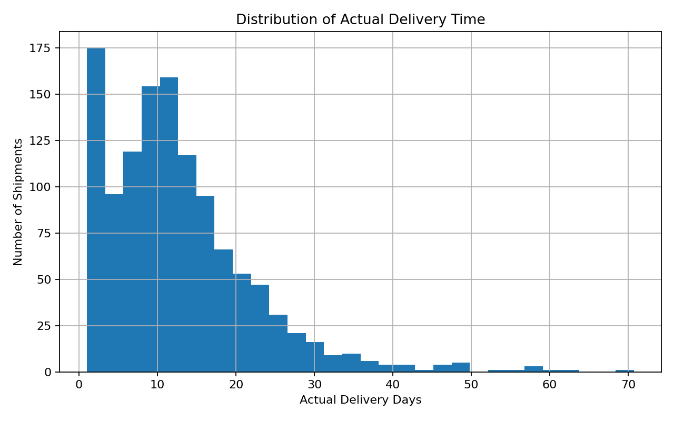
The delivery-time distribution shows how shipment durations are spread. A concentration around the central range represents normal operations, while the longer tail highlights shipments that require closer monitoring.
Figure 2. Monthly Shipment Volume
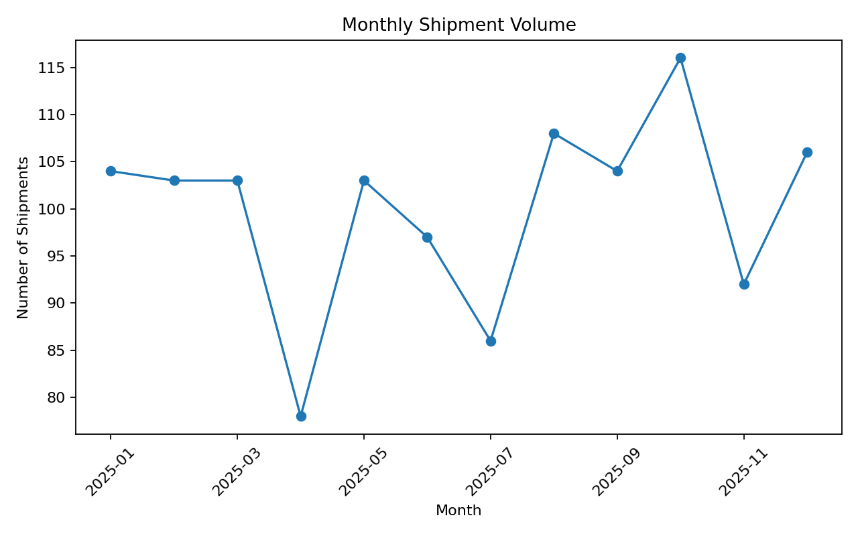
The monthly trend helps identify changes in shipment activity throughout the year. Peaks can be used for capacity planning, staffing, and transportation resource allocation.
Figure 3. Average Logistics Cost by Transport Mode
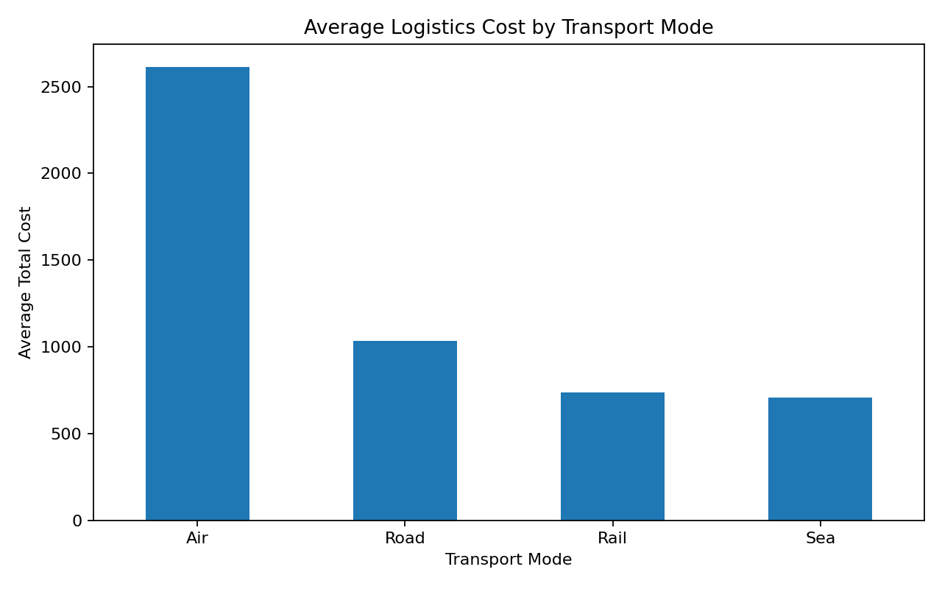
The comparison shows that transport mode has a material effect on average logistics cost. Higher-cost modes may be justified when delivery speed or service requirements are more important than cost minimization.
Figure 4. On-Time Delivery Rate by Region
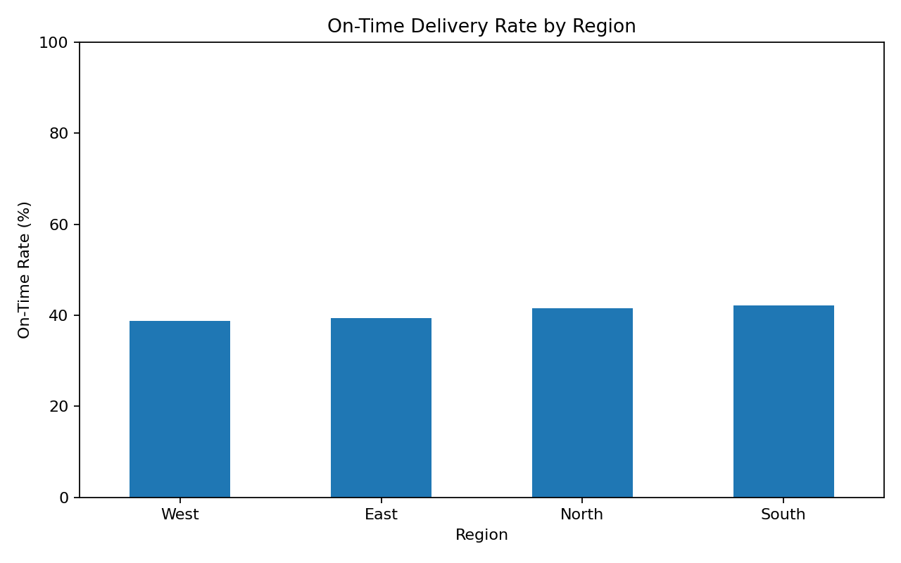
Regional comparison helps identify areas with weaker service reliability. Lower-performing regions can be investigated for route conditions, traffic, capacity constraints, or operational bottlenecks.
Figure 5. Distance vs Total Logistics Cost
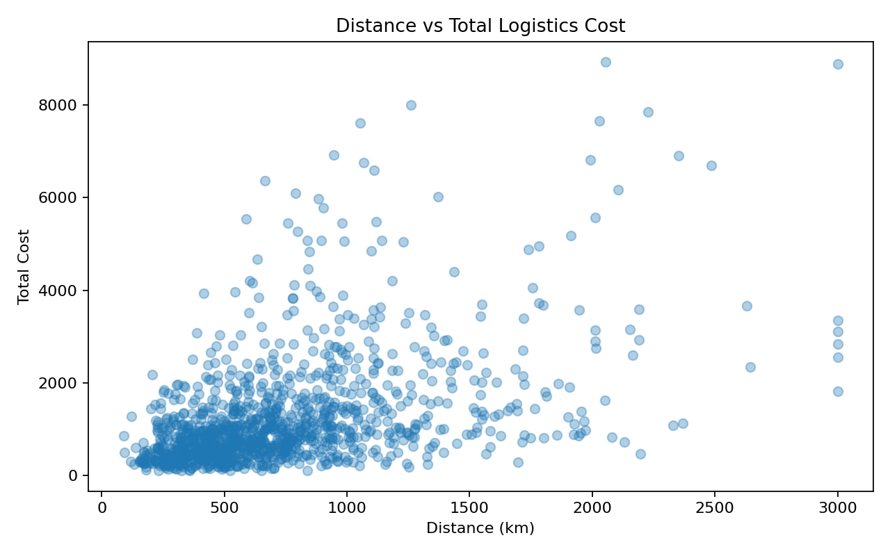
The scatter plot shows the relationship between route distance and total logistics cost. The positive relationship indicates that longer routes generally create higher cost exposure.
Figure 6. Correlation Matrix
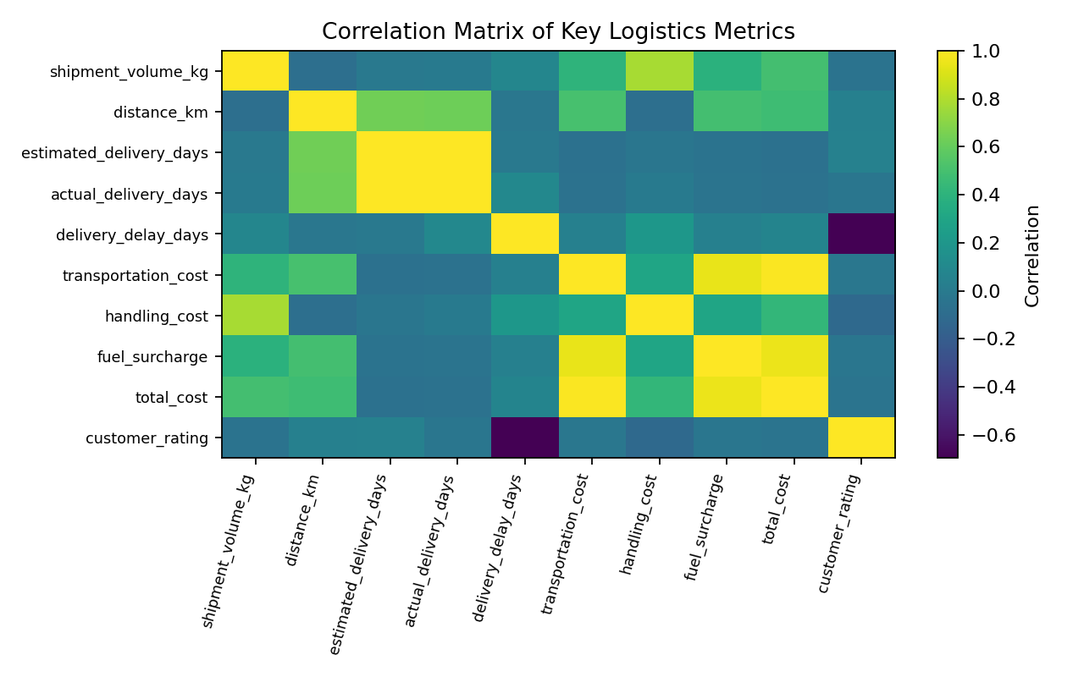
The correlation matrix summarizes linear relationships between numerical logistics variables. It is useful for identifying potential cost drivers and variables associated with delivery performance.

5. Analytical Insights
- Delivery reliability should be monitored as a core service KPI because delays can affect customer satisfaction and downstream operations.
- Distance and shipment volume are important cost considerations. Longer and larger shipments require stronger route and capacity planning.
- Transportation mode creates a trade-off between speed and cost. Premium modes can improve responsiveness but should be used selectively where the service requirement justifies the additional cost.
- Regional differences in on-time delivery performance can reveal bottlenecks that may not be visible in an overall average.
- The relationship between delivery delays and customer ratings suggests that service reliability has a direct customer-experience implication.
- A combined view of cost, delivery time, shipment volume, and service level provides a more balanced basis for logistics decisions than a single KPI.

6. Recommendations
- Create a recurring dashboard for shipment volume, average delivery time, on-time rate, and cost.
- Investigate regions with below-average on-time delivery and identify route-specific causes.
- Monitor long-distance and high-volume shipments as higher-risk cost and service segments.
- Review transport-mode selection for high-cost shipments and evaluate lower-cost alternatives when service requirements allow.
- Use delivery-delay trends as an early warning indicator for customer satisfaction and operational issues.
- Combine operational KPIs with business targets to support proactive logistics planning.

7. Python Tools and Visualization Rationale
Pandas was used for data loading, grouping, aggregation, and descriptive analysis. NumPy was used for reproducible simulation and numerical calculations. Matplotlib was used to create the visualizations. Histograms were selected for distributions, line charts for time trends, bar charts for categorical comparisons, scatter plots for relationships between continuous variables, and a correlation matrix for multivariate relationship analysis.

8. Conclusion
The task demonstrates how logistics data can be converted into practical operational insights through a structured analytics process. Starting with data simulation and validation, the analysis progresses through descriptive statistics, KPI calculation, visualization, interpretation, and recommendations. The resulting approach can be adapted to real logistics datasets to support decisions related to delivery reliability, cost control, capacity planning, and customer service.

9. Reproducibility
The dataset is generated with a fixed random seed and saved as CSV. The notebook and Python script can be rerun from the task folder using Python 3 with Pandas, NumPy, and Matplotlib installed.

10. Representative Python Code
The following excerpts show the main techniques used in the analysis. The complete executable code is available in Advanced_Logistics_Analysis.ipynb and advanced_logistics_analysis.py.
Descriptive statistics and median calculation
# Calculate central tendency and descriptive statistics
numeric_cols = [
"shipment_volume_kg", "distance_km", "actual_delivery_days",
"delivery_delay_days", "total_cost", "customer_rating"
]
df[numeric_cols].describe().T
df[numeric_cols].median()
On-time delivery performance
# Calculate the on-time delivery KPI
on_time_rate = df["on_time_delivery"].eq("Yes").mean() * 100
print(f"On-time delivery rate: {on_time_rate:.2f}%")
Categorical comparison using a bar chart
# Compare average cost by transport mode
mode_cost = (
df.groupby("transport_mode")["total_cost"]
.mean()
.sort_values(ascending=False)
)
mode_cost.plot(kind="bar", figsize=(8, 5))
plt.title("Average Logistics Cost by Transport Mode")
plt.xlabel("Transport Mode")
plt.ylabel("Average Total Cost")
plt.show()
Relationship analysis using a scatter plot
# Examine the relationship between distance and cost
plt.figure(figsize=(8, 5))
plt.scatter(df["distance_km"], df["total_cost"], alpha=0.35)
plt.title("Distance vs Total Logistics Cost")
plt.xlabel("Distance (km)")
plt.ylabel("Total Cost")
plt.show()
print(df["distance_km"].corr(df["total_cost"]))
Correlation analysis
# Correlation analysis
corr_cols = [
"shipment_volume_kg", "distance_km", "estimated_delivery_days",
"actual_delivery_days", "delivery_delay_days", "total_cost",
"customer_rating"
]
correlation_matrix = df[corr_cols].corr().round(2)
correlation_matrix
These examples demonstrate the core analytical workflow: summarizing the data, calculating logistics KPIs, comparing operational groups, examining relationships, and identifying correlated variables.

