ADVANCED DATA ANALYSIS AND
VISUALIZATION IN LOGISTICS
Delivery Performance Analysis Report
Python • Exploratory Data Analysis • Logistics Performance

Dataset size | 99,441 orders
Final variables | 16 columns
Duplicate rows | 0
Primary focus | Delivery time, delay, order status and monthly performance

1. Objective
The objective of this analysis is to evaluate logistics delivery performance using Python, identify important delivery patterns and bottlenecks, and communicate the findings through a focused set of business-relevant visualizations.
The analysis concentrates on the metrics that directly support the task: order status, actual delivery duration, delivery delay categories, and changes in late-delivery rates over time.

2. Dataset Overview and Preparation
The final analytical dataset contains 99,441 rows and 16 columns. The dataset includes order identifiers, order status, purchase and delivery timestamps, estimated delivery dates, derived delivery-time measures, delay classifications, and purchase-period fields.
Item | Result | Interpretation
Rows | 99,441 | Final analytical records
Columns | 16 | Includes original and derived logistics metrics
Duplicate rows | 0 | No duplicate records identified
Completed delivery records | 96,476 | Records with actual delivery duration
Missing actual delivery days | 2,965 | Primarily associated with orders without a completed delivery date
Missing delay category | 2,965 | Consistent with unavailable actual delivery date
The final validation showed no duplicate rows. Missing delivery-duration and delay-category values were retained rather than artificially imputed because an actual delivery date is not available for those records. This preserves the distinction between completed and non-completed orders.

3. Exploratory Data Analysis

3.1 Order Status
The order-status distribution is strongly concentrated in completed deliveries. The remaining statuses represent orders at different stages of the order lifecycle or orders that did not complete.
Order status | Orders
Delivered | 96,478
Shipped | 1,107
Canceled | 625
Unavailable | 609
Invoiced | 314
Processing | 301
Created | 5
Approved | 2

3.2 Central Tendency and Spread
For records with an available actual delivery duration, the mean delivery time was 12.56 days and the median was 10.22 days. The difference between mean and median, together with the large maximum value, indicates a right-skewed delivery-time distribution.
Metric | Actual delivery days | Delivery delay days
Count | 96,476 | 96,476
Mean | 12.5587 | -11.1791
Median | 10.2178 | -11.9489
Standard deviation | 9.5465 | 10.1861
Minimum | 0.5334 | -146.0161
75th percentile | 15.7203 | -6.3900
Maximum | 209.6286 | 188.9751

3.3 Correlation
The correlation between actual delivery days and delivery delay days is approximately 0.607. This indicates a moderate positive relationship: orders that take longer to deliver generally tend to have larger delivery delays, although the relationship is not perfect.
correlation = orders[['actual_delivery_days', 'delivery_delay_days']].corr()
# actual_delivery_days ↔ delivery_delay_days = 0.607221

4. Key Visualizations and Interpretation
Four visualizations are included. They were selected to cover the most important dimensions of the task without adding redundant charts: overall order status, delivery-time distribution, delay severity, and monthly late-delivery performance.
Figure 1. Order Status Distribution
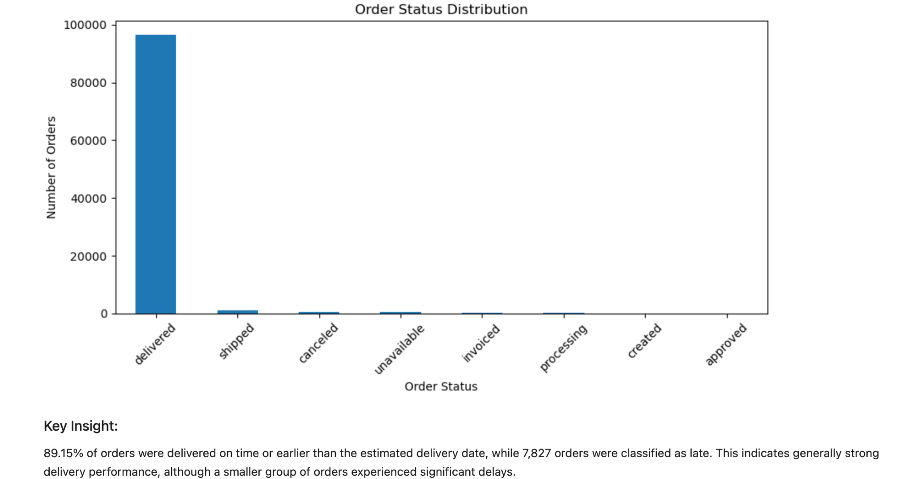
This chart shows that delivered orders dominate the dataset. The remaining statuses form a much smaller share, indicating that the main performance analysis can focus on completed deliveries while separately monitoring non-completed orders.

Figure 2. Monthly Late Delivery Rate
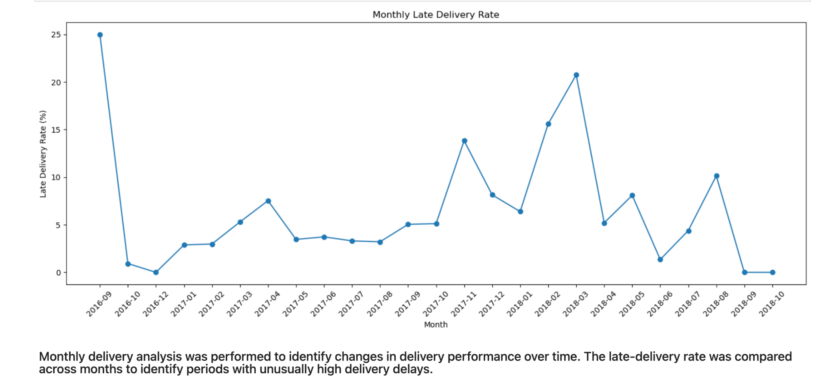
The monthly trend shows substantial variation in late-delivery performance. The highest visible late-delivery rates occur around September 2016 and March 2018, with several additional spikes during late 2017 and early 2018. These periods are useful candidates for deeper operational review.

Figure 3. Delivery Delay Categories
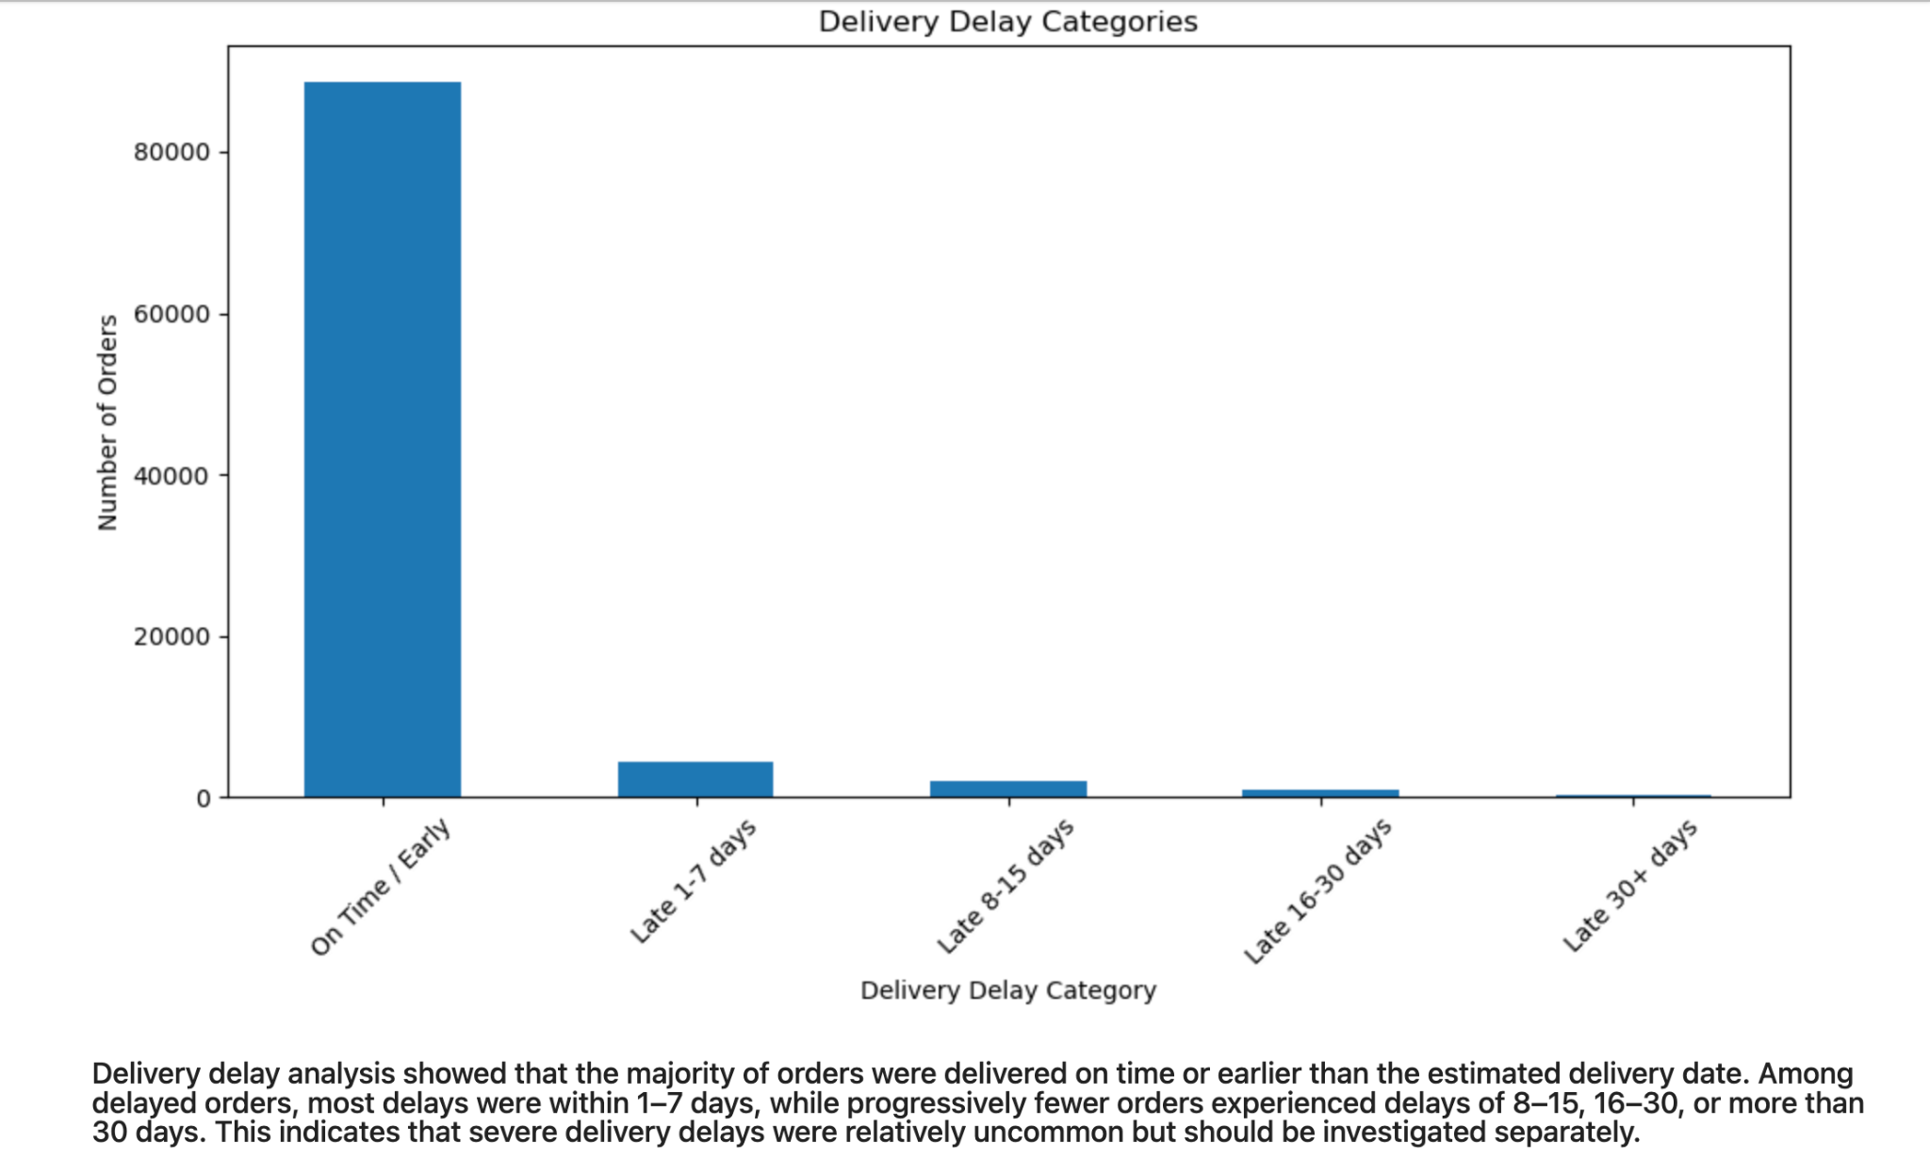
The chart shows that 88,649 orders were classified as on time/early. Among delayed orders, 1–7 day delays are the largest group, followed by 8–15 days, 16–30 days, and 30+ days. Severe delays therefore represent a small but operationally important tail.

Figure 4. Distribution of Actual Delivery Time
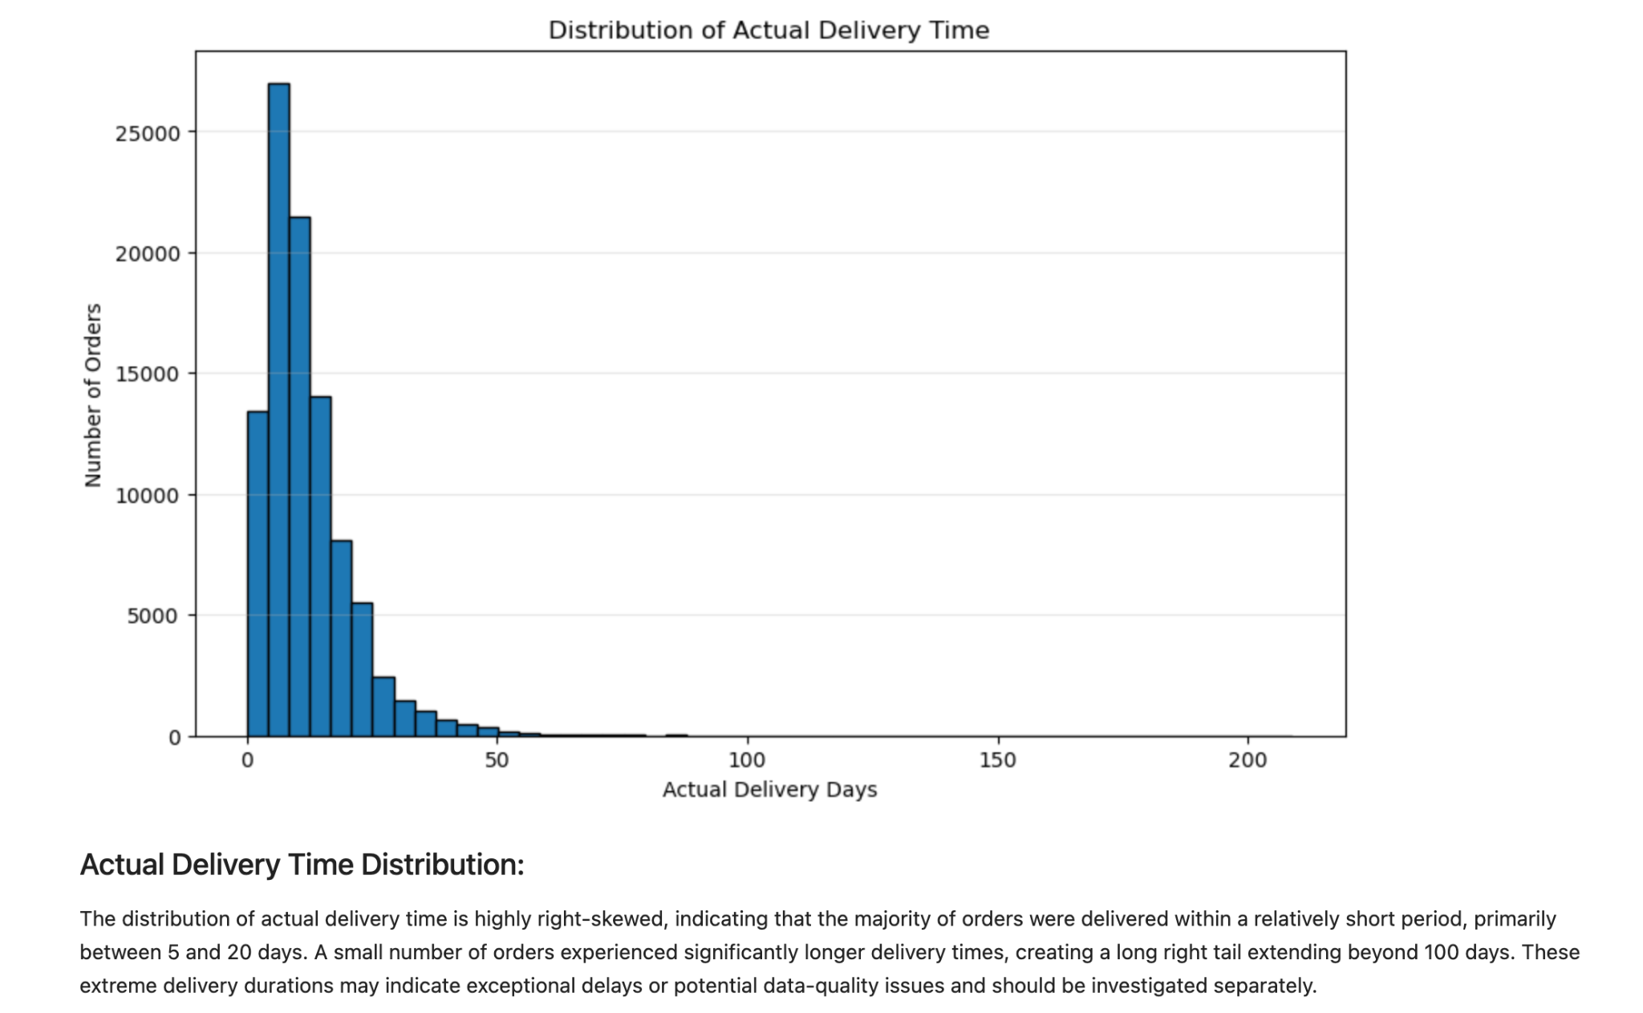
Actual delivery time is strongly right-skewed. Most orders are concentrated in the lower delivery-time range, while a small number of orders extend far beyond the typical range, including values above 100 days. These extreme observations should be investigated as potential exceptional delays or data-quality cases.

5. Key Logistics Performance Findings
- 89.15% of all records fall into the On Time / Early delay category, while 7,827 orders are classified as late.
- Within delayed orders, the largest delay group is 1–7 days (4,481 orders), showing that most late deliveries are relatively short delays.
- Only 360 orders fall into the 30+ day delay category, so severe delays are uncommon but deserve targeted investigation.
- The median actual delivery time is about 10.22 days, while the mean is about 12.56 days, showing the influence of longer delivery durations.
- The maximum actual delivery duration is approximately 209.63 days, creating a pronounced long right tail.
- Monthly late-delivery rates vary considerably, indicating that delivery performance is not equally stable across all periods.
- The 0.607 correlation between actual delivery days and delay days suggests that longer delivery durations are meaningfully associated with delivery lateness.

6. Operational Insights and Potential Bottlenecks
The analysis suggests that overall delivery performance is relatively strong, but aggregate performance can hide specific operational problems.
- Short delays are the main late-delivery pattern. Operational teams should focus first on preventing small delays from accumulating into larger service failures.
- The monthly spikes suggest that delivery performance may be affected by period-specific operational conditions. The affected months can be examined for capacity, carrier, geography, seasonality, or process changes.
- The long right tail in actual delivery time indicates a small set of highly delayed orders. These cases should be reviewed individually rather than allowing them to distort typical delivery-time expectations.
- Non-delivered order statuses should be monitored separately because their missing actual delivery dates make them unsuitable for completed-delivery duration calculations.

7. Recommendations
- Monitor monthly late-delivery rate as a core logistics KPI and investigate periods with unusually high values.
- Create an exception-management process for orders delayed more than 15 or 30 days.
- Analyze high-delay orders by carrier, geography, product/category, and order volume where those fields are available.
- Track completed and non-completed orders separately so that missing delivery dates are interpreted correctly.
- Use median delivery time alongside mean delivery time because the distribution is strongly right-skewed.
- Investigate extreme delivery durations above the normal operating range for root causes and possible data-quality issues.

8. Python Analysis Approach
The analysis was performed using pandas for data preparation and summary statistics and matplotlib for visualization. The following excerpts represent the key analytical operations used in the notebook.
# Order-status distribution
orders['order_status'].value_counts()
# Delivery-delay distribution
orders['delivery_delay_category'].value_counts(dropna=False)
# Percentage distribution
orders['delivery_delay_category'].value_counts(normalize=True, dropna=False) * 100
# Descriptive statistics
eda_summary = orders[numeric_cols].describe().T
eda_summary['median'] = orders[numeric_cols].median()
# Correlation analysis
correlation = orders[numeric_cols].corr()
# Save the final cleaned dataset
orders.to_csv('cleaned_orders.csv', index=False)
The visualizations were generated from the cleaned analytical dataset. The report includes the four available chart outputs as embedded images so that the analytical evidence and interpretations can be reviewed directly within the DOC file.

9. Conclusion
The logistics analysis indicates generally strong delivery performance, with the majority of orders delivered on time or earlier. However, monthly variation, a measurable relationship between delivery duration and delay, and a small number of extreme delivery cases reveal opportunities for operational improvement. The most useful next step for deeper logistics decision-making would be to segment the problematic orders by operational dimensions such as carrier, location, product, and order volume, if those fields are available.

Appendix: Final Dataset Validation
Final validation confirmed 99,441 rows, 16 columns, and zero duplicate rows. The final dataset contains derived fields for actual delivery duration, delivery-time outlier flag, delay category, delay days, delivery status, and purchase-period attributes.

