DATA COLLECTION, CLEANING,
AND PREPROCESSING FOR LOGISTICS ANALYSIS
Data Collection and Preparation using Python

Reference Dataset: Olist E-commerce Order Dataset
Final delivery-analysis records: 96,470 | Tool: Python / Pandas

Practical Data Preprocessing Report

Prepared by: Nitesh Godse

Contents
1. Objective
2. Data Collection Simulation
3. Dataset Overview
4. Initial Data Quality Assessment
5. Missing Value Analysis
6. Data Cleaning and Preprocessing Methodology
7. Delivery Feature Engineering
8. Delivery Performance Classification
9. Outlier Detection using IQR
10. Outlier Treatment
11. Min-Max Normalization
12. Final Validation
13. Key Findings
14. Impact on Logistics Analytics and Decision-Making
15. Reflection
16. Conclusion
17. Appendix A – Python Preprocessing Code

1. Objective
The objective of this task is to simulate a practical data collection and preprocessing pipeline for logistics analysis using Python. The process focuses on assessing data quality, converting and validating date fields, handling missing information according to analytical importance, engineering delivery-performance features, identifying unusual delivery durations, and applying normalization.
The final goal is to prepare a reliable, structured, and analysis-ready logistics dataset that can support later exploratory analysis, dashboard development, KPI reporting, and predictive modeling.

2. Data Collection Simulation
The reference dataset used for this task is the Olist e-commerce order dataset. The order-level data contains information about order status, purchase time, approval time, carrier delivery time, customer delivery time, and estimated delivery date. These fields are suitable for simulating a logistics delivery-performance workflow.
Dataset characteristic | Description
Reference dataset | Olist e-commerce order-delivery dataset
Original records | 99,441 order records
Delivery analysis population | 96,478 delivered orders before the final filter
Final analysis records | 96,470 delivered orders with valid customer delivery dates
Primary analysis focus | Actual delivery duration, estimated delivery duration, delay, and delivery performance
Main timestamp fields | Purchase, approval, carrier delivery, customer delivery, and estimated delivery dates
Target output | Cleaned and feature-enriched logistics delivery dataset

3. Dataset Overview
The preprocessing workflow begins with the order dataset loaded into a Pandas DataFrame. The initial dataset contains 99,441 records and eight order-level columns. All timestamp columns were initially stored as object/string data types and therefore required conversion before time-based calculations could be performed.
Field | Role in analysis
order_id | Unique order identifier
customer_id | Customer identifier
order_status | Order lifecycle status
order_purchase_timestamp | Starting point for delivery-duration calculations
order_approved_at | Order approval timestamp
order_delivered_carrier_date | Date the order was handed to the carrier
order_delivered_customer_date | Customer delivery timestamp; critical for actual delivery duration
order_estimated_delivery_date | Expected delivery date; used for estimated duration and delay

4. Initial Data Quality Assessment
An initial quality assessment was performed using Pandas to identify missing values, duplicate records, and data types. No duplicate rows were found. Missing values were concentrated in operational timestamp fields, especially customer delivery timestamps.
Column | Missing values | Initial data type
order_id | 0 | object
customer_id | 0 | object
order_status | 0 | object
order_purchase_timestamp | 0 | object
order_approved_at | 160 | object
order_delivered_carrier_date | 1,783 | object
order_delivered_customer_date | 2,965 | object
order_estimated_delivery_date | 0 | object

Quality assessment result
Duplicate rows = 0. The timestamp columns required conversion from object/string to datetime64[ns] before delivery-time calculations.

5. Missing Value Analysis
Missing values were not treated uniformly because their analytical importance depends on the order status and the calculation being performed. The workflow first examined missing timestamps by order status and then restricted the delivery-time analysis to completed deliveries.
Order status | Missing approval | Missing carrier date | Missing customer delivery date
approved | 0 | 2 | 2
canceled | 141 | 550 | 619
created | 5 | 5 | 5
delivered | 14 | 2 | 8
invoiced | 0 | 314 | 314
processing | 0 | 301 | 301
shipped | 0 | 0 | 1,107
unavailable | 0 | 609 | 609

There were 96,478 delivered orders. Of these, only 8 had a missing customer delivery timestamp. Because customer delivery time is required to calculate actual delivery duration, those eight records were excluded from the delivery-analysis subset. This produced 96,470 usable delivery-analysis records.
Missing-value treatment decision
The final dataset retains 14 missing approval timestamps and 1 missing carrier timestamp. These fields are not required for the actual delivery-duration calculation, while the critical purchase, customer-delivery, and estimated-delivery fields are complete.

6. Data Cleaning and Preprocessing Methodology
- Load the order dataset into Pandas and inspect its structure.
- Check missing values, duplicate rows, and data types.
- Convert all five timestamp columns to datetime64[ns] using errors='coerce'.
- Identify the delivered-order population and exclude delivered records without a customer delivery timestamp.
- Retain non-critical missing operational timestamps when they do not affect the target calculation.
- Engineer actual delivery duration, estimated delivery duration, and delay days.
- Classify each delivery as On Time or Delayed.
- Check for impossible negative delivery durations and identify zero-day deliveries.
- Detect unusually long delivery durations using the IQR method.
- Flag outliers instead of deleting them because they may represent genuine logistics events.
- Apply Min-Max normalization to actual delivery duration.
- Perform final validation and export the cleaned dataset to CSV.

7. Delivery Feature Engineering
Three numerical features were created to convert raw timestamps into logistics-performance measures.
Feature | Formula / definition | Purpose
actual_delivery_days | customer delivery date − purchase timestamp | Measures the actual elapsed delivery duration.
estimated_delivery_days | estimated delivery date − purchase timestamp | Measures the delivery duration originally expected by the system.
delay_days | actual delivery days − estimated delivery days | Positive values indicate delay; zero or negative values indicate on-time/early delivery.

The actual delivery-duration distribution had a mean of 12.09 days, a median of 10 days, and a maximum of 209 days. The estimated delivery duration had a mean of 23.37 days and a median of 23 days.
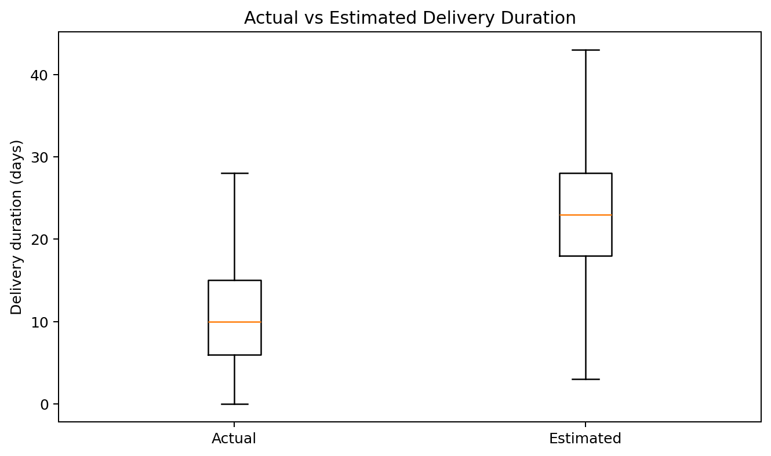
Figure 1. Comparison of actual and estimated delivery duration.
The average delay difference was -11.28 days and the median was -12 days. Because the delay metric is calculated as actual minus estimated duration, negative values indicate that the order was delivered earlier than the estimated date.

8. Delivery Performance Classification
A categorical delivery-performance feature was created from delay_days. Orders with delay_days greater than zero were labelled 'Delayed'; orders with zero or negative delay_days were labelled 'On Time'.
Performance | Orders | Percentage
On Time | 89,163 | 92.43%
Delayed | 7,307 | 7.57%
Total | 96,470 | 100.00%

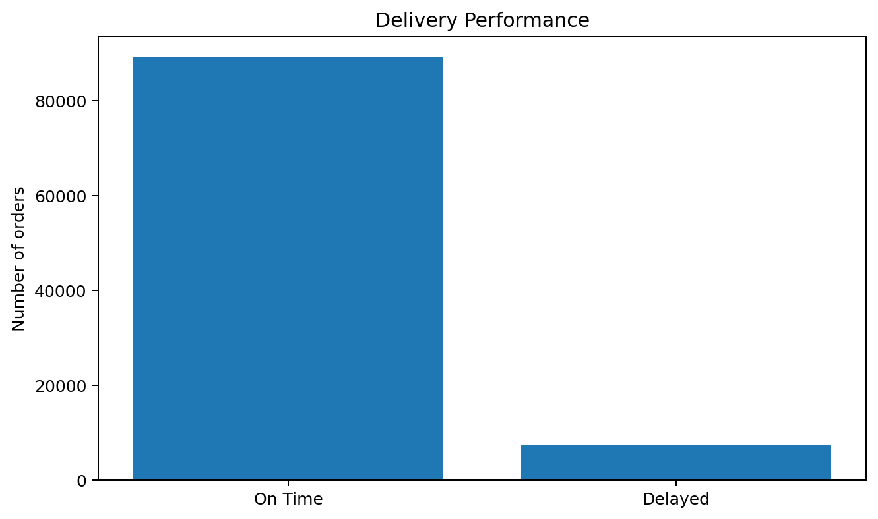
Figure 2. Delivery performance distribution.
Key result
92.43% of the final delivery-analysis records were classified as On Time, while 7.57% were classified as Delayed.

9. Outlier Detection using IQR
The Interquartile Range (IQR) method was used to identify unusually long delivery durations. IQR is appropriate for this feature because delivery times are not symmetrically distributed and extreme delays can strongly influence the mean.
Statistic | Value
Q1 | 6.0 days
Q3 | 15.0 days
IQR | 9.0 days
Lower bound | -7.5 days
Upper bound | 28.5 days
Outlier records | 5,022
Outlier percentage | 5.21%

The upper IQR threshold is 28.5 days. Delivery durations above this threshold were flagged as outliers. A total of 5,022 records (5.21%) were identified. Among the flagged records, the mean delivery duration was 40.05 days and the maximum was 209 days.
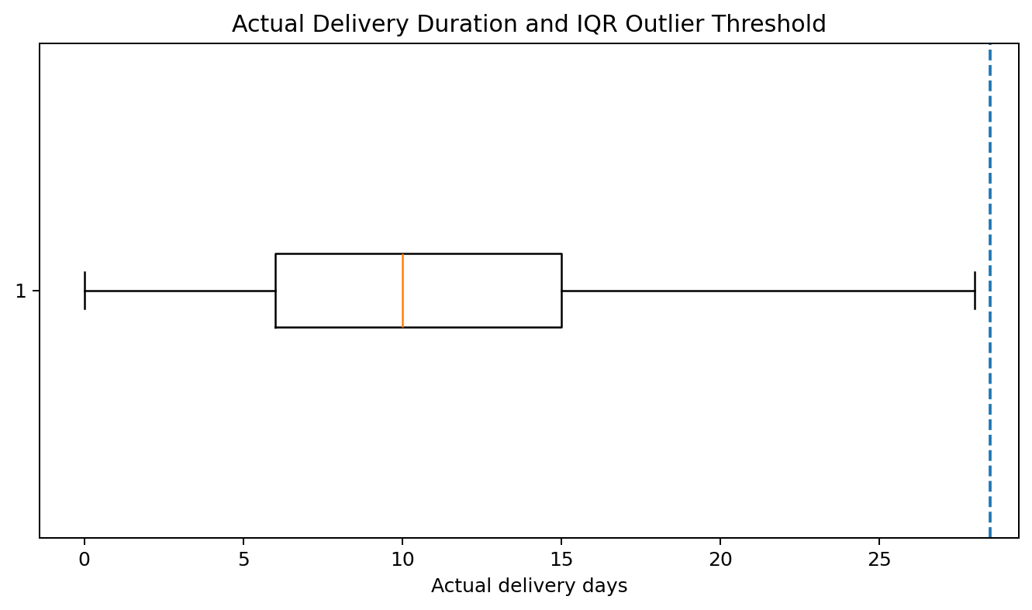
Figure 3. Actual delivery duration with the IQR upper-threshold marker.

10. Outlier Treatment
The identified outliers were retained rather than deleted. In a logistics context, an unusually long delivery can represent a genuine operational event such as a severe delay, routing issue, carrier problem, or other service disruption. Removing these observations could hide the very performance problems that logistics analysis is intended to identify.
Instead, a delivery_time_outlier flag was added. The final dataset contains 91,448 records labelled Normal and 5,022 labelled Outlier.
Treatment decision
Outliers are flagged for investigation, not automatically treated as erroneous records.

11. Min-Max Normalization
Min-Max normalization was applied to actual_delivery_days. The transformation rescales the feature to a 0–1 range using the observed minimum and maximum delivery durations.
Formula:
x_normalized = (x - x_min) / (x_max - x_min)
The observed actual delivery duration ranged from 0 to 209 days. After transformation, the normalized feature had a minimum of 0.0 and a maximum of 1.0. The normalized feature can support comparison and future machine-learning workflows.

12. Final Validation
Validation check | Result | Interpretation
Final records | 96,470 | Final delivery-analysis dataset
Duplicate rows | 0 | No duplicate rows
Missing purchase date | 0 | Critical field complete
Missing customer delivery date | 0 | Critical field complete
Missing estimated date | 0 | Critical field complete
Missing approval date | 14 | Retained; non-critical for delivery-duration calculation
Missing carrier date | 1 | Retained; non-critical for delivery-duration calculation
Negative delivery days | 0 | No impossible negative durations
Zero-day deliveries | 13 | Same-day delivery records retained
Outlier records | 5,022 | Flagged, not deleted
Normalized range | 0.0 to 1.0 | Min-Max normalization successful

The final validation confirms that all fields required for delivery-time analysis are complete, duplicate rows are absent, no negative delivery durations exist, outliers are explicitly flagged, and the normalized feature is correctly bounded between 0 and 1.

13. Key Findings
- The original dataset contained 99,441 order records.
- 96,478 orders had delivered status; 8 delivered records lacked a customer delivery timestamp and were excluded from delivery-time calculations.
- The final delivery-analysis dataset contains 96,470 records.
- Median actual delivery duration was 10 days, while median estimated delivery duration was 23 days.
- 89,163 orders (92.43%) were classified as On Time and 7,307 (7.57%) as Delayed.
- 5,022 records (5.21%) had actual delivery durations above the IQR threshold of 28.5 days.
- No negative actual delivery durations were found.
- Min-Max normalization successfully transformed actual delivery duration to a 0–1 range.

14. Impact on Logistics Analytics and Decision-Making
Data quality directly affects logistics KPIs and operational decisions. Reliable delivery dates allow organizations to measure service performance consistently, while delay classification can help separate normal operations from orders requiring attention.
- Delivery-performance monitoring: the On Time/Delayed classification provides a direct KPI for service quality.
- Operational issue identification: flagged long-delivery orders can be investigated rather than hidden through automatic deletion.
- Customer experience analysis: accurate actual and estimated delivery measures support assessment of delivery expectations.
- Planning and resource allocation: reliable delivery-duration data can support operational planning and capacity decisions.
- Future analytics: the cleaned and normalized dataset is suitable as a foundation for exploratory analysis, dashboards, and predictive models.

15. Reflection
This exercise demonstrates that data preprocessing is not simply a technical cleaning step; it directly influences the reliability of logistics conclusions. Missing values, duplicate records, incorrect date types, and extreme delivery durations can distort KPIs if they are handled without considering their business meaning.
A key learning from this workflow is that missing values should be treated according to their role in the analysis. Similarly, an outlier should not automatically be considered an error. In this dataset, unusually long delivery durations may contain important operational information, so the outliers were flagged and retained.

16. Conclusion
The logistics preprocessing pipeline successfully converted the raw order data into a validated delivery-analysis dataset containing 96,470 records. The workflow addressed data-quality assessment, timestamp conversion, missing-value analysis, delivery feature engineering, performance classification, IQR-based outlier detection, outlier flagging, normalization, and final validation.
The final dataset showed an On Time rate of 92.43% and a Delayed rate of 7.57%. A total of 5,022 delivery records were flagged as unusually long and retained for future investigation. The resulting cleaned dataset provides a reliable foundation for subsequent logistics analysis and decision-making.

17. Appendix A – Python Preprocessing Code
The following appendix contains the Python code used in the supplied notebook for the preprocessing workflow. The code is presented in execution order and preserves the core implementation used in the task.
import pandas as pd
import numpy as np
orders = pd.read_csv('/Users/nitesh/Downloads/Task 1/olist_orders_dataset.csv')
print(orders.head())
print(orders.shape)
print(orders.info())
print(orders.isnull().sum())
print("Duplicate rows:", orders.duplicated().sum())
print(orders.dtypes)
date_cols = [
"order_purchase_timestamp",
"order_approved_at",
"order_delivered_carrier_date",
"order_delivered_customer_date",
"order_estimated_delivery_date"
]
for col in date_cols:
orders[col] = pd.to_datetime(orders[col], errors="coerce")
print(orders[date_cols].dtypes)
print(
orders.groupby("order_status")[
[
"order_approved_at",
"order_delivered_carrier_date",
"order_delivered_customer_date"
]
].apply(lambda x: x.isna().sum())
)
print("Delivered orders:", (orders["order_status"] == "delivered").sum())
print(
"Delivered orders with missing customer delivery date:",
orders.loc[
orders["order_status"] == "delivered",
"order_delivered_customer_date"
].isna().sum()
)
print(
"Delivered orders with missing purchase date:",
orders.loc[
orders["order_status"] == "delivered",
"order_purchase_timestamp"
].isna().sum()
)
print(
"Delivered orders with missing estimated date:",
orders.loc[
orders["order_status"] == "delivered",
"order_estimated_delivery_date"
].isna().sum()
)
delivery_orders = orders[
(orders["order_status"] == "delivered") &
(orders["order_delivered_customer_date"].notna())
].copy()
print("Delivery analysis records:", len(delivery_orders))
print(delivery_orders.isna().sum())
delivery_orders["actual_delivery_days"] = (
delivery_orders["order_delivered_customer_date"]
- delivery_orders["order_purchase_timestamp"]
).dt.days
print(delivery_orders["actual_delivery_days"].describe())
delivery_orders["estimated_delivery_days"] = (
delivery_orders["order_estimated_delivery_date"]
- delivery_orders["order_purchase_timestamp"]
).dt.days
print(delivery_orders["estimated_delivery_days"].describe())
delivery_orders["delay_days"] = (
delivery_orders["actual_delivery_days"]
- delivery_orders["estimated_delivery_days"]
)
print(delivery_orders["delay_days"].describe())
delivery_orders["delivery_performance"] = delivery_orders[
"delay_days"
].apply(
lambda x: "Delayed" if x > 0 else "On Time"
)
print(delivery_orders["delivery_performance"].value_counts())
q1 = delivery_orders["actual_delivery_days"].quantile(0.25)
q3 = delivery_orders["actual_delivery_days"].quantile(0.75)
iqr = q3 - q1
lower_bound = q1 - 1.5 * iqr
upper_bound = q3 + 1.5 * iqr
print("Q1:", q1)
print("Q3:", q3)
print("IQR:", iqr)
print("Lower bound:", lower_bound)
print("Upper bound:", upper_bound)
outliers = delivery_orders[
(delivery_orders["actual_delivery_days"] < lower_bound) |
(delivery_orders["actual_delivery_days"] > upper_bound)
]
print("Number of outliers:", len(outliers))
print("Percentage of outliers:", len(outliers) / len(delivery_orders) * 100)
print(outliers["actual_delivery_days"].describe())
print(
"Negative actual delivery days:",
(delivery_orders["actual_delivery_days"] < 0).sum()
)
print(
"Zero-day deliveries:",
(delivery_orders["actual_delivery_days"] == 0).sum()
)
delivery_orders["delivery_time_outlier"] = delivery_orders[
"actual_delivery_days"
].apply(
lambda x: "Outlier" if x > upper_bound else "Normal"
)
print(
delivery_orders["delivery_time_outlier"].value_counts()
)
min_delivery = delivery_orders["actual_delivery_days"].min()
max_delivery = delivery_orders["actual_delivery_days"].max()
delivery_orders["actual_delivery_days_normalized"] = (
(delivery_orders["actual_delivery_days"] - min_delivery)
/ (max_delivery - min_delivery)
)
print(
delivery_orders[
[
"actual_delivery_days",
"actual_delivery_days_normalized"
]
].head()
)
print(
"Normalized minimum:",
delivery_orders["actual_delivery_days_normalized"].min()
)
print(
"Normalized maximum:",
delivery_orders["actual_delivery_days_normalized"].max()
)
print("========== FINAL VALIDATION ==========")
print("Final records:", len(delivery_orders))
print(
"Duplicate rows:",
delivery_orders.duplicated().sum()
)
print("\nMissing values:")
print(delivery_orders.isna().sum())
print(
"\nNegative delivery days:",
(delivery_orders["actual_delivery_days"] < 0).sum()
)
print(
"\nOutlier records:",
(delivery_orders["delivery_time_outlier"] == "Outlier").sum()
)
print(
"\nDelivery performance:"
)
print(delivery_orders["delivery_performance"].value_counts())
print(
"\nNormalized range:",
delivery_orders["actual_delivery_days_normalized"].min(),
"to",
delivery_orders["actual_delivery_days_normalized"].max()
)
delivery_orders.to_csv(
"logistics_delivery_cleaned.csv",
index=False
)
print("Cleaned dataset saved successfully.")
Final output file generated by the notebook: logistics_delivery_cleaned.csv

