Chrony

Purpose – Time Synchronization

Package name – chronyd

Config file 🡪 /etc /chrony.conf

Log file 🡪 /var/log/chrony

Service – systemctl start /restart chronyd

Program command – chronyc

Step 1 -> Install the package : - yum install -y chrony

Step 2 🡪 go to /etc/chrony.conf file add google server address

vi /etc/chrony.conf

add below line

server 8.8.8.8

and save the file

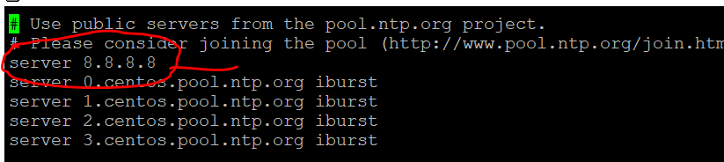

Step 3 – start the chronyd service

systemctl start chronyd

step 4 : -check the status of chronyd service

systemctl status chronyd

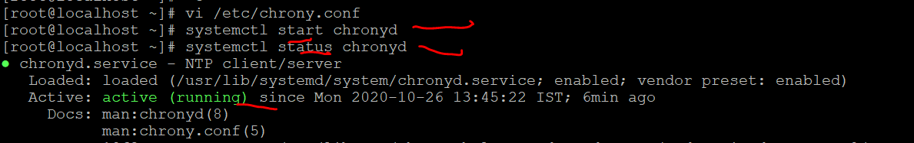

Step 5 : to check our configuration is working or not .we get respone from google server

Type🡪 chronyc

We ll get chronyc command prompt

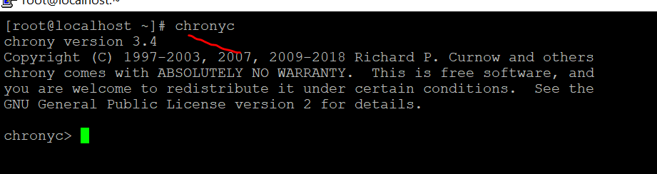

Step 6

Type -- > help at chronyc command prompt

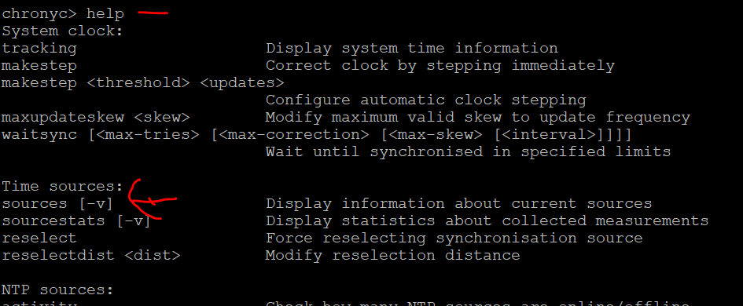

Step 7 : 🡪 sources command will display the current source for our chrony

Type sources on chronyc command prompt

