Linux Assignment

**1.How to make a directory**

Ans: -

**-Definition:**

mkdir command is used to create a directory.

**-Command :**

mkdir testing

**-Describe the command:**

mkdir: it is used to create a directory.

testing: it is the name of the folder.

**-Output(Output content to be pasted along with screenshot).**

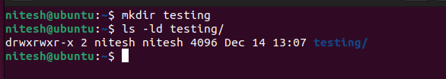

**2.Remove a directory.**

Ans:

**-Definition:**

rmdir command is used to remove the directory.

**-Command:**

rmdir testing

**-Describe the command:**

rmdir: it is used to remove folder.

testing: it is the name of the folder.

**-Output(Output content to be pasted along with screenshot).**

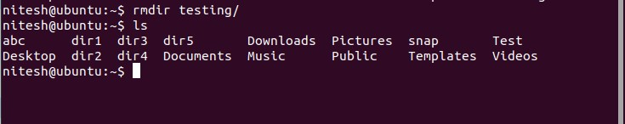

**3. Make a copy of a file.**

**-Definition:**

cp command is used to make a copy of file.

**-Command:**

cp testing.txt test.txt

**-Describe the command:**

cp: it is used to make copy of a file.

testing.txt: it is the old name of a file

test.txt: it is the copy of file..

**-Output(Output content to be pasted along with screenshot).**

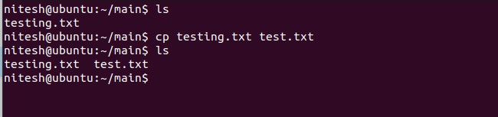

**4.Move or rename a file.**

Ans:

**-Definition :**

mv command is used to move or rename a file or directory.

**-Command:**

mv testing.txt cd abc/ and mv testing.txt test.txt

**-Describe the command:**

mv: it used to move or rename to a file.

testing.txt: is a file moved in abc folder and testing.txt rename with name of test.txt.

**-Output(Output content to be pasted along with screenshot).**

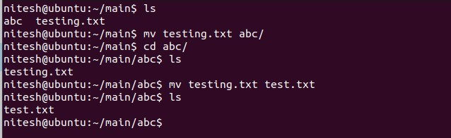

**5.Create an empty file.**

Ans:

**-Definition:**

touch is a command which is used to create an empty file.

**-Command:**

touch test.txt

**-Describe the command:**

touch: it is used to create an empty file.

test.txt: it is the name of a file.

**-Output(Output content to be pasted along with screenshot).**

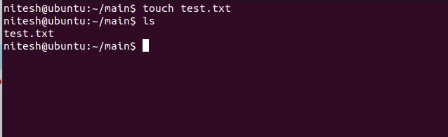

**6.Remove multiple files with a single command**

Ans:

**-Definition:**

rm is a command which is used to remove multiple files in once.

**-Command:**

rm test.txt test1.txt test2.txt

**-Describe the command:**

rm: it is used to remove files.

  test.txt & test1.txt & test2.txt: these are the name of multiple files.

**-Output(Output content to be pasted along with screenshot).**

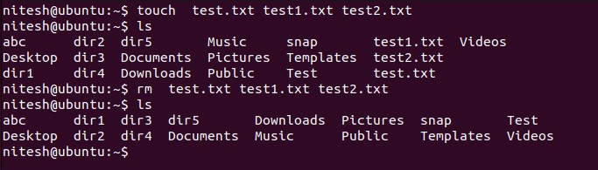

**7.Remove content from the folder without removing folder.**

Ans:

**-Definition:**

find -type f -delete is a command which is used to delete all content in directory without removing folder.

**-Command:**

find  -type f -delete

**-Describe the command:**

find -type f -delete: it is used to delete all content.

**-Output(Output content to be pasted along with screenshot).**

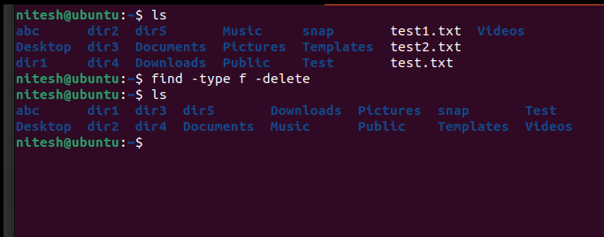

8.Create multiple folder(a-z) with a single command.

Ans:

**-Definition:**

mkdir {a..z} is command which is used to create multiple folder.

**-Command:**

mkdir {a..z}

**-Describe the command:**

mkdir {a..z}: it used to create multiple folders.

a to z: these are the name of folders.

**-Output(Output content to be pasted along with screenshot**).

