WUKWAY
Skip the Queue. Not the Food.
Product & Technical Specification
For Engineering & Product Handoff — v1.0
August 2026

1. Executive Summary
WUKWAY is a local food pre-ordering and pickup platform focused on India's offline food economy — street thelas, small restaurants, stalls, and quick-service shops. Unlike Swiggy or Zomato, WUKWAY does not deliver food. Customers discover nearby outlets on foot, order and pay in advance, declare how far away they are, and walk in to collect a ready order using a pickup token — skipping the physical waiting queue entirely.

1.1 What Makes This Different
- No delivery fleet: no riders, no delivery logistics, no delivery SLAs. This removes the single biggest cost and operational complexity of a food-delivery business.
- Walking-distance discovery: outlets are surfaced by walking time, not driving distance — built for dense Indian markets, college areas, office lanes and street-food clusters.
- Queue elimination, not order fulfillment: the core value proposition is “order ahead, skip the line,” which is a fundamentally different problem from “get food delivered.”
- Vendor-friendly economics: small vendors keep the full ticket price minus a lightweight commission/subscription — no delivery commission stacked on top.

1.2 Who This Document Is For
This is a build specification for the engineering team. It defines every app, every feature, the data model, the recommended technology stack, hosting architecture on AWS, and a phased MVP roadmap. Section 12 lists open product decisions the team should confirm with you before or during Phase 1.

2. Product Scope — Three Applications
WUKWAY is a two-sided marketplace with an operations layer, which means three distinct applications share one backend:
App | Platform | Primary User | Purpose
Customer App | Android (React Native) | End customers | Discover outlets, order ahead, track pickup
Vendor App | Android tablet (React Native) or Web | Thela/outlet owner or staff | Receive orders, manage menu, mark order status
Admin Panel | Web (React.js) | WUKWAY internal ops team | Onboard outlets, manage cities, offers, commissions, support
Table 2.1 — Application overview
The original prototype you shared covers the Customer App in detail (sections 3.1–3.11 below map to it 1:1). The Vendor App and Admin Panel are not in the prototype but are mandatory for the platform to function — they are specified in sections 3.12 and 3.13.

3. Feature Specification

3.1 Discovery & Location (Customer App)
- Location Detection — identifies the customer's current location on launch.
- Walking-Time Distance — outlets shown by walking time (min), not kilometres.
- The Lane — nearby food outlets within walking distance, the core home feed.
- Outlet Open/Closed Status — real-time indicator of whether an outlet is accepting orders.

3.2 Search
- Direct Search Bar — immediate search for food or outlets.
- Menu-Wide Search — searches across multiple vendors and menus simultaneously.
- Food/Craving Search — free-text terms like “spicy”, “pani puri”, “momos”.
- Price-Based Search — structured queries such as “under ₹100”.
- Rotating Search Suggestions — prompts rotate periodically to inspire discovery.

3.3 Home / The Lane
- Nearby Outlet Cards, Walking Time, Outlet USP, Featured/Popular Food, Pickup Deals, Live Social Proof.
- Craving Filters: All · Under ₹100 · Spicy · Trending · Quick Bite.

3.4 Outlet / Menu Experience
- Outlet Profile, Full Menu, Menu Categories.
- Item Tags — Spicy, Quick, Bestseller, Under ₹100.
- Thela Picks — recommended/popular items from that outlet.
- Quick Choice Section, One-Tap Add, Quantity Selector, Running Cart Total.

3.5 Quick Choice / Decision Features
- “What Are You After?” intent picker: I'm Hungry · Quick Bite · Under ₹100 · For 2 People · Spicy Picks.
- Build My Pickup — recommends a combo based on preferences.
- Thela Picks — popular choices surfaced to speed up decisions.

3.6 Pickup Ordering
- Pickup Cart / Ticket — order represented as a pickup ticket, not a delivery cart.
- Live Cart Bar — persistent access to the current order while browsing.
- ETA Declaration — customer selects how far away they are: 5 / 10 / 15 min.
- Pickup Timing Calculation — combines customer ETA with vendor prep time to schedule cooking start.
- Order Confirmation — confirms the pickup order and captures payment.

3.7 Order Tracking
Customer-facing flow: Order Placed → Preparing → Ready → Pickup.
- Order Placed / Preparation / Ready status indicators.
- Pickup Token — unique code required at the outlet to collect the order.
- Pickup Instructions and Pickup Completion confirmation.

3.8 Scan / Nearby Discovery
- Scan Section for discovering nearby participating outlets while physically walking around.
- Walking-Based Discovery, Outlet-to-Menu Navigation.

3.9 Feed
- Local Food Feed, Trending Food, Local Specials, Food Discovery Cards, Feed-to-Order Flow.

3.10 Cart
- Current Items, Quantity Adjustment, Item Removal, Running Total, Pickup Outlet, Pickup ETA, Order Confirmation.

3.11 Customer Navigation
Bottom navigation: Home · Scan · Feed · Cart.

3.12 Vendor App — New, Required for MVP
Not in the original prototype. Every vendor needs this to accept and fulfil orders — without it, the customer flow above has no one on the other end.
- Outlet availability toggle: open/closed, pause new orders (e.g. when overwhelmed).
- Order inbox: incoming orders with sound/push alert, Accept / Reject action.
- Order status control: move an accepted order through Preparing → Ready, and mark Collected by scanning or entering the pickup token.
- Prep-time settings: per-item or per-outlet default preparation time, used by the Pickup Timing Calculation.
- Menu management: add/edit/remove items, prices, photos, tags (Spicy, Bestseller, etc.), mark items sold out.
- Offers management: create simple Pickup Deals (e.g. “10% off before 6pm”), start/stop them.
- Daily summary: orders count, revenue collected, busiest hours (lightweight, not full analytics).
- Payout view: settlement status and history (payouts are ultimately handled by the payment gateway/admin).

3.13 Admin Panel — New, Required for MVP
Internal tool for the WUKWAY ops team to run the marketplace as a SaaS operation across multiple cities/zones.
- Outlet onboarding & approval: KYC/document upload, verification, activation.
- City/zone management: control which areas are live, geofencing for The Lane.
- Commission & plan configuration: per-outlet commission %, or flat subscription plans.
- Platform-wide offers: promo codes, first-order discounts, city-wide campaigns.
- Order & dispute monitoring: search any order, view its full state history, issue refunds.
- Analytics dashboard: GMV, active outlets, order volume, cancellation rate, top outlets/items per city.
- Support tools: customer/vendor ticket handling, manual order status override.
- Content moderation: review menu photos/descriptions for quality and policy compliance.

4. Core Flows

4.1 Application Ecosystem
How the three apps connect to one backend platform and the third-party services each depends on.
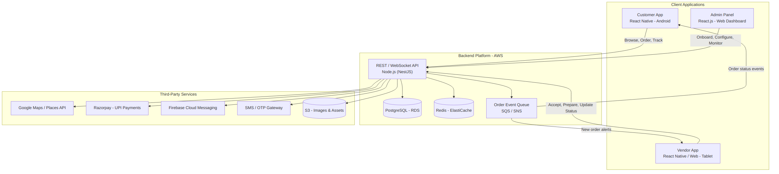
Figure 4.1 — WUKWAY app & service ecosystem

4.2 Customer Journey
The end-to-end path a customer takes from opening the app to collecting food, matching the prototype's core flow, grouped into three phases.
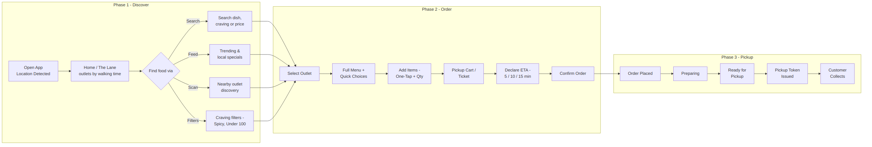
Figure 4.2 — Customer journey, discovery to pickup

4.3 Order Lifecycle (State Machine)
This is the single most important diagram for the backend team — it defines every state an order can be in and who (customer, vendor, or system) triggers each transition. Build the Orders table and API around these exact states.
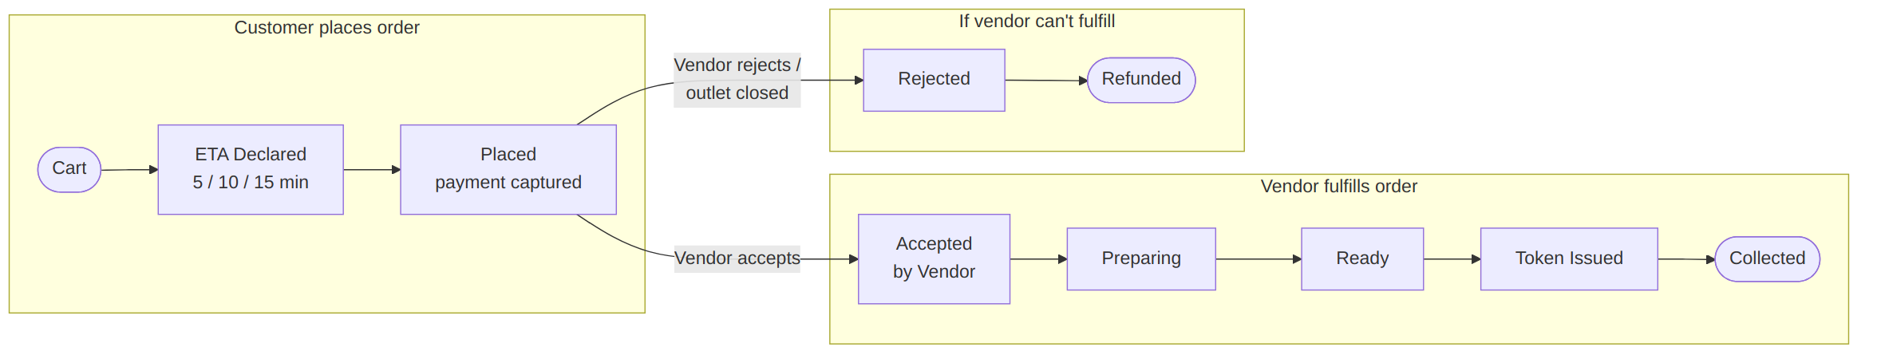
Figure 4.3 — Order status state machine

5. Data Model — Core Entities
High-level entity list to seed the database schema. Exact columns to be finalized by the backend team; relationships noted below.
Entity | Key Fields | Relationships
User | id, phone, name, default_location, role (customer) | 1–many Orders, 1–many Addresses/Locations
Vendor / Outlet | id, name, city_id, geo_lat/lng, USP, open_status, avg_prep_time, commission_% | 1–many MenuItems, 1–many Orders, 1–many Offers
MenuItem | id, outlet_id, name, price, category, tags[], prep_time, is_available | many–many via OrderItems
Order | id, customer_id, outlet_id, status, eta_minutes, placed_at, ready_at, token, total_amount | 1–many OrderItems, 1 Payment
OrderItem | id, order_id, menu_item_id, quantity, unit_price | belongs to Order & MenuItem
Offer | id, outlet_id (nullable for platform-wide), type, value, valid_from/to | belongs to Outlet or Platform
Payment | id, order_id, gateway_ref, amount, status, method | belongs to Order
City / Zone | id, name, polygon/geofence, is_live | 1–many Outlets
Table 5.1 — Core entities and relationships

6. API Surface (High-Level)
Grouped endpoint areas — the backend team should design these as versioned REST resources (e.g. /api/v1/...), with WebSocket or push-based events layered on top of Orders for real-time status updates.
Group | Examples
Auth | OTP request/verify, token refresh, role-based session (customer / vendor / admin)
Discovery | nearby outlets by geo + walking time, outlet detail, menu detail, search, feed, craving filters
Cart & Order | cart CRUD, ETA declaration, order create, order detail, order status stream
Vendor Ops | order accept/reject, status update, menu CRUD, item availability toggle, prep-time config
Payments | create payment intent, webhook/callback handling, refund
Admin | outlet onboarding/approval, city/zone config, commission config, offers, analytics, disputes
Notifications | push token registration, order status push, promotional push
Table 6.1 — API groups

7. Non-Functional Requirements
- Real-time order status: customer and vendor apps must reflect status changes within 1–2 seconds — use WebSockets or a push-notification-backed poll, not manual refresh.
- Location accuracy: walking-time estimates should use a mapping API's walking-directions endpoint, not straight-line distance, especially in dense markets with one-way lanes.
- Multi-tenancy: the platform must support many independent cities/zones from day one in the data model, even if only one city is launched first.
- Payments & payouts: UPI-first payment experience; vendor payout cycle (e.g. T+1) handled via the payment gateway's route/split feature or manual settlement in MVP.
- Notifications: push notifications are core to the product (new order alert to vendor, ready alert to customer) — not optional.
- Offline / low-connectivity tolerance: vendor tablets in busy stalls may have patchy Wi-Fi/data — the Vendor App should queue status updates and retry, not silently fail.
- Data privacy: handle customer phone numbers and location data per India's Digital Personal Data Protection (DPDP) Act — minimize retention, get consent for location.
- Scalability: design for horizontal scaling of the API layer and read-heavy discovery queries (outlets/menu) separate from write-heavy order flow.

8. Recommended Technology Stack
Chosen for three things: (1) team can ship an Android-only React Native app fast, (2) everything hosts cleanly and affordably on AWS, (3) it is a well-trodden, easy-to-hire-for stack for an early-stage SaaS — nothing exotic.

8.1 Client Applications
Layer | Recommendation | Why
Customer App | React Native (Android only for now) | Matches your requirement directly; single codebase can extend to iOS later at low incremental cost
Vendor App | React Native (tablet-optimized) or a lightweight React web app | Same team/skillset as customer app; web option is fastest to ship for MVP if vendors can use a browser on a tablet
Admin Panel | React.js + a component library (e.g. Ant Design / MUI) | Internal tool — speed of build matters more than custom design
State/Data | React Query (server state) + Zustand/Redux Toolkit (client state) | Simple, widely known, avoids boilerplate-heavy Redux-only setups
Table 8.1 — Client stack

8.2 Backend
Layer | Recommendation | Why
API Framework | Node.js + NestJS (TypeScript) | Structured, batteries-included framework; same language as the RN apps, easing full-stack hiring
Primary Database | PostgreSQL (Amazon RDS) | Strong relational fit for orders/menus/geo queries; PostGIS extension available for geo-distance filtering
Cache / Sessions | Redis (Amazon ElastiCache) | Fast reads for outlet/menu discovery, OTP rate-limiting, session tokens
Real-time updates | WebSockets (Socket.io on ECS) or AWS AppSync (managed GraphQL subscriptions) | Needed for live order status; AppSync trades control for less ops overhead
Async / Events | Amazon SQS + SNS | Decouples order events (new order → vendor alert, ready → customer alert) from the request/response cycle
File / Image Storage | Amazon S3 + CloudFront | Menu photos, outlet images, cheap and simple to host and serve
Table 8.2 — Backend stack

8.3 Hosting & Infrastructure (AWS)
Concern | Recommendation | Why
Compute | ECS on Fargate (containers, no server management) | Easiest path from a Node.js app to production on AWS; scales automatically, no EC2 patching
API entry point | Application Load Balancer + API Gateway (optional, for rate limiting/auth at the edge) | Standard, reliable, integrates with ACM for free SSL
CI/CD | GitHub Actions → build Docker image → push to ECR → deploy to ECS | Fully AWS-native, minimal extra tooling cost
Infra as Code | Terraform | Reproducible environments (dev/staging/prod), easy to hand over or audit
Monitoring & Logs | CloudWatch (logs/alarms) + Sentry (app error tracking) | CloudWatch is native/free-tier friendly; Sentry catches app-level bugs CloudWatch won't surface well
Domains/SSL | Route 53 + AWS Certificate Manager | Native integration, free SSL certificates
Table 8.3 — AWS hosting

8.4 Third-Party Services
Purpose | Recommendation | Why
Maps & walking-time | Google Maps Platform (Places + Directions API) | Best coverage of Indian streets/lanes; walking-mode directions built in
Payments | Razorpay | Best UPI support for the Indian market, has route/split payments useful for vendor payouts
Push Notifications | Firebase Cloud Messaging (FCM) | Free, standard for Android, integrates directly with React Native
SMS / OTP | MSG91 or Twilio (India routes) | Reliable OTP delivery in India at low per-message cost
Crash/Error tracking | Sentry | Works across React Native and Node.js backend with one account
Table 8.4 — Third-party integrations

8.5 Why Not Serverless-First (Lambda) for the API
Lambda + API Gateway is viable and can be cheaper at very low volume, but the WebSocket-driven, session-heavy nature of live order tracking is simpler to reason about and debug on always-on containers (ECS Fargate) in the early stage. Revisit serverless once traffic patterns are well understood — it's a valid Phase 2+ cost optimization, not a Phase 1 requirement.

9. MVP Phasing & Roadmap

Phase 1 — MVP (build first)
The minimum to prove the core loop: discover → order → declare ETA → pickup.
- Customer App: Location, Home/The Lane, Search, Outlet + Full Menu, Quick Choices, Cart, ETA Declaration, Order Status, Pickup Token.
- Vendor App: Order inbox (accept/reject), status control (Preparing/Ready/Collected), menu management, availability toggle.
- Admin Panel: outlet onboarding/approval, single-city zone config, basic order monitoring.
- Payments: Razorpay UPI checkout, basic refund flow on rejection.
- One city/zone live, manual vendor onboarding is acceptable at this stage.

Phase 2 — Engagement & Discovery
- Feed (trending, local specials, food discovery cards).
- Scan-based nearby discovery.
- Live Social Proof, Pickup Deals/Offers engine, promo codes.
- Vendor daily summary dashboard, payout view.
- Admin analytics dashboard (GMV, cancellation rate, top outlets).

Phase 3 — Scale & Optimization
- Multi-city rollout, self-serve vendor onboarding.
- Recommendation-driven “Build My Pickup” personalization.
- Cost optimization pass on backend (serverless where it now makes sense).
- iOS version of the Customer App, if warranted by demand.

10. Open Questions for the Team / You to Decide
Flagging these now avoids rework later — worth a short decision call before Phase 1 kicks off.
- Payment timing: does the customer pay in full at order confirmation, or only pay at pickup (cash/UPI on collection)? This materially changes the refund and no-show handling logic.
- No-show handling: what happens if a customer declares ETA, the vendor prepares food, and the customer never arrives? Needs a policy (e.g. hold slot for X minutes, partial charge).
- Vendor onboarding model: will WUKWAY ops onboard vendors manually (door-to-door, likely for MVP) or self-serve via the Admin/Vendor app?
- Commission vs. subscription: flat monthly fee per outlet, or a % commission per order — or a hybrid?
- Vendor App form factor: is a low-cost Android tablet provided to vendors, or should it also work as a simple web page on any phone/laptop they already have?

11. Summary for the Dev Team
Build order: Customer App core loop → Vendor App core loop → Admin approval tooling → payments → real-time status → everything else in Phase 2/3. The Order state machine in Figure 4.3 is the contract between all three apps — get that right first and the rest of the build follows naturally.

Prepared as a build-ready handoff document. Diagrams are in Mermaid format — the source .mmd files can be shared alongside this document if the team wants to edit them directly.

