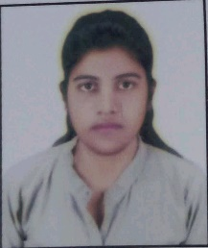**RESUME**

**SHAIKH SHAISTA**

+91 89284 19613

Email Id: [shaikhshaista2109@gmail.com](mailto:shaikhshaista2109@gmail.com)

**OBJECTIVE**

To work with an organization where I can learn new skills and increase my abilities for the organizational

Goal as well as myself.

**EDUCATIONAL** **QUALIFICATION**

* Pursuing B.E final year from Mumbai University.
* Passed out 10th in year 2017

Marks 86%

* Passed out 12th in year 2019

Marks 70% (Eng. Entrance Exam Marks 94%)

* Passed out third year in year 2022

Pointer 9.96

**Other** **Academic** **Detail**

* Got 1st Prize in Science Exhibition
* Got 2nd Prize in Poster Presentation

**Technical Skills**

* Basic knowledge of computer
* AUTO CAD
* MS-CIT
* Microsoft Excel
* Microsoft Word
* Microsoft Power Point

**Technical Courses**

* Process Design Engineering In Altitude Training Institute (Duration:6 Months)

**Work Experience**

FRESHER

**Strength & Hobbies**

* Hard & Smart Working
* Honest & Punctual
* Good Communication skills
* Teaching, Reading & Arts

**Personal Details**

Father’s Name : Shaikh Mohd Masood Alam

Date-Of-Birth : 21st September 2000

Address : Flat no. 501 H-Wing Balaji Z P Hills Building NR Krishna

Marriage Hall Khadanroad Ambernath Krishna Marriage

Hall Thane Maharashtra-421505

Marital Status : Single

Date …………… **Shaikh Shaista**