KANTIPUR ENGINEERING COLLEGE
(Affiliated to Tribhuvan University)

Dhapakhel, Lalitpur

[Subject Code: EX 654]
A MINOR PROJECT PROPOSAL ON
“PROGRAMMABLE LOGIC CONTROLLER (PLC) IMPLEMENTATION USING ESP32 FOR INDUSTRIAL AUTOMATION”

Submitted by:

KABIN ADHIKARI [010/BEI/079]
AMRIT MAINALI [004/BEI/079]
ABHISHEK RANA [003/BEI/079]
HARI SHANKAR MANDAL [008/BEI/079]

Submitted to:
Department of Computer and Electronics Engineering

June, 2025

ACKNOWLEDGEMENT
We would like to express our sincere gratitude to all those who have contributed to the preparation of this proposal. First and foremost, we are thankful to Kantipur Engineering College for providing us with the opportunity to submit this proposal.
We are deeply grateful to Er. Sujin Gwachha sir, whose guidance and support were invaluable throughout the process. Their expertise and insightful feedback helped shape this proposal into its final form.
We would also like to acknowledge the support and encouragement from the Department of Computer and Electronics who provided us with their assistance and valuable suggestions.
KABIN ADHIKARI [010/BEI/079]
AMRIT MAINALI [004/BEI/079]
ABHISHEK RANA [003/BEI/079]
HARI SHANKAR MANDAL [008/BEI/079]

ABSTRACT
In modern industrial and residential environments, automation plays a vital role in improving efficiency, reducing human intervention, and conserving resources. Programmable Logic Controllers (PLCs) are widely used in automation systems due to their reliability, modularity, and real-time control capabilities. However, traditional PLCs are often costly and lack flexibility for prototyping, education, or small-scale use.
This project presents the design and implementation of a low-cost, programmable logic controller using the ESP32 microcontroller and the OpenPLC platform. The system is programmed using Ladder Logic, adhering to the IEC 61131-3 standard, to replicate industrial PLC behavior. As a real-world application, an Automatic Water Tank Filling System is developed to demonstrate the functionality of the ESP32-based PLC. The system uses level sensors to monitor water levels and relay-based output control to operate a water pump, ensuring automatic filling while preventing overflow.
The proposed system is modular, expandable, and cost-effective, making it ideal for academic projects, prototype development, and small industrial automation tasks. By combining open-source software and affordable hardware, this project demonstrates a practical and scalable alternative to conventional PLCs.
Keywords: Programmable Logic Controller, ESP32, OpenPLC, Ladder Logic, Automation System, IEC 61131-3

TABLE OF CONTENTS
ACKNOWLEDGEMENT i
ABSTRACT ii
LIST OF ABBREVIATIONS vii
CHAPTER 1 1
INTRODUCTION 1
1.1 Background 1
1.2 Problem Statement 1
1.3 Overview 1
1.4 Objective 2
1.5 Features/Application 2
1.6 Feasibility Analysis 3
1.6.1 Economic Feasibility 3
1.6.2 Technical Feasibility 3
1.6.3 Operational Feasibility 3
CHAPTER 2 5
LITERATURE REVIEW 5
2.1 Related Theory and Research 5
Chapter 3 7
SYSTEM REQUIREMENTS 7
3.1 Hardware Requirements 7
3.1.1 ESP32 Development Board 7
3.1.2 Relay Module 7
3.1.3 LED Bulbs 8
3.1.4 Opto-coupler 8
3.1.5 Water Pump or Solenoid Valve 9
3.1.6 Power Supply 10
3.1.7 Ultrasonic Sensor 10
3.2 Software Requirements 11
3.2.1 OpenPLC 11
3.2.2 ESP-IDF 11
3.2.3 EasyEDA 11
CHAPTER 4 12
METHODOLOGY 12
4.1 System Block Diagram 12
4.1.1 ESP-PLC Architecture 12
4.1.2 Automatic Water Tank Filling System 13
4.2 Flow-chart 15
CHAPTER 5 16
EPILOUGE 16
5.1 Budget Analysis 16
5.2 Work Schedule 16
5.2.1 Gantt chart 17
5.3 Expected Outcome 17
REFERENCES 19

LIST OF FIGURES
  - ESP-32 Development Board 7
  - Relay Module 8
  - LED Bulbs 8
  - Opto-coupler 9
  - Water Pump or Solenoid valve …………………………………………… 9
  - Power Supply……………………………………………………………… 10
  - Ultrasonic Sensor………………………………………………………….. 10
  - ESP-PLC Block Diagram 12
  - System Block Diagram……………………………………………………. 13
  - Flowchart of the System ………………………………………………….. 15
5.1 Gantt Chart of the project …………………………………………………. 17

LIST OF TABLES
5.1 Cost estimation table 16

LIST OF ABBREVIATIONS
PLC: Programmable Logic Array
IoT: Internet of Things
GPIO: General Purpose Input Output
LED: Light Emitting Diode
Wi-Fi: Wireless Fidelity

CHAPTER 1

INTRODUCTION
  - Background
In the industrial world, automation plays a significant role in improving efficiency, safety, and precision. One of the key components of any automation system is the Programmable Logic Controller (PLC), which processes real-time input data and generates control outputs based on logical operations. Traditional PLCs are widely used in industries but are often expensive, inflexible, and not easily scalable for small projects or educational use.
The advancement of low-cost microcontrollers like the ESP32 and the availability of open-source platforms such as OpenPLC have made it possible to replicate PLC behavior using affordable hardware. This has opened up new opportunities in both education and small-scale industrial automation.
  - Problem Statement
Although traditional PLCs are highly reliable and robust, their high cost and proprietary nature limit their use in academic projects, prototype development, and low-budget automation tasks. Additionally, small-scale industries and household systems often lack intelligent control systems for managing water tanks and other resources, leading to issues such as manual labor, overflow, and resource wastage.
There is a need for a cost-effective, programmable, and flexible PLC solution that can perform standard industrial tasks like liquid level control, while being accessible for students, researchers, and small businesses.
  - Overview
This project focuses on the implementation of a PLC using ESP32, an affordable microcontroller with sufficient I/O capabilities and support for real-time operations. The project uses the OpenPLC platform, which allows ladder logic programming based on IEC 61131-3 standards, replicating the logic control style of industrial PLCs.
The project demonstrates the working of this ESP32-based PLC by automating a Water Tank Filling System. The system uses level sensors to detect water levels and automatically turns the pump on or off using a relay, preventing overflows and ensuring proper water management. All logic is programmed using ladder diagrams and uploaded to the ESP32.
  - Objective
- To design and implement a cost-effective, programmable logic controller (PLC) using the ESP32 microcontroller and the OpenPLC platform,
- To demonstrate its industrial automation capabilities through an Automatic Water Tank Filling System using ladder logic programming.

  - Features/Application
- Ladder Logic Control via OpenPLC Platform
The system is programmed using ladder logic on the OpenPLC platform, providing seamless and industry-standard logic execution compatible with IEC 61131-3.
- Dual Compatibility: AC and DC Load Control
The use of relay-based output switching allows the system to safely control both AC and DC loads, making it highly flexible for diverse automation tasks.
- Remote Diagnostics and Configuration via Wi-Fi
Built on the ESP32, the system supports wireless access for real-time monitoring, configuration, and remote firmware updates, allowing for on-the-go maintenance and debugging.
- Low-Cost and Modular Design
Utilizes open-source software and easily available components, making it budget-friendly, especially for educational, research, or small-scale industrial use. Its modular I/O setup supports expansion with additional sensors and actuators.
- Real-Time Response and Reliability
Designed for responsive and reliable automation, mimicking the behavior of traditional PLCs with significantly lower hardware complexity.
- Safety and Electrical Isolation
Output relays and input protections ensure safe control of high-voltage devices without risking the microcontroller.
- Wide Range Application
Industrial and Smart home automation using AC/DC loads, Industrial process control for motors and sensors, Remote monitoring and diagnostics over Wi-Fi, Educational platform for learning PLC and ladder logic.

  - Feasibility Analysis

1.6.1 Economic Feasibility
The system is highly economical, especially when compared to conventional PLCs. It is well-suited for academic projects, training purposes, and light industrial tasks, offering significant value for money while delivering core PLC functionality.

1.6.2 Technical Feasibility
The proposed ESP32-based PLC system is technically feasible due to the availability of low-cost, reliable hardware and mature open-source platforms like OpenPLC. The ESP32 offers sufficient processing power, multiple I/O pins, and built-in Wi-Fi, making it suitable for real-time control and remote configuration. Components such as relays and water level sensors are readily available and easily interfaced with the microcontroller. Programming with ladder logic ensures compatibility with industrial standards. The system is modular, scalable, and can be adapted for various automation tasks with minimal effort.

1.6.3 Operational Feasibility
The proposed system is operationally feasible as it is designed to perform a well-defined and practical task automatic water tank filling using programmable logic and real-time sensor input. The system mimics standard industrial PLC behavior, making it intuitive for users familiar with ladder logic. Its relay-based output allows safe control of AC and DC loads, while the ESP32’s built-in Wi-Fi enables remote monitoring and configuration. The system requires minimal maintenance, is easy to operate, and can be scaled or repurposed for other automation applications, ensuring practical usability in real-world scenarios.

CHAPTER 2

LITERATURE REVIEW

2.1 Related Theory and Research
Industrial automation relies heavily on Programmable Logic Controllers (PLCs) for real-time process control and decision-making. Traditional PLCs are often expensive and proprietary, which makes them hard to access for students or small-scale projects. Open-source platforms like OpenPLC and affordable microcontrollers like the ESP32 have made it easier to build custom automation systems that work like real PLCs. Additionally, relays offer a cost-effective and versatile way to control both AC and DC loads safely, addressing the limitations of semiconductor switches like TRIACs.
The document outlines the historical evolution and core functions of Programmable Logic Controllers (PLCs), emphasizing their durability in harsh industrial conditions and their origin in the U.S. automotive industry. Initially designed to replace complex relay-based control systems, PLCs offered a more efficient and reprogrammable solution for automation. Over time, the high cost and complexity of traditional PLCs led to the adoption of simpler platforms like Arduino for smaller-scale applications. This shift enabled cost-effective automation using open-source software and minimal hardware. The document further explores how an Arduino board can be transformed into a PLC-like controller using the ARTe framework and appropriate I/O interfaces. [1]
Seneviratne et al. describe the use of optically-isolated relay driver circuits for safely controlling high-voltage AC or DC loads with Arduino-based systems. Their work highlights various relay board configurations and emphasizes the practicality of using relay shields—such as the Arduino 4 Relays Shield—for compact, industrial-grade PLC applications. [2]
López et al. (2021) demonstrated that the ESP32, a dual-core microcontroller with built-in Wi-Fi and Bluetooth, can handle real-time control tasks reliably. They used FreeRTOS to manage tasks, showing the ESP32’s potential for automation applications. However, their system didn’t support standard PLC programming languages like Ladder Logic, which limits its compatibility with industrial standards. [3]
Fernandes et al. (2019) described OpenPLC as an open-source platform that follows the IEC 61131-3 standard, allowing programming in Ladder Logic (LD), Function Block Diagram (FBD), and other PLC languages. It supports hardware like Arduino, Raspberry Pi, and ESP32, making it ideal for education and prototyping. [4]
Ladder Logic is one of the most popular PLC programming languages because it’s visually simple and resembles traditional relay-based circuits. Zhou et al. (2018) noted its ease of use in industrial settings and its compatibility with modern digital control systems, making it a go-to choice for engineers.
In their comparative study of output switching devices, Sharma and Mehta evaluated the effectiveness of relays vs. TRIACs for automation applications. Their findings indicated that relays offer broader compatibility, as they can control both AC and DC loads while maintaining galvanic isolation. The study emphasized relays as more suitable for flexible and safe switching, especially in projects involving microcontrollers like the ESP32. [5]

Chapter 3

SYSTEM REQUIREMENTS

3.1 Hardware Requirements

3.1.1 ESP32 Development Board
ESP32 is a low-cost, low-power, and highly versatile microcontroller with integrated Wi-Fi and Bluetooth connectivity. ESP32 is used as the core controller for automating airport baggage handling conveyor systems. It features a dual-core processor and a wide range of digital and analog input/output pins, making it ideal for managing motors, sensors, and real-time control tasks. Its built-in wireless capabilities allow for remote monitoring, diagnostics, and system updates. The ESP32 can run ladder logic programs developed using the OpenPLC platform, enabling robust, industrial-style automation in a compact and energy-efficient design.
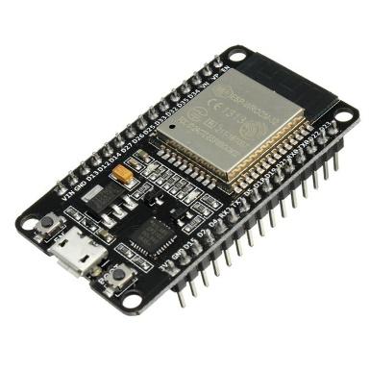

Figure 3.1: Esp-32 Development Board
Source: https://augustyneoguserfix.z13.web.core.windows.net/esp-wroom-32-esp32-esp-32s-arduino.html

3.1.2 Relay Module
A relay module is an electrically operated switch that allows a low-power control signal to switch a higher power circuit, making it suitable for controlling actuators like linear actuators. It acts as an intermediary, enabling a microcontroller or other control system to manage devices that require more power than the control system can directly provide. It’s enables the ESP32 (low-power device) to control water pumps or solenoid valves, which run on 5V, 12V, or 220V.
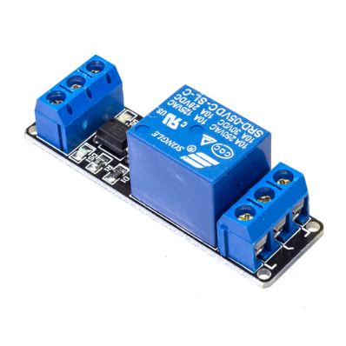
Figure 3.2 Relay Module
Source: https://robu.in/the-basics-of-optocoupler-relay/

3.1.3 LED Bulbs
An LED is a low-power, long-lasting light source that emits light when electrical current passes through it. In the automation system, LEDs act as visual indicators to show conveyor belt status—such as active, idle, or fault conditions. Controlled by the ESP32 microcontroller via its GPIO pins, these LEDs provide clear, energy-efficient feedback to operators based on real-time system conditions.
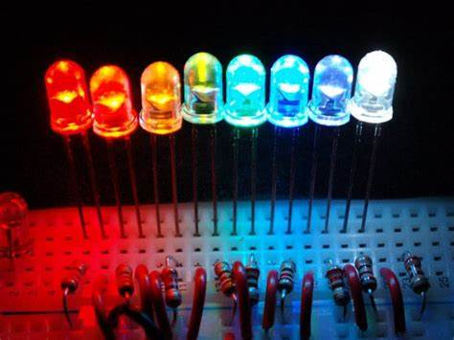

Figure 3.3: LED Bulbs
Source:https://cdnlearn.adafruit.com/guides/cropped_image/000/000/206/medium640/LEDrainbow.jpg?1534968137

3.1.4 Opto-coupler
An opto-coupler, also known as an opto-isolator, is an electronic component that transfers electrical signals between two isolated circuits using light. In the baggage handling automation system, an opto-coupler is used to safely interface the ESP32 microcontroller with high-voltage components like motor drivers or relays. It prevents electrical noise or surges from damaging the microcontroller by isolating its low-voltage control signals from the high-power side of the system. When the ESP32 sends a signal, the opto-coupler activates an internal LED, which in turn triggers a photosensitive transistor on the output side—allowing the control of higher voltage circuits without direct electrical contact.
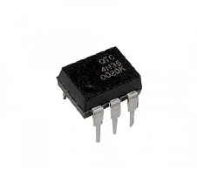
Figure 3.4: Opto-coupler
Source: https://www.majju.pk/assets/uploads/2018/08/4n35-2000x2000.jpg

3.1.5 Water Pump or Solenoid Valve
A water pump and a solenoid valve (also known as an actuator) are both used to control the flow of water, but they function differently. A water pump actively moves water from one location to another, creating a flow. A solenoid valve, on the other hand, acts as a gate, controlling whether or not water can flow through a pipe by opening or closing a valve.
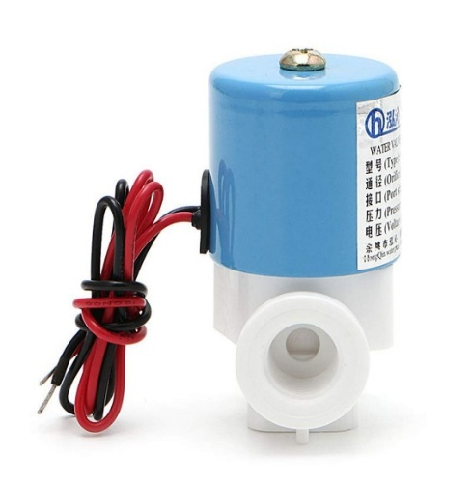

Figure 3.5 Water Pump or Solenoid valve
Source: https://www.amazon.com/Beduan-Electric-Solenoid-Filter-System/dp/B07N85JYQ8

3.1.6 Power Supply
A power supply is an electrical device that provides electrical power to an electrical load, like a computer or other electronic device. It converts electrical energy from a source (like a wall outlet) into a suitable format and voltage for the load to use. Essentially, it acts as a bridge between the power source and the device, ensuring the device receives the correct and safe amount of power to function.
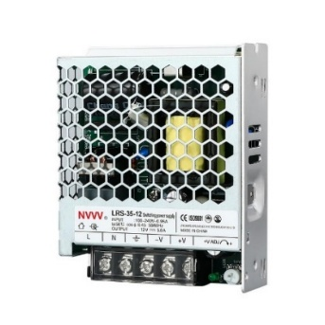

Figure 3.6 Power Supply
Source: https://cnnvvv.com/sk/novinky/ako-funguje-napajanie-plc/#

3.1.7 Ultrasonic Sensor
An ultrasonic sensor measures distance by emitting ultrasonic waves and timing their echo, calculating distance as Distance = (Time × Speed of Sound) / 2 (~343 m/s). Models like the HC-SR04 (2–400 cm range, ~1 cm accuracy) use Trigger and Echo pins, interfacing easily with microcontrollers like the ESP32. Cost-effective and reliable, they suit applications like liquid level monitoring or obstacle detection, though sensitive to temperature and soft surfaces. In the Automatic Water Tank Filling System, the sensor monitors water levels, enabling precise pump control via the ESP32-based PLC’s ladder logic.
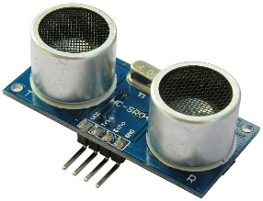
Figure 3.7 Ultrasonic Sensor
https://electrosome.com/wp-content/uploads/2014/10/HC-SR04-Ultrasonic-Sensor.jpg

3.2 Software Requirements

3.2.1 OpenPLC
OpenPLC is an open-source automation platform that supports programming in industrial languages like ladder logic, based on the IEC 61131-3 standard. In this project, it is used to develop and simulate control logic for the ESP32 microcontroller. Acting as the bridge between software and hardware, OpenPLC enables real-time automation of airport baggage conveyors, making it a flexible and cost-effective replacement for traditional PLCs.

3.2.2 ESP-IDF
ESP-IDF (Espressif IoT Development Framework) is the official development platform for ESP32 microcontrollers. It provides low-level access to hardware features and supports multitasking with FreeRTOS. In this project, ESP-IDF is used to build custom firmware for controlling baggage conveyor operations, offering high reliability, real-time performance, and integration with wireless communication.

3.2.3 EasyEDA
EasyEDA is an online platform used for designing schematics, PCBs, and simulating circuits. In this project, it helps create custom PCB layouts that connect the ESP32 with other components like sensors and relays. Its user-friendly tools and built-in libraries streamline the design process and support direct ordering of PCB prototypes.

CHAPTER 4

METHODOLOGY

4.1 System Block Diagram

4.1.1 ESP-PLC Architecture
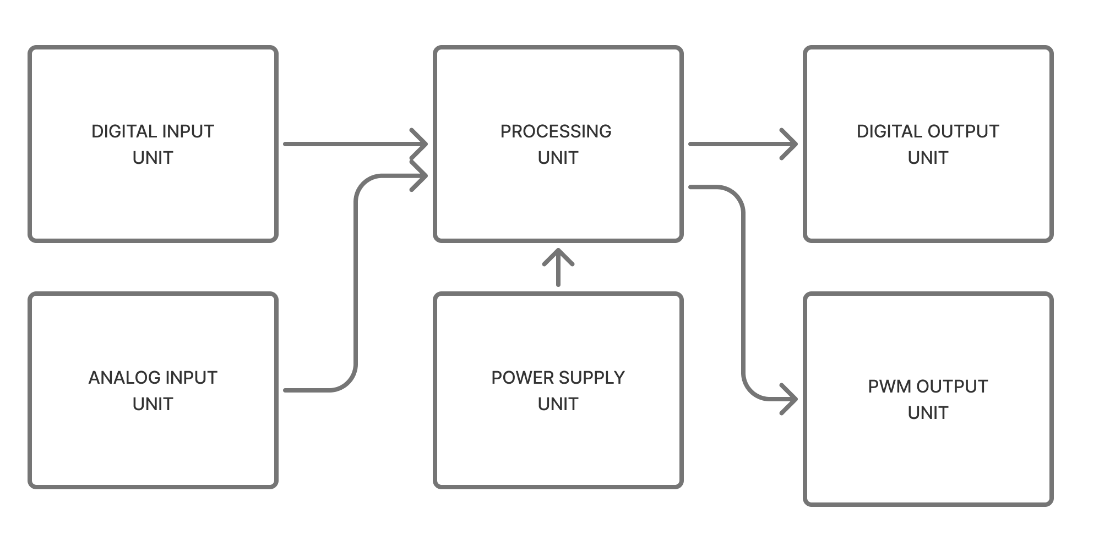

Figure 4.1: ESP-PLC Block Diagram
The diagram represents the internal architecture of the ESP32-based programmable logic controller (PLC). It illustrates how different units interact with the ESP32 to perform control operations in a structured and modular way. The entire system is powered by a regulated power supply unit, which ensures stable voltage for the microcontroller and connected components.
The digital input unit collects binary signals from external sources like switches, sensors, or buttons. These signals are sent to the processing unit (ESP32), which interprets them based on the programmed ladder logic. For inputs that vary in voltage, such as those from temperature or level sensors, the analog input unit is used. These analog values are read through the ESP32’s ADC pins, allowing the PLC to handle more than simple on/off logic.
The processing unit, which is the ESP32 microcontroller, runs the OpenPLC runtime environment. It processes all incoming input data, executes the control logic, and determines the appropriate output actions in real time. It serves as the brain of the entire system.
Outputs are handled by two separate units. The digital output unit sends on/off signals to external devices such as relays, LEDs, or alarms. Meanwhile, the PWM output unit generates pulse-width modulated signals that can control devices like motors or dimmable lights where gradual or variable output is needed.
Each component of this architecture works together to create a reliable, flexible, and fully functional PLC system, capable of handling both industrial and educational automation tasks

4.1.2 Automatic Water Tank Filling System
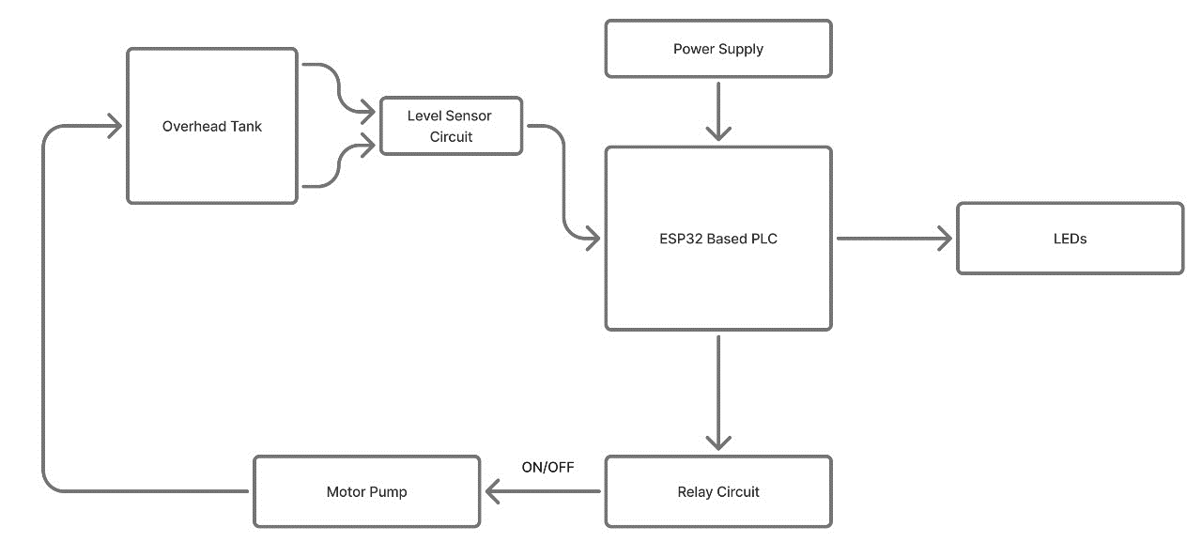
Figure 4.2: System Block Diagram
This diagram illustrates the working flow of your Automatic Water Tank Filling System using an ESP32-based PLC. The system automates the water filling process by monitoring the water level and controlling the motor pump accordingly, all based on ladder logic.

Water is stored in an overhead tank, and its level is continuously monitored by a level sensor circuit. This circuit detects whether the water level has dropped below or risen above preset thresholds (e.g., low and high levels). The sensor outputs are fed to the ESP32-based PLC, which is powered by a dedicated power supply unit. Based on the sensor input and the programmed logic, the ESP32 determines whether the motor needs to be turned ON or OFF.
The PLC then sends an output signal to a relay circuit, which acts as a switch to control the motor pump. If the water level is low, the relay is triggered to turn the motor ON, pumping water into the tank. When the water reaches the high level, the logic disables the relay, turning the motor OFF, thus preventing overflow.
Additionally, LEDs connected to the output of the ESP32 serve as visual indicators, showing the status of the water level or motor operation. This setup ensures automatic water management, reduces manual intervention, and avoids wastage due to overflow or dry running of the pump.

4.2 Flow-chart
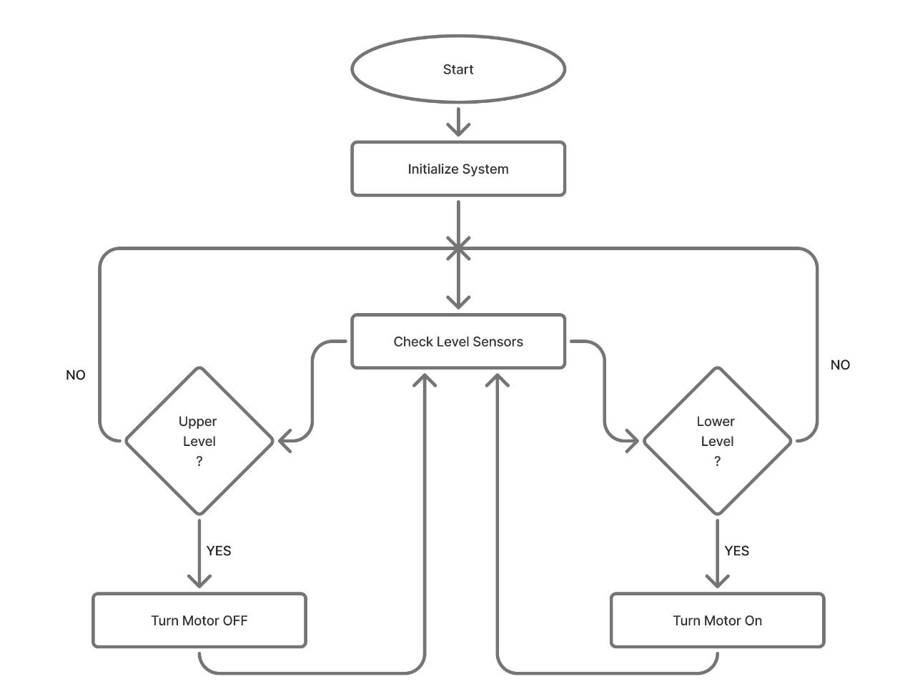

Figure 4.3: Flowchart of the System

CHAPTER 5

EPILOUGE

5.1 Budget Analysis
Name of components | Quantity | Unit price | Total
ESP-32 | 1 | 800 | 800
Dc water pump | 1 | - | 300
Relay (12v) | 5 | 60 | 300
Resistors | 20 | - | 50
Diode | 5 | - | 50
Optocoupler | 15 | - | 200
Led | 15 | 5 | 75
Ultrasonic Sensor | 1 | 60 | 60
2-Terminal connector | 10 | 5 | 50
 |  | Grand Total | 1885/-

Table 5.1: Cost estimation table

5.2 Work Schedule
The work schedule was meticulously planned to ensure the timely completion of the entire project. The project was divided into several stages, encompassing research and development, hardware and software integration, testing, and fine-tuning.

5.2.1 Gantt chart
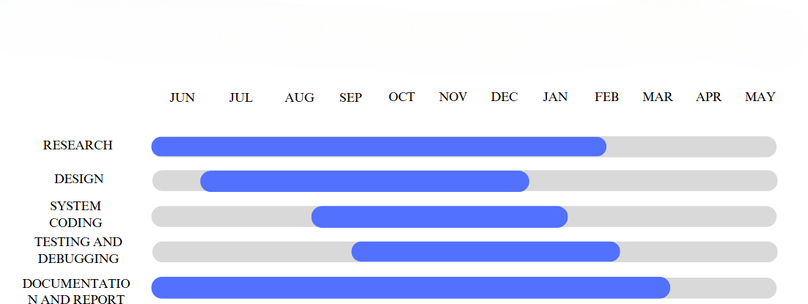

Figure 5.1: Gantt Chart of the project

5.3 Expected Outcome
The ultrasonic sensor (HC-SR04) in the ESP32-based PLC will enable accurate, real-time water level monitoring in the Automatic Water Tank Filling System. It will reliably measure distances (2–400 cm, ~1 cm accuracy), allowing the PLC to execute ladder logic in OpenPLC to control the water pump via a relay. The system will automatically turn the pump ON when the water level drops below a low threshold and OFF when the tank reaches a full threshold, preventing overflow and ensuring efficient water management. LEDs will provide visual feedback on system status (e.g., pump ON, tank full), and Wi-Fi connectivity will enable remote monitoring of water levels. The setup will be cost-effective (~60/- for the sensor), modular, and scalable for other automation tasks, delivering robust performance for educational and small-scale industrial applications.
- A working programmable logic controller will be developed using the ESP32 microcontroller, running the OpenPLC runtime. The system will be capable of real-time control and logic execution using ladder logic programming.
- Reliable execution of ladder logic programs developed in OpenPLC for industrial-grade automation.
- The system will be able to control both AC and DC electrical loads (such as motors, lamps, or fans) using electromechanical relays, ensuring safe and flexible load management.
- Remote access to system diagnostics and configuration via built-in Wi-Fi.
- Full implementation on low-cost, scalable hardware suitable for modernizing legacy PLC systems.

REFERENCES
[1] Dahmane Roumaissa and Rabia Zohra, “Design and Implementation of PLC using Arduino Due,” 2018
[2] Pradeeka Seneviratne, Building Arduino PLCs: The essential techniques you need to develop Arduino-based PLCs, Srilanka, 2017
[3] Garcia, A., & Lopez, J. (2022). ESP32-based industrial control systems: Performance and scalability analysis. Journal of Embedded Systems, 18(3), 201–210.
[4] Fernandes, F., Alves, T., & Reis, M. (2019). OpenPLC: An IEC 61131-3 compliant open-source industrial controller. IEEE Transactions on Industrial Informatics, 15(4), 1987–1996. https://doi.org/10.1109/TII.2018.2871845
[5] Sharma, A., & Mehta, R. (2020). Comparative analysis of relays and TRIACs in industrial control systems. Journal of Electrical Engineering and Technology, 15(2), 789–797. https://doi.org/10.1007/s42835-019-00345-8
[6] Gupta, R., Sharma, S., & Kumar, P. (2018). Design and implementation of a microcontroller-based conveyor belt control system. International Journal of Automation and Computing, 15(3), 345–352. https://doi.org/10.1007/s11633-017-1087

