**Report**

In this project the data replication is simulated with various scenarios and the outputs of different test cases are as below. To simulate the various scenarios, I have made the following conditions:

* Randomly choose a client and cut any one of the outgoing channel.
* Randomly choose a server and close the connection for a short duration to simulate the server crashing situation.
* The client chooses to access the files randomly in the set of servers.
* Some servers are made to receive just the server vote request without receiving the client request. So it does not contribute to the majority vote servers.

**Note:** As all the files in the beginning of the execution will not have any data in it to be read, we start the process with a write request and thereon it’s randomly generated. This is because the initial read requests will fails as nothing is written in the file but subsequent read request after a write request will always be successful. In the other hand all the write requests will be successful if it gets majority votes from the servers.

**Simulation 1**

It was carried out for 100 requests with all 5 clients and 7 servers running. The results of this test case is presented in the form of logs and stored in text files in the folder “Outputs 1”. This folder will contain all the logs of all 5 clients and 7 servers separately in each text file for convenience.

**Simulation 2**

It was carried out for 500 requests with all 5 clients and 7 servers running. The results of this test case is presented in the form of logs and stored in text files in the folder “Outputs 2”. This folder will contain all the logs of all 5 clients and 7 servers separately in each text file for convenience.

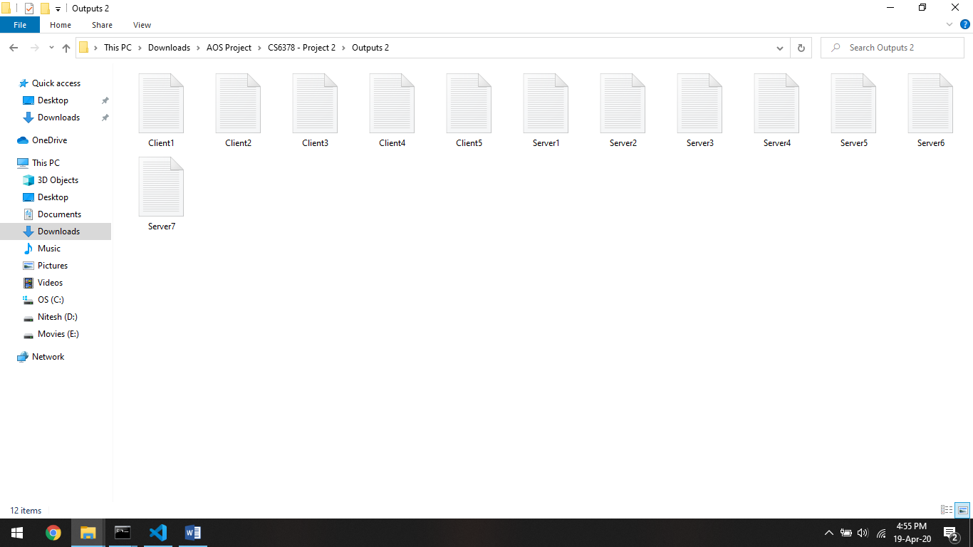

**Simulation 3**

It was carried out for 5 requests with 3 Clients (C1, C2, C5) and all 7 servers. The output logs of this test case is show below as screenshots.

Client 1

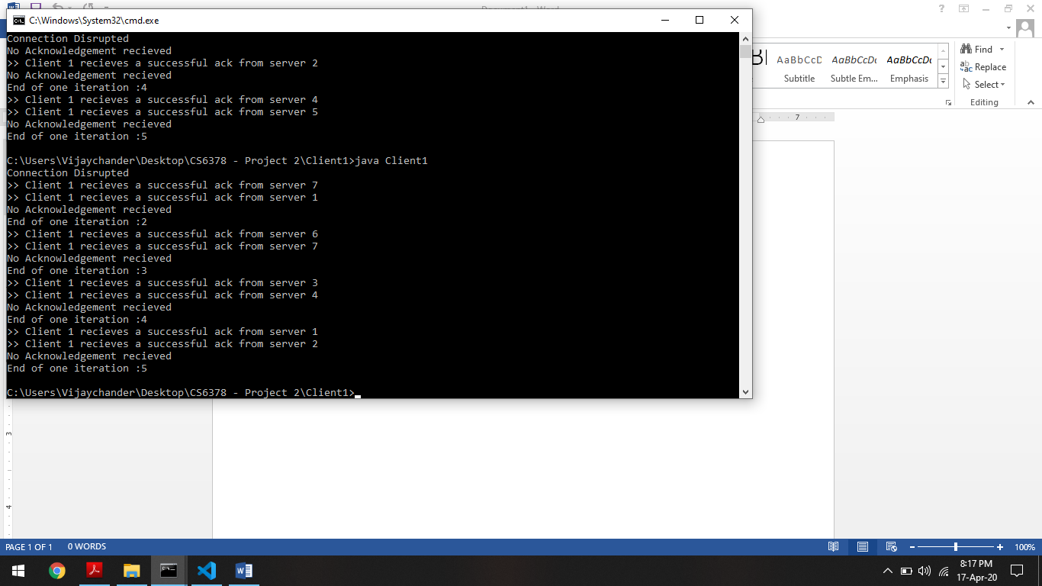

Client 2

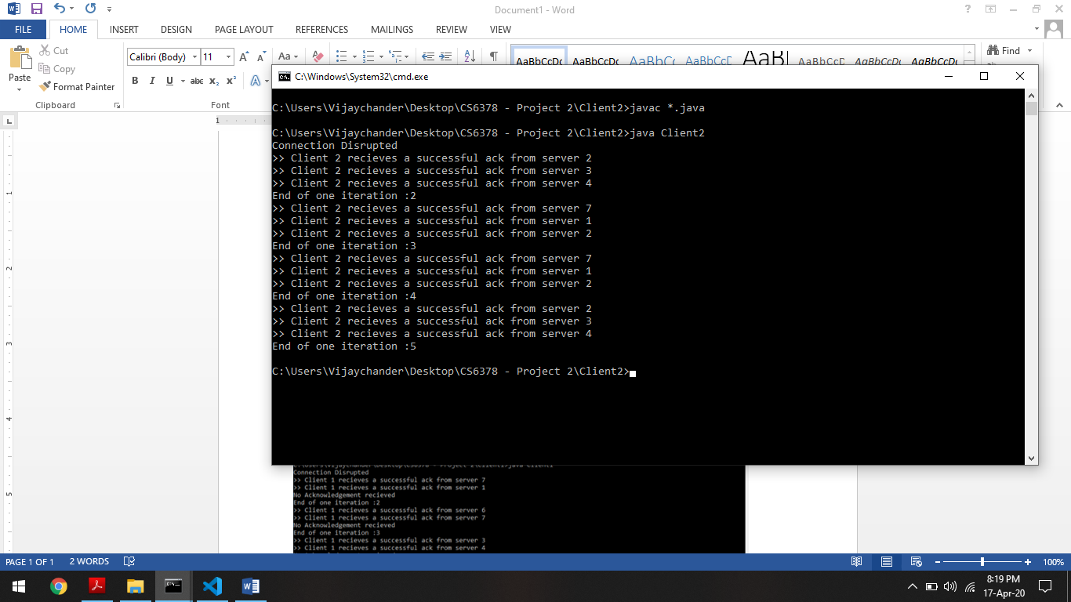

Client 5

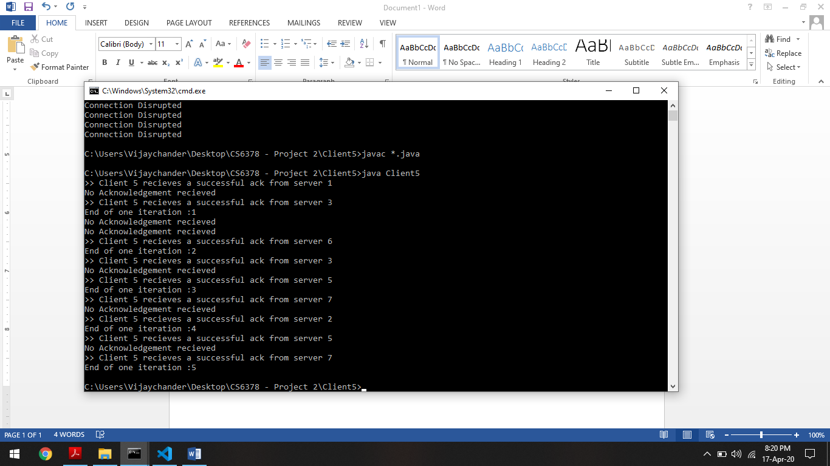

Server 7

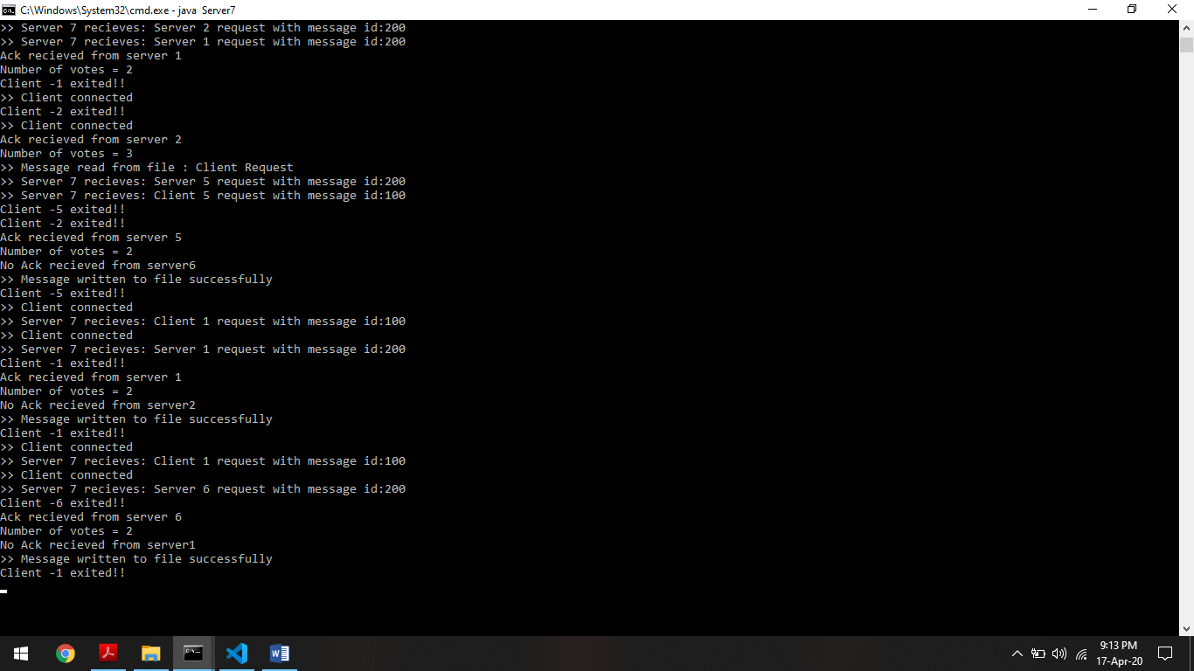

Server 6

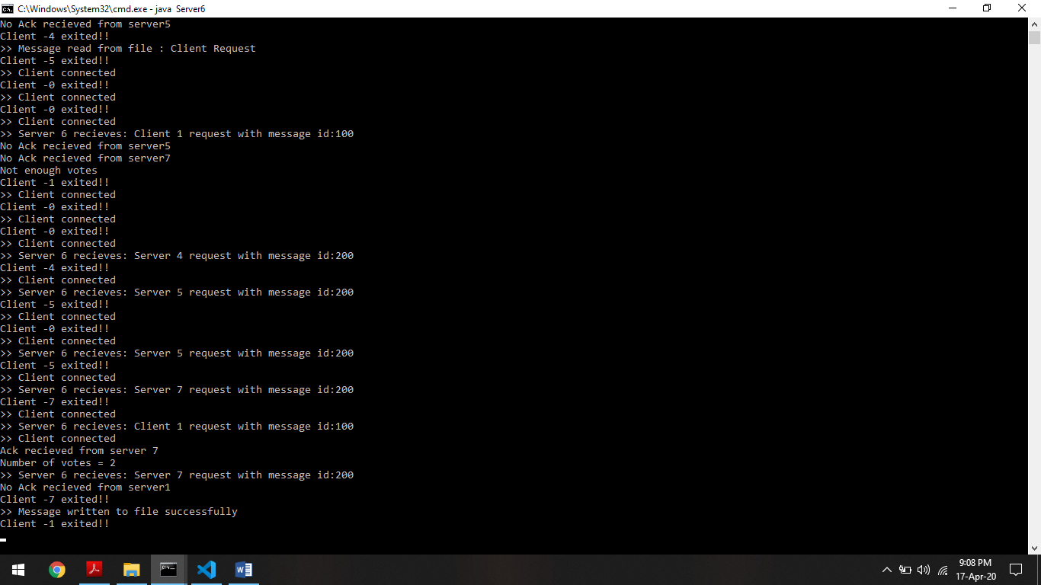

Server 5

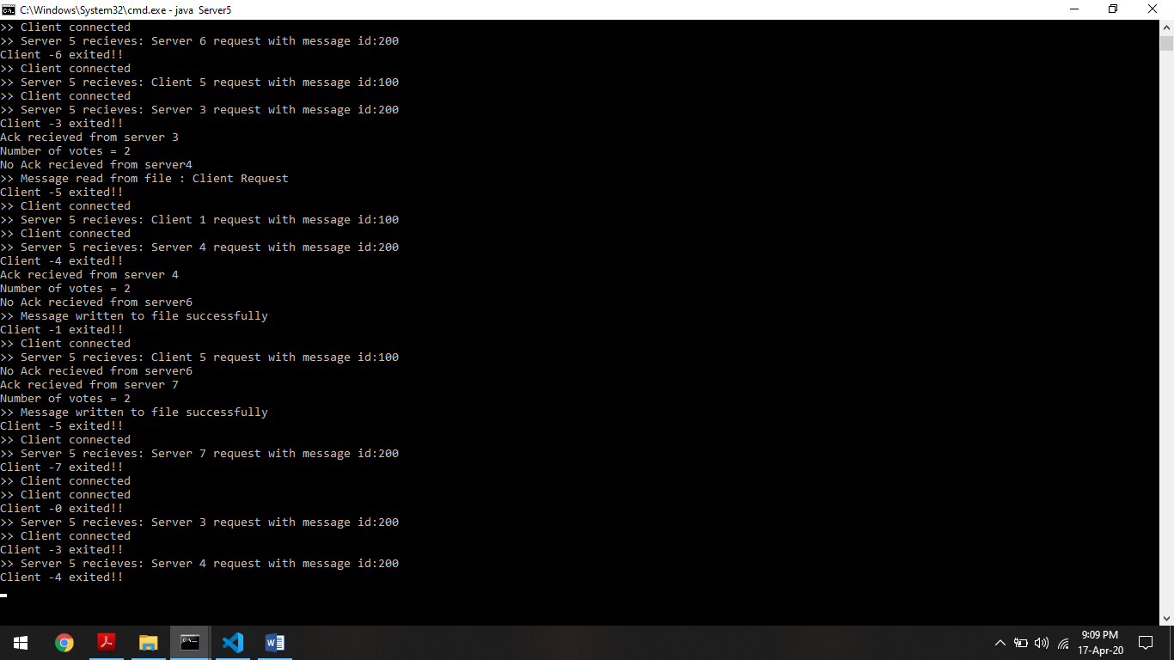

Server 4

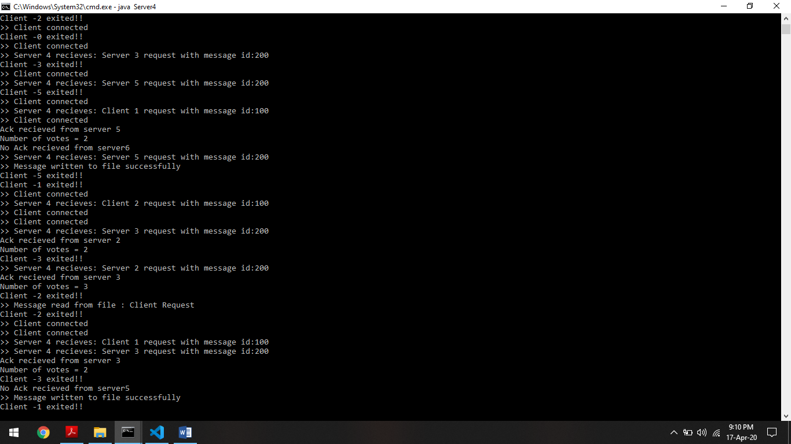

Server 3

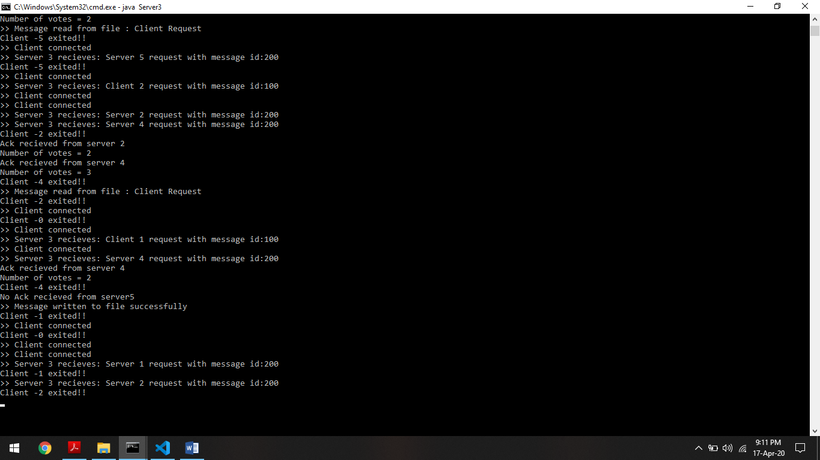

Server 2

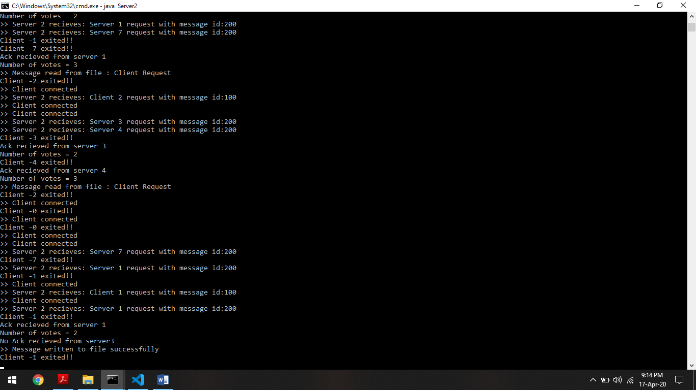

Server 1

