**!!!! Nitesh Rawal !!!!**

**Fitness Strom “ Gym Management System “**

**The objective of the Fitness Strom “ Gym Management System “ is to provide a system which handles the information of the people coming into the gym Simplify the business of fitness with management software that packs a real punch.**

**Its is build using Java , JFrames and JDBC for backend I have used MYSQL database to store and retrieve the information of gym member**  **For backing up the database**.**.**

**Due to this urge of people, the ultimatum of gyms is increasing day by day. People love to spend a lot many hours to achieve their desired shape and size in a gym so as to improve or maintain their overall physique. Supervising this kind of data by hand can be a difficult and strenuous process. So there is a dire need of automating gym function by creating an application that is Gym management system.**

**Technology deployed in this System**

**Java**

**Jdbc**

**Mysql**

**Modules of Gym Management System**

**The Main module of this GYM Management system is ADMIN MODULE**

**He can login through his id and password**

**He can add new member and save their information such as name ,id,mob no. , email,gender , aadhar no. , gym time , age , amount, mother and father name**

**He can update and delete member informations**

**He can view list of members and their information**

**He can add payment and save it to the database also he can view payments and their history on a date.**

**Advantages of a gym management system**

* Ensures transparency of payments
* It saves time
* It is user-friendly
* Ease of accessibility
* Less maintenance cost

**Database Tables**

1. **member**

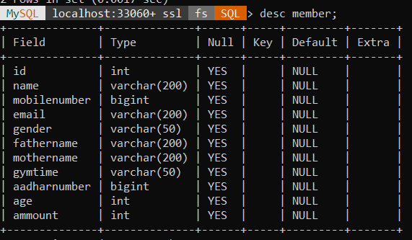

1. **Payment**

