Project – firstapp

App – firstapp

Settings.py

INSTALLED_APPS = [

    'rest_framework',

    'api',

]

Firstapp, models.py

from django.db import models

# Create your models here.

class Student(models.Model):

    name = models.CharField(max_length=100)

    roll = models.IntegerField()

    city = models.CharField(max_length=100)

firstapp, admin.py

from django.contrib import admin

from .models import Student

# Register your models here.

@admin.register(Student)

class StudentAdmin(admin.ModelAdmin):

    list_display = ['id', 'name', 'roll', 'city']

add student detail from admin panal

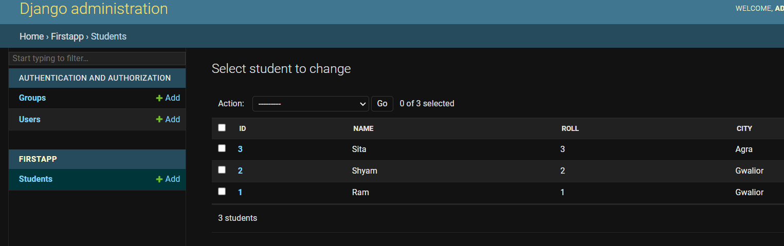

Firstapp, serializers.py

from rest_framework import serializers

class StudentSerializer(serializers.Serializer):

        name = serializers.CharField(max_length=100)

        roll = serializers.IntegerField()

        city = serializers.CharField(max_length=100)

Firstapp, views.py

from django.http import HttpResponse

from django.shortcuts import render

from itsdangerous import Serializer

from .models import Student

from .serializers import StudentSerializer

from rest_framework.renderers import JSONRenderer

# Create your views here.

def home(request):

    return HttpResponse('hi')

def student_detail(request, pk):

    stu = Student.objects.get(id=pk)

    serializer = StudentSerializer(stu)

    json_data = JSONRenderer().render(serializer.data)

    return HttpResponse(json_data, content_type = 'application/json')

    serializer = StudentSerializer(stu)

    json_data = JSONRenderer().render(serializer.data)

    return HttpResponse(json_data, content_type = 'application/json')

firstapp, urls.py

# from django import views

from . import views

from django.urls import URLPattern, path

urlpatterns = [

    path('', views.home, name='home'),

    path('stuinfo/<int:pk>', views.student_detail)

]

Access by

<http://127.0.0.1:8000/stuinfo/1>

**# query set (all student data)**

Firstapp, views.py

def student_list(request):

    stu = Student.objects.all()

    serializer = StudentSerializer(stu, many = True)

    json_data = JSONRenderer().render(serializer.data)

    return HttpResponse(json_data, content_type = 'application/json')

firstapp, urls.py

path('stuinfo/', views.student_list),

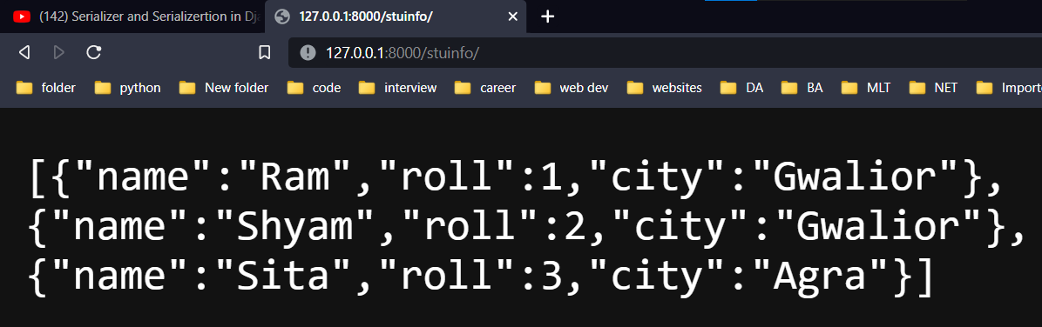

Other separate application

otherapp.py

import requests

URL = "http://127.0.0.1:8000/stuinfo/"

req = requests.get(url = URL)

data = req.json()

print(data)

import

from django.http import HttpResponse, JsonResponse

replace

    json_data = JSONRenderer().render(serializer.data)

    return HttpResponse(json_data, content_type = 'application/json')

with

    return JsonResponse(serializer.data)

if want to show id as well in the output

firstapp.py serializer.py

        id = serializers.IntegerField()

post data from any client app(otherapp) to main app database

otherapp.py

import requests

import json

# URL = "http://127.0.0.1:8000/stuinfo/"

# req = requests.get(url = URL)

# data = req.json()

# print(data)

URL = "http://127.0.0.1:8000/stucreate/"

data = {

    'id' : 5,

    'name' : 'shalini',

    'roll' : 101,

    'city' : 'jhansi',

}

json_data = json.dumps(data)

r = requests.post(url = URL, data = json_data)

data = r.json()

print(data)

firstapp, serializers.py

from rest_framework import serializers

from .models import Student

class StudentSerializer(serializers.Serializer):

        id = serializers.IntegerField()

        name = serializers.CharField(max_length=100)

        roll = serializers.IntegerField()

        city = serializers.CharField(max_length=100)

        def create(self,validated_data):

                return Student.objects.create(**validated_data)

firstapp, views.py

@csrf_exempt

def student_create(request):

    if request.method == 'POST':

        json_data = request.body

        stream = io.BytesIO(json_data)

        pythondata = JSONParser().parse(stream)

        serializerr = StudentSerializer(data = pythondata)

        if serializerr.is_valid():

            serializerr.save()

            res = {'msg': 'Data Created'}

            json_data = JSONRenderer().render(res)

            return HttpResponse(json_data, content_type='application/json')

        else:

            json_data = JSONRenderer().render(serializerr.errors)

            return HttpResponse(json_data, content_type='application/json')

urls.py

path('stucreate/', views.student_create),

