EB < Feedback Tool >

User guide

< 0.1 >, < draft >

Elektrobit Automotive GmbH

Am Wolfsmantel 46

91058 Erlangen, Germany

Phone: +49 9131 7701 0

Fax: +49 9131 7701 6333

Email: info.automotive@elektrobit.com

**Technical support**

https://www.elektrobit.com/support

**Legal disclaimer**

Confidential information.

ALL RIGHTS RESERVED. No part of this publication may be copied in any form, by photocopy, microfilm,

retrieval system, or by any other means now known or hereafter invented without the prior written permission

of Elektrobit Automotive GmbH.

All brand names, trademarks, and registered trademarks are property of their rightful owners and are used

only for description.

Copyright 20[xx], Elektrobit Automotive GmbH.

Table of contents

1. Overview
2. Access to application
   1. Roles
   2. How to get access to the tool
   3. How superadmin can create users.
3. Application Login
4. Feedback Tool Features
   1. Add new training
   2. Feedback Report
   3. EB Guide Training
5. Overview

EB being a product company provides trainings to external customers and internal resources.

Feedback Tool is a web-based tool developed in EB internally to collect the feedback from trainings.

1. Access to application
   1. Roles

Feedback tool has 4 roles

1. Super admin – can create users, create training, delete training, and edit training. And can see all the trainings which are created by different users.
2. Admin - –create training and edit training. And can see only the trainings which are created him.
3. Others/ trainers – This role type users can only see the report and graphs.
4. Trainees – They can only give the feedback.
   1. How to get access to the tool
   2. How Superuser shall create users
5. Application Login
6. Feedback Tool Features

The features of the tool are explained in detailed through Superadmin Login.

* 1. Add new training

Once you login, you land in ‘**Training List**’ page.

**User details** and **Logout** option is available on top right of the page

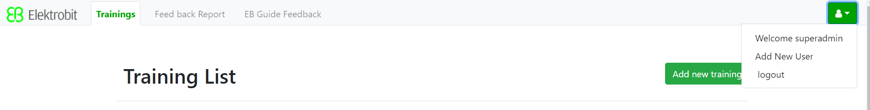

* + 1. Create Training

Click on **Add new training** button

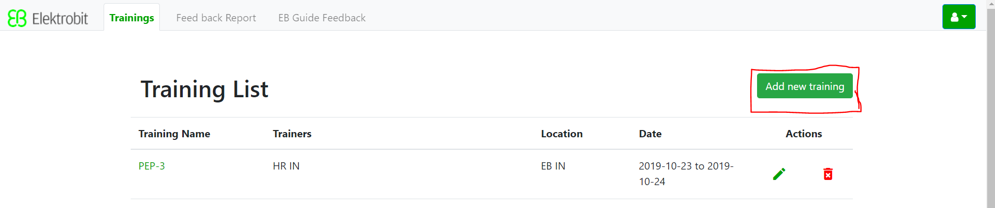

* + 1. After click on **Add new training** button, **Create New Training** module will open

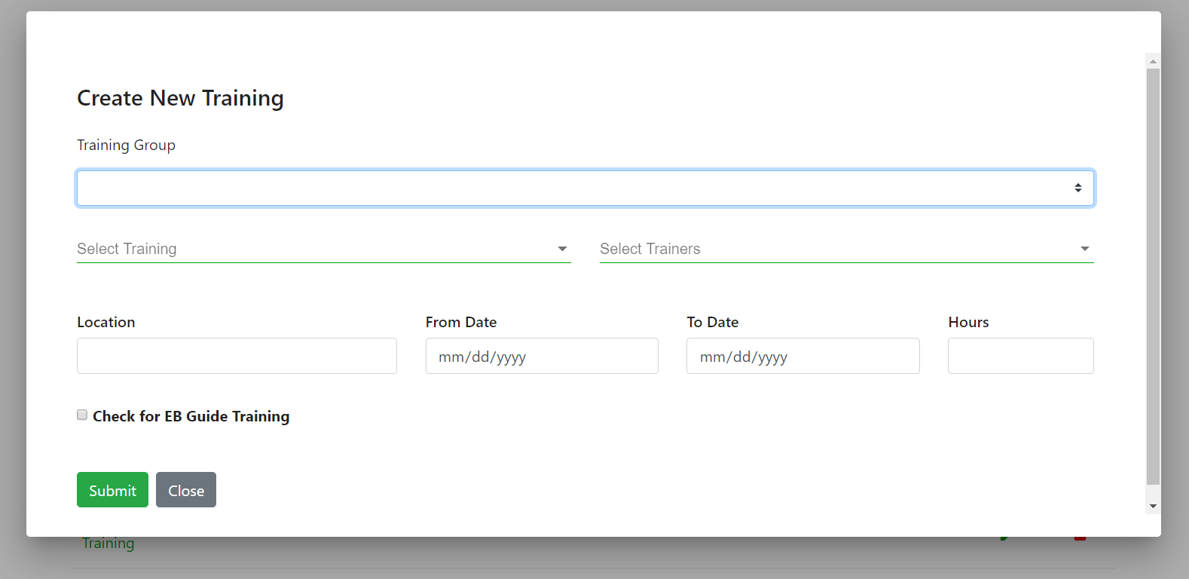

* + 1. Select Training Group

Each training is a part of groups, right now we have 3 groups

1. EB Products
2. HR
3. Others

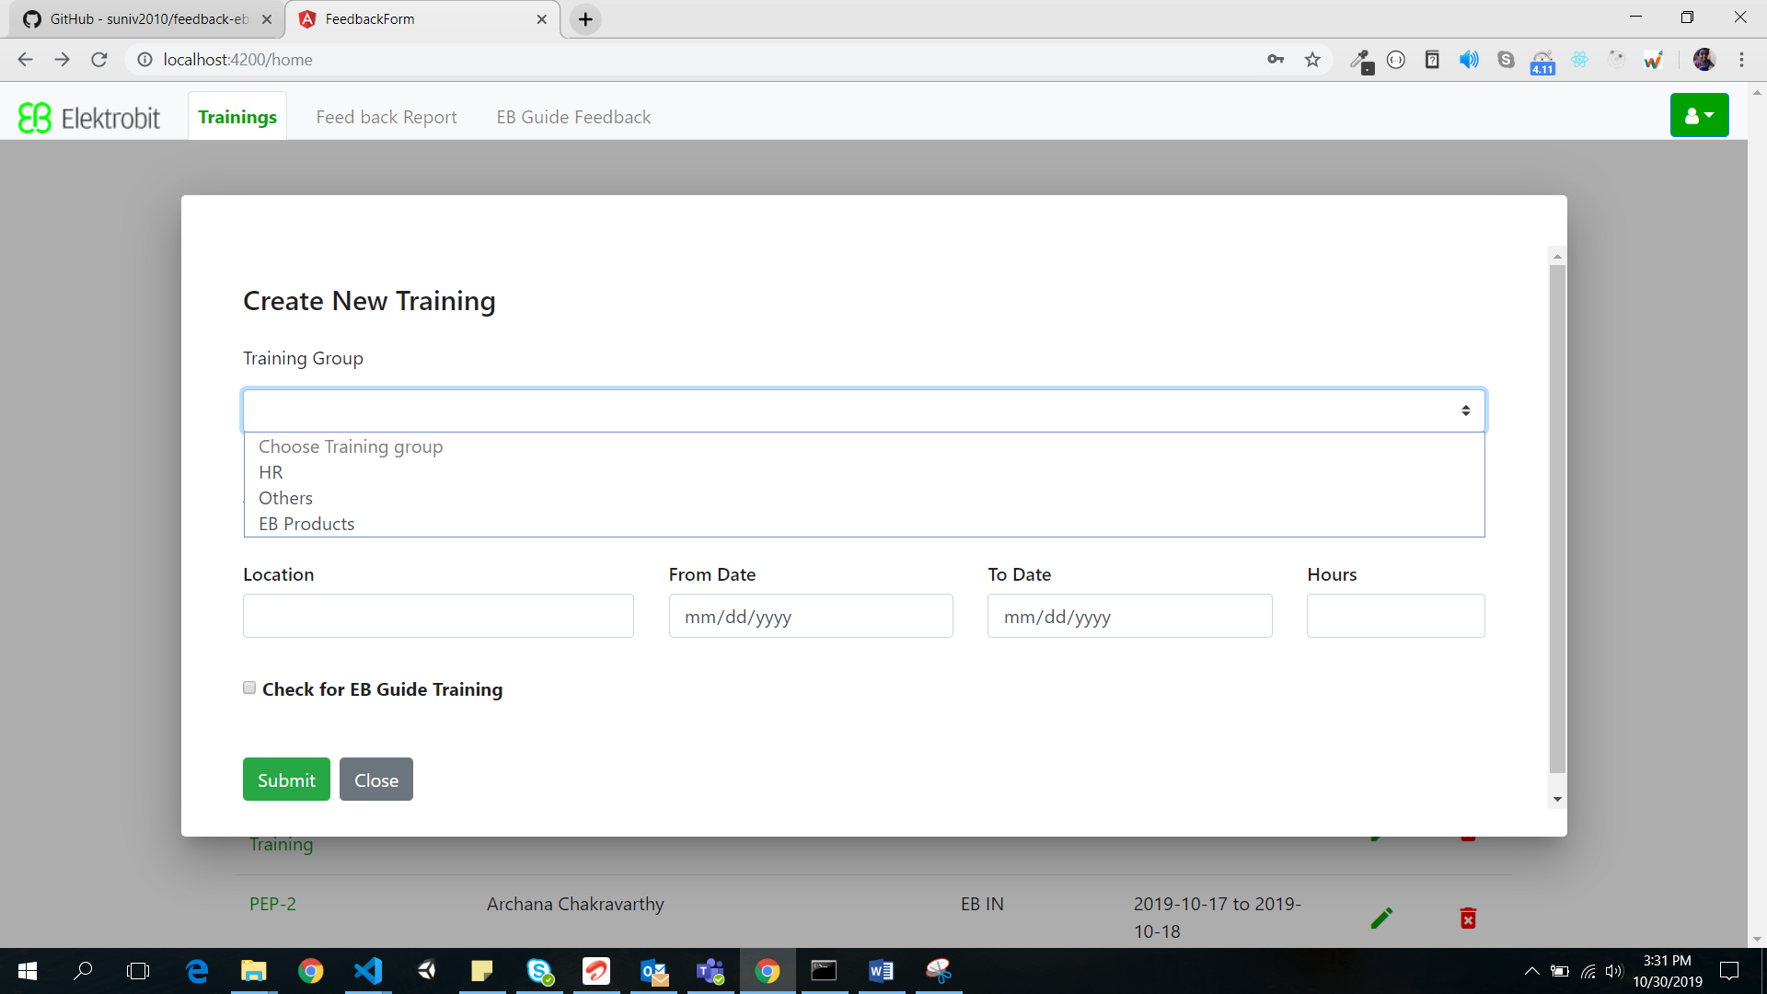

Based on your selection of Training group, the relevant trainings shall be populated.

Eg: If you choose EB products group the below trainings are populated

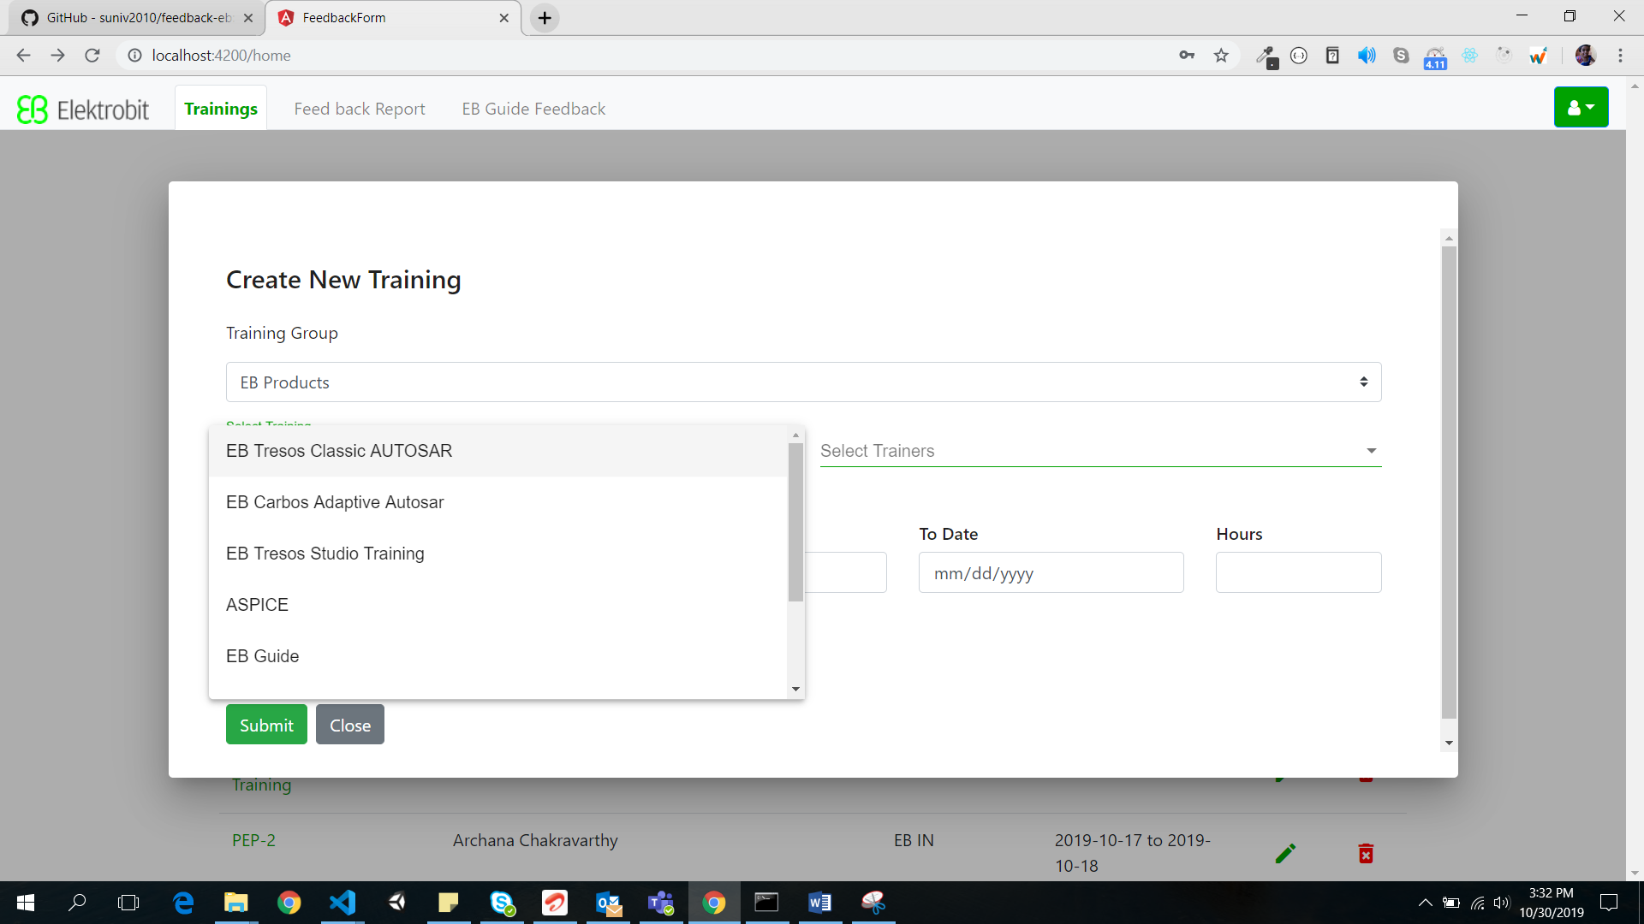

You can either choose any of these trainings and fill rest all the details (From date, To date, Trainers, and Training hours) and click on **Submit** button. This will create the training detail. Or, Add New Training to the List (Refer 4.1.4)

* + 1. Add New Training to the List

To add a new training for the particular group, first select the relevant group (Eg: HR training group) and Click on “Add new training” as shown in the below screen.

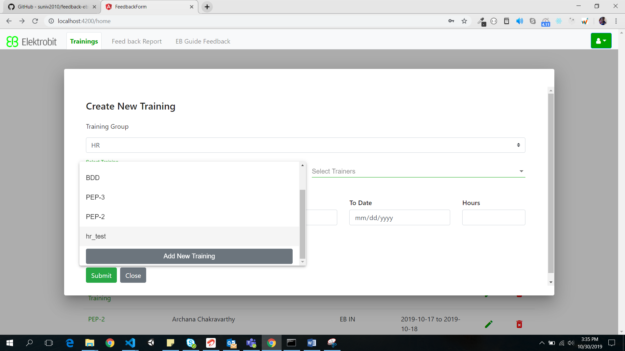

After you click on “Add new training”, **Add New Training** pop up will appear, where you can type the new training name and click on **Add** button.

Below screenshot shows the group as HR and code conduct is the training which we need to add.

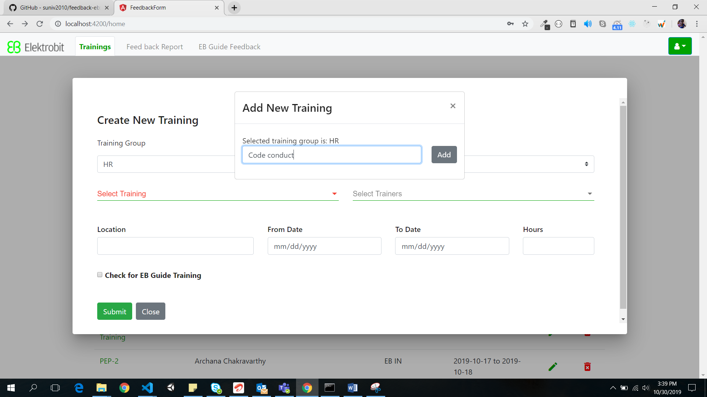

After click on add button you can see the code conduct is in drop down list

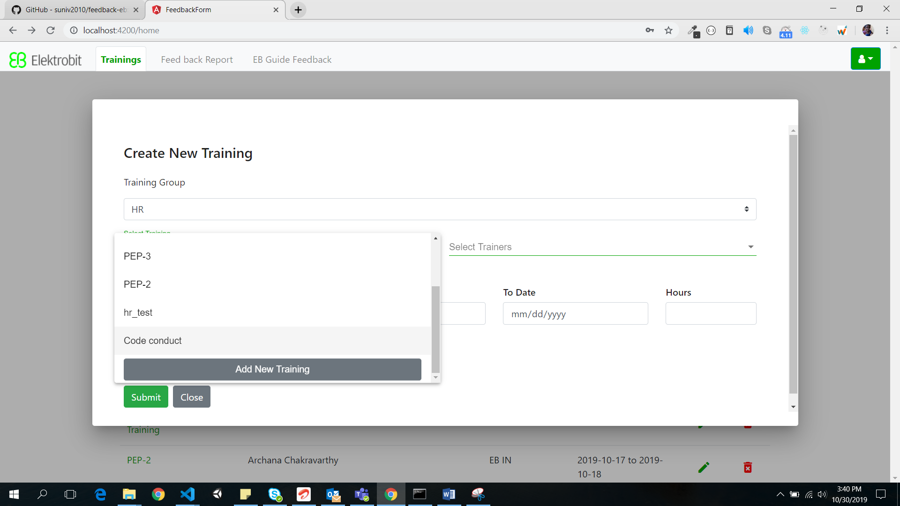

* + 1. Add New Trainers

Similar to Adding New Training, New Trainers can be added

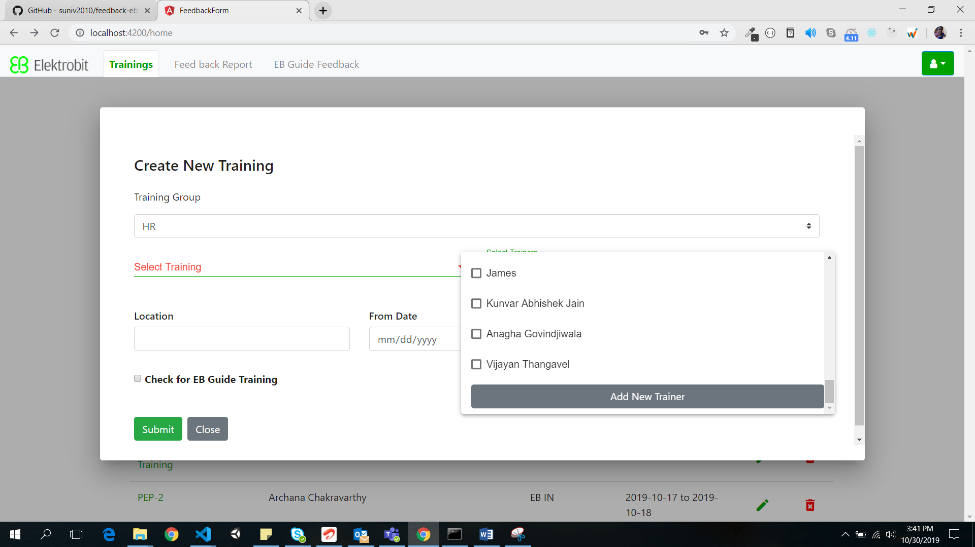

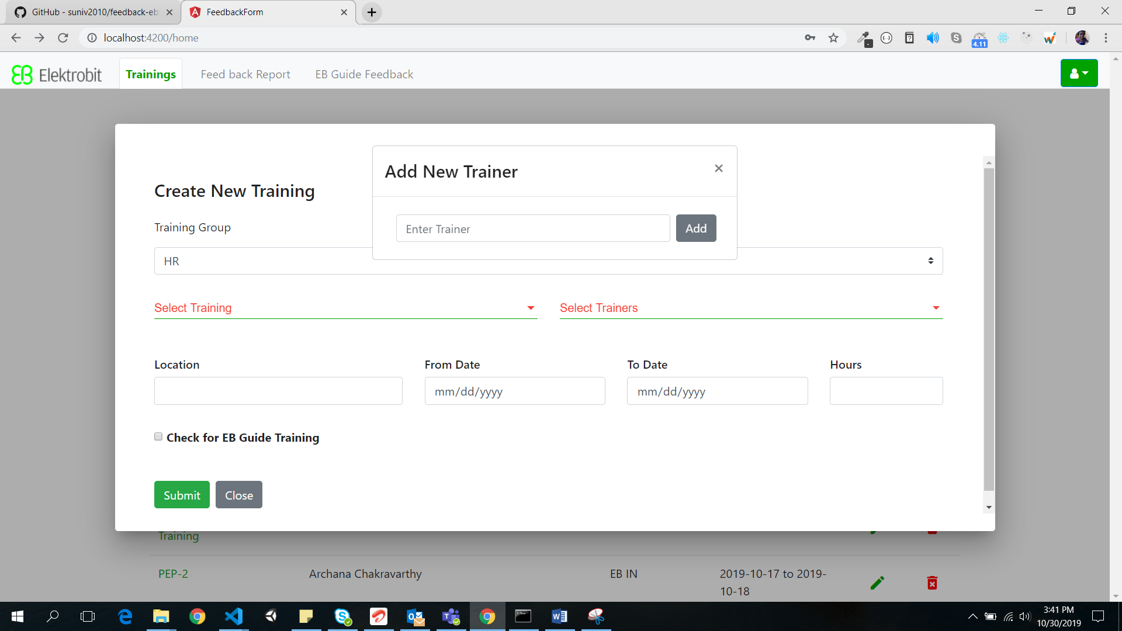

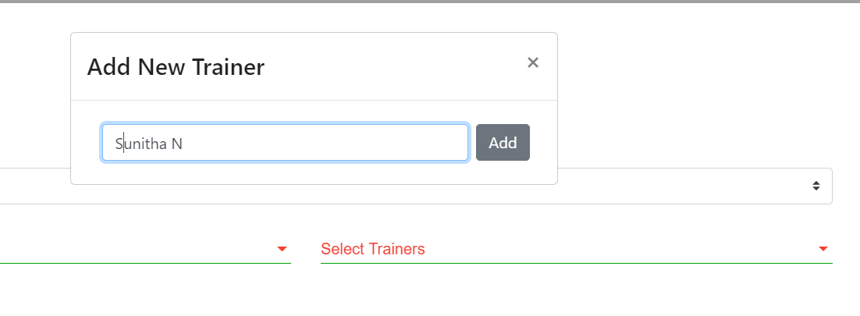

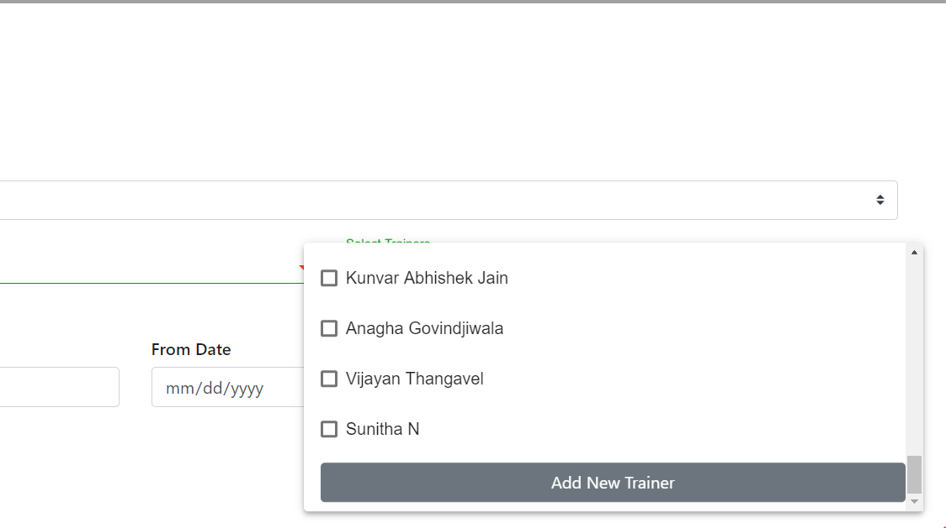

The remaining details can be filled (From date, To date, Trainers, and Training hours) and click on **Submit** button. This will create the training.

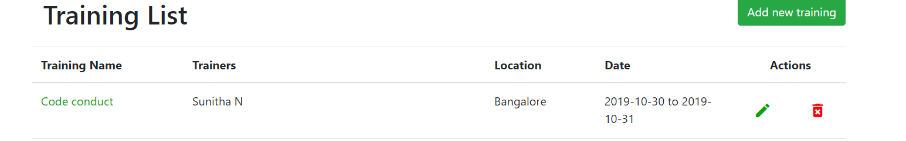

* + 1. Share the URL to the Trainees

Click

* + 1. Edit Training

Click on the below Icon shown in the screenshot

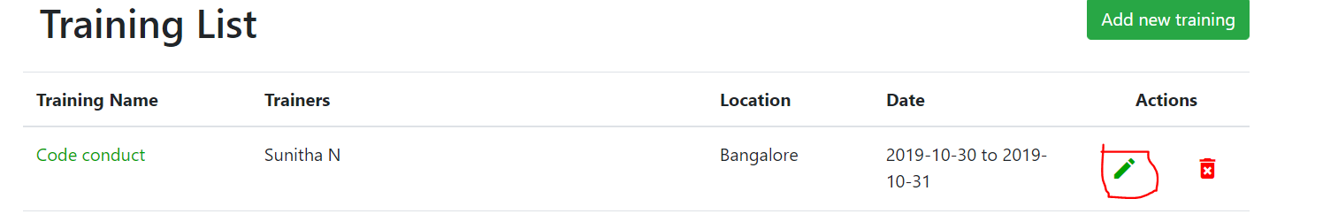

After click on edit button below pop up will be open

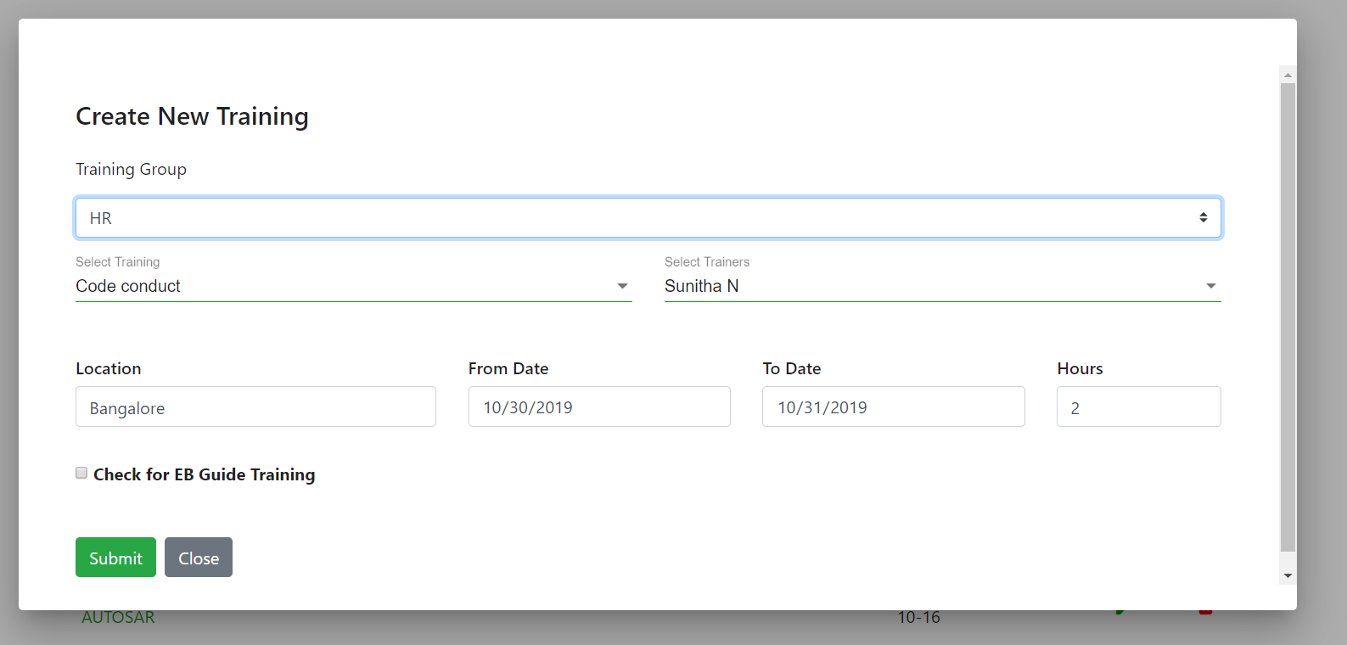

You can change any of the details and click on submit.

* + 1. Delete Training

Click on delete icon, this will delete the entry from the table

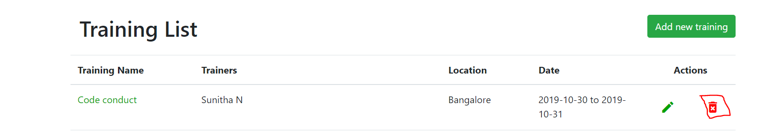

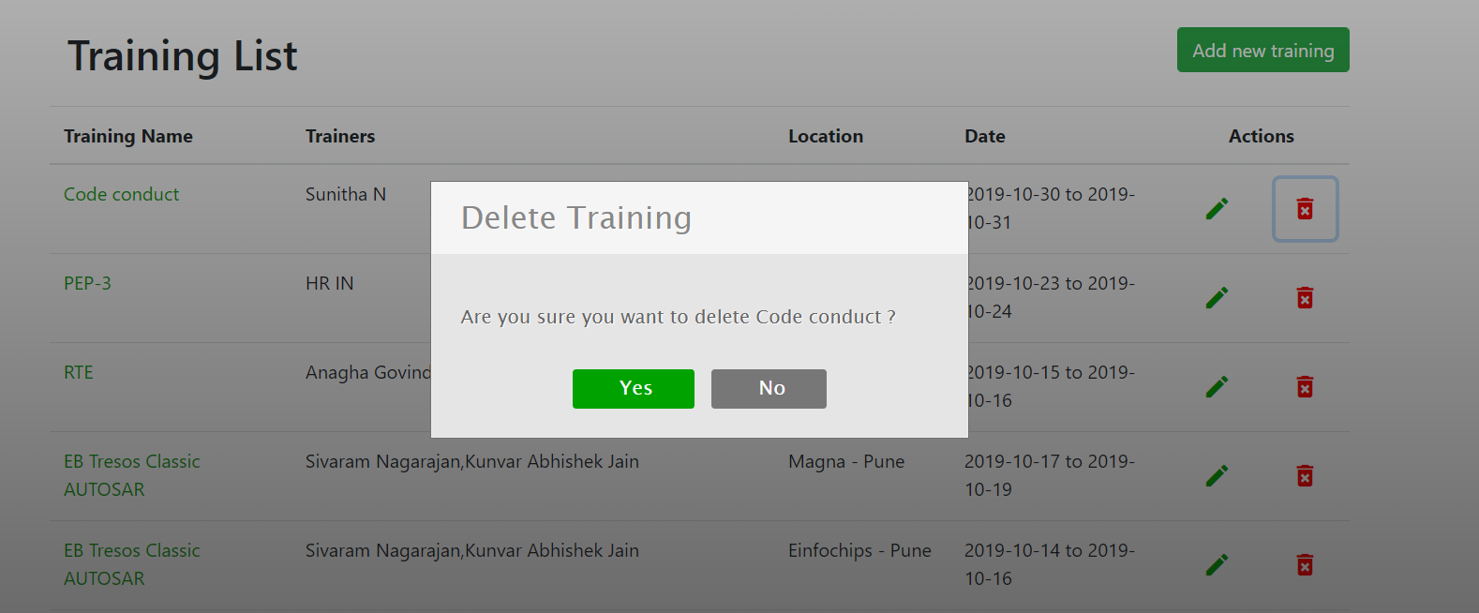

After click on yes button that particular training detail will be deleted

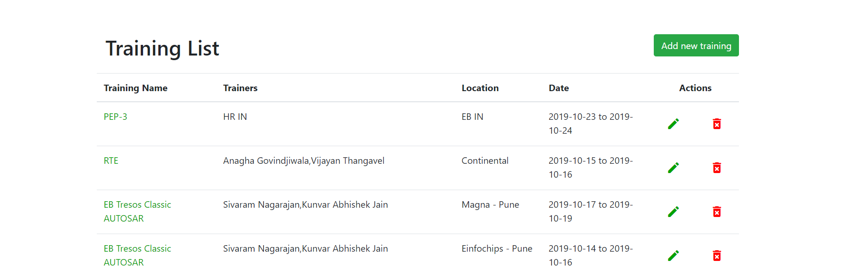

* 1. Feedback Report
  2. EB Guide Training