1. **Retrieve the total number of orders placed.**

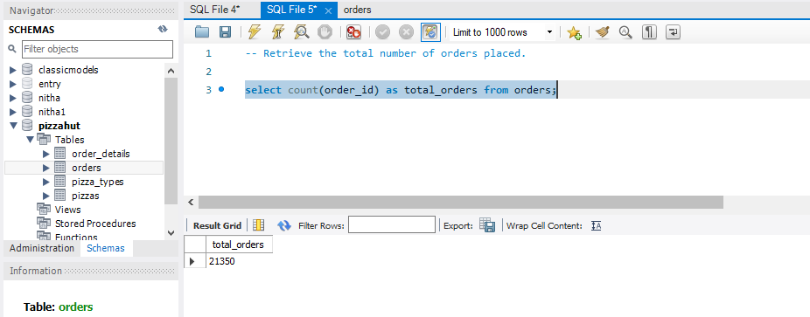

1. **Calculate the total revenue generated from pizza sales.**

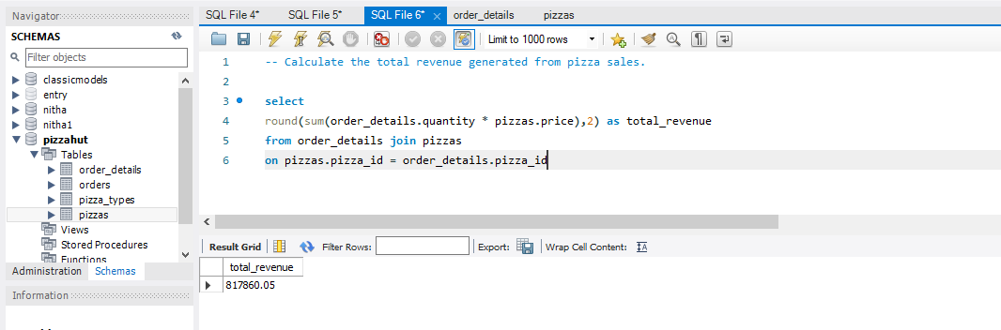

1. **Identify the highest-priced pizza.**

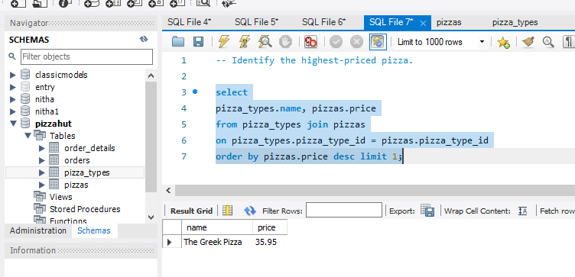

1. **Identify the most common pizza size ordered.**

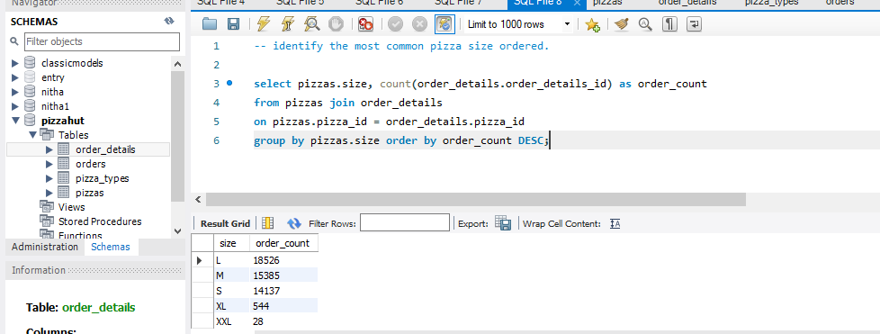

1. **List the top 5 most ordered pizza types along with their quantities.**

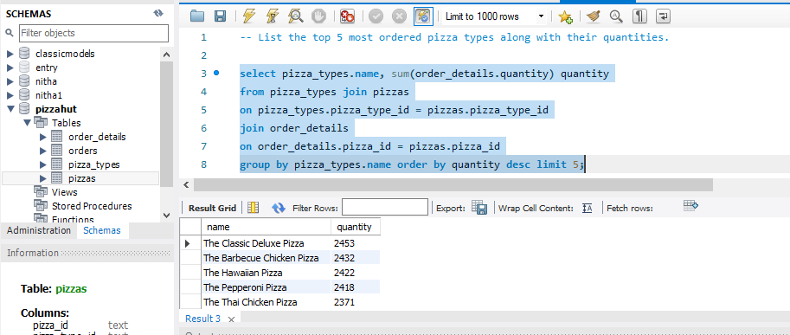

1. **Join the necessary tables to find the total quantity of each pizza category ordered.**

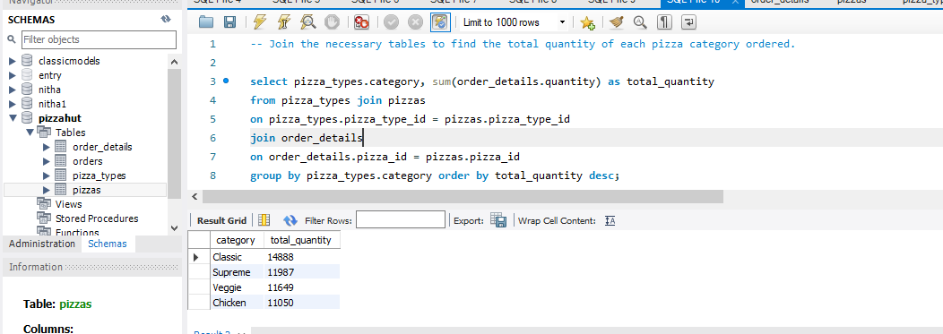

1. **Determine the distribution of orders by hour of the day.**

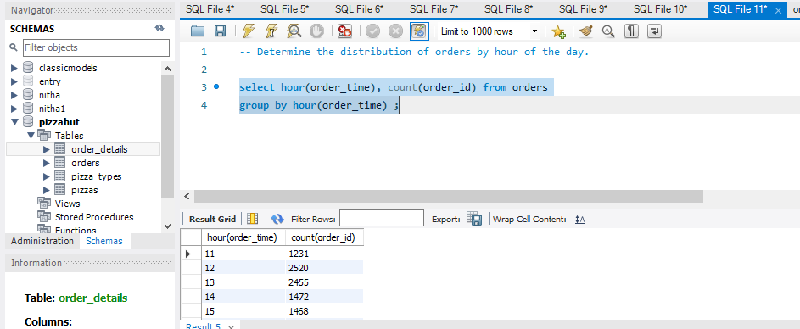

**8. Join relevant tables to find the category-wise distribution of pizzas.**

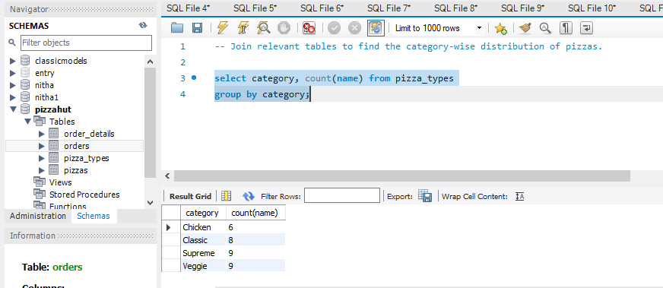

**9.Group the orders by date and calculate the average number of pizzas ordered per day.**

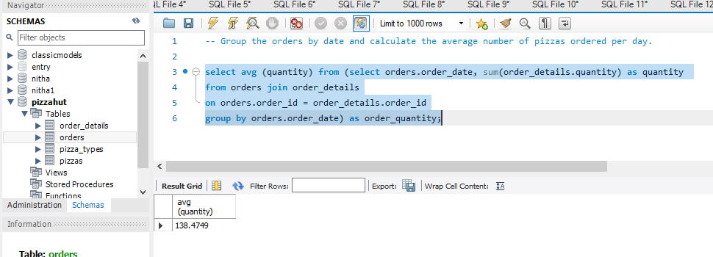

**10. Determine the top 3 most ordered pizza types based on revenue.**

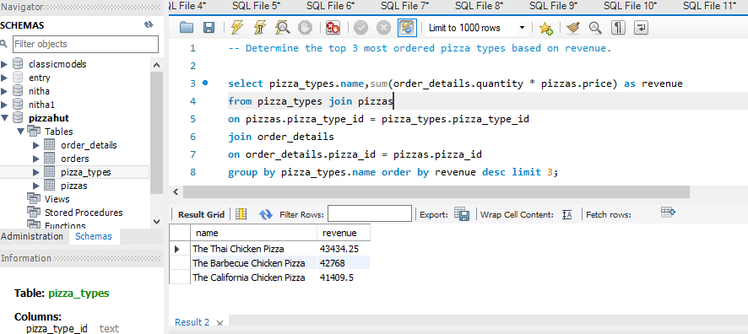

**11. Calculate the percentage contribution of each pizza type to total revenue.**

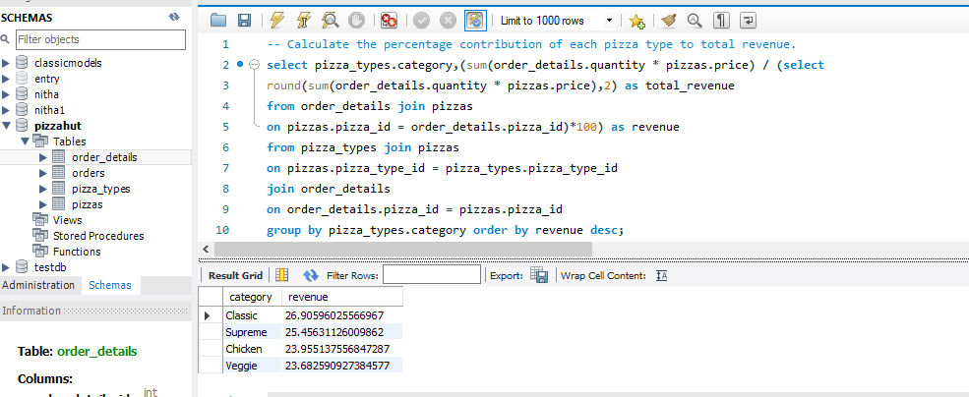

1. **Determine the top 3 most ordered pizza types based on revenue for each pizza category.**

