Nitheese Thirumoorthy

ASU ID:1225417336

**PROJECT PART 2**

**Experimenting with SVM**

**Introduction:**

The aim of the project is to classify a given set of data, containing 1883 samples, using SVM(Standard Vector Machine) by training it with another given set of data, containing of 4786 samples.Standard Vector Machines are supervised learning models, which can be used to find a hyper plane in an N dimensional space with any number of classes that can classify these classes accurately Here, we specifically use the **LIBSVM** library for the purpose of training and testing a SVM.

**Method:**

1. Both the training data and the testing data has 3 features (X1,X2,X3) along with their respective labels (Y). A particular data point is represented using these 3 features. For example, the i’th training sample is represented by X1[i], X2[i] and X3[i]. Its class label is Y[i].
2. In Step-0 Part-1, We train three SVM classifiers on each of the three features and test it on testing data respectively. That is, we train one SVM on X1_train and test it on X1_test and note its accuracy. Likewise, we train the second SVM on X2_train and test it on X2_test and note its accuracy as well. We repeat the same for the third feature as well.We train a SVM using the “**svm_train**” method , which takes **prob** and **param** as it is parameters. prob contains the particular training feature X_k and the label Y. param contains parameters which configure the SVM. We pass “-t 0” for **linear kernel** type and “-c 10” for the **cost** as parameters.
3. In the Step-0 Part-2, we again train three SVM classifiers on the three features respectively, but this time, we calculate the **posterior probabilities**, by passing “-b 1” as a parameter while training and testing. While performing testing using the “**svm_predict**” function, an array containing the posterior probabilities is also produced as an output. This array is named as “pval” in the code. pval[i][j] contains the probability that the i’th data point belongs the j’th label.
4. In Step1, we make use of the posterior probabilities which we have calculated previously in part 2 of step 0. We have calculated the posterior probabilities for each of the 3 features. In this step, we combine the posterior probabilities of these three features by the formula,



The final recognition result is then obtained as



1. In Step 2, we concatenate all the three feature vectors (X1,X2and X3) and we obtain the combined dataset X. We train the SVM on this combined dataset (X_train in our case). We also concatenate the the three features in the test data as well. Then, we perform classification on the combined test data and note down its accuracy.

**Results:**

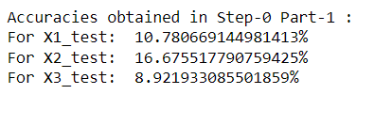

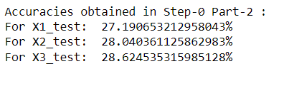



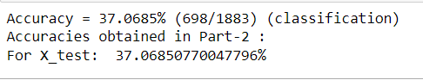

**Conclusion:**

1. It can be seen that the accuracy obtained in part-1 and part-2 of Step-0 are very low compared to that in Step-1 and Step-2. It is because in Step-0, we train three individual SVM classifiers on each of the three classifiers respectively. A data point, in this case, is represented only by one of the three features and hence the reported low accuracy.
2. But in Step-1 and Step-2 , we could see that the testing accuracy has significantly improved compared to that of Step-0. This is because, in both of these steps, all of the three feature vectors characterize a data point. In Step-1, we used the combined posterior probabilities to classify the test data, while in the case of Step-2, we combine all the three features to train and test the SVM classifier. Hence the accuracy is high compared to that of Step-0.