**Protein Secondary structure prediction-APOE GENE**

**GOR IV TOOL**

**Wild-type protein structure prediction**

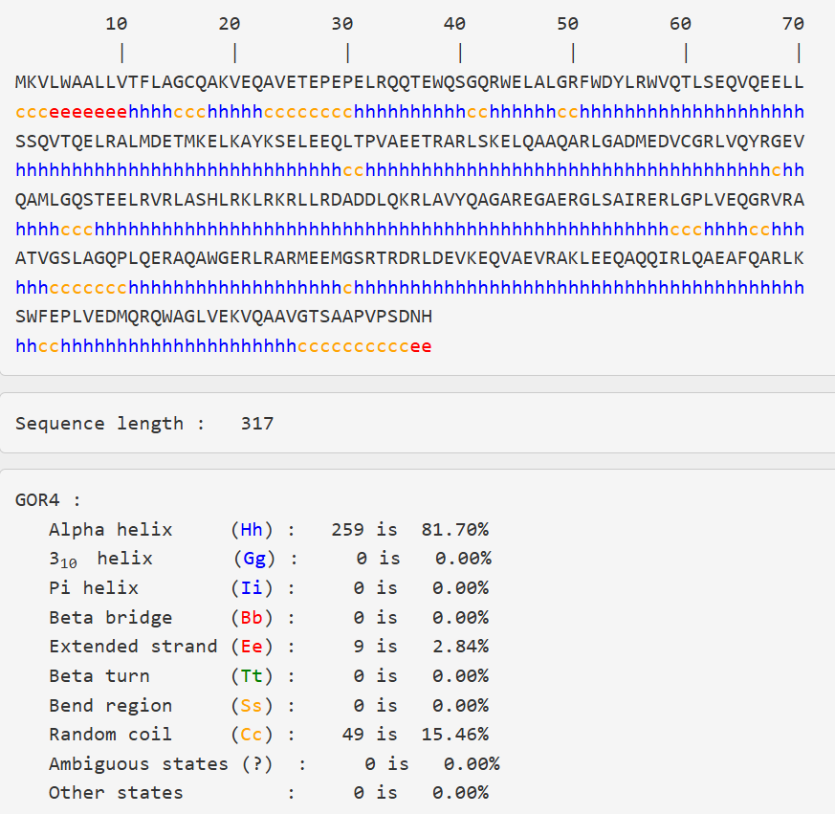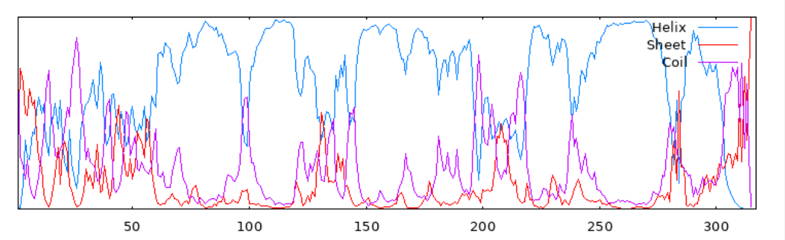

Result of secondary structure prediction- wild-type protein

**Secondary structure Prediction of mutant-rs7412**

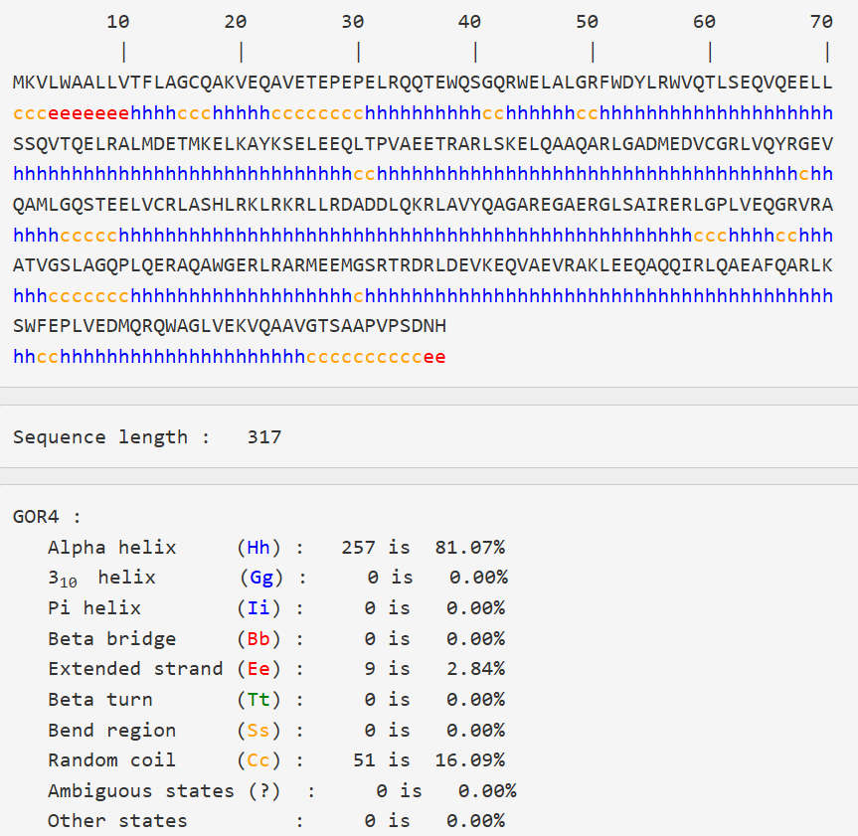

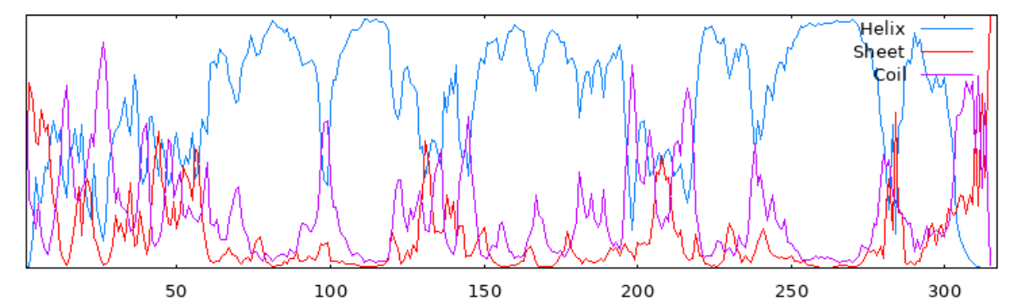

Result of secondary structure prediction of **mutant-rs7412**

**Secondary structure Prediction of mutant-rs769455**

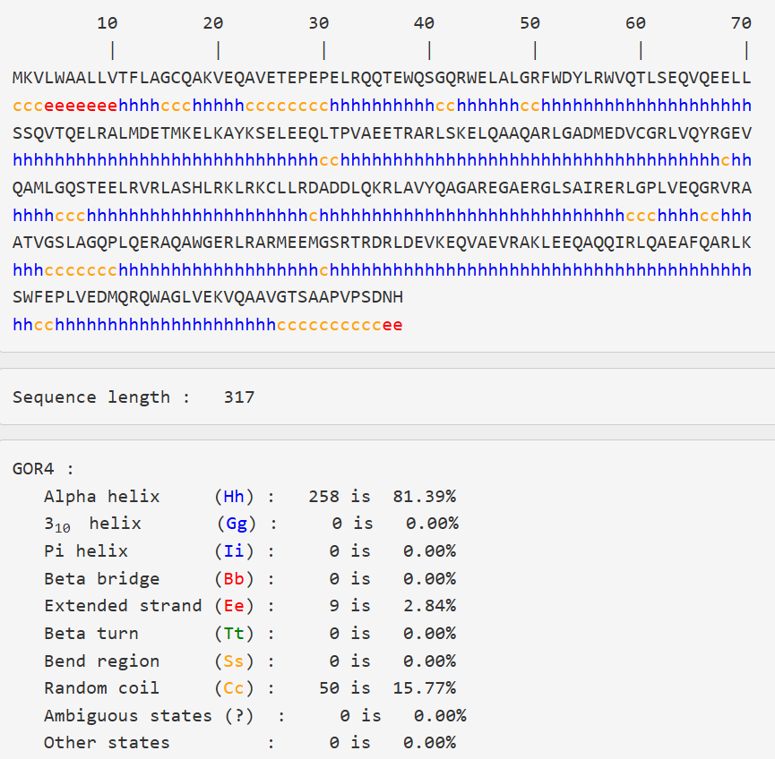

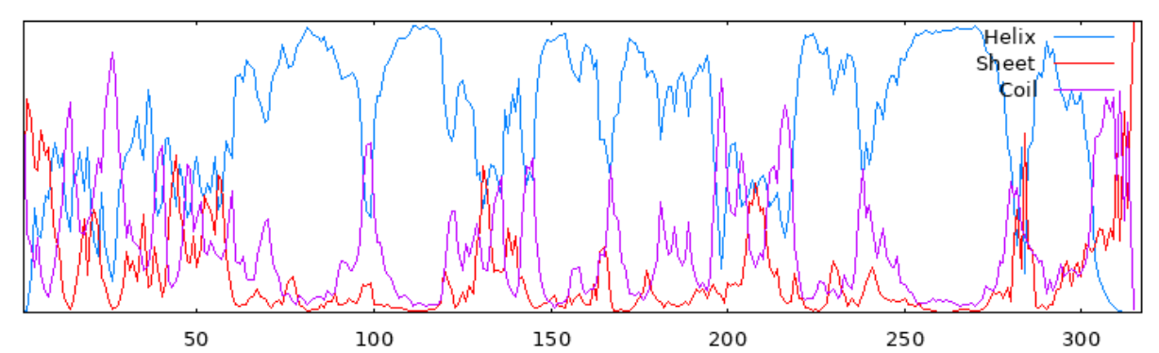

Result of secondary structure prediction of **mutant-rs769455**

**FINAL RESULT**

|  |  |  |  |
| --- | --- | --- | --- |
| **Secondary Structure Element** | **Wild Type (%)** | **rs7412 Mutant (%)** | **rs769455 Mutant (%)** |
| **Alpha helix (Hh)** | 259 (81.70%) | 257 (81.07%) | 258 (81.39%) |
| **3₁₀ helix (Gg)** | 0 (0.00%) | 0 (0.00%) | 0 (0.00%) |
| **Pi helix (II)** | 0 (0.00%) | 0 (0.00%) | 0 (0.00%) |
| **Beta bridge (Bb)** | 0 (0.00%) | 0 (0.00%) | 0 (0.00%) |
| **Extended strand (Ee)** | 9 (2.84%) | 9 (2.84%) | 9 (2.84%) |
| **Beta turn (Tt)** | 0 (0.00%) | 0 (0.00%) | 0 (0.00%) |
| **Bend region (Ss)** | 0 (0.00%) | 0 (0.00%) | 0 (0.00%) |
| **Random coil (Cc)** | 49 (15.46%) | 51 (16.09%) | 50 (15.77%) |

**CONCLUSION**

* Alpha helix content remains very stable across wild type and mutants, with a decrease (~0.6%) in the rs7412 mutant.
* Extended strand content remains constant (2.84%) across all variants.
* Random coil shows a slight increase in the rs7412 mutant (~0.6%) and a minor increase in rs769455 (~0.3%) compared to wild type.
* No new or missing secondary structure elements appeared due to mutations.
* Overall, secondary structure is conserved between wild type and these mutants, suggesting these mutations likely do not cause major structural changes in the protein.