**Protein Secondary structure prediction-BDNF GENE**

**GOR IV TOOL**

**Wild-type protein structure prediction**

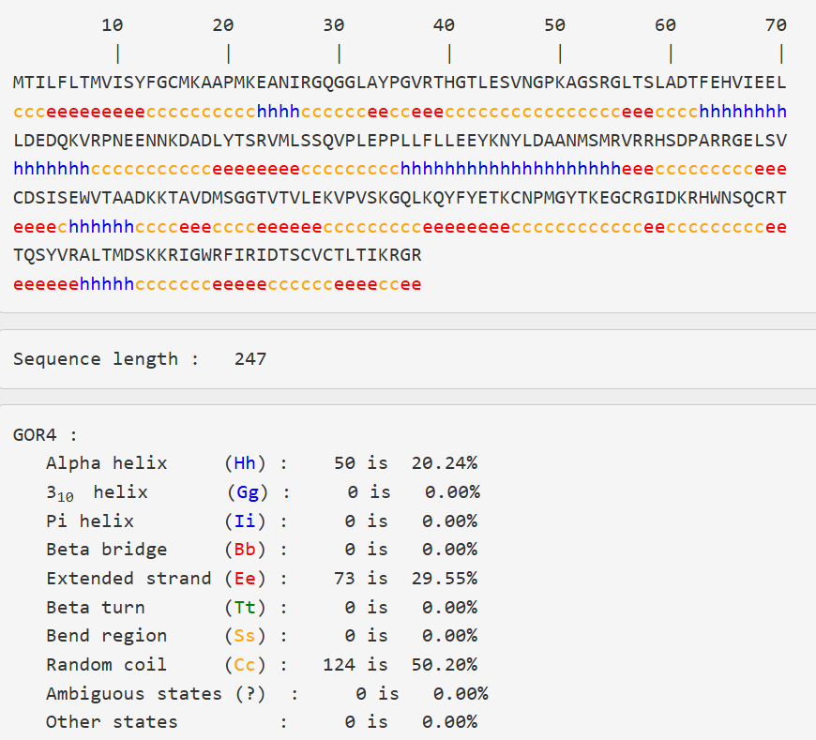

Result of secondary structure prediction- wild-type protein

**Secondary structure Prediction of mutant-** **rs6265**

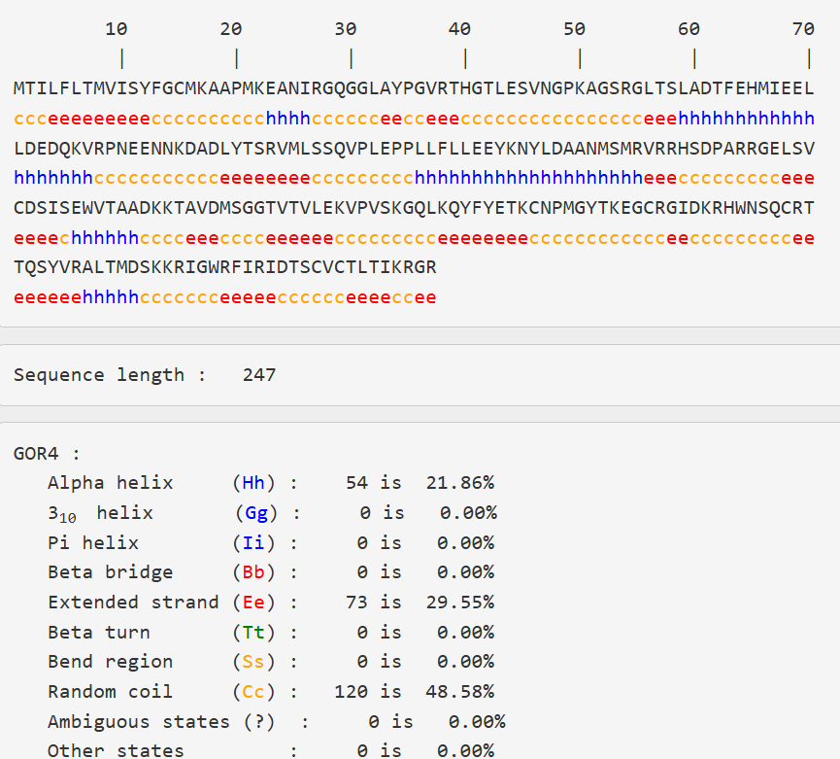

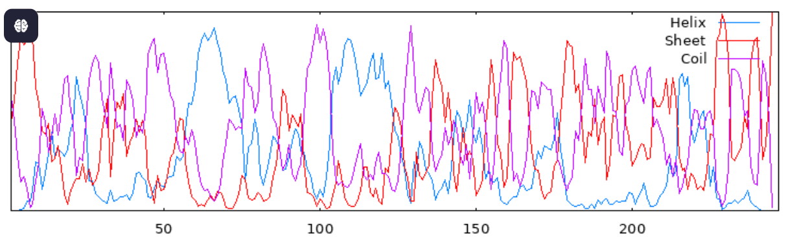

Result of secondary structure prediction of **mutant-** **rs6265**

**Secondary structure Prediction of mutant-** **rs1048218**

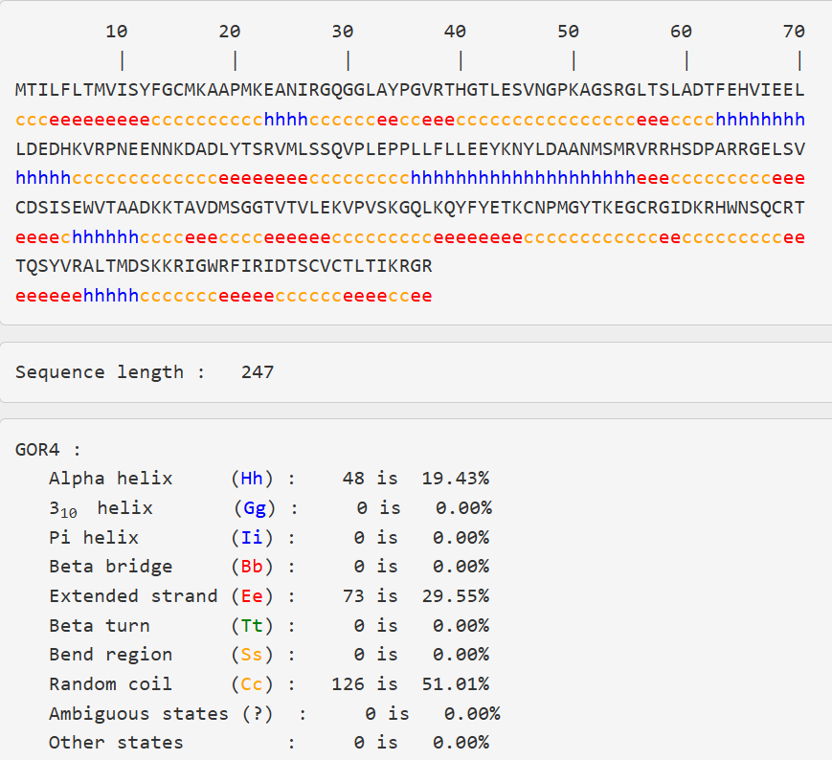

Result of secondary structure prediction of **mutant-rs1048218**

**Secondary structure Prediction of mutant-rs8192466-T>I**

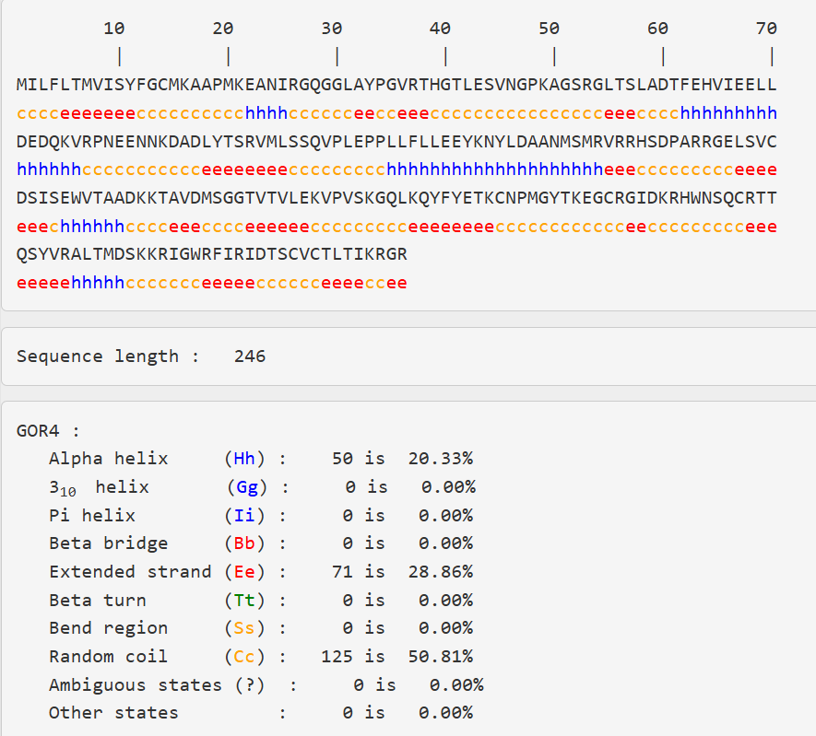

Result of secondary structure prediction of **mutant-rs8192466-T>I**

**Secondary structure Prediction of mutant-rs8192466-T>N**

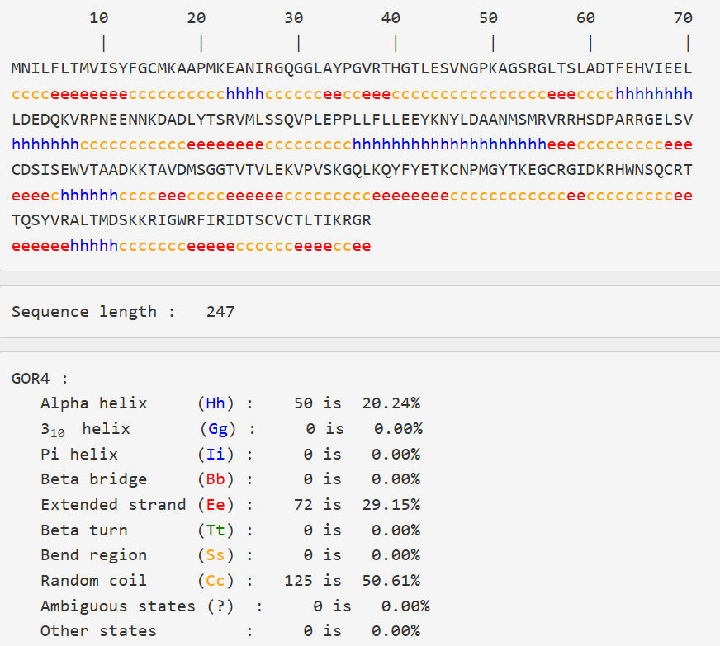

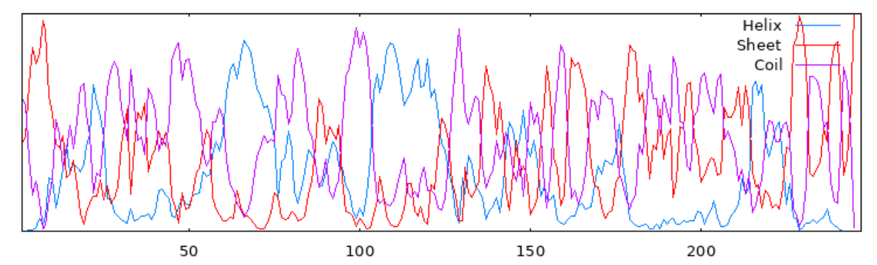

Result of secondary structure prediction of **mutant-rs8192466-T>N**

**FINAL RESULT**

|  |  |  |  |  |  |
| --- | --- | --- | --- | --- | --- |
| **Structure Type** | **Wild Type** | **rsidrrs6265** | **rs1048218** | **rs8192466-T>I** | **rs8192466-T>N** |
| **Alpha helix (Hh)** | 50 (20.24%) | 54 (21.86%) | 48 (19.43%) | 50 (20.33%) | 50 (20.24%) |
| **3_10 helix (Gg)** | 0 (0.00%) | 0 (0.00%) | 0 (0.00%) | 0 (0.00%) | 0 (0.00%) |
| **Pi helix (II)** | 0 (0.00%) | 0 (0.00%) | 0 (0.00%) | 0 (0.00%) | 0 (0.00%) |
| **Beta bridge (Bb)** | 0 (0.00%) | 0 (0.00%) | 0 (0.00%) | 0 (0.00%) | 0 (0.00%) |
| **Extended strand (Ee)** | 73 (29.55%) | 73 (29.55%) | 73 (29.55%) | 71 (28.86%) | 72 (29.15%) |
| **Beta turn (Tt)** | 0 (0.00%) | 0 (0.00%) | 0 (0.00%) | 0 (0.00%) | 0 (0.00%) |
| **Bend region (Ss)** | 0 (0.00%) | 0 (0.00%) | 0 (0.00%) | 0 (0.00%) | 0 (0.00%) |
| **Random coil (Cc)** | 124 (50.20%) | 120 (48.58%) | 126 (51.01%) | 125 (50.81%) | 125 (50.61%) |

**Conclusion**

* rsidrrs6265 mutant shows a small increase in alpha helix (~1.6%) and decrease in random coil (~1.6%).
* rs1048218 mutant has a slight decrease in alpha helix (~0.8%) and increase in random coil (~0.8%).
* rs8192466-T>I and rs8192466-T>N mutants are very close to wild type, with minimal extended strand and coil percentage changes.
* No new secondary structure elements (like 3_10 helix, Pi helix, beta turn, or bends) appear due to mutations.
* The secondary structure is conserved between wild type and these mutants, indicating that these mutations might not drastically alter the protein’s overall folding or stability.