Gnanadurai.G  Senior electrical in charge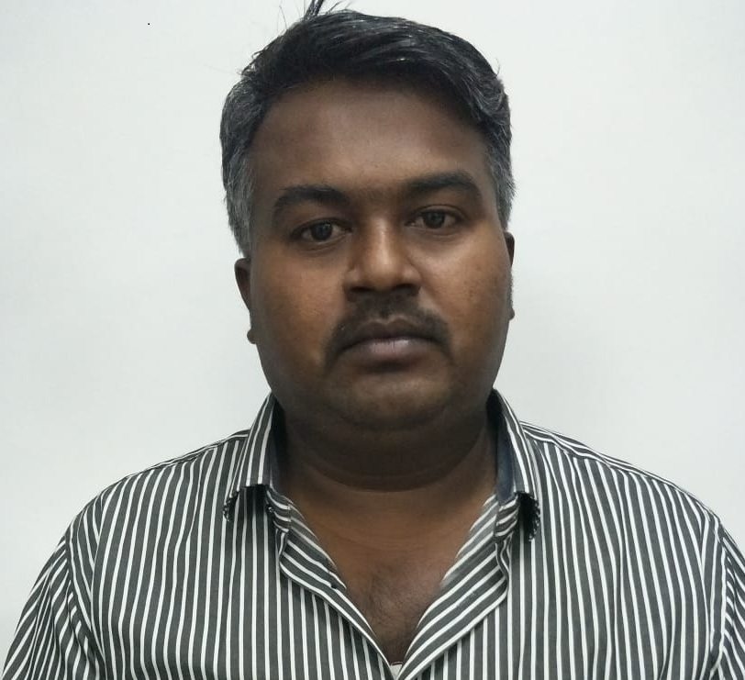 | Gnanadurai.G  Muniyan kovil street  Kattumavadi  Manamel kudi(T.k)  Pudukkottai (D.T)  pin;614630  Phone number-+962770447755  Date of Birth-16/5/1985  email:durai2675@gmail.com
ㅡ  Skills | A time-served and suitably qualified electrician with extensive knowledge of electrical legislation, codes, and standards of practice. Experienced in installing, maintaining and testing electrical systems and equipment in domestic, commercial and industrial environments. Physically fit for demanding work and having own transport and willing to travel. Possessing an in depth knowledge of safety procedures for both construction and maintenance projects
ㅡ  Experience | 1) ELECTRICIAN ( 2006-2010)  Ambattur clothing limited ,CHENNAI  2) SENIOR ELECTRICAL IN CHARGE (2010-2015)  Ambattur Clothing international ,BAHARIN  3) SENIOR ELECTRICAL IN CHARGE (2015-present)  TUSKER APPAREL,JORDAN
ㅡ  Education | G.H.S.S KATTUMAVADI / +2  TAMILNADU ITI / I T C ELECTRICIAN
ㅡ  Duties | *Maintaining and repairing all electrical equipment.  *maintenance of all types of fusing machines.  *installation and maintenance of all types of air compressors.  *maintenance of heavy oil,diesel boilers.  *maintenance of `Absorption chillers.  *maintenance of generators  **Using test equipment & hand tools to diagnose, locate & fix electrical problems.  *Checking & testing circuit breakers and replacing them where required. *Responsible for costing and estimating commercial jobs, tenders and enquiries.  *Tracing, diagnosing and rectifying electrical faults.  *Carrying out electrical installation and maintenance work.  *Carrying out new project work, design and installation.  *Interpreting work instructions, drawings and schematic diagrams.

ㅡ

Languages known Tamil-native

English

Hindi

