SIMATS ENGINEERING
ASSESSMENT TOOL 1

COURSE NAME: Database Management Systems COURSE CODE: CSA0506

COURSE OUTCOME COVERED

CO2: Apply the relational model, relational algebra, SQL query structures, and views to solve database querying and data manipulation problems. (BL3, BL6)

Activity Tool : Analytical Problem Solving (High) Assessment Tool Weightage: 35%

Dr. Hemavathi R

QUESTIONS Total Marks: 50
Q.No | Question | Bloom's Level | Marks
1 | Apply relational algebra operations (σ, π, ∪, -, ×, ⋈) on the given Employee and Department relations to retrieve required records. | BL3 – Apply | 5
2 | Write SQL DDL statements to create STUDENT(SID, Name, DOB, DeptID) and DEPARTMENT(DeptID, DeptName) tables with all appropriate constraints. | BL3 – Apply | 5
3 | Formulate SQL queries using GROUP BY, HAVING, and aggregate functions (COUNT, SUM, AVG, MAX, MIN) on a given Sales dataset. | BL3 – Apply | 5
4 | Write a correlated sub-query to find employees earning more than the average salary of their own department. | BL3 – Apply | 5
5 | Apply all types of JOIN operations (INNER, LEFT OUTER, RIGHT OUTER, FULL OUTER, CROSS) on Employee and Project tables. | BL3 – Apply | 5
6 | Create a view 'DeptSalaryView' that displays department name, total employees, and average salary. Write a query on this view. | BL6 – Create | 5
7 | Construct a relational algebra expression for the following: Find names of students who are enrolled in all courses offered. | BL6 – Create | 5
8 | Write SQL DML statements (INSERT, UPDATE, DELETE) with | BL3 – Apply | 5

 | integrity constraint enforcement for a given scenario.
9 | Apply tuple relational calculus to express a query: Find all employees who work in the 'IT' department and earn more than 50000. | BL3 – Apply | 5
10 | Design a relational schema for an Airline Reservation System and write 5 SQL queries demonstrating joins, sub-queries, and views. | BL6 – Create | 5

Code of Conduct:

I P. Nitheesh Kumar(192524051) (Name / Reg No) certify that this submission is my original work and that I have adhered to the guidelines specified for this assessment. I understand that any violation of academic integrity rules will result in disciplinary action.

Signature of the student:
P. Nitheesh kumar
- Apply relational algebra operations (σ, π, ∪, -, ×, ⋈) on the given Employee and Department relations to retrieve required records.

Assume:

Employee(EmpID, EmpName, DeptID, Salary)

EmpID | EmpName | DeptID | Salary
101 | Rahul | D1 | 60000
102 | Priya | D2 | 45000
103 | Amit | D1 | 55000

Assume:
Employee(EmpID, EmpName, DeptID, Salary) DeptID DeptName
D1 IT
D2 HR

- Selection (σ)
Employees earning more than 50000
^{𝝈}𝑺𝒂𝒍𝒂𝒓𝒚>𝟓𝟎𝟎𝟎𝟎^{(𝑬𝒎𝒑𝒍𝒐𝒚𝒆𝒆)}

- Projection (π)
Display employee names only

𝝅_{𝑬𝒎𝒑𝑵𝒂𝒎𝒆}(𝑬𝒎𝒑𝒍𝒐𝒚𝒆𝒆)

- Union (∪)
Employees from IT and HR

𝑰𝑻𝑬𝒎𝒑𝒍𝒐𝒚𝒆𝒆𝒔 ∪ 𝑯𝑹𝑬𝒎𝒑𝒍𝒐𝒚𝒆𝒆𝒔

- Set Difference (−) Employees not working in IT
𝑬𝒎𝒑𝒍𝒐𝒚𝒆𝒆 − 𝝈_{𝑫𝒆𝒑𝒕𝑰𝑫=}′_{𝑫𝟏}′(𝑬𝒎𝒑𝒍𝒐𝒚𝒆𝒆)

- Cartesian Product (×)
𝑬𝒎𝒑𝒍𝒐𝒚𝒆𝒆 × 𝑫𝒆𝒑𝒂𝒓𝒕𝒎𝒆𝒏𝒕

- Join (⋈)
Employee details with department names
^{𝑬𝒎𝒑𝒍𝒐𝒚𝒆𝒆 ⋈}𝑬𝒎𝒑𝒍𝒐𝒚𝒆𝒆.𝑫𝒆𝒑𝒕𝑰𝑫=𝑫𝒆𝒑𝒂𝒓𝒕𝒎𝒆𝒏𝒕.𝑫𝒆𝒑𝒕𝑰𝑫 ^{𝑫𝒆𝒑𝒂𝒓𝒕𝒎𝒆𝒏𝒕}
- Write SQL DDL statements to create STUDENT(SID, Name, DOB, DeptID) and DEPARTMENT(DeptID, DeptName) tables with all appropriate constraints
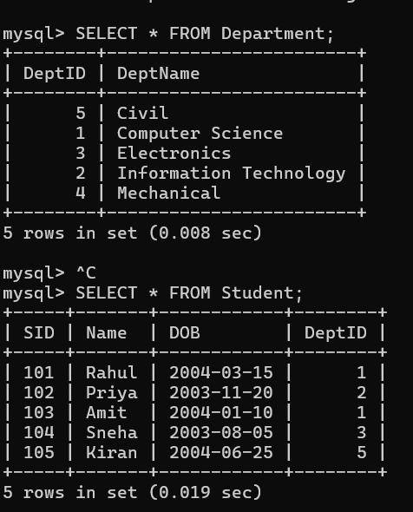
- Formulate SQL queries using GROUP BY, HAVING, and aggregate functions (COUNT, SUM, AVG, MAX, MIN) on a given Sales dataset.
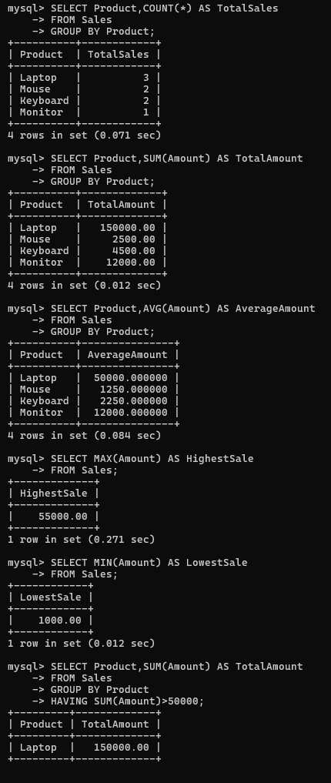
- Write a correlated sub-query to find employees earning more than the average salary of their own department.
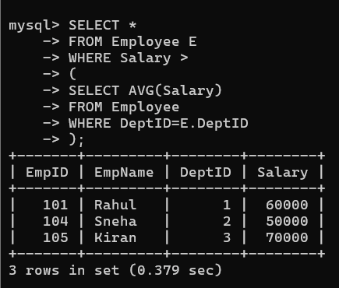
- Apply all types of JOIN operations (INNER, LEFT OUTER, RIGHT OUTER, FULL OUTER, CROSS) on Employee and Project tables.
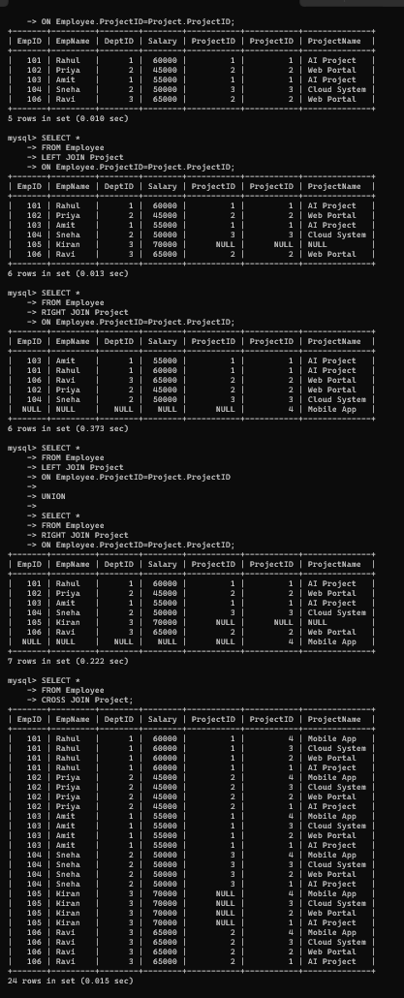
- Create a view 'DeptSalaryView' that displays department name, total employees, and average salary. Write a query on this view.
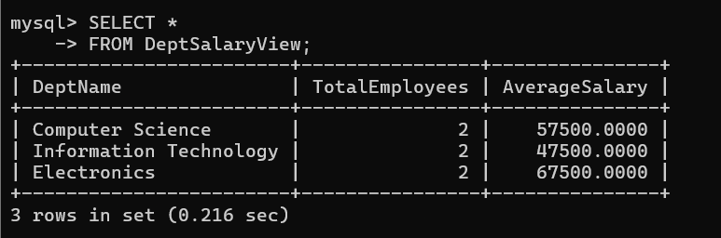
- Construct a relational algebra expression for the following: Find names of students who are enrolled in all courses offered.
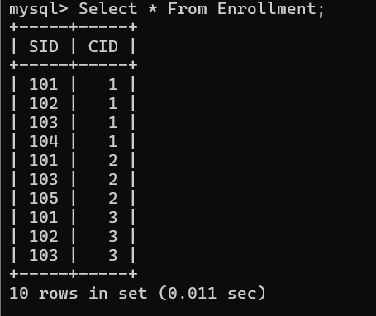
- Write SQL DML statements (INSERT, UPDATE, DELETE) with integrity constraint enforcement for a given scenario.
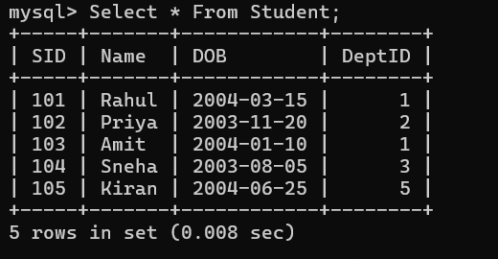
- Apply tuple relational calculus to express a query: Find all employees who work in the 'IT' department and earn more than 50000.
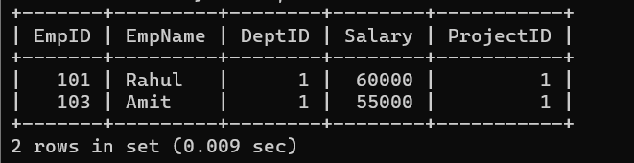
- Design a relational schema for an Airline Reservation System and write 5 SQL queries demonstrating joins, sub-queries, and views.
