SIMATS ENGINEERING
ASSESSMENT TOOL 2

COURSE NAME: Database Management Systems COURSE CODE: CSA05

COURSE OUTCOME COVERED

CO2: Apply the relational model, relational algebra, SQL query structures, and views to solve database querying and data manipulation problems. (BL3, BL6)

Activity Tool : Scenario-Based Task (High) Assessment Tool Weightage: 35%

Dr. Hemavathi R

QUESTIONS Total Marks: 50
Q.No | Question | Bloom's Level | Marks
1 | Given the scenario of a School Management System, identify relations and write SQL to list all students with their class teacher and grade. | BL3 – Apply | 5
2 | A hospital wants to track patient appointments. Design the relational schema and write SQL to find doctors with more than 10 appointments this month. | BL3 – Apply | 5
3 | In an e-commerce scenario, write SQL queries using sub-queries to find products that have never been ordered. | BL3 – Apply | 5
4 | For a university database, write relational algebra expressions to find students enrolled in both 'DBMS' and 'OS' courses. | BL3 – Apply | 5
5 | Given a payroll scenario, create a view showing employees whose salary is below department average and write a query to update their salary by 10%. | BL6 – Create | 5
6 | In a banking scenario, apply JOIN operations to retrieve customer account details, transaction history, and branch information. | BL3 – Apply | 5
7 | A retail store needs daily sales summary. Write SQL with GROUP BY and HAVING to report total sales per category exceeding Rs. 10,000. | BL3 – Apply | 5

8 | For a library system scenario, construct tuple relational calculus expressions to find members who borrowed books from all genres. | BL3 – Apply | 5
9 | Given an inventory management scenario, define CHECK and FOREIGN KEY constraints and demonstrate their enforcement through SQL. | BL3 – Apply | 5
10 | Design a relational schema for an HR system and create materialized views for monthly attendance and performance summaries. | BL6 – Create | 5

Code of Conduct:

S

- Given the scenario of a School Management System, identify relations and write SQL to list all students

with their ass teacher and grade
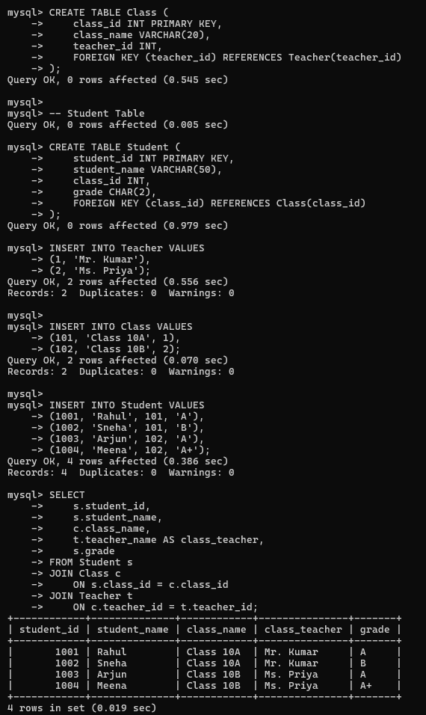
- A hospital wants to track patient appointments. Design the relational schema and write

SQL to find doctors with more than 10 appointments this month.
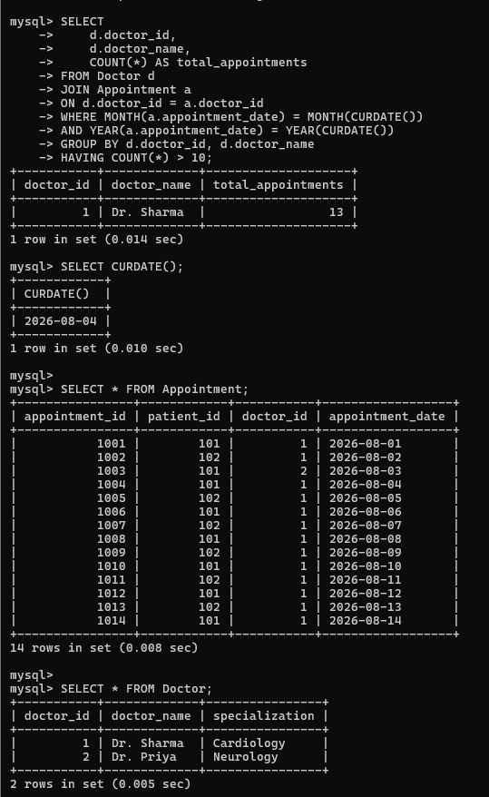

- In an e-commerce scenario, write SQL queries using sub-queries to find products that have never been ordered.
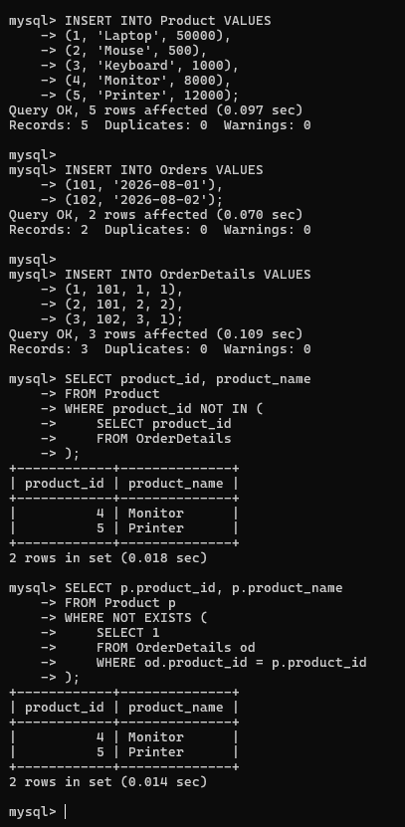

- For a university database, write relational algebra expressions to find students enrolled in both 'DBMS' and 'OS' courses.
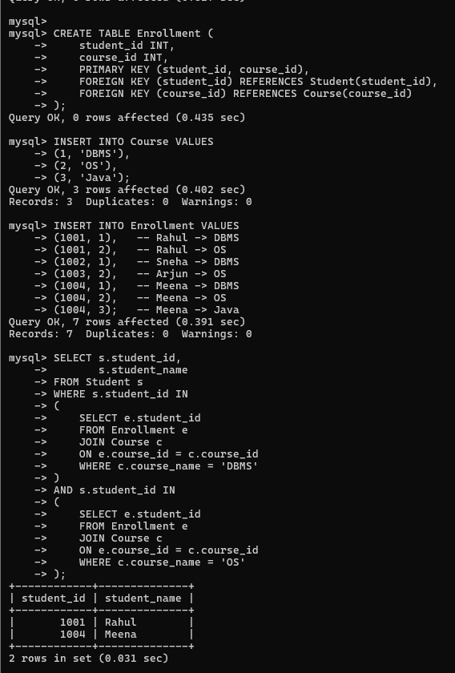

- Given a payroll scenario, create a view showing employees whose salary is below department average and write a query to update their salary by 10%.
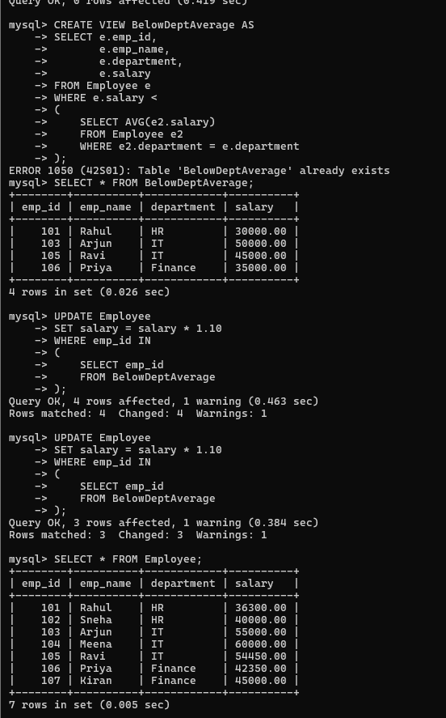

- In a banking scenario, apply JOIN operations to retrieve customer account details, transaction history, and branch information.
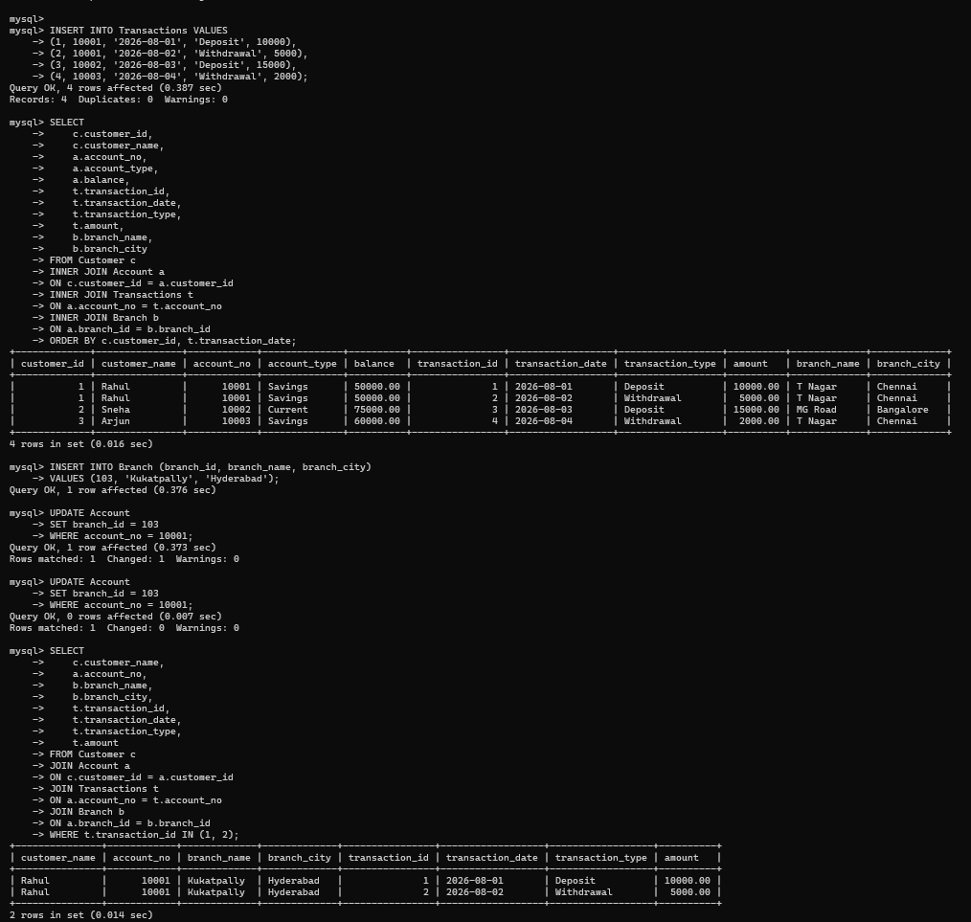

- A retail store needs daily sales summary. Write SQL with GROUP BY and HAVING to report total sales per category exceeding Rs. 10,000.

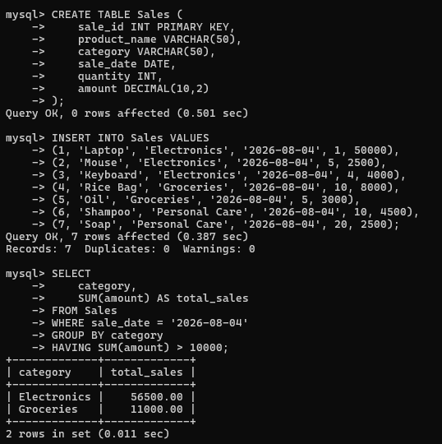

- For a library system scenario, construct tuple relational calculus expressions to find members who borrowed books from all genres.

{
m.member_name | Member(m) AND FOR ALL g (
Book(g) →
EXISTS b EXISTS br (
Book(b) AND Borrow(br) AND
b.book_id = br.book_id AND br.member_id = m.member_id AND b.genre = g.genre
)
)
}
Explanation
- Member(m) selects each library member.
- FOR ALL g checks every genre available in the Book relation.
- EXISTS b ensures there is a book in that genre.
- EXISTS br verifies that the member has borrowed a book belonging to that genre.
- Members satisfying this condition have borrowed books from all genres available in the library.

- Given an inventory management scenario, define CHECK and FOREIGN KEY constraints and demonstrate their enforcement through SQL

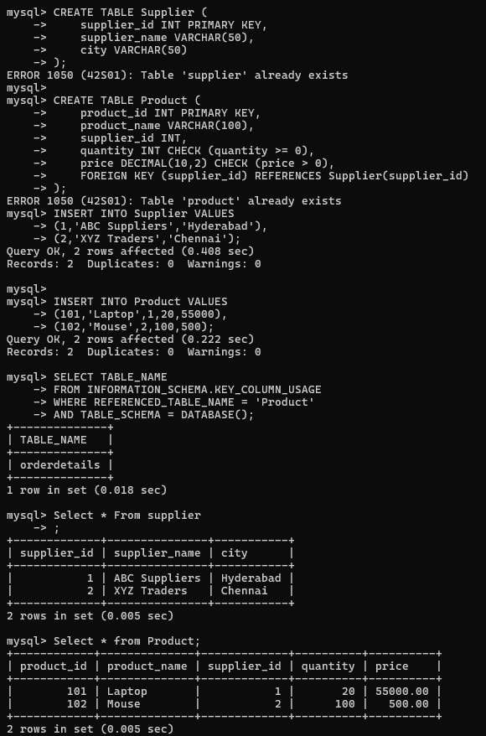

- Design a relational schema for an HR system and create materialized views for monthly attendance and performance summaries.

