**RFID BASED ATTENDANCE SYSTEM USING MICROCONTROLLER**

**BY**

**SRUTI VERMA-18BCE1005**

**SHAUMAYA OJHA-18BCE1074**

**K.G.NITHESH GURUDAAS-18BCE1101**

A project report submitted to

**Prof. Dr. D. Vydeki**

**SCHOOL OF ELECTRONICS ENGINEERING**

In partial fulfilment of the requirements for the course of

**CSE2005-MICROPROCESSOR AND INTERFACING**

IN

**B.tech COMPUTER SCIENCE ENGINEERING**



**VIT UNIVERSITY, CHENNAI**

**VANDALUR KELAMBAKAM ROAD**

**CHENNAI-600127**

**MARCH-2020**

**BONAFIDE CERTIFICATE**

**Certified that this project report entitled “RFID BASED ATTENDANCE SYSTEM USING MICROCONTROLLER”**

**Is a bonafide work of**

**Sruti Verma [18BCE1005],**

**Shaumaya Ojha [18BEC1059],**

**K.G.Nithesh Gurudaas [18BCE1101]**

**Who carried out the project work under my supervision and guidance.**

###### **Prof. Dr. D. Vydeki**

###### Professor (SG)

School of Electronics Engineering [SENSE]

VIT University, Chennai

Chennai- 600 127.

**ABSTRACT:**

In this project, an RFID based attendance system is implemented using microcontroller for ease of taking attendance in schools and colleges.

This project was aimed at reducing the effective time taken for registering attendance in classes and to decrease the burden on faculties.

Every student will be given an ID card with a unique RFID identification number. An EM-18 module is used as a RFID reader. A microcontroller is used to store the IDs of the students of the class, and will crosscheck the ID number sent by the EM-18 module. An LCD display is used to show the students who are present and those that are absent, and to show the count of students.

When the ID card is shown near an RFID reader (EM-18 module), RFID reader will extract whatever information is stored on the ID card by using induction based on Radio frequency. Initially, the attendance value of all students is set to absent (or 0). Now, the data extracted by the EM-18 module is sent to the microcontroller, and the microcontroller will now check if the number is present in the database, and if it isn’t present in the database, the LCD display will display a message that it is an invalid number. If the number is present in the database, then the microcontroller will set the attendance value to present (or 1), and will display that name along with the attendance status. Upon pressing an interrupt button, the module will display everyone’s name and their attendance status, and then will display count at last.

**Table of Contents**

|  |  |  |  |
| --- | --- | --- | --- |
| **Chapter No.** | **Title** | | **Page No.** |
|  | **Abstract** | | 3 |
|  | **List of Figures** | | **5** |
|  | **List of Tables** | | **7** |
| **1** | **Introduction** | | **12** |
|  | 1.1 | Objectives | **12** |
|  | 1.2 | Scope | **12** |
| **2** | **Design/ Implementation** | | **13** |
|  | 2.1 | Introduction | **13** |
|  | 2.2 | Design Approach | **13** |
|  | 2.3 | Proposed System | **14** |
|  |  | 2.3.1 Economic Feasibility | **14** |
|  |  | 2.3.2 Technical feasibility | **15** |
|  |  | 2.3.3 Operational feasibility | **15** |
|  | 2.4 | Overview of Software | **15** |
|  | 2.5 | Hardware Specification | **16** |
|  | 2.6 | Software Requirement | **18** |
|  | 2.7 | Summary | **9** |
| **3** | **Result and Analysis/Testing** | | **22** |
|  | 3.1 |  |  |
| 3.2 |  |  |
| 3.3 |  |  |
| 3.4 | Summary | **22** |
| **4** | **Conclusion and future Enhancement** | | **23** |
| **5** | **Appendix** | | **23** |
| **8** | **References**  **Bio- Data** | | **25** |

**LIST OF FIGURES:**

***BLOCK DIAGRAM:***

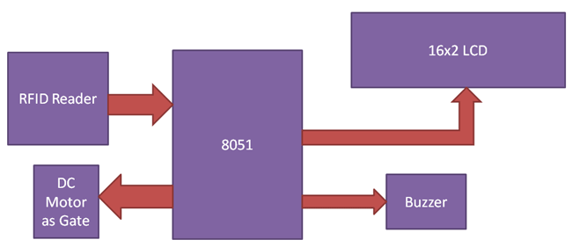

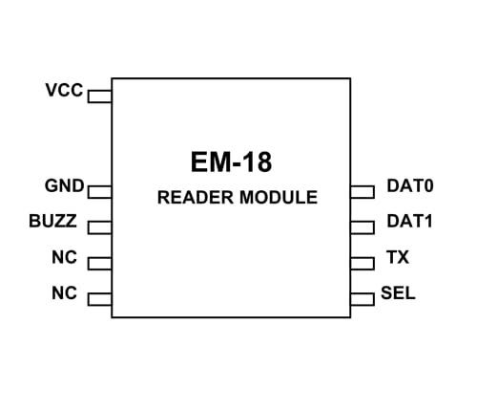

***AT89S52 PIN DIAGRAM:***

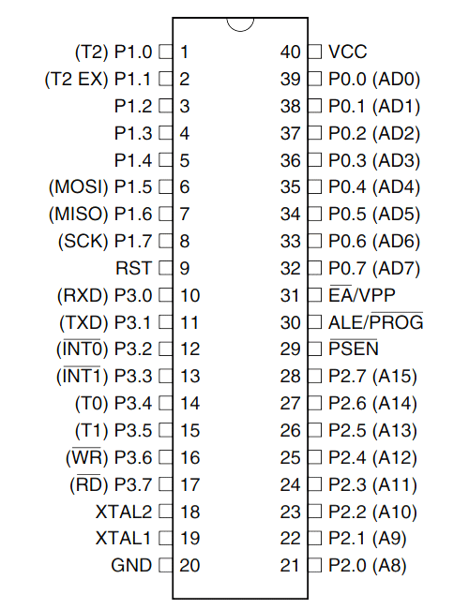

***16 PIN LCD Configuration:***

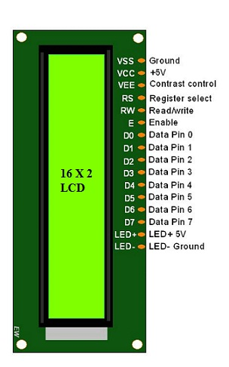

#### Circuit Diagram

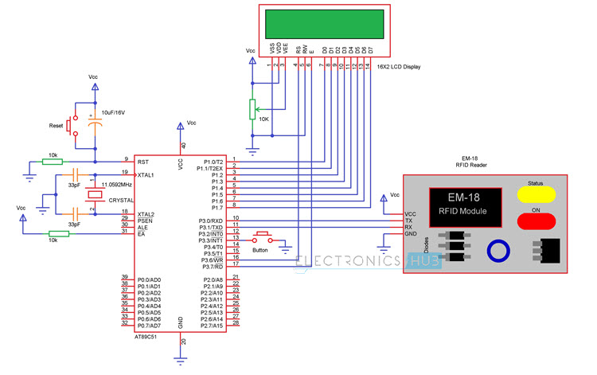

**LIST OF TABLES:**

FEATURES OF EM-18 RFID READER:



### *****AT89S52 Pin Configuration*****

|  |  |  |
| --- | --- | --- |
| **Pin Number** | **Pin Name** | **Description** |
| 1 | P1.0 (T2) | Timer/Counter or 0th GPIO pin of PORT 1 |
| 2 | P1.1 (T2.EX) | Timer/Counter/External Counter or 1st GPIO pin of PORT 1 |
| 3 | P1.2 | 2nd GPIO pin of PORT 1 |
| 4 | P1.3 | 3rd GPIO pin of PORT 1 |
| 5 | P1.4 | 4th GPIO pin of PORT 1 |
| 6 | P1.5 (MOSI) | MOSI for in System Programming or 5th GPIO pin of PORT 1 |
| 7 | P1.6 (MISO) | MISO for in System Programming or 6th GPIO pin of PORT 1 |
| 8 | P1.7 (SCK) | SCK for in System Programming or 7th GPIO pin of PORT 1 |
| 9 | RST | Making this pin high will reset the Microcontroller |
| 10 | P3.0 (RXD) | RXD Serial Input or 0th GPIO pin of PORT 3 |
| 11 | P3.1 (TXD) | TXD Serial Output or 1st GPIO pin of PORT 3 |
| 12 | P3.2 (INT0’) | External Interrupt 0 or 2nd GPIO pin of PORT 3 |
| 13 | P3.3 (INT1’) | External Interrupt 1 or 3rd GPIO pin of PORT 3 |
| 14 | P3.4 (T0) | Timer 0 or 4th GPIO pin of PORT 3 |
| 15 | P3.5 (T1) | Timer 1 or 5th GPIO pin of PORT 3 |
| 16 | P3.6 (WR’) | Memory Write or 6th GPIO pin of PORT 3 |
| 17 | P3.7 (RD’) | Memory Read or 7th GPIO pin of PORT 3 |
| 18 | XTAL2 | External Oscillator Output |
| 19 | XTAL1 | External Oscillator Input |
| 20 | GND | Ground pin of MCU |
| 21 | P2.0(A8) | 0th GPIO pin of PORT 2 |
| 22 | P2.1 (A9) | 1st GPIO pin of PORT 2 |
| 23 | P2.2 (A10) | 2nd GPIO pin of PORT 2 |
| 24 | P2.3 (A11) | 3rd GPIO pin of PORT 2 |
| 25 | P2.4 (A12) | 4th GPIO pin of PORT 2 |
| 26 | P2.5 (A13) | 5th GPIO pin of PORT 2 |
| 27 | P2.6 (A14) | 6th GPIO pin of PORT 2 |
| 28 | P2.7 (A15) | 7th GPIO pin of PORT 2 |
| 29 | PSEN’ | Program store Enable used to read external program memory |
| 30 | ALE / PROG’ | Address Latch Enable / Program Pulse Input |
| 31 | EA’ / VPP | External Access Enable / Programming enable Voltage |
| 32 | P0.7 (AD7) | Address / Data pin 7 or 7th GPIO pin of PORT 0 |
| 33 | P0.6 (AD6) | Address / Data pin 6 or 6th GPIO pin of PORT 0 |
| 34 | P0.5 (AD5) | Address / Data pin 5 or 5th GPIO pin of PORT 0 |
| 35 | P0.4 (AD4) | Address / Data pin 4 or 4th GPIO pin of PORT 0 |
| 36 | P0.3 (AD3) | Address / Data pin 3 or 3rd GPIO pin of PORT 0 |
| 37 | P0.2 (AD2) | Address / Data pin 2 or 2nd GPIO pin of PORT 0 |
| 38 | P0.1 (AD1) | Address / Data pin 1 or 1st GPIO pin of PORT 0 |
| 39 | P0.0 (AD0) | Address / Data pin 0 or 0th GPIO pin of PORT 0 |
| 40 | VCC | Positive pin of MCU (+5V) |

|  |  |
| --- | --- |
| **AT89S52 Microcontroller Features** | |
| CPU | 8-bit PIC |
| Number of  Pins | 40 |
| Operating Voltage (V) | 4 to 5.5 V |
| Number of Programmable I/O pins | 32 |
| ADC Module | Nil |
| Timer Module | 16-bit(1) |
| Comparators | Nil |
| DAC Module | Nil |
| Communication Peripherals | UART(1) |
| External Oscillator | Up to 23Mhz |
| Internal Oscillator | Nil |
| Program Memory Type | Flash |
| Program Memory (KB) | 8KB |
| CPU Speed (MIPS) | - |
| RAM Bytes | 256 x 8-bit |
| Data EEPROM | Nil |

***LCD PIN CONFIGURATION:***

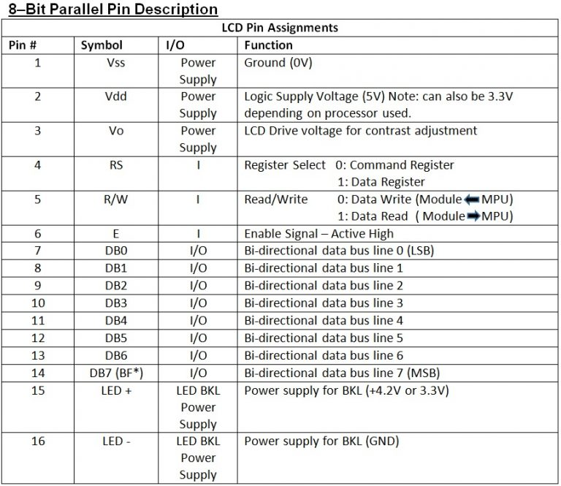

#### 

# 1 INTRODUCTION

## 1.1 OBJECTIVES AND GOALS

* Design a circuit for the attendance system
* To retrieve the data stored on the ID card
* To store information about students and their attendance status on the microcontroller
* To cross check and verify the attendance of each student

## 1.2 BENEFITS/SCOPE

* We can reduce the burden on teachers for taking attendance
* Time taken for registering attendance is reduced
* This can also be extended with biometrics, retinal and applied in workspaces also

## FEATURES

* RFID cards for student
* EM-18 module to read the RFID cards
* Microcontroller to monitor and store and verify all the information
* LCD to display information

# 2 DESIGN/IMPLEMENTATION

The aim of this project is to design an RFID Technology based Attendance System using 8052 microcontroller, in which the attendance of students or employees is automatically recorded with the swipe of a card. The working of the project is explained here.

## 2.1 INTRODUCTION

When this circuit is powered ON, initially the microcontroller will display the message as Swipe the card on the LCD display. When the RFID reader detects the ID card, it will send the unique card no to the microcontroller via serial terminal.

With the help of suitable programming, we need to compare the received card no. with the numbers that are already stored in the microcontroller or any database. Once, if any of these numbers are match with the received card no., then the corresponding name stored in that no. is displayed on the LCD display and also the attendance for the name stored in the corresponding number is marked. By pressing the button, the attendance recording will be closed and the details are displayed on the LCD repeatedly until the microcontroller has been reset.

## 2.2 DESIGN APPROACH

The main components of the project are 8052 based microcontroller, 16×2 LCD, and RFID reader module. First we’ll see the basic connections with respect to the microcontroller. Here, we’ll need to connect a crystal, a reset circuit and external access. To use the on-chip oscillator, an 11.0592 MHz quartz crystal is connected to pins 18 (XTAL2) and 19 (XTAL1) of the microcontroller. Two 33pF ceramic capacitors are connected from the crystal to ground. The reset on the 8052 microcontroller is active high i.e. upon applying a high pulse to RST pin, the microcontroller will reset. A 10KΩ resistor is connected from the RST (Pin 9) of the microcontroller to ground.

A 10µF electrolytic capacitor is connected between the positive supply and RST pin. A push button is connected across the capacitor. The External Access pin (Pin 31) is connected to positive supply using a 10KΩ resistor. This completes the basic connections with respect to microcontroller. Now we’ll connect the LCD to microcontroller. To adjust the contrast of the display, a pot is connected to contrast adjust pin i.e. Pin 3 of LCD. First, connect the three control pins of the LCD i.e. RS, RW and E to P3.6, GND and P3.7. Then connect the 8 data pins of the LCD display to PORT1 pins of the microcontroller. After connecting the display, now we are going to connect the RFID reader module. Connect the TX pin of RFID Reader to RXD pin i.e. P3.0 of the microcontroller. Similarly, connect the RX pin of RFID Reader to TXD pin i.e. P3.1 of the microcontroller. Finally, a button is connected to P3.3 (IN) to view the attendance details.

**2.3 PROPOSED SYSTEM**

The basic concept of RFID implementation for underground utilities is that an RFID tag is placed on or near the utility at regular intervals. In practice, the tags have been spaced every 25 to 50 ft and at specific locations such as a tee, elbow, change in elevation, or valve. Depending upon the technology used, the tag would do one of the following: use a unique frequency to identify only the type of utility (no information about owner, depth, size, or other characteristics), a unique identification number that can be cross-referenced to an external database, or specific information about the utility that is embedded in the RFID tag.

**2.3.1 ECONOMIC FEASIBILITY**

There are approximately 80,000 centerline miles of highway in the TxDOT system. To estimate the minimum cost of implementing RFID technology to mark the underground system, the researchers assumed that there was one utility paralleling each centerline mile (a conservative estimate) and that RFID tags were buried every 50 ft along the utility (another conservative estimate). The most common marker used today is a proprietary product. Multiple versions are available, with costs that range from $8 per marker to over $20 per marker depending upon the level of RFID technology employed. Assuming the lowest cost of $8 to purchase the lowest technology RFID marker (provides only an indication of the type of utility, but no additional information about the utility), the material costs of the markers themselves would be over $67 million. This does not include the cost of installing the markers. In order to properly locate the marker, the depth and lateral position of the utility must be identified every 50 ft. A hole is then dug and the marker is placed in the hole. Estimating a cost of $20 per hole, the total installation cost of the markers would be over $160 million. Combined with the material costs, the research team estimates that it would cost over $200 million to mark the underground utilities in the TxDOT ROW and potentially much more depending upon the total number of utilities. In comparison to a retroactive installation, the RFID markers can be installed at little additional installation costs when installed at the time the utility is placed in the ground.

**2.3.2 TECHNICAL FEASIBILITY**

Any application of RFID to underground utilities would require the use of a passive tag, as it would not be feasible to dig up an active tag approximately every five years to replace the battery. Any ROW management activity that would require the asset information to be read from more than 5 ft away would require an active tag. However, the agency would need to replace the battery on such a tag at periodic intervals. The battery replacement demands are likely to require greater maintenance than the typical access to the information provided by the RFID tag. As such, it is not likely that active tags would be used for ROW management activities.

**2.3.3 OPERATIONAL FEASIBILITY**

Testing conducted as part of this research effort indicated that the off-theshelf RFID products are very durable. However, the use of the technology for marking underground utilities is relatively new and the ability to use the technology over a period of 20 to 50 years is unproven.

**2.4 OVERVIEW OF SOFTWARE**

**UVISION IDE**

The µVision IDE combines project management, run-time environment, build facilities, source code editing, and program debugging in a single powerful environment. µVision is easy-to-use and accelerates your embedded software development. µVision supports multiple screens and allows you to create individual window layouts anywhere on the visual surface.

**2.5 HARDWARE SPECIFICATION**

1. *AT89C51 MICROCONTROLLER:*

The **AT89C51** is an age old 8-bit microcontroller from the Atmel family. It works with the popular 8051 architecture. It is a 40 pin IC package with 4Kb flash memory. It has four ports and all together provide 32 Programmable GPIO pins. It does not have in-built ADC module and supports only USART communication. Although it can be interfaced with external **ADC IC** like the [ADC084](https://components101.com/adc0804-pinout-datasheet) or the [ADC0808](https://components101.com/adc0808-pinout-features-datasheet).

1. *AT89C51 PROGRAMMING BOARD:*

8bit  microcontroller board for evaluation board applications

1. *11.0592 MHz QUARTZ CRYSTAL*

This 11.0592 MHz Quartz Crystal provides a stable clock signal for integrated circuits and stabilizes the frequencies for radio transmitters and receivers. It is commonly used for clocks, radios, watches, cellphones, and computers.

1. *2*33pf ceramic capacitors*

This 33 pF ceramic disk capacitor is used with crystal. it is require to start the crystal, without this cap crystal may start or may not start. So this capacitor is a must for crystal to work properly every time you power up your system.

1. *2*10k ohm resistor*
2. *10uf electrolytic capacitor*

An electrolytic capacitor is a type of capacitor that uses an electrolyte to achieve a larger capacitance than other capacitor types. An electrolyte is a liquid or gel containing a high concentration of ions. Electrolytic capacitor are commonly made of tantalum or aluminum, although other materials may be used. Aluminum electrolytic capacitors are found in many applications such as power supplies, computer motherboards and many domestic appliances.

*7) 2* push button*

A push button is a simple type of switch that controls an action in a machine or some type of process.

1. 16*2 LCD DISPLAY

An LCD is an electronic display module which uses liquid crystal to produce a visible image. The 16×2 LCD display is a very basic module commonly used in [DIYs](https://www.electronicsforu.com/category/electronics-projects/hardware-diy) and circuits. The 16×2 translates o a display 16 characters per line in 2 such lines. In this LCD each character is displayed in a 5×7 pixel matrix.

*9)3*1 kilo ohm resistor*

The **10 kilo ohm Potentiometer** is a **three terminal variable resistor** which is used to vary or change the resistance and used to control any device.

1. *EM-18 RFID READER MODULE*

EM-18 RFID reader module uses a RFID reader that can read 125 KHz tags. It gives out a serial output and has a range of about 8-12 cm. There is a built-in **antenna** and it can be connected to the PC with the help of **RS232**.

1. *RFID TAGS OR CARDS*

**Radio-frequency identification** (**RFID**) uses [electromagnetic fields](https://en.wikipedia.org/wiki/Electromagnetic_field) to automatically identify and track tags attached to objects. An RFID tag consists of a tiny radio transponder; a radio receiver and transmitter. When triggered by an electromagnetic interrogation pulse from a nearby RFID reader device, the tag transmits digital data, usually an identifying inventory number, back to the reader. This number can be used to inventory goods.

1. *CONNECTING WIRES*

**2.6 SOFTWARE SPECIFICATION**

The [µVision Debugger](http://www.keil.com/mdk5/debug) provides a single environment in which you may test, verify, and optimize your application code. The debugger includes traditional features like simple and complex breakpoints, watch windows, and execution control and provides full visibility to device peripherals.

**UVISION PROJECT MANAGER AND RUN TIME ENVIRONMENT**

With the µVision Project Manager and Run-Time Environment you create software application using pre-build software components and device support from Software Packs. The software components contain libraries, source modules, configuration files, source code templates, and documentation. Software components can be generic to support a wide range of devices and applications.

**2.7 SUMMARY**

When a person puts their RFID tag to RFID reader then RFID reads tag’s data and send it to [8051 microcontroller](http://circuitdigest.com/8051-microcontroller-projects) and then microcontroller compares this data with defined data or information. If data is matched with defined data then microcontroller increment the attendance by one of the tag’s person and if matched is not occurred then microcontroller shows invalid card on LCD and buzzer is beeping continuously for some time.

**CODE:**

#include<reg51.h>  
#include<string.h>  
#include<stdio.h>  
#define lcdport P1

sbit rs=P1^0;  
sbit rw=P1^1;  
sbit en=P1^2;  
sbit m1=P2^4;  
sbit m2=P2^5;  
sbit buzzer=P2^6;  
char i,rx_data[50];  
char rfid[13],ch=0;  
int count1, count2, count3;  
unsigned char result[1];

 void delay(int itime)  
{  
    int i,j;  
    for(i=0;i<itime;i++)  
    for(j=0;j<1275;j++);  
}

void daten()  
{  
    rs=1;  
    rw=0;  
    en=1;  
    delay(5);  
    en=0;  
}

void lcddata(unsigned char ch)  
{  
    lcdport=ch & 0xf0;  
    daten();  
    lcdport=(ch<<4) & 0xf0;  
    daten();  
}

void cmden(void)  
{  
    rs=0;  
    en=1;  
    delay(5);  
    en=0;  
}

void lcdcmd(unsigned char ch)  
{  
    lcdport=ch & 0xf0;  
    cmden();  
    lcdport=(ch<<4) & 0xf0;  
    cmden();  
}

void lcdstring(char *str)  
{  
    while(*str)  
    {  
        lcddata(*str);  
        str++;  
    }  
}

void lcd_init(void)  
{  
    lcdcmd(0x02);  
    lcdcmd(0x28);  
    lcdcmd(0x0e);  
    lcdcmd(0x01);  
}

void uart_init()  
{  
 TMOD=0x20;  
 SCON=0x50;  
 TH1=0xfd;  
 TR1=1;  
}  
char rxdata()  
{  
  while(!RI);  
    ch=SBUF;      
    RI=0;  
    return ch;  
}

void main()  
{  
    buzzer=1;  
    uart_init();  
    lcd_init();  
    lcdstring("  RFID Based    ");  
    lcdcmd(0xc0);  
    lcdstring("Attendance Systm");   
    delay(400);  
    while(1)  
    {  
        lcdcmd(1);  
        lcdstring("Place Your Card:");  
        lcdcmd(0xc0);  
        i=0;  
        for(i=0;i<12;i++)  
        rfid[i]=rxdata();  
        rfid[i]='\0';  
        lcdcmd(1);  
        lcdstring("Your ID No. is:");  
        lcdcmd(0xc0);  
        for(i=0;i<12;i++)  
        lcddata(rfid[i]);  
        delay(100);  
        if(strncmp(rfid,"160066A5EC39",12)==0)  
        {  
            count1++;  
            lcdcmd(1);  
            lcdstring(" Attendance ");  
            lcdcmd(0xc0);  
            lcdstring(" Registered");  
            delay(200);  
            lcdcmd(1);  
            lcdstring(" Student1 ");  
            lcdcmd(0xc0);  
            lcdstring("Attnd. No.: ");  
            sprintf(result, "%d", count1);  
            lcdstring(result);  
              
            m1=1;  
            m2=0;  
            delay(300);  
            m1=0;  
            m2=0;  
            delay(200);  
            m1=0;  
            m2=1;  
            delay(300);  
            m1=0;  
            m2=0;  
        }  
          
        else if(strncmp(rfid,"160066BD7AB7",12)==0)  
            {  
            count2++;  
            lcdcmd(1);  
            lcdstring(" Attendance ");  
            lcdcmd(0xc0);  
            lcdstring(" Registered");  
            delay(200);  
            lcdcmd(1);  
            lcdstring(" Student2 ");  
            lcdcmd(0xc0);  
            lcdstring("Attnd. No.: ");  
            sprintf(result, "%d", count2);  
            lcdstring(result);  
              
            m1=1;  
            m2=0;  
            delay(300);  
            m1=0;  
            m2=0;  
            delay(200);  
            m1=0;  
            m2=1;  
            delay(300);  
            m1=0;  
            m2=0;  
      }  
              
                else if(strncmp(rfid,"160066203060",12)==0)  
            {  
                count3++;  
            lcdcmd(1);  
            lcdstring(" Attendance ");  
            lcdcmd(0xc0);  
            lcdstring(" Registered");  
            delay(200);  
            lcdcmd(1);  
            lcdstring(" Student3 ");  
            lcdcmd(0xc0);  
            lcdstring("Attnd. No.: ");  
            sprintf(result, "%d", count3);  
            lcdstring(result);  
              
            m1=1;  
            m2=0;  
            delay(300);  
            m1=0;  
            m2=0;  
            delay(200);  
            m1=0;  
            m2=1;  
            delay(300);  
            m1=0;  
            m2=0;

            }

        else   
        {  
           lcdcmd(1);  
           lcdstring("Invalid Card");  
           buzzer=0;  
           delay(300);  
           buzzer=1;        }  } }

**3 RESULTS AND ANALYSIS TESTING**

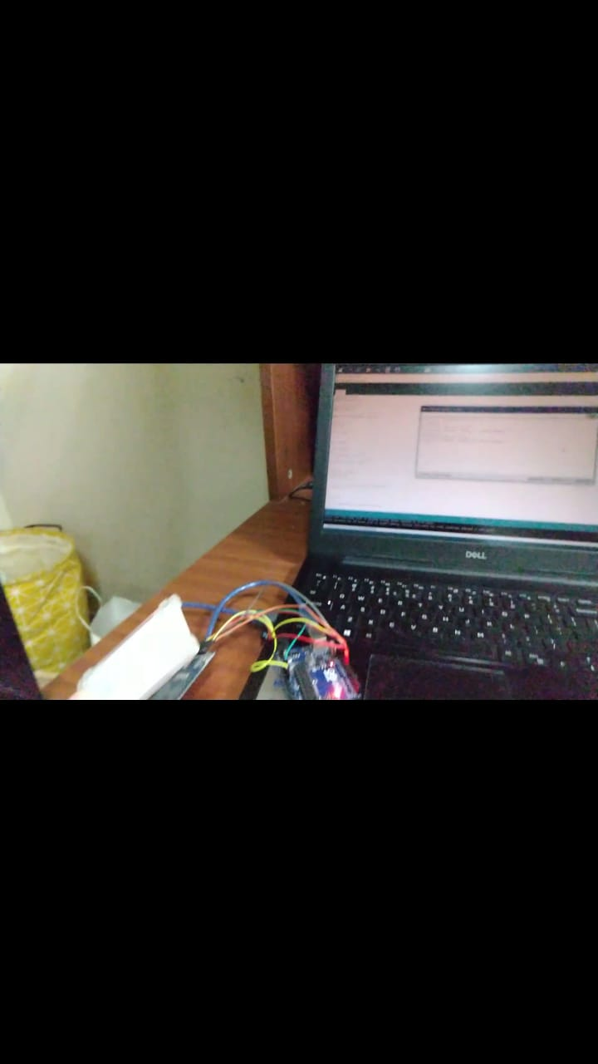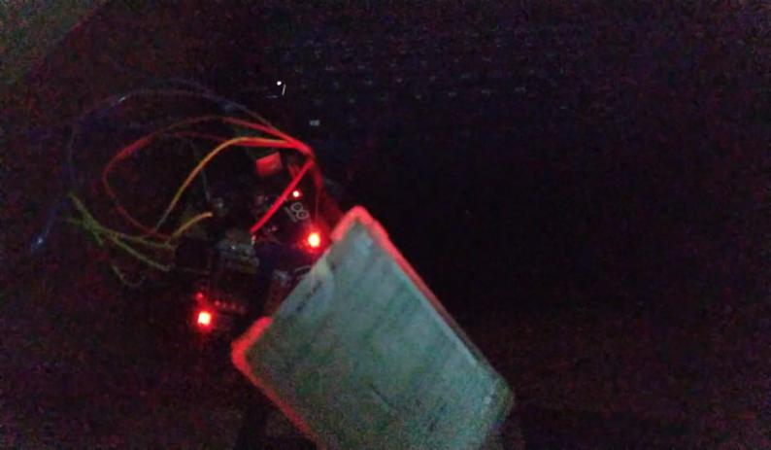

Till now we have written and executed the code. In above pictures our ID card of VIT is placed on RFID reader(em18 MODULE) and through our software and code answer generated is 94 75 83 54 .

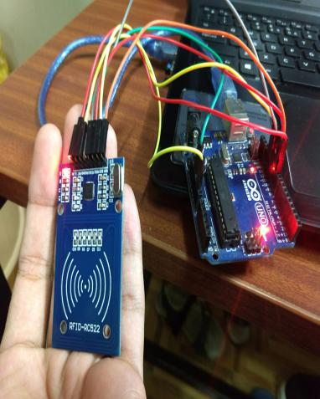FIRST WE TESTED WORKING OF RFID USING OUR VIT ID CARDS BY PLACING IT ON RFID READER CONNECTED TO ARDUINO. ARDUINO HERE WAS USED FOR BASIC TESTING BUT ARDUINO IS NOT USED IN OUR PROJECT.

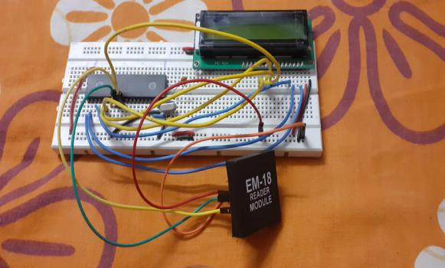

THIS PIC CONSISTS OF 8051 MICRCONTROLLER,16*2 LCD,CRSTAL OSCILLATOR,em-18 reader module

CIRCUIT CONNECTION(above picture)

**3.4 SUMMARY**

**We planned to use the isp programmer in college hich is in ece labs to dump code in micrcontroller,so we didn’t buy it. Now we don’t have isp programmer.**

We have to simulate the final model and see for errors if it occurs during execution.(TASK LEFT).

**Otherwise we have done 75% of the project. Code and hardware circuit is ready.**

**TROUBLESHOOTING AND RECTIFYING IS LEFT.**

**4 CONCLUSION & FUTURE ENHANCEMENT**

The design and implementation of a RFID primarily based automatic attendance gadget that's the intention and goal of this paper changed into effectively carried out. This gadget gives an effective and more handy technique of taking attendance when in comparison to the guide machine. data are more organized, the gadget is user pleasant, information manipulation and retrieval is accomplished through the graphical interface. The system may be implemented in any academic organization.

Further improvement can be undertaken on this project for better enhancement: A webcam can be integrated into the system to monitor the person who swaps the card, thus avoiding the problem of a person scanning in for another person. The attendance system can be enhanced to biometric technology which is a full proof technique that captures a person’s unique biological or physical features and prevents unauthorized activities.

**5 APPENDIX**

**Radio-frequency identification** (**RFID**) uses [electromagnetic fields](https://en.wikipedia.org/wiki/Electromagnetic_field) to automatically identify and track tags attached to objects. An RFID tag consists of a tiny radio transponder; a radio receiver and transmitter. When triggered by an electromagnetic interrogation pulse from a nearby RFID reader device, the tag transmits digital data, usually an identifying inventory number, back to the reader. This number can be used to inventory goods. There are two types. *Passive tags* are powered by energy from the RFID reader's interrogating [radio waves](https://en.wikipedia.org/wiki/Radio_wave). *Active tags* are powered by a battery and thus can be read at a greater range from the RFID reader; up to hundreds of meters. Unlike a [barcode](https://en.wikipedia.org/wiki/Barcode), the tag doesn't need to be within the line of sight of the reader, so it may be embedded in the tracked object. RFID is one method of [automatic identification and data capture](https://en.wikipedia.org/wiki/Automatic_identification_and_data_capture) (AIDC).

RFID tags are used in many industries. For example, an RFID tag attached to an automobile during production can be used to track its progress through the assembly line; RFID-tagged pharmaceuticals can be tracked through warehouses; and [implanting RFID microchips](https://en.wikipedia.org/wiki/Microchip_implant_(animal)) in livestock and pets enables positive identification of animals.

Since RFID tags can be attached to cash, clothing, and possessions, or implanted in animals and people, the possibility of reading personally-linked information without consent has raised serious privacy concerns.

The 8052 microcontroller is the 8051's "big brother." It is a slightly more powerful microcontroller, sporting a number of additional features which the developer may make use of:

* 256 bytes of Internal RAM (compared to 128 in the standard 8051).
* A third 16-bit timer, capable of a number of new operation modes and 16-bit reloads.
* Additional SFRs to support the functionality offered by the third timer.

**6 REFERENCES**

<https://circuitdigest.com/microcontroller-projects/rfid-based-attendance-system/>

<http://www2.keil.com/mdk5/uvision/>

<https://www.electronicshub.org/rfid-based-attendance-system/>

[**https://www.edgefx.in/rfid-based-attendance-system-circuit-and-working/**](https://www.edgefx.in/rfid-based-attendance-system-circuit-and-working/)

**BIO DATA**

1. **SRUTI VERMA(18BCE1005)**

Phone NO.: 6380886773

Email-id: sruti.verma2018@vitstudent.ac.in

1. **SHAUMAYA OJHA(18BCE1074)**

Phone NO.: 6900222306

Email-id: shaumaya.ojha2018@vitstudent.ac.in

1. **K.G. NITHESH GURUDAAS(18BCE1101)**

Phone NO.: 9994709300

Email-id: kg.nitheshgurudass2018@vitstudent.ac.in