create database test;

\c test--->to set as a data base

create table in PgAdimin

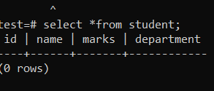

insert into student(id,name,marks,department)values(101,'Abiseck',65,'IT');

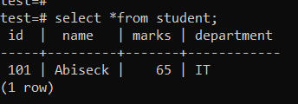

insert into student(id,name,marks,department)values(102,'Bala',75,'CSE');

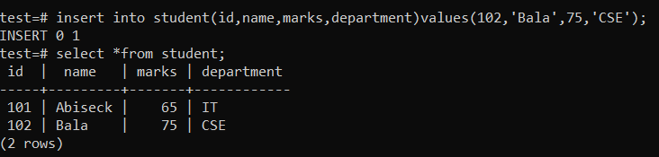

Alter table student add column course varchar(10);

insert into student(id,name,marks,department,course)values(103,'Chandru',58,'ECE','IOT');

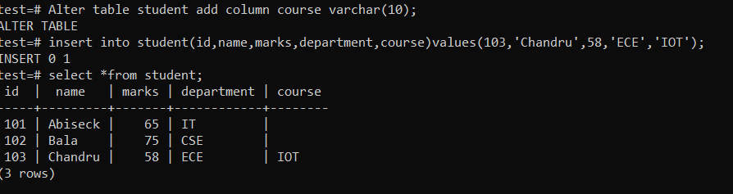

alter table student rename to student_details;

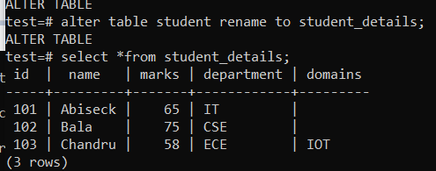

insert into student_details values(104,'Dhivaghar',54,'Mech','SM'),(105,'hari Kishore',88,'EEE','Eltro'),(106,'Jeffrin',77,'EIT','IOT');

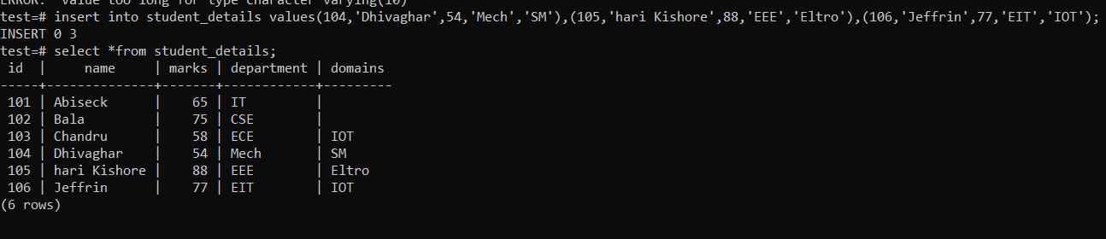

delete from student_details where id=102;

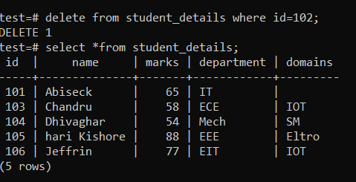

truncate table student_details;

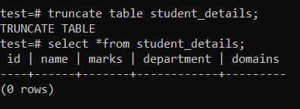

drop table student_details;

