FitPick
Digital Wardrobe & Outfit Planner
Project Report
Software Engineering · Final Project Submission (Part C)
Author Nithilan A (nithi0307)
Repository github.com/nithi0307/fitpick
Stack React 19 + Vite · FastAPI · PostgreSQL 16 · Docker

Contents
1. Problem statement
2. User stories
3. System architecture and system design
4. Design of tests
5. Appendix A — Software Requirements Specification
6. Appendix B — Data Flow Diagrams
7. Appendix C — Entity Relationship Diagram
8. Appendix D — UML diagrams
9. Appendix E — Code listing and GitHub link

1. Problem statement

1.1 The problem
Most people own far more clothes than they actually wear. Items get pushed to the back of a wardrobe and forgotten, near-duplicates are bought because nobody can remember what is already owned, and the outfit that worked well last month is never written down anywhere. The result is a daily decision that takes longer than it should and a wardrobe that is used at a fraction of its value.
The underlying difficulty is that a wardrobe has no index. A person can only see the few garments at the front of the rail, so there is no way to search it, no way to filter it by occasion or season, and no way to record a combination that worked. Existing shopping apps are built to sell new clothes, not to organise clothes already owned.
FitPick addresses this by giving the wardrobe a digital index. Every garment is recorded once with its category, colour, season, brand, size and price. From then on the collection can be searched, filtered and sorted in seconds, garments can be combined into named outfits that are saved for reuse, and the application reports what is actually owned and how often it is worn.

1.2 Who it is for
Persona | Situation | What FitPick gives them
Priya, 20  College student | A moderate wardrobe on a tight budget. Repeats the same few outfits and has bought duplicates by mistake. | A complete view of what she already owns, so she stops re-buying and starts re-combining.
Arjun, 29  Working professional | Needs formal and smart-casual looks ready for the week and has no time to decide each morning. | Saved outfits tagged by occasion, so getting dressed becomes choosing from a short list.
Meera, 24  Fashion enthusiast | A large wardrobe she enjoys experimenting with, but no record of what she has tried. | An outfit builder, favourites, and statistics about categories, colours and cost per wear.

1.3 Vision and objectives
Vision
To make wardrobe management simple and organised, so that every user can see what they own, plan outfits easily, and get more value from the clothes they already have.

The objectives that follow from this vision are:
- Record a garment with enough detail to find it again, in under thirty seconds.
- Make any garment findable by name, brand, category or season in a single interaction.
- Let a user assemble and save an outfit from existing garments, and reopen it later.
- Report honest statistics about the wardrobe — totals, favourites, most worn, value, wear rate.
- Run identically on any machine so the project can be demonstrated and marked reliably.

1.4 Scope
In scope | Out of scope for this version
Recording, editing and deleting clothing items | AI or machine-learning outfit recommendation
Searching, filtering and sorting the wardrobe | Weather-based or calendar-based suggestions
Building, saving and favouriting outfits | Social features — sharing, following, comments
Dashboard and wardrobe analytics | Shopping, price tracking or retailer integration
Profile screen and account details | Real authentication, sessions and multi-user accounts
Containerised local deployment | Cloud hosting, CI/CD pipeline, mobile applications

1.5 Constraints and assumptions
- Constraint — an academic project built by one developer against a fixed deadline, so the technology stack was kept deliberately small.
- Constraint — must run locally with free, open tooling; no paid cloud services.
- Constraint — no real authentication in this version, so the application is single-user. The database schema already carries a user_id on every record so that multi-user support is an addition rather than a rewrite.
- Assumption — users are willing to spend some initial effort entering their wardrobe, because the payoff is repeated daily.
- Assumption — photographs are optional. Text details alone are enough to make the wardrobe useful, so the application illustrates each garment from its category and colour.
- Assumption — users access FitPick from a laptop or phone browser; no native application is needed.

1.6 Success metrics
Metric | Target
Time to record a first clothing item after opening the app | under 2 minutes
Time to assemble and save an outfit | under 1 minute
Wardrobe search response for a 500-item wardrobe | under 1 second
Test users rating the interface “easy to use” or better | 80%

2. User stories
Requirements were captured as user stories, written as GitHub issues and prioritised with MoSCoW on a project board called FitPick Development Board. Fifteen stories were placed in Must Have — they define a usable product — and ten in Should Have. The Could Have and Won't Have columns were left empty on purpose: anything that did not serve the vision was kept out of the backlog entirely rather than parked in it.

2.1 Must Have
The Status column states honestly what exists today. “Full” means the story works end to end through the interface; “API” means the backend endpoint and its tests exist but no screen calls it yet; “UI only” means the screen exists but there is no backend behind it.
# | As a user I want to… | …so that | Status
1 | register an account | my wardrobe is private to me | UI only
2 | log in | I can reach my own wardrobe | UI only
3 | log out | I can leave the app safely on a shared computer | UI only
4 | add a clothing item | my wardrobe is recorded in one place | Full
5 | edit a clothing item | I can correct details I entered wrongly | API
6 | delete a clothing item | items I no longer own stop cluttering the list | API
7 | view my whole wardrobe | I can see everything I own at once | Full
8 | search my clothing | I can find one garment without scrolling | Full
9 | filter my clothing | I can narrow the wardrobe to what is relevant | Full
10 | create an outfit | I can reuse a combination that works | Full
11 | edit an outfit | I can adjust a saved look | Partial
12 | delete an outfit | outfits I no longer wear are removed | API
13 | save a favourite outfit | my best looks are easy to find | Partial
14 | view a dashboard | I get an overview without hunting for it | Full
15 | update my profile | my account details stay correct | UI only

2.2 Should Have
# | As a user I want to… | …so that | Status
16 | organise clothing into categories | the wardrobe has a structure I recognise | Full
17 | tag items and outfits by occasion | I can dress for the day's plan | Full
18 | see recently added clothing | I notice what I have just logged | Full
19 | see wardrobe statistics | I understand what I actually own | Full
20 | upload a photo of an item | I recognise the garment visually | UI only
21 | favourite individual clothing items | my go-to pieces are one click away | Full
22 | view the details of one item | I can check size, brand and notes | API
23 | sort my clothing | I can see newest, most worn or most expensive first | Full
24 | view my outfit history | I can return to looks I built before | Partial
25 | change my password | my account stays secure | UI only

2.3 Delivery summary
Status | Count | Meaning
Full | 12 | Working end to end from the interface against the API and database
Partial | 3 | Core behaviour works; one part of the story is still missing
API only | 4 | Endpoint implemented and tested, but no screen calls it yet
UI only | 6 | Screen exists; the supporting backend is listed as future work
Total | 25 | 15 Must Have and 10 Should Have

2.4 A story in full
Each story carries acceptance criteria. Story 4 is shown in full as an example of how the backlog items were written:
Story 4 — Add Clothing Item
As a FitPick user I want to add a clothing item with its details so that my wardrobe is recorded in one place.

Acceptance criteria
1. The form captures name, category, subcategory, colour, season, brand, size, price, tags and notes.
2. Name, category and colour are required; everything else is optional.
3. The category must be one of the six defined categories, and an unknown value is rejected.
4. On save the item appears immediately in My Wardrobe and in the dashboard totals.
5. The user is returned to My Wardrobe after a successful save.

Criteria 3 and 4 are each covered by an automated test — test_rejects_unknown_category and test_dashboard_updates_after_adding_an_item. The full traceability from stories to tests is in Section 4.5.

3. System architecture and system design

3.1 Architecture style
FitPick uses a layered (three-tier) architecture. The presentation tier is a React single-page application; the application tier is a FastAPI REST service holding all business rules; the data tier is PostgreSQL. Calls travel downwards only — the browser talks to the API, the API talks to the database, and no tier skips a level or calls upwards. All three run as separate containers defined in docker-compose.yml.
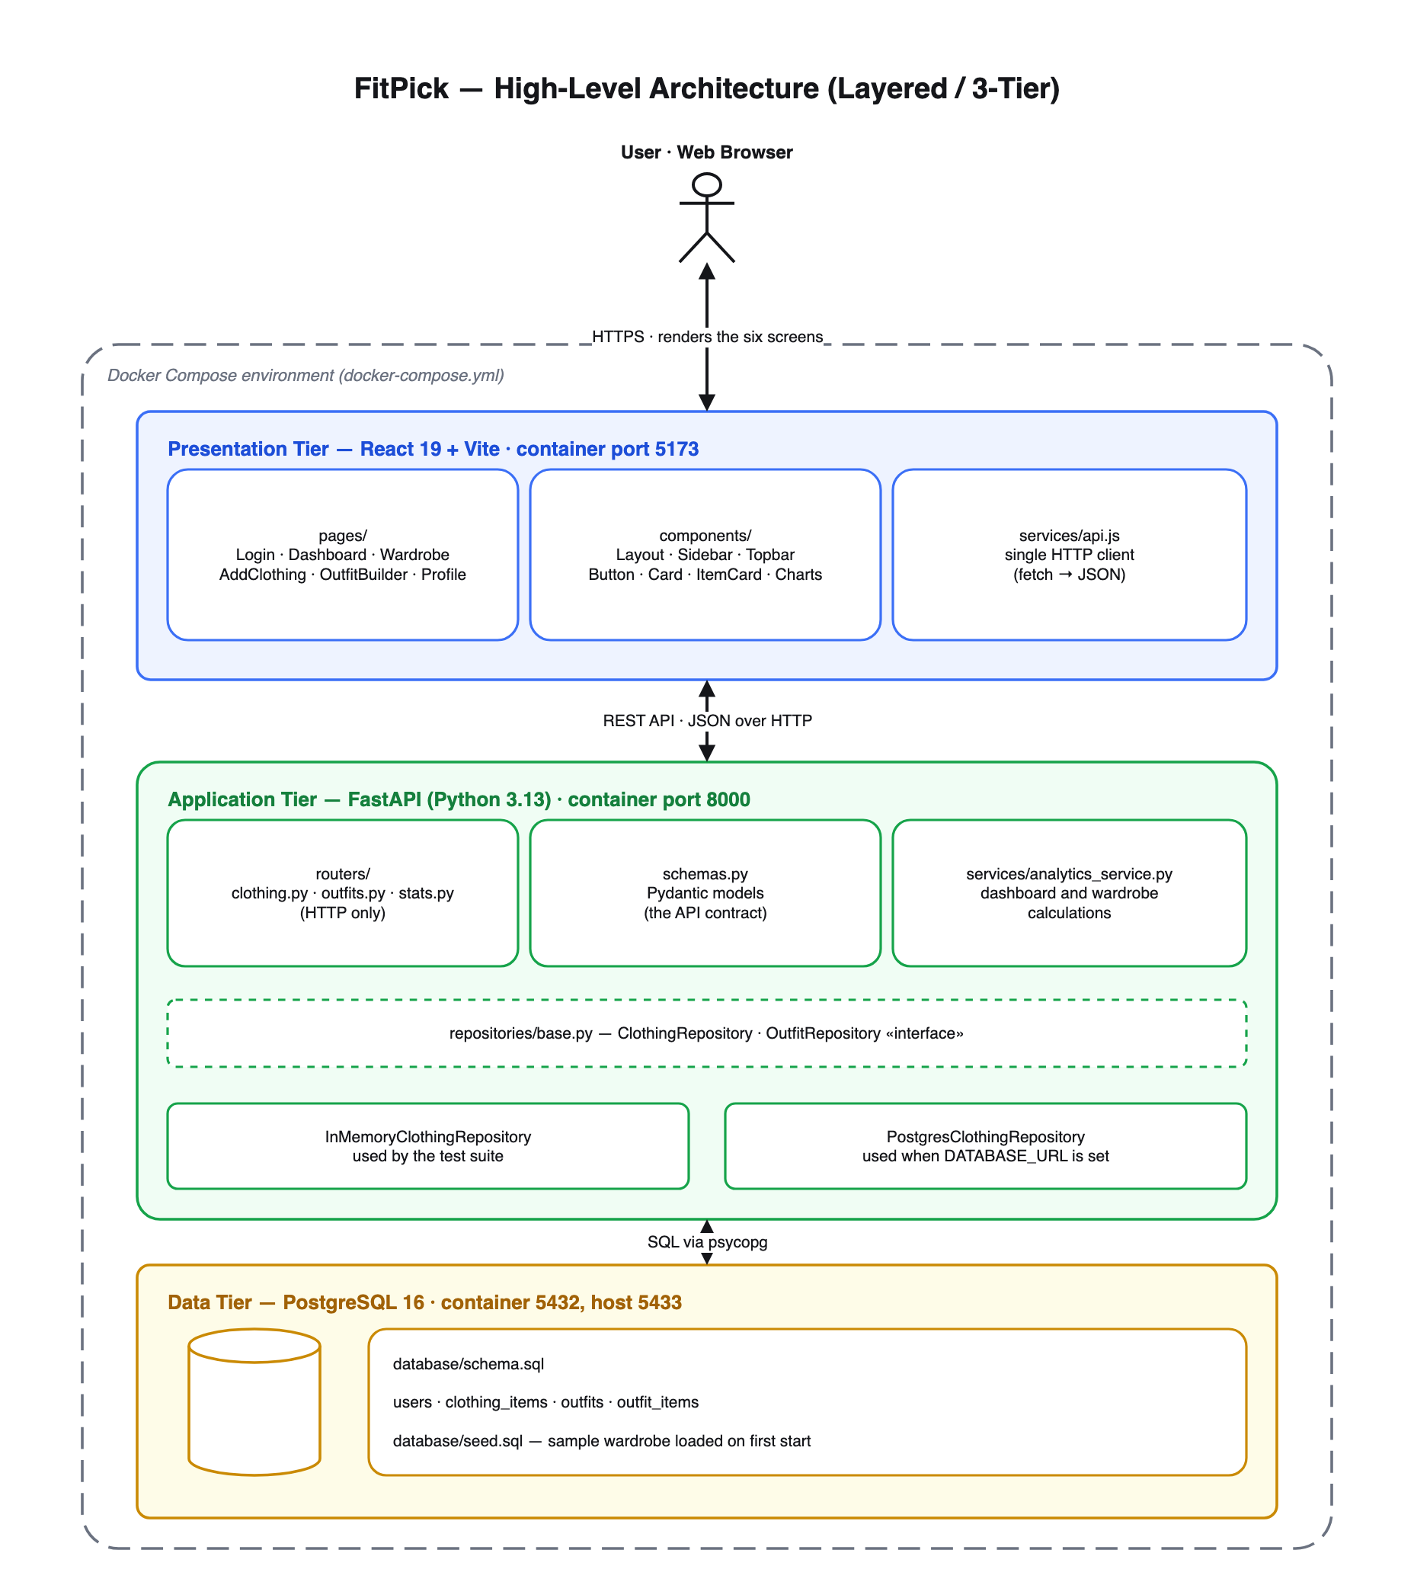
Figure 1 — FitPick high-level architecture (editable source: docs/design/architecture/fitpick-architecture.drawio)

3.2 Why this style was chosen
- It fits the problem. FitPick is a CRUD application over a small relational model. A layered design is the standard, proven shape for that, and it avoids the operational cost of micro-services for a system that has one developer and one database.
- It enforces separation of concerns. The UI never writes SQL and the database never knows React exists, so each tier can be understood, tested and replaced on its own.
- It supports independent evolution. The React app can be restyled, the API can gain endpoints and the schema can be tuned without any of those changes rippling outwards.
- It is simple to build and explain. One command starts the whole system, and the single diagram above describes it completely.
- It leaves room to grow. Authentication, image storage or outfit suggestions are added as new modules inside the existing tiers, not as a restructure.

3.3 Module responsibilities
Module | Responsibility | Must not
frontend/src/pages/ | One file per screen; holds screen state and arranges components | know the backend URL or build HTTP requests
frontend/src/components/ | Reusable presentation — Layout, Sidebar, Topbar, Button, Card, ItemCard, Charts | know which screen is rendering it
frontend/src/services/api.js | The only module that talks to the backend; returns plain objects | contain screen logic or formatting
backend/routers/ | Translate HTTP to repository and service calls, and set status codes | contain storage logic or calculations
backend/schemas.py | Pydantic models that define the API contract and validate input | know how data is stored
backend/services/ | Business calculations for the dashboard and analytics | perform I/O or know about HTTP
backend/repositories/ | Storage behind one interface, with in-memory and PostgreSQL implementations | know about HTTP or business rules
database/ | Schema and seed data | contain application logic

3.4 Design principles in the code

Abstraction
Each layer exposes a small, stable interface and hides how it works. Pages never call fetch; they call named functions such as getClothingItems() and receive plain objects. Routers never touch storage; they call a repository that offers six methods. Because the routers depend only on those method names, FitPick can run against an in-memory store or PostgreSQL with no change to any endpoint:
backend/repositories/__init__.py — one place decides which storage is used
def _build() -> tuple[ClothingRepository, OutfitRepository]:
dsn = os.environ.get("DATABASE_URL")
if dsn:
from repositories.postgres_repository import (
PostgresClothingRepository,
PostgresOutfitRepository,
)
return PostgresClothingRepository(dsn), PostgresOutfitRepository(dsn)

clothing = InMemoryClothingRepository()
return clothing, InMemoryOutfitRepository(clothing)

Modularity
The codebase is a set of small files with one job each: six page files matching the six designed screens, seven shared components, one API client, three routers, one schema module, one service and one repository per entity. Adding a feature means adding a module, not editing existing ones — a new backend feature is a new router plus one line:
backend/main.py
from routers import clothing, outfits, stats

app.include_router(clothing.router)
app.include_router(outfits.router)
app.include_router(stats.router)

Cohesion
Sidebar.jsx only renders navigation. Button.jsx only renders a styled button and knows nothing about what happens on click. analytics_service.py only calculates figures and performs no I/O. routers/clothing.py only handles HTTP concerns such as 404s and status codes. Most files are under sixty lines, and each one can be read and tested on its own.

Low coupling
Modules communicate only through explicit interfaces: React props, the single api.js client, the Pydantic schemas, and the repository interface. Layout renders pages through React Router's <Outlet />, so the shell never imports a page and pages never import the sidebar:
frontend/src/components/Layout.jsx
* so the shell never imports a page and pages never import the sidebar.
*/
export default function Layout() {
return (
<div className="layout">
<Sidebar />
<div className="main">
<Outlet />
</div>
</div>
);
}

3.5 User interface design
The six screens were designed in Figma and then implemented as six React pages with the same names. The brand mark returns to the Dashboard from anywhere, and the account chip opens a menu holding profile, settings and log out. They share one design system: royal blue #3B6FF6 for primary actions and the active navigation item, white cards with rounded corners and soft shadows on a light grey #F6F7F9 ground, and a single sans-serif typeface.
Decision | Effect on usability
One fixed sidebar on every screen after login | Navigation never moves, so the layout is learned once
Exactly one blue primary button per screen | The next step is always obvious; everything else is secondary
The same card used for items, outfit slots and statistics | Content is recognised instantly across screens
Search and filters sit directly above the wardrobe grid | Supports the “find an item in seconds” objective
Short labelled forms with placeholder examples | Reduces the effort of the one tedious task — data entry
Explicit loading and error messages | The user is never left looking at a blank screen
Garments drawn from category and colour when no photo exists | The wardrobe looks complete from the first item

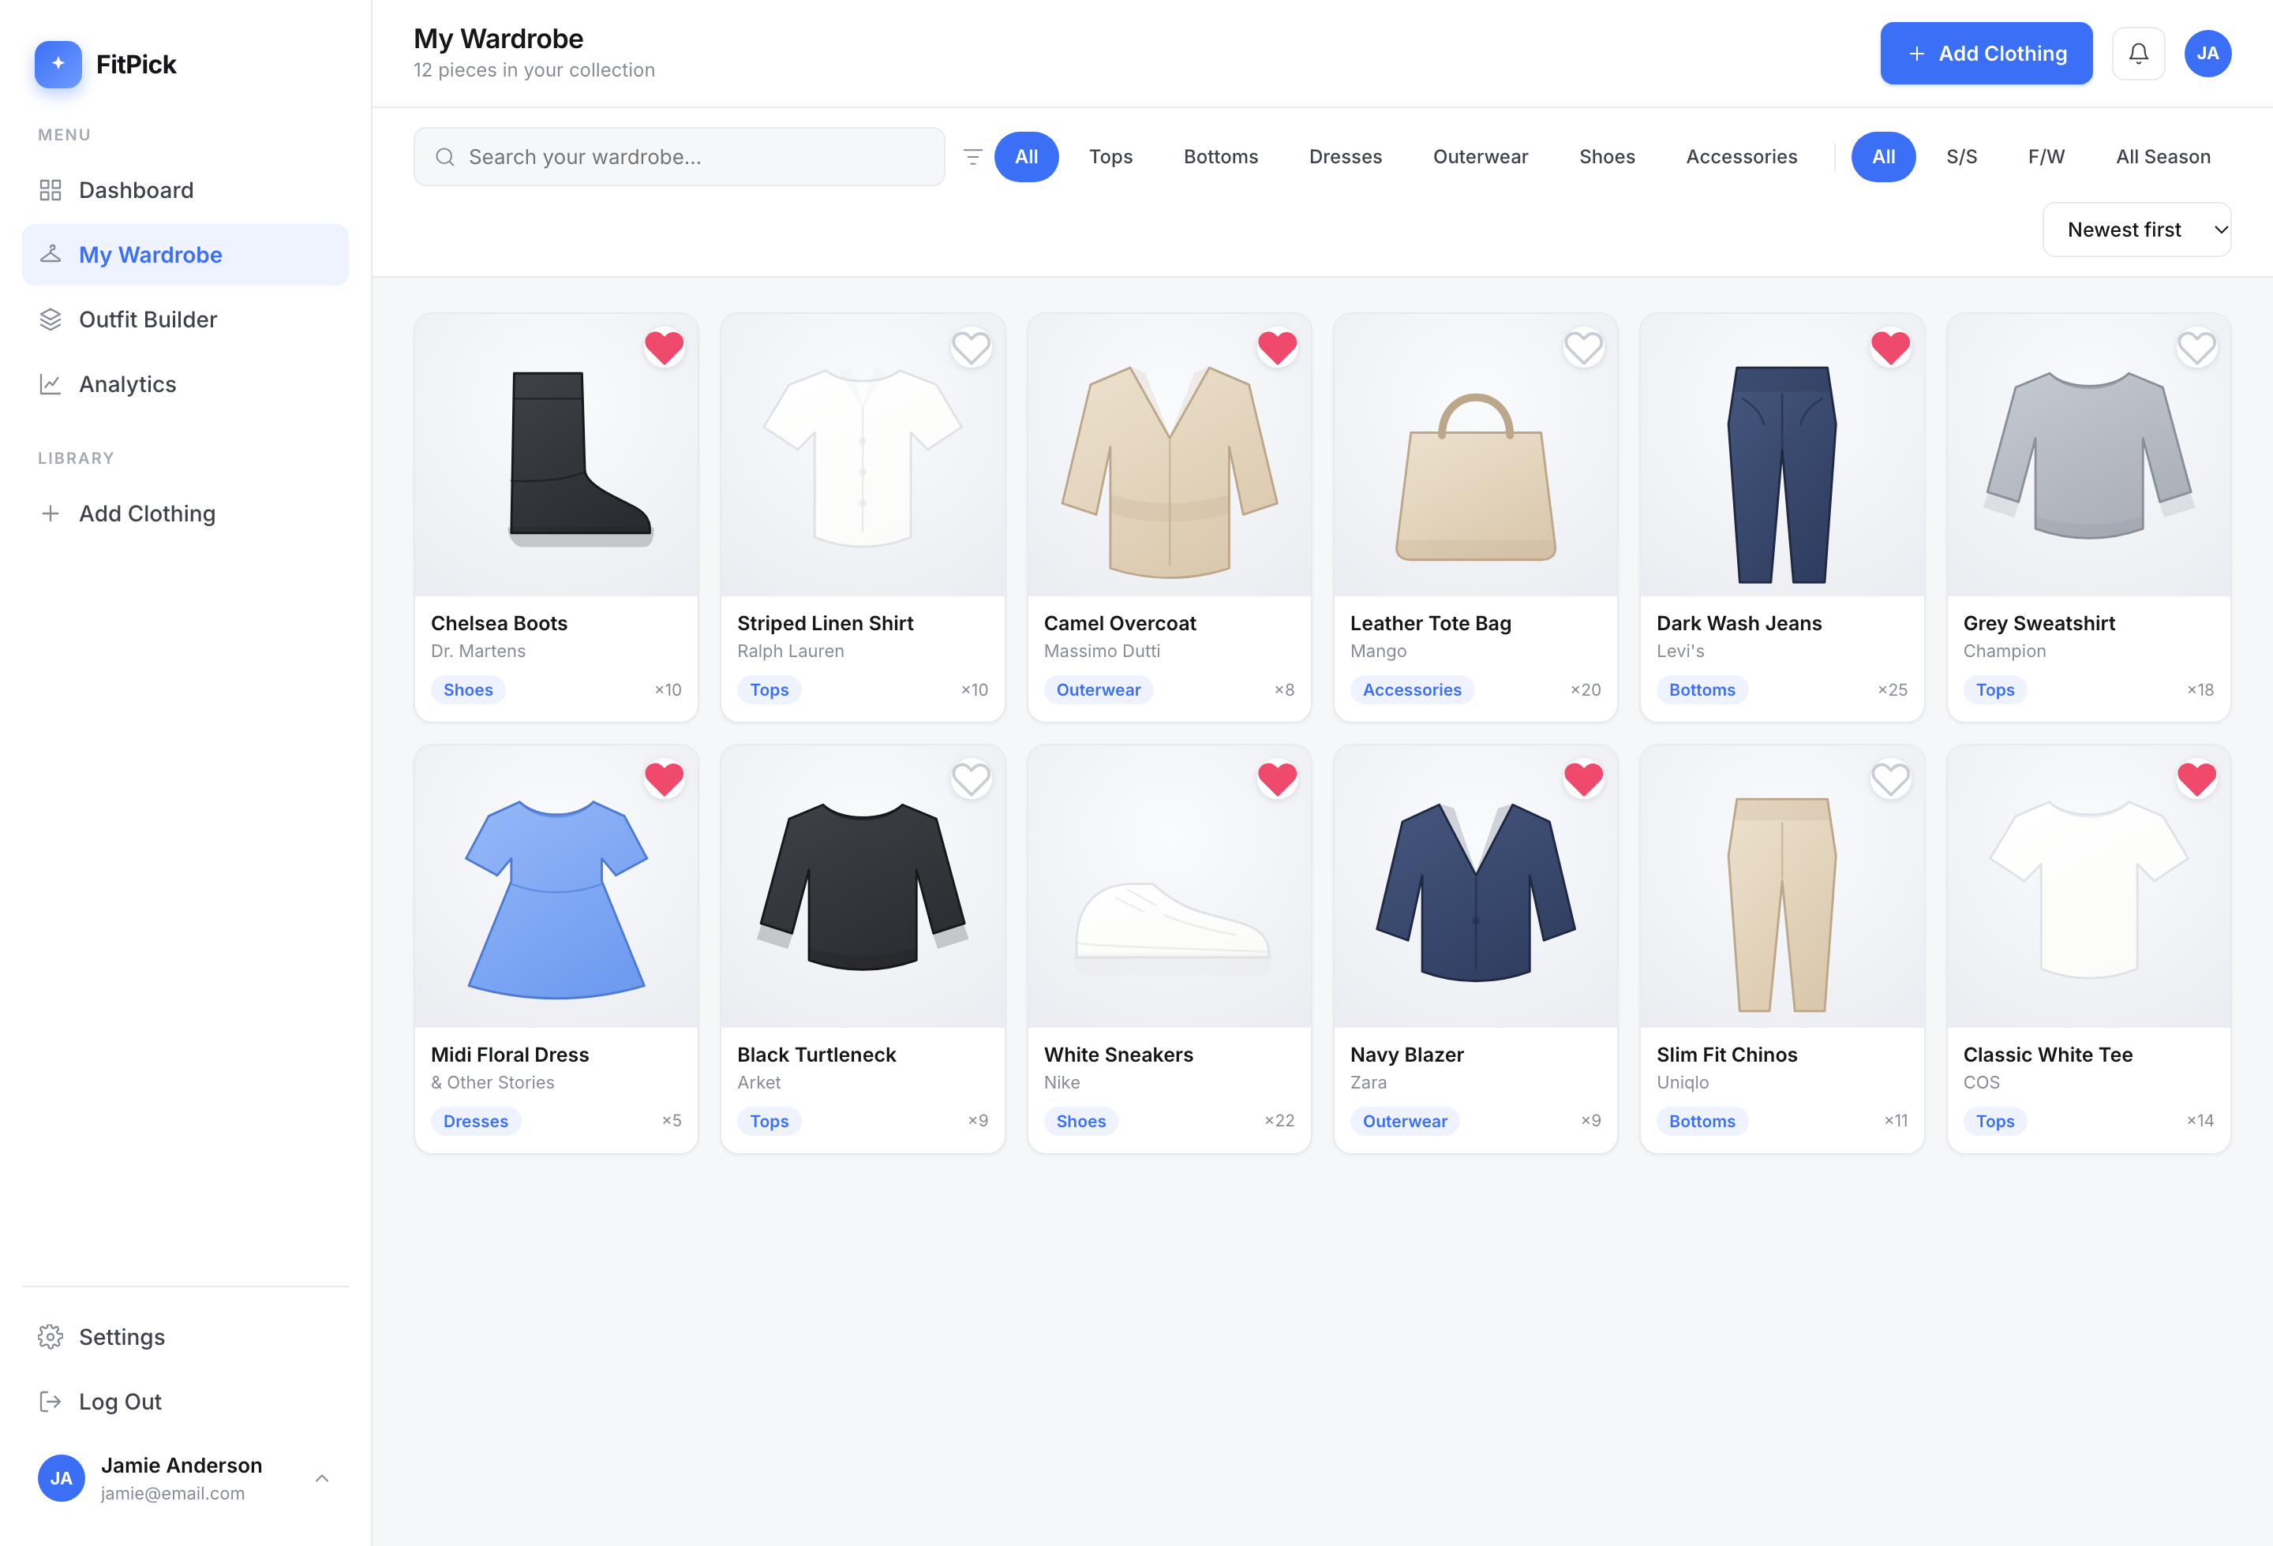
Figure 2 — My Wardrobe: the design system applied. The other five screens are in Part A, Section 8.

3.6 Key design decisions
Decision | Alternative considered | Why this one
Layered 3-tier architecture | Micro-services | One developer, one database and a CRUD workload; micro-services would add deployment cost and no benefit
Repository interface with two implementations | Calling SQL directly from routers | The test suite runs with no database, and the storage engine can change without touching an endpoint
Separate analytics service | Calculations inside routers | Keeps calculations testable without HTTP and keeps routers cohesive
Pydantic schemas as the API contract | Hand-written validation | Validation, serialisation and the OpenAPI documentation all come from one definition
Normalised PostgreSQL schema with a join table | Storing outfit items as a JSON array | An outfit-to-item link is genuinely many-to-many; foreign keys keep it consistent
SVG garments generated from category and colour | Bundled stock photographs | No licensing or storage concern, consistent look, and real photo upload can replace it later
Hand-drawn SVG charts | A charting library | Two chart shapes did not justify roughly 100 kB of dependency
Docker Compose for the whole stack | Manual local installation | One command reproduces the exact environment on any machine

4. Design of tests
Tests were designed from the acceptance criteria of the user stories, not written afterwards to match the code. Three levels are used, and a fourth technique — mutation testing — measures whether those tests are actually strong. The full run output is in Part A; this section explains how the cases were designed.

4.1 Test levels and their purpose
Level | What it proves | Tests
Unit | One calculation is correct in isolation, including its boundaries | 11
Integration | Router, validation, serialisation and storage work together over real HTTP | 25
Regression | A fault that was found once cannot return | 10
Mutation | The tests above would actually fail if the code were wrong | 30 mutants

4.2 Test-case design techniques
Cases were derived using standard black-box techniques rather than chosen arbitrarily:
Technique | Applied to | Cases produced
Equivalence partitioning | The category field: valid categories vs. anything else | One valid category is accepted; “Hats” is rejected with HTTP 422
Boundary value analysis | “Added this week”, which uses a seven-day cut-off | Items 0, 7 and 8 days old; only the first two count
Boundary value analysis | Rounding of wardrobe value and average wears | Values chosen to produce a third decimal place and a repeating decimal
State transition testing | The favourite flag on an item | Off → on → off must return to the original value
Error guessing | A brand-new account with nothing in it | Empty wardrobe must not divide by zero or call max() on an empty list
Interface testing | Every REST endpoint | Correct status codes: 200, 201, 204, 404, 422

4.3 Representative test cases
ID | Pre-condition | Action | Expected result
TC-01 | Seeded wardrobe of 12 items | POST /clothing with a valid body | 201 Created; the item is returned with a new id and appears in the list
TC-02 | Seeded wardrobe | POST /clothing with category “Hats” | 422 Unprocessable Entity; nothing is stored
TC-03 | Seeded wardrobe | GET /clothing?search=levi | Only “Dark Wash Jeans” is returned (brand match)
TC-04 | Seeded wardrobe | GET /clothing?category=Shoes | Exactly the two Shoes items are returned
TC-05 | Item 5 is not a favourite | POST /clothing/5/favourite twice | is_favourite returns to its original value
TC-06 | No item with id 9999 | DELETE /clothing/9999 | 404 Not Found
TC-07 | Seeded wardrobe | GET /stats/dashboard | total_items equals the number of items; the breakdown sums to the same number
TC-08 | Empty wardrobe | analytics_stats(repository) | average_wears is 0.0 and top_category is the placeholder, with no exception
TC-09 | Items 0, 7 and 8 days old | dashboard_stats(...) | added_this_week is 2
TC-10 | Outfit does not exist | POST /outfits with item_ids = [] | 422 Unprocessable Entity

4.4 Test data strategy
A twelve-item seed wardrobe is defined once in backend/seed_data.py and mirrored in database/seed.sql, so the tests, the development database and the screenshots all describe the same wardrobe. Tests that need a different shape of data build their own: the empty_wardrobe fixture supplies an unseeded repository pair for edge-case work.
backend/tests/test_analytics_unit.py — a helper builds precise data for boundary cases
item = repo.add(ClothingItemCreate(
name=name, category=category, colour=colour, brand=brand, price=price
))
item.times_worn = worn
item.created_at = date.today() - timedelta(days=days_old)
return item

4.5 Traceability: user story to test
Every Must Have story with implemented behaviour is covered by at least one automated test:
Story | Covering tests
4 Add clothing item | test_add_item_then_read_it_back, test_add_item_increases_wardrobe_count, test_rejects_unknown_category, test_rejects_item_without_a_name
5 Edit clothing item | test_update_item_changes_only_given_fields, test_reg07_updating_one_field_keeps_the_others
6 Delete clothing item | test_delete_item_removes_it, test_reg02_deleting_a_missing_item_is_a_404
7 View wardrobe | test_seeded_wardrobe_is_returned
8 Search clothing | test_search_matches_item_name, test_reg01_search_also_matches_the_brand, test_reg08_search_is_case_insensitive
9 Filter clothing | test_filter_by_category, test_reg03_category_all_does_not_filter_anything_out
10 Create outfit | test_create_outfit_from_existing_items, test_outfit_needs_at_least_one_item, test_outfit_rejects_unknown_item
12 Delete outfit | test_delete_outfit
13 Favourite outfit | test_favourite_an_outfit
14 View dashboard | test_dashboard_totals_match_the_wardrobe, test_breakdown_adds_up_to_the_total, test_reg10_deleted_item_disappears_from_the_statistics
19 Wardrobe statistics | test_analytics_wardrobe_value_is_the_sum_of_prices, test_average_wears_is_the_mean_rounded_to_one_decimal, plus 6 more unit tests
21 Favourite clothing items | test_toggle_favourite_flips_the_flag, test_reg06_favourite_toggles_back_to_its_original_value
23 Sort clothing items | test_sort_by_most_worn

4.6 Results
Test outcome
46 of 46 tests pass.
Mutation score 100% (30 of 30 mutants killed), improved from 60% after eleven mutation-driven unit tests were added.
Frontend: ESLint clean and the production build succeeds.
Stories 1–3, 15, 20 and 25 are not covered by automated tests because their backend does not exist yet; they are listed as future work rather than claimed as complete.

5. Appendix A — Software Requirements Specification

A.1 Purpose
This appendix specifies what the FitPick software must do. It is written for the developer and the assessor, and is the reference against which the tests in Section 4 were designed.

A.2 Product perspective
FitPick is a self-contained web application with no dependency on an external system. It consists of a browser client, a REST API and a relational database, deployed together as three containers. It replaces no existing system; it fills a gap between a shopping app and a spreadsheet.

A.3 Functional requirements
ID | Requirement | Priority | Status
FR-01 | The system shall allow a user to record a clothing item with name, category, subcategory, colour, season, brand, size, price, tags and notes. | Must | Done
FR-02 | The system shall reject a clothing item whose category is not one of the six defined categories. | Must | Done
FR-03 | The system shall reject a clothing item with no name or no colour. | Must | Done
FR-04 | The system shall list all clothing items belonging to the user. | Must | Done
FR-05 | The system shall filter clothing items by free-text search over name and brand. | Must | Done
FR-06 | The system shall filter clothing items by category and by season. | Must | Done
FR-07 | The system shall sort clothing items by newest, name, most worn or price. | Should | Done
FR-08 | The system shall update any subset of a clothing item's fields, leaving the others unchanged. | Must | Done
FR-09 | The system shall delete a clothing item, and return 404 if it does not exist. | Must | Done
FR-10 | The system shall toggle the favourite flag on a clothing item. | Should | Done
FR-11 | The system shall create an outfit from one or more existing clothing items. | Must | Done
FR-12 | The system shall reject an outfit with no items or with an unknown item id. | Must | Done
FR-13 | The system shall list saved outfits and allow one to be reopened for editing. | Must | Partial
FR-14 | The system shall delete an outfit and toggle its favourite flag. | Must | Done
FR-15 | The system shall report total items, total outfits, favourites, most-worn item, items added in the last seven days and a per-category breakdown. | Must | Done
FR-16 | The system shall report wardrobe value, average wears per item, top category, favourite brand and a colour breakdown. | Should | Done
FR-17 | The system shall allow a user to register, log in and log out. | Must | Future
FR-18 | The system shall allow a user to update profile details and change password. | Must | Future
FR-19 | The system shall store an uploaded photograph for a clothing item. | Should | Future

A.4 Non-functional requirements
ID | Category | Requirement
NFR-01 | Performance | A wardrobe query shall return in under one second for a wardrobe of 500 items.
NFR-02 | Usability | A new user shall be able to record their first item within two minutes.
NFR-03 | Portability | The system shall build and run on any machine with Docker, using one command.
NFR-04 | Maintainability | No module shall depend on the internals of another; all communication is through defined interfaces.
NFR-05 | Testability | The automated test suite shall run without a database and complete in under five seconds.
NFR-06 | Reliability | The system shall behave correctly for an empty wardrobe and for missing records.
NFR-07 | Security | Passwords shall be stored as hashes; the schema provides password_hash rather than a plain field.
NFR-08 | Compatibility | The interface shall work in current versions of Chrome, Safari, Firefox and Edge.

A.5 External interfaces
Interface | Description
User interface | Six browser screens served by Vite on port 5173, described in Section 3.5
API interface | A JSON REST API on port 8000; the OpenAPI description is generated at /docs
Database interface | PostgreSQL 16 on container port 5432, published on host port 5433, reached with psycopg
Configuration | DATABASE_URL selects PostgreSQL storage; VITE_API_URL overrides the backend address

A.6 API specification
Method and path | Purpose | Success
GET / | Service banner and version | 200
GET /health | Liveness probe | 200
GET /clothing | List items, with search, category, season and sort parameters | 200
GET /clothing/categories | The six valid categories | 200
GET /clothing/{id} | One item | 200 / 404
POST /clothing | Create an item | 201 / 422
PUT /clothing/{id} | Partially update an item | 200 / 404
POST /clothing/{id}/favourite | Toggle the favourite flag | 200 / 404
DELETE /clothing/{id} | Delete an item | 204 / 404
GET /outfits | List saved outfits | 200
GET /outfits/occasions | The six valid occasions | 200
POST /outfits | Create an outfit | 201 / 422
POST /outfits/{id}/favourite | Toggle the favourite flag | 200 / 404
DELETE /outfits/{id} | Delete an outfit | 204 / 404
GET /stats/dashboard | Dashboard figures | 200
GET /stats/analytics | Analytics figures | 200

6. Appendix B — Data Flow Diagrams
The data flow diagrams describe FitPick in terms of the data that moves through it. The context diagram shows the system as a single process with its one external entity; the level 1 diagram decomposes that process into the five activities the system performs and the four stores it keeps.

B.1 Context diagram (Level 0)
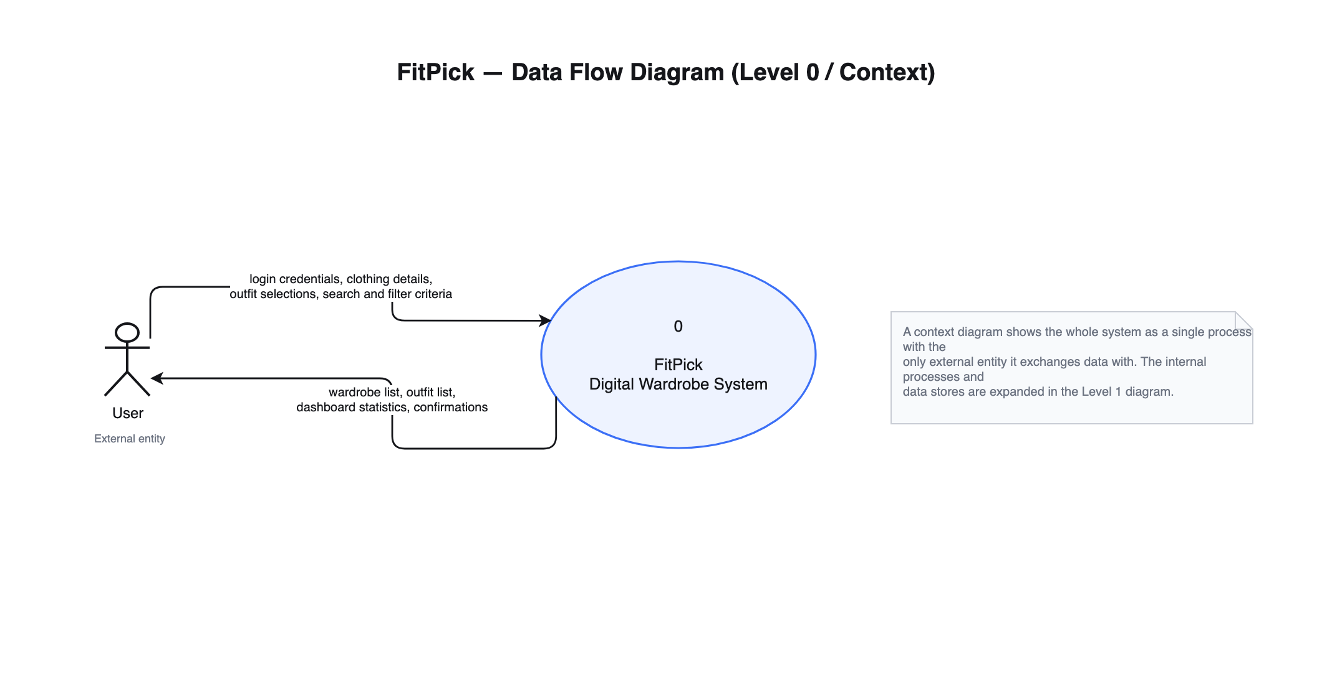
Figure 3 — Level 0 context diagram

B.2 Level 1 diagram
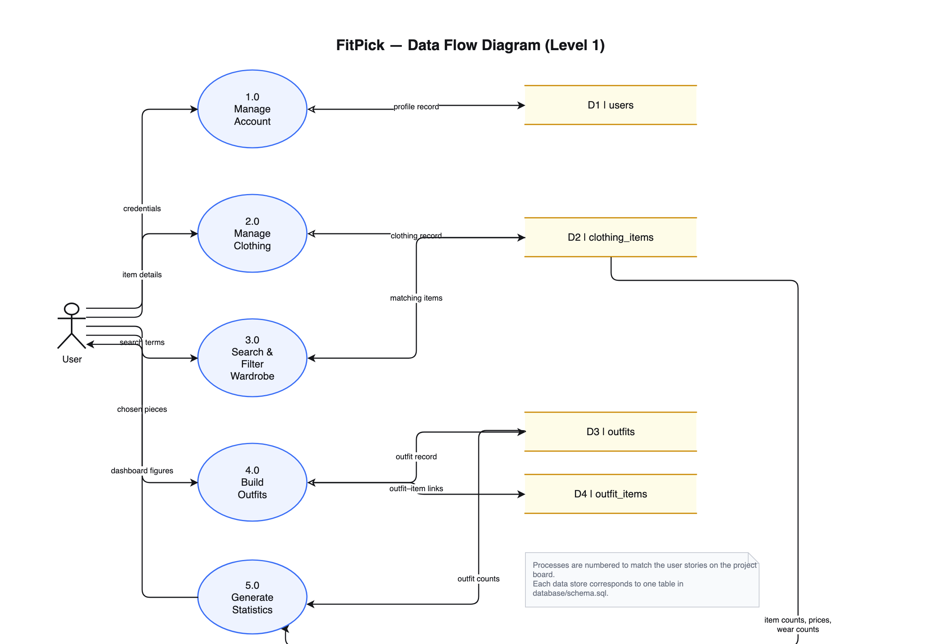
Figure 4 — Level 1 data flow diagram. Each data store maps to one table in database/schema.sql.

B.3 Process descriptions
Process | Input | Processing | Output
1.0 Manage Account | Credentials, profile details | Validate and persist the user record | Confirmation; profile record in D1
2.0 Manage Clothing | Item details, item id | Validate against the schema, then create, update or delete | Clothing record in D2; confirmation
3.0 Search & Filter Wardrobe | Search text, category, season, sort order | Read D2 and apply the filters and ordering in turn | The matching list of items
4.0 Build Outfits | Chosen item ids, name, occasion | Check every item exists, then write the outfit and its links | Outfit in D3; links in D4
5.0 Generate Statistics | Item and outfit records | Count, sum, average and rank | Dashboard and analytics figures

7. Appendix C — Entity Relationship Diagram
FitPick stores four entities. A user owns many clothing items and creates many outfits; an outfit contains many clothing items and a clothing item can appear in many outfits, so that relationship is resolved by the outfit_items join table.
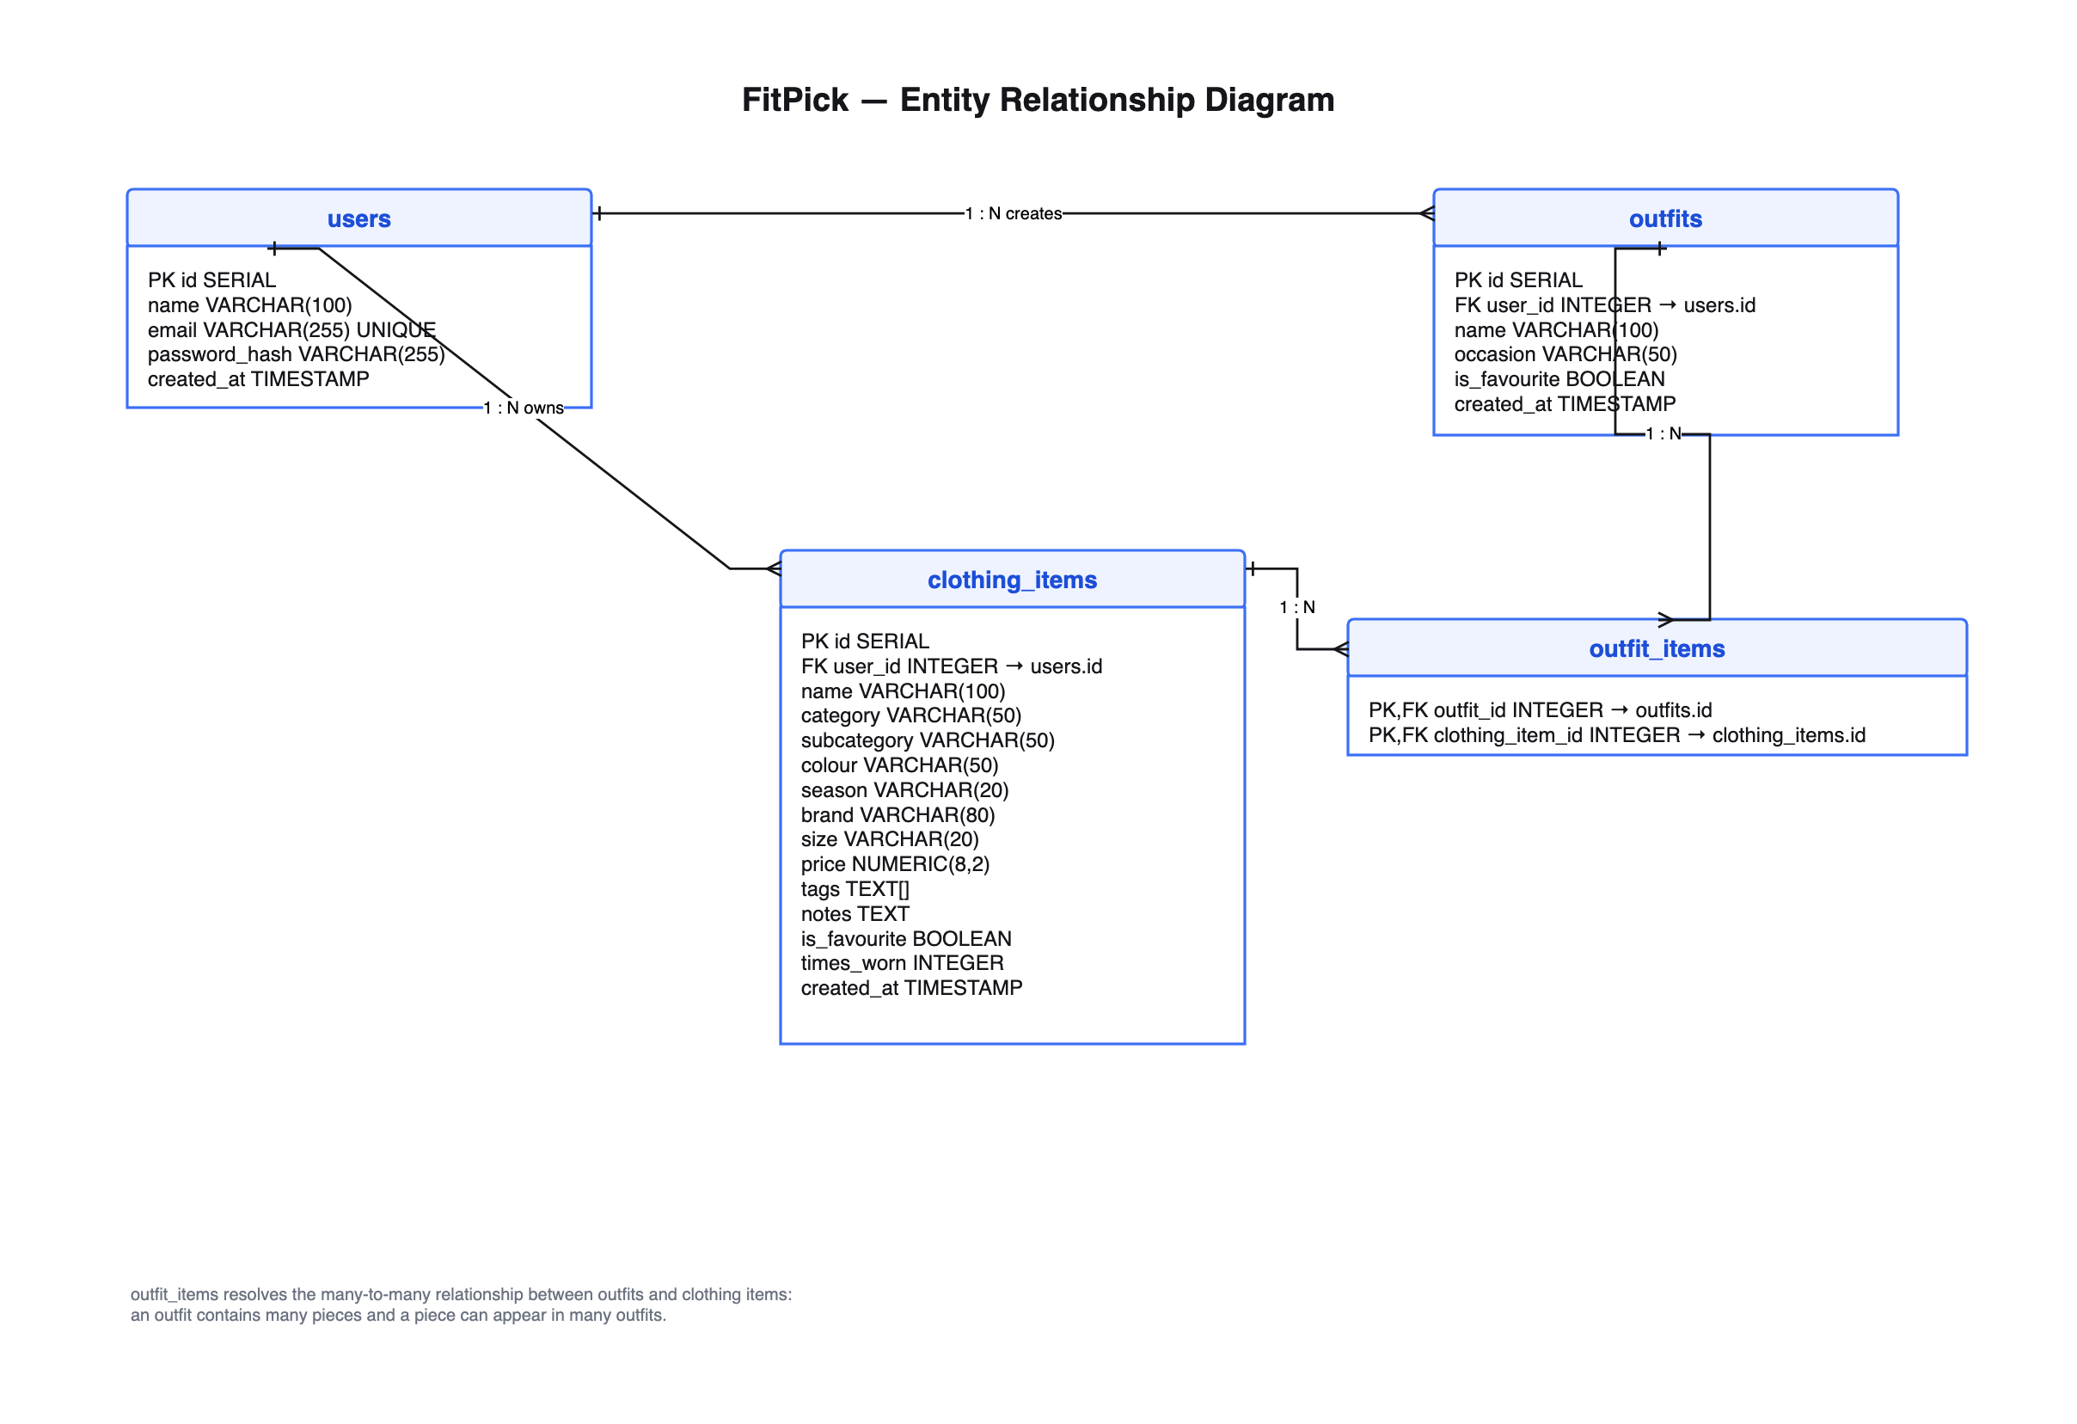
Figure 5 — Entity relationship diagram (crow's-foot notation)

C.1 Data dictionary — clothing_items
Column | Type | Constraint | Meaning
id | SERIAL | Primary key | Surrogate identifier
user_id | INTEGER | FK → users.id, NOT NULL | Owner of the garment
name | VARCHAR(100) | NOT NULL | Display name, e.g. “Navy Blazer”
category | VARCHAR(50) | NOT NULL | One of six: Tops, Bottoms, Outerwear, Shoes, Dresses, Accessories
subcategory | VARCHAR(50) | Default '' | Finer type, e.g. Blazer, Jeans, Sneakers
colour | VARCHAR(50) | NOT NULL | Primary colour; also selects the garment illustration tint
season | VARCHAR(20) | Default 'All Season' | S/S, F/W or All Season
brand | VARCHAR(80) | Default '' | Used by search and by the favourite-brand statistic
size | VARCHAR(20) | Default '' | Free text, because sizing differs by brand
price | NUMERIC(8,2) | Default 0 | Price paid; feeds the wardrobe-value statistic
tags | TEXT[] | Default '{}' | Occasion tags such as Casual or Office
notes | TEXT | Default '' | Free text, e.g. care instructions
image_url | TEXT | Nullable | Reserved for the photo-upload story
is_favourite | BOOLEAN | Default FALSE | Marked by the heart control in the wardrobe grid
times_worn | INTEGER | Default 0 | Wear counter; feeds most-worn and average-wears
created_at | TIMESTAMP | Default NOW() | Used by “recently added” and “added this week”

C.2 Other tables
Table | Columns | Notes
users | id, name, email (unique), password_hash, created_at | A password hash is stored, never a plain password
outfits | id, user_id, name, occasion, is_favourite, created_at | Occasion is one of six values used by the Outfit Builder
outfit_items | outfit_id, clothing_item_id | Composite primary key; both columns cascade on delete

C.3 Referential integrity
Every foreign key uses ON DELETE CASCADE, so deleting a user removes their wardrobe and outfits, and deleting a garment removes it from every outfit that referenced it. This prevents orphan rows without any application-level clean-up code.
database/schema.sql — the join table that resolves the many-to-many relationship
-- Join table: which clothing items make up an outfit (many-to-many)
CREATE TABLE IF NOT EXISTS outfit_items (
outfit_id INTEGER NOT NULL REFERENCES outfits(id) ON DELETE CASCADE,
clothing_item_id INTEGER NOT NULL REFERENCES clothing_items(id) ON DELETE CASCADE,
PRIMARY KEY (outfit_id, clothing_item_id)
);

CREATE INDEX IF NOT EXISTS idx_clothing_user ON clothing_items (user_id);
CREATE INDEX IF NOT EXISTS idx_clothing_category ON clothing_items (category);
CREATE INDEX IF NOT EXISTS idx_outfits_user ON outfits (user_id);

8. Appendix D — UML diagrams

D.1 Use case diagram
Two actors interact with FitPick. A Guest can only register or log in. A Registered User reaches everything else. The grouped use cases on the left are the ones a user starts directly; each includes the detailed sub-functions on the right.
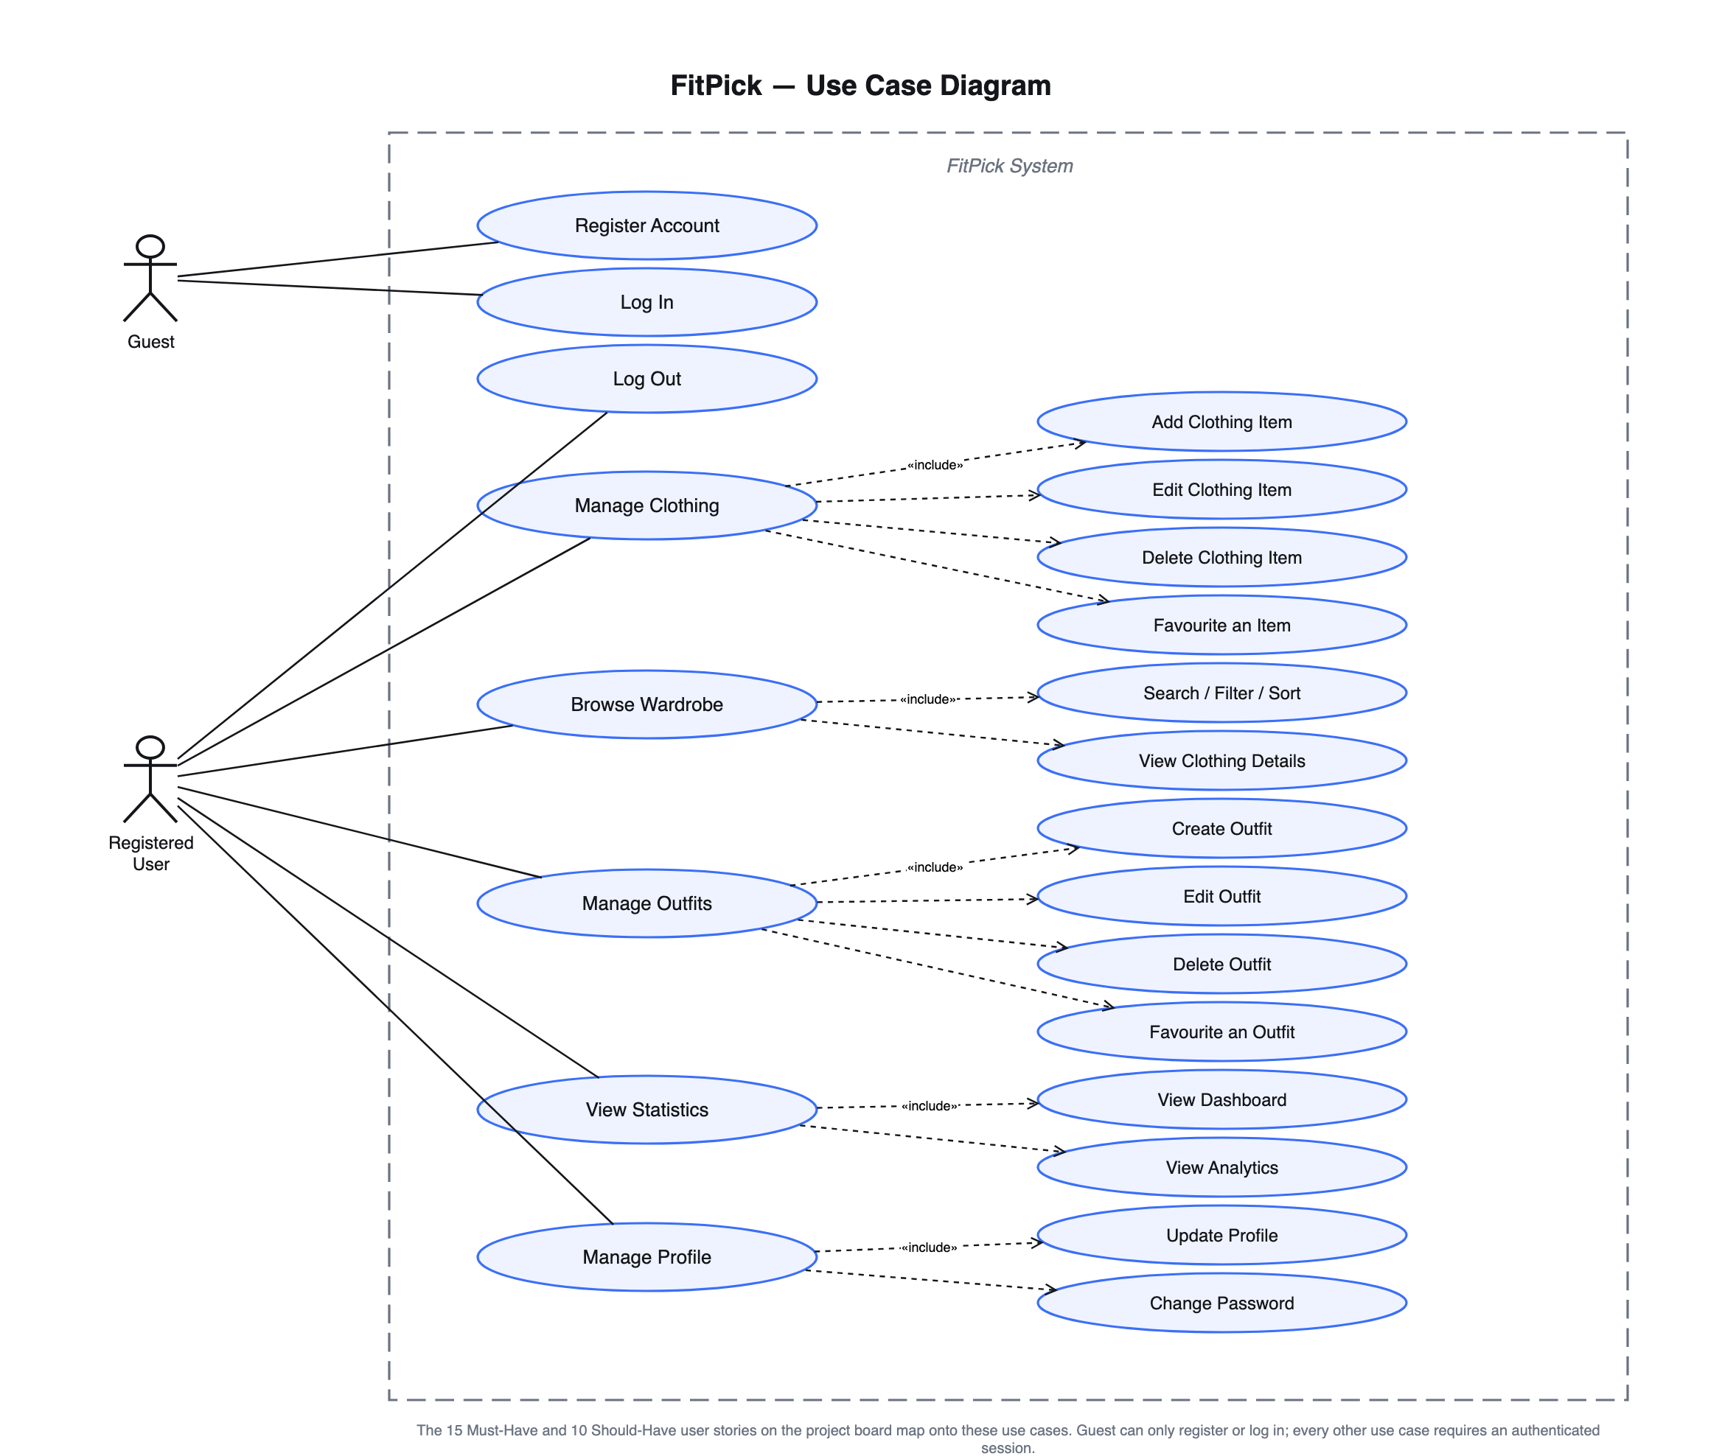
Figure 6 — Use case diagram. The 25 backlog stories map onto these use cases.

D.2 Class diagram
The backend class diagram shows the structure that makes the storage layer replaceable. ClothingRepository is an abstract interface; two concrete classes implement it, and the routers and the analytics service depend on the interface alone.
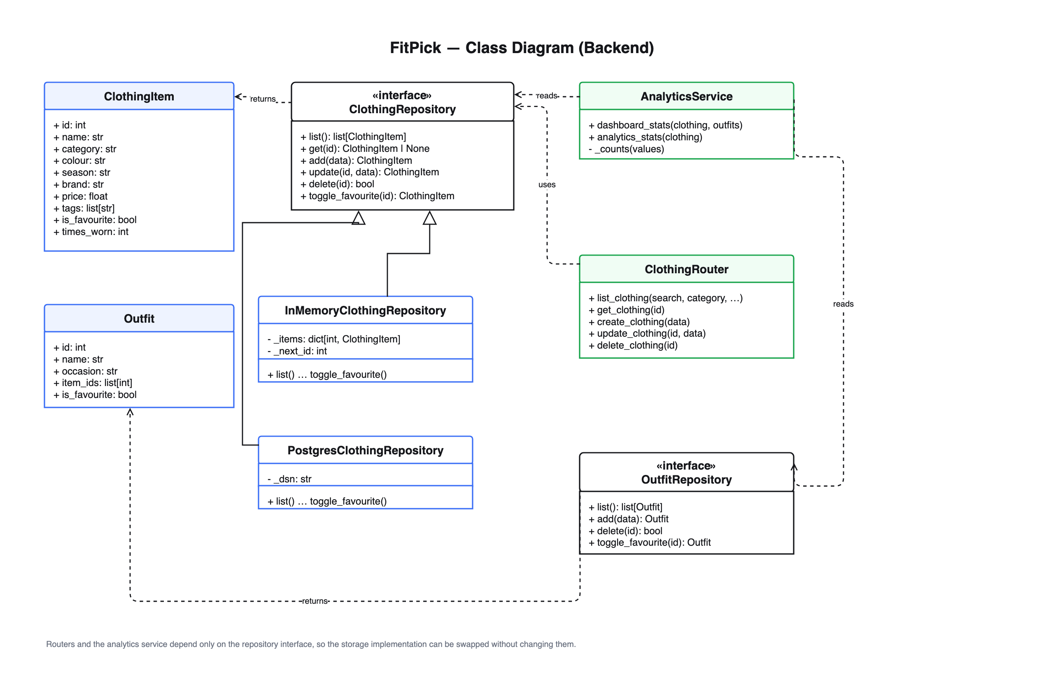
Figure 7 — Class diagram of the backend

D.3 Sequence diagram
Adding a clothing item is the fullest path through the system — it touches every tier and has both a success and a failure branch:
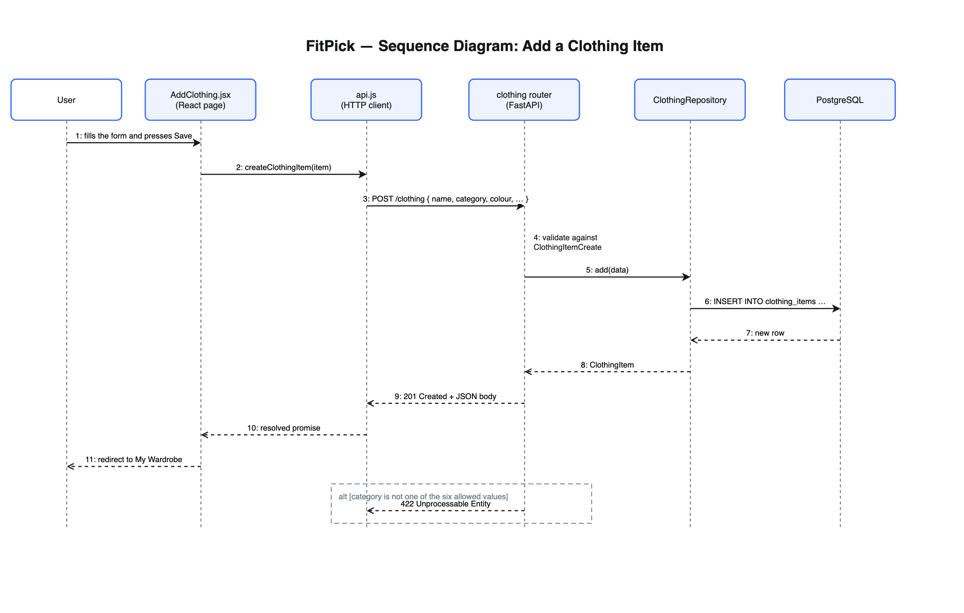
Figure 8 — Sequence diagram: adding a clothing item

9. Appendix E — Code listing and GitHub link

E.1 Repository
Source code
https://github.com/nithi0307/fitpick

The repository contains the full source, the automated tests, the editable Draw.io diagram sources, the exported PNGs, every screenshot used in these reports, and both report documents.

E.2 Repository structure
fitpick/
├── frontend/ React 19 + Vite single-page application
│ └── src/
│ ├── App.jsx route table
│ ├── pages/ Login, Dashboard, Wardrobe, AddClothing,
│ │ OutfitBuilder, Profile
│ ├── components/ Layout, Sidebar, Topbar, Button, Card,
│ │ ItemCard, Charts, Garment, Icon, HeroArt
│ ├── services/api.js the only module that calls the backend
│ └── styles/global.css design tokens and shared component styles
├── backend/ FastAPI application
│ ├── main.py app factory: CORS + router registration
│ ├── routers/ clothing.py, outfits.py, stats.py
│ ├── schemas.py Pydantic models — the API contract
│ ├── services/analytics_service.py dashboard and analytics calculations
│ ├── repositories/ base.py, memory_repository.py,
│ │ postgres_repository.py, __init__.py (factory)
│ ├── seed_data.py the twelve-item sample wardrobe
│ └── tests/ 46 tests across unit, integration, regression
├── database/
│ ├── schema.sql four tables, foreign keys and indexes
│ └── seed.sql the same sample wardrobe, in SQL
├── docs/
│ ├── design/architecture/ architecture .drawio + .png
│ ├── design/diagrams/ DFD, ERD, use case, class, sequence
│ ├── design/wireframes/ the six designed screens
│ ├── screenshots/ application and terminal evidence
│ └── *.pdf this report and the testing report
├── docker-compose.yml frontend 5173, backend 8000, database 5433
└── README.md

E.3 Key listings

E.3.1 Repository interface — backend/repositories/base.py
from schemas import ClothingItem, ClothingItemCreate, ClothingItemUpdate, Outfit, OutfitCreate

class ClothingRepository(ABC):
@abstractmethod
def list(self) -> list[ClothingItem]: ...

@abstractmethod
def get(self, item_id: int) -> ClothingItem | None: ...

@abstractmethod
def add(self, data: ClothingItemCreate) -> ClothingItem: ...

@abstractmethod
def update(self, item_id: int, data: ClothingItemUpdate) -> ClothingItem | None: ...

@abstractmethod
def delete(self, item_id: int) -> bool: ...

@abstractmethod
def toggle_favourite(self, item_id: int) -> ClothingItem | None: ...

E.3.2 Analytics service — backend/services/analytics_service.py
def _counts(values: list[str]) -> list[CategoryCount]:
counter = Counter(values)
ordered = sorted(counter.items(), key=lambda pair: (-pair[1], pair[0]))
return [CategoryCount(label=label, count=count) for label, count in ordered]

def dashboard_stats(clothing: ClothingRepository, outfits: OutfitRepository) -> DashboardStats:
items = clothing.list()
cutoff = date.today() - timedelta(days=7)
recent = [i for i in items if i.created_at and i.created_at >= cutoff]
most_worn = max(items, key=lambda i: i.times_worn, default=None)

return DashboardStats(
total_items=len(items),
total_outfits=len(outfits.list()),
favourites=sum(1 for i in items if i.is_favourite),
most_worn=most_worn.name if most_worn else "—",
most_worn_count=most_worn.times_worn if most_worn else 0,
added_this_week=len(recent),
breakdown=_counts([i.category for i in items]),
)

def analytics_stats(clothing: ClothingRepository) -> AnalyticsStats:
items = clothing.list()
categories = _counts([i.category for i in items])
brands = _counts([i.brand for i in items if i.brand])

E.3.3 Clothing router — backend/routers/clothing.py
router = APIRouter(prefix="/clothing", tags=["clothing"])

@router.get("", response_model=list[ClothingItem])
def list_clothing(
search: str = "",
category: str = "All",
season: str = "All",
sort: str = "newest",
repository: ClothingRepository = Depends(get_clothing_repository),
):
items = repository.list()

if search:
needle = search.lower()
items = [i for i in items if needle in i.name.lower() or needle in i.brand.lower()]
if category != "All":
items = [i for i in items if i.category == category]
if season != "All":
items = [i for i in items if i.season == season]

sorters = {
"newest": lambda i: -i.id,
"name": lambda i: i.name.lower(),
"most-worn": lambda i: -i.times_worn,
"price": lambda i: -i.price,
}
return sorted(items, key=sorters.get(sort, sorters["newest"]))

@router.get("/categories", response_model=list[str])
def list_categories():

E.3.4 API client — frontend/src/services/api.js
const BASE_URL = import.meta.env.VITE_API_URL ?? "http://localhost:8000";

async function request(path, options = {}) {
const response = await fetch(`${BASE_URL}${path}`, {
headers: { "Content-Type": "application/json" },
...options,
});

if (!response.ok) {
throw new Error(`Request failed: ${response.status}`);
}

return response.status === 204 ? null : response.json();
}

function query(params) {
const search = new URLSearchParams(
Object.entries(params).filter(([, value]) => value !== "" && value != null)
);
return search.toString() ? `?${search}` : "";
}

E.3.5 Route table — frontend/src/App.jsx
* Route table. Login stands alone; every other screen is nested inside
* Layout and therefore gets the sidebar automatically.
*/
export default function App() {
return (
<BrowserRouter>
<Routes>
<Route path="/" element={<Login />} />

<Route element={<Layout />}>
<Route path="/dashboard" element={<Dashboard />} />
<Route path="/wardrobe" element={<Wardrobe />} />
<Route path="/add-clothing" element={<AddClothing />} />
<Route path="/outfit-builder" element={<OutfitBuilder />} />
<Route path="/profile" element={<Profile />} />
</Route>
</Routes>
</BrowserRouter>
);
}

E.3.6 Wardrobe screen — frontend/src/pages/Wardrobe.jsx (extract)
const [status, setStatus] = useState("loading");
const [search, setSearch] = useState("");
const [category, setCategory] = useState("All");
const [season, setSeason] = useState("All");
const [sort, setSort] = useState("newest");

useEffect(() => {
let cancelled = false;
getClothingItems({ search, category, season, sort })
.then((data) => {
if (!cancelled) {
setItems(data);
setStatus("ready");
}
})
.catch(() => !cancelled && setStatus("error"));
return () => {
cancelled = true;
};
}, [search, category, season, sort]);

async function handleFavourite(item) {
const updated = await toggleClothingFavourite(item.id);
setItems((current) => current.map((i) => (i.id === updated.id ? updated : i)));
}

return (
<>
<Topbar title="My Wardrobe" subtitle={`${items.length} pieces in your collection`}>
<Link to="/add-clothing">
<Button>

E.4 Running the project
With Docker — the whole system
$ git clone https://github.com/nithi0307/fitpick.git
$ cd fitpick
$ docker compose up --build

Without Docker — for development
# terminal 1
$ cd backend && python3.13 -m venv .venv
$ .venv/bin/pip install -r requirements-dev.txt
$ .venv/bin/uvicorn main:app --reload

# terminal 2
$ cd frontend && npm install && npm run dev

E.5 Future work
- Real authentication: password hashing, sessions and per-user data, which the schema already supports through user_id.
- Screens for editing and deleting clothing items and outfits, so stories 5, 6 and 12 become end-to-end rather than API-only.
- Photograph upload and storage, replacing the generated garment illustrations.
- A wear-logging action so times_worn is updated by the user rather than seeded.
- Outfit suggestions based on occasion, season and what has not been worn recently.

