NAME: NITHIESH KUMAR S S
REGNO: 24BCE1143

GHOSTPASS MONGODB PROJECT

GhostPass
CAPTCHA-Based Authentication System using MongoDB, Express.js, Node.js and JavaScript
1. Abstract and Outcome
GhostPass is a backend-based authentication system developed using MongoDB, Express.js, and Node.js. The system allows administrators to create users, generate random CAPTCHA codes, validate login credentials, update user records, and delete user accounts through RESTful APIs.
The project demonstrates CRUD operations, MongoDB document management, REST API development, CAPTCHA generation, and user authentication using Express.js and Mongoose.

2. Objectives
- Manage user accounts efficiently.
- Generate random CAPTCHA codes dynamically.
- Validate login credentials using username, password, and CAPTCHA.
- Demonstrate MongoDB CRUD operations.
- Implement RESTful APIs using Express.js.
- Test APIs using Postman.
- Verify database records using MongoDB Compass.

3. Technology Stack
Backend
- Node.js
- Express.js
Database
- MongoDB Community Edition
- MongoDB Compass
ODM
- Mongoose
API Testing
- Postman
Development Environment
- Visual Studio Code

4. Methodology
Phase 1: Requirement Analysis
Requirements were identified for user registration, CAPTCHA generation, login validation, and user management.
Phase 2: Database Design
MongoDB collections were designed using Mongoose schemas.
Collection:
- Users
Phase 3: Backend Development
RESTful APIs were created using Express.js.
Implemented operations:
- Create
- Read
- Update
- Delete
- CAPTCHA Generation
- Login Authentication
Phase 4: Testing
All APIs were tested using Postman and verified using MongoDB Compass.

5. System Architecture
Postman
↓
Express.js Routes
↓
Mongoose Models
↓
MongoDB Database

6. Database Collection
Users
Fields:
- Username
- Password
- CAPTCHA
- Failed Attempts
- Account Lock Status
User Schema
{
username: String,
password: String,
captcha: String,
failedAttempts: Number,
isLocked: Boolean
}

7. Features Implemented
User Management
- Add User
- View Users
- Update User
- Delete User
CAPTCHA Module
- Generate Random CAPTCHA
- CAPTCHA Validation During Login

Authentication Module
- Username Verification
- Password Verification
- CAPTCHA Verification
- Failed Login Tracking
- Account Lock Mechanism

8. API Endpoints
User Operations
GET /users
POST /users
PUT /users/:id
DELETE /users/:username
CAPTCHA Operations
GET /captcha
Authentication Operations
POST /login

Security Operations
PUT /reset/:id
PUT /unlock/:id

9. Testing and Verification
RUNNING THE NODE.JS IN PORT 5000:
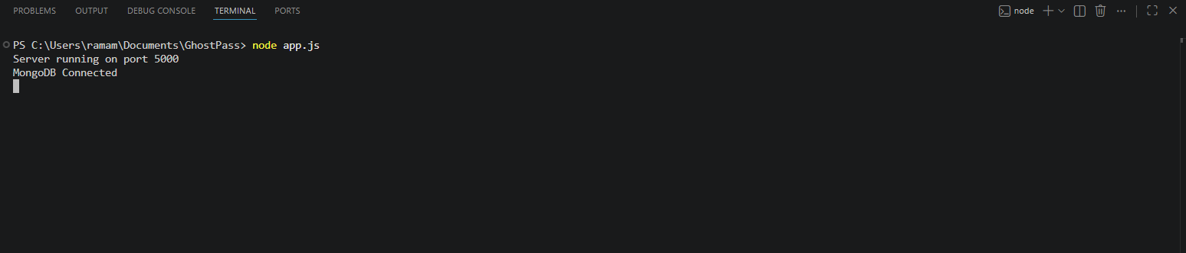

GENERATE CAPTCHA PART:
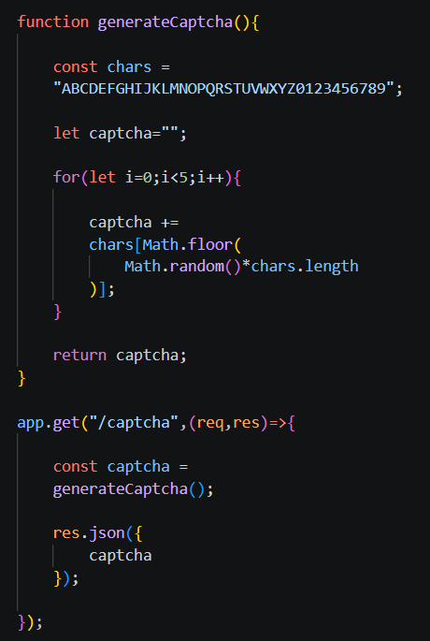

TESTING WITH POSTMAN:
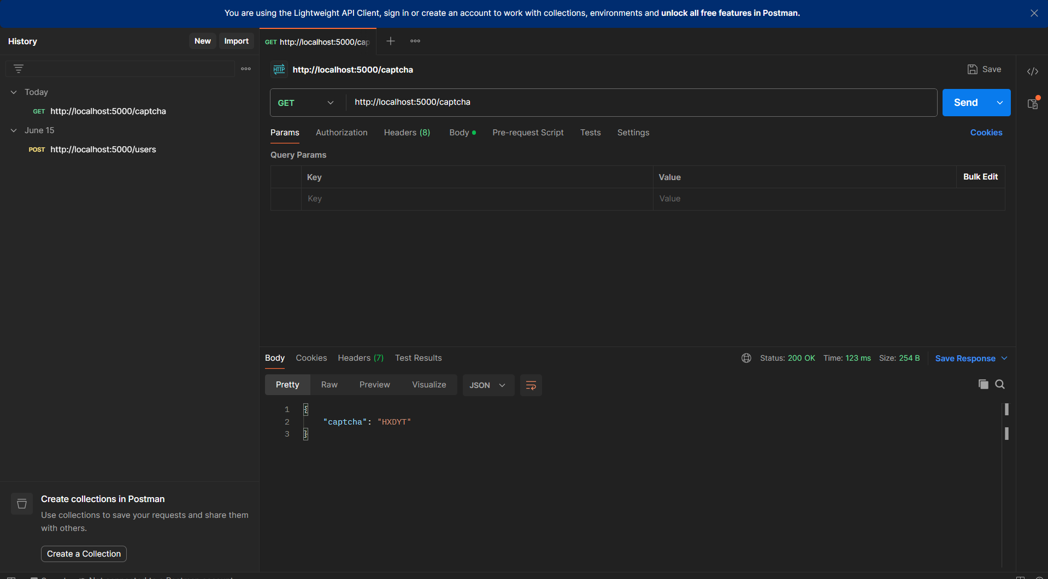
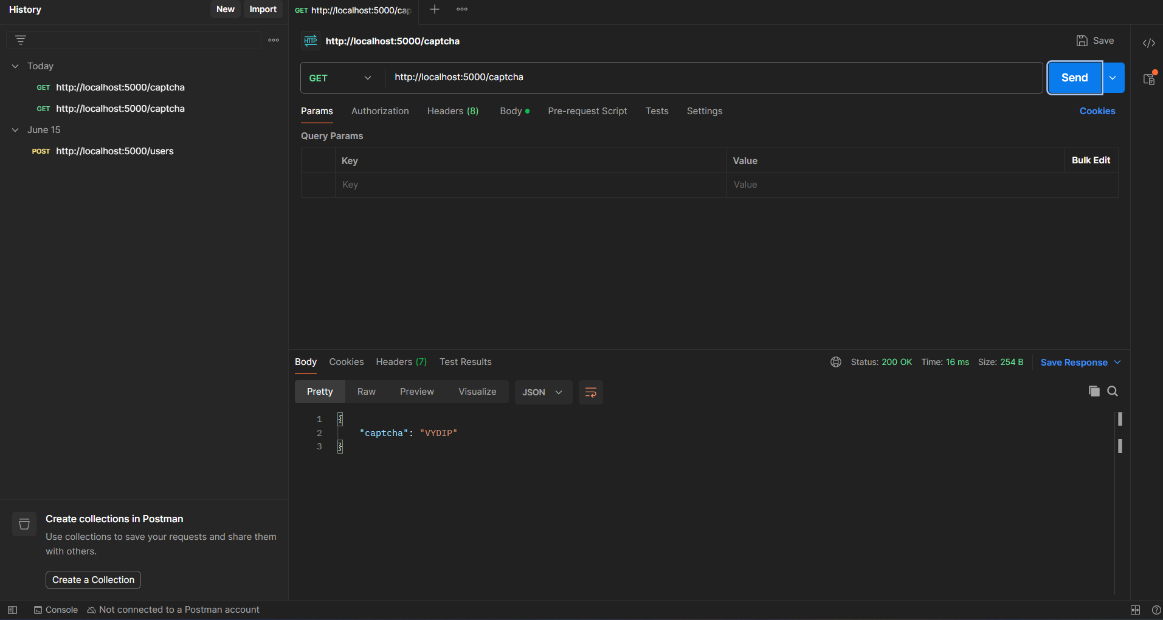

CREATE USER CODE:
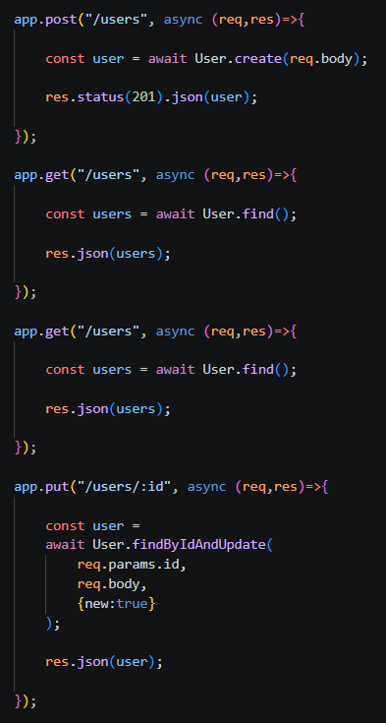
TESTING CREATE USER:
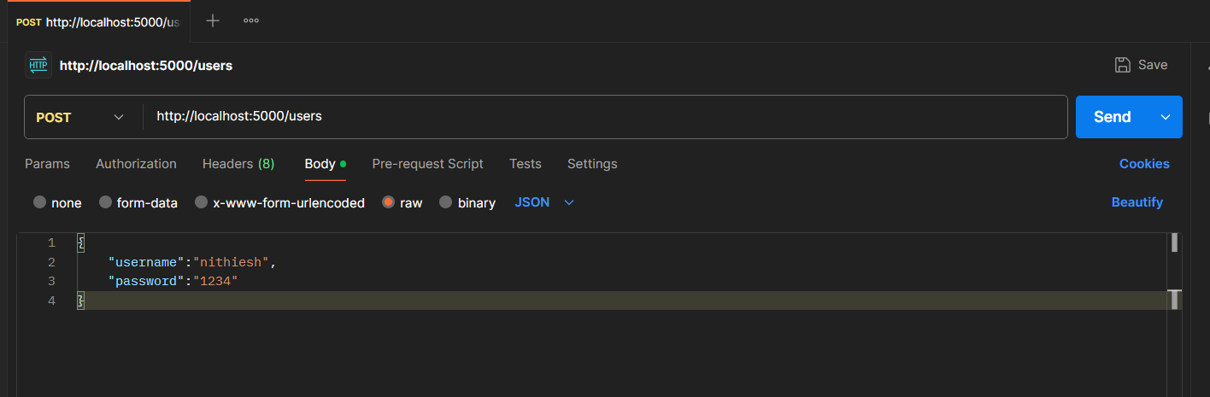
MONGODB COMPASS GETS UPDATED:
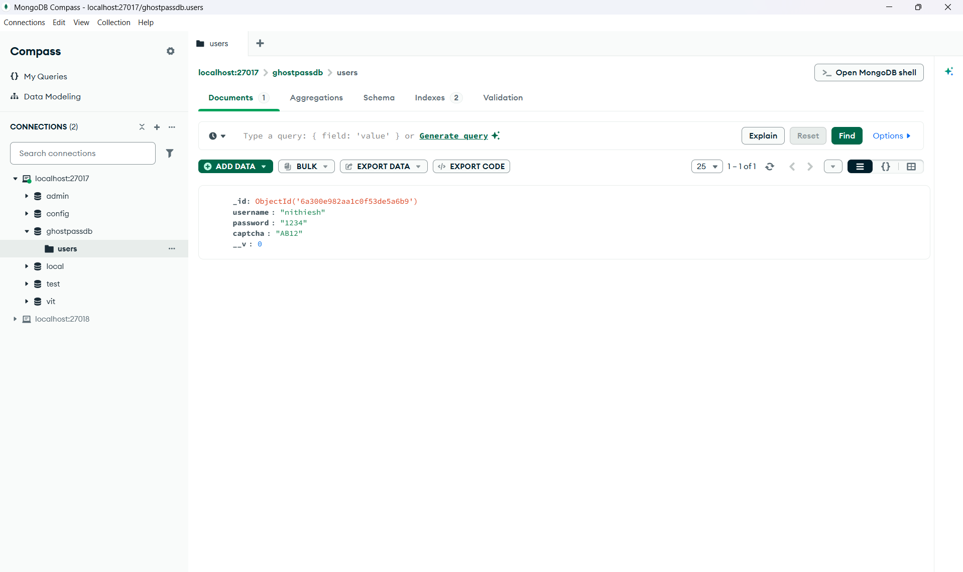
LOGIN CODE:
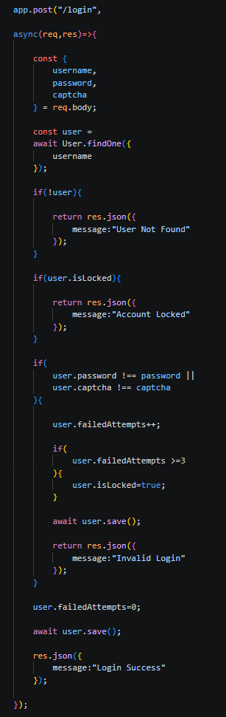

TESTING LOGIN WITH POSTMAN:
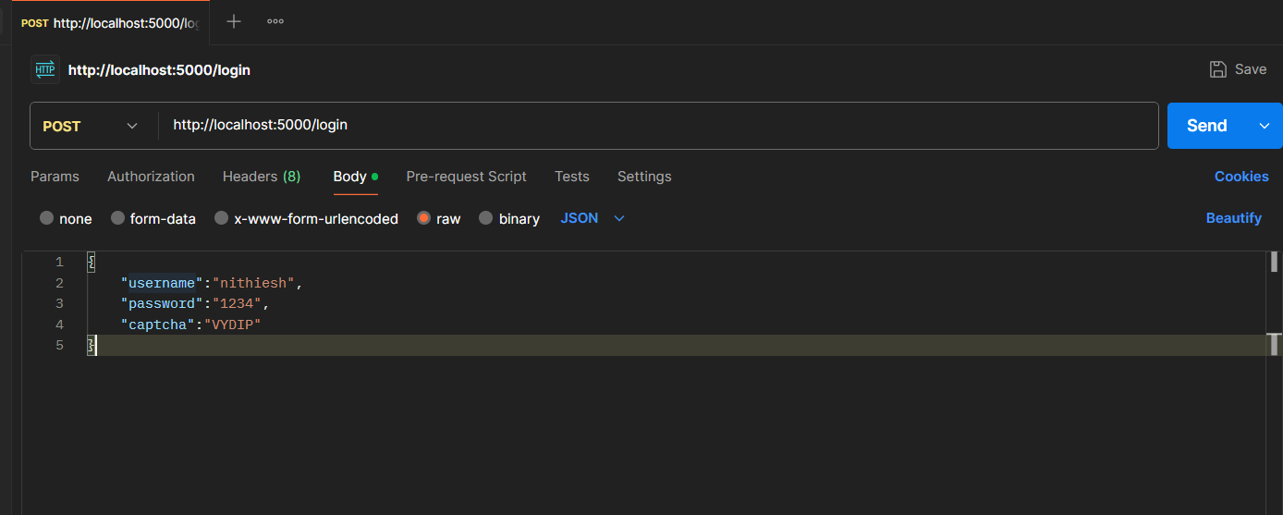
(USING THE CREATED USER AND THE RECENTLY GENERATED CAPTCHA WHILE CREATING)
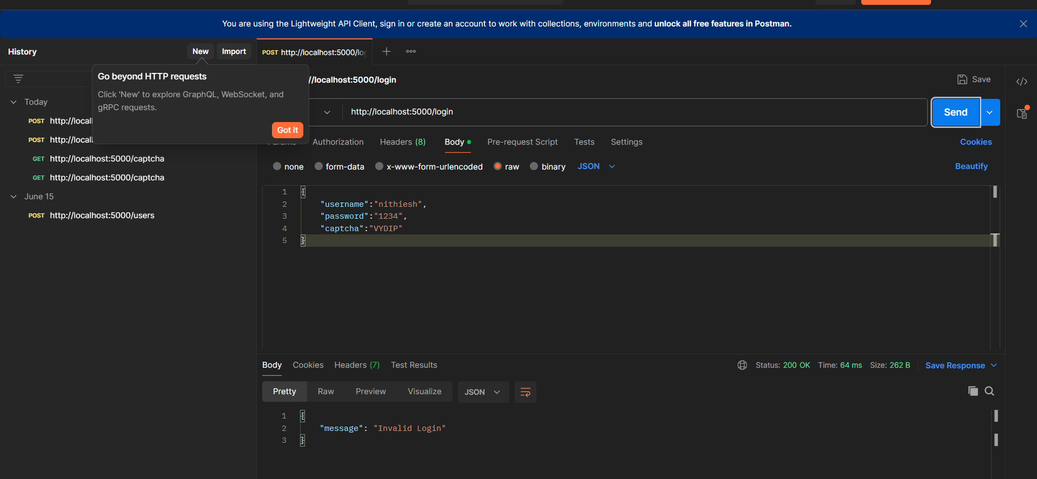

INVALID LOGIN DUE TO WRONG CAPTCHA
WRONG PASSWORD WRT USERNAME:
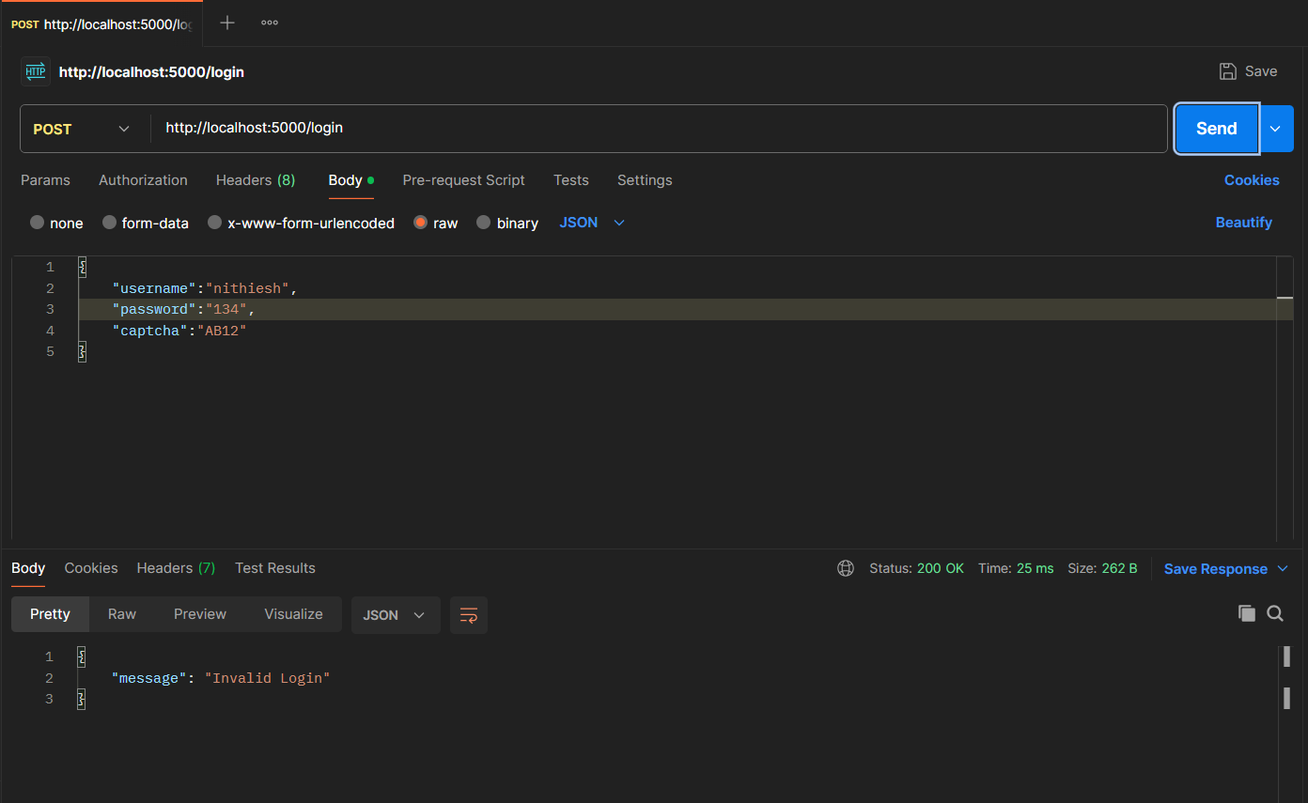

WRONG USERNAME WRT PASSWORD:
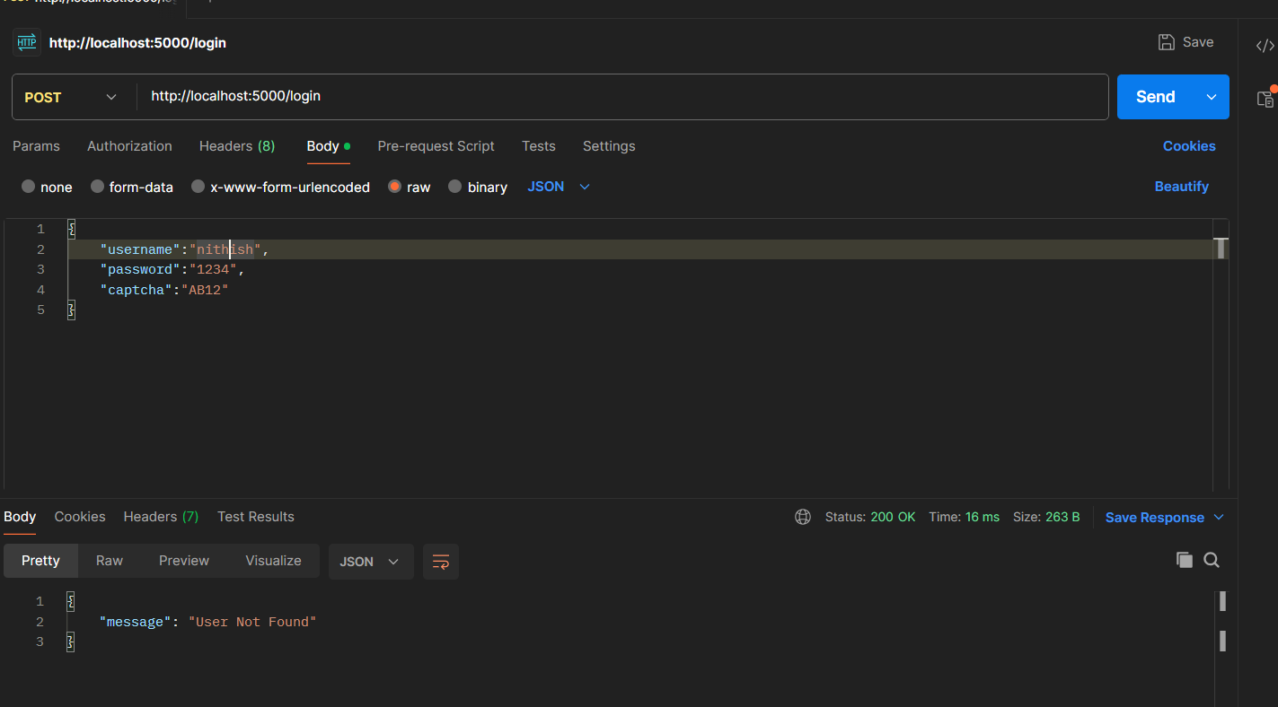
USING CORRECT CAPTCHA, USERNAME AND PASSWORD MAKES THE LOGIN SUCCESSFUL!
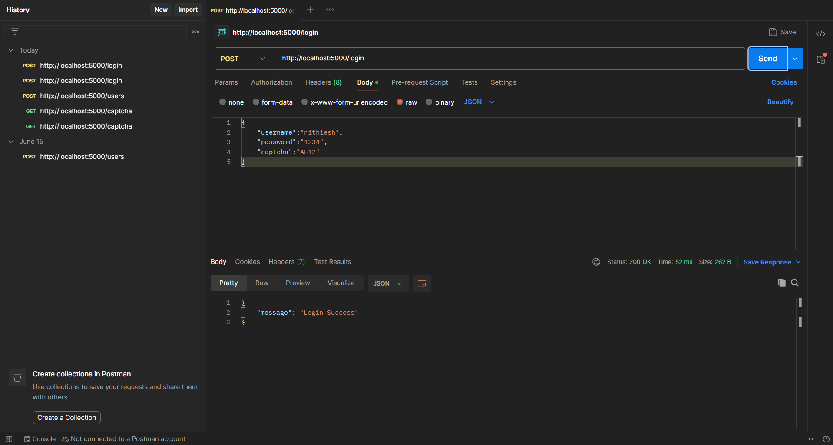

READ OPERATION(GET API) CODE:
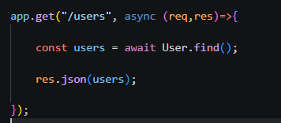

TESTING GET API:
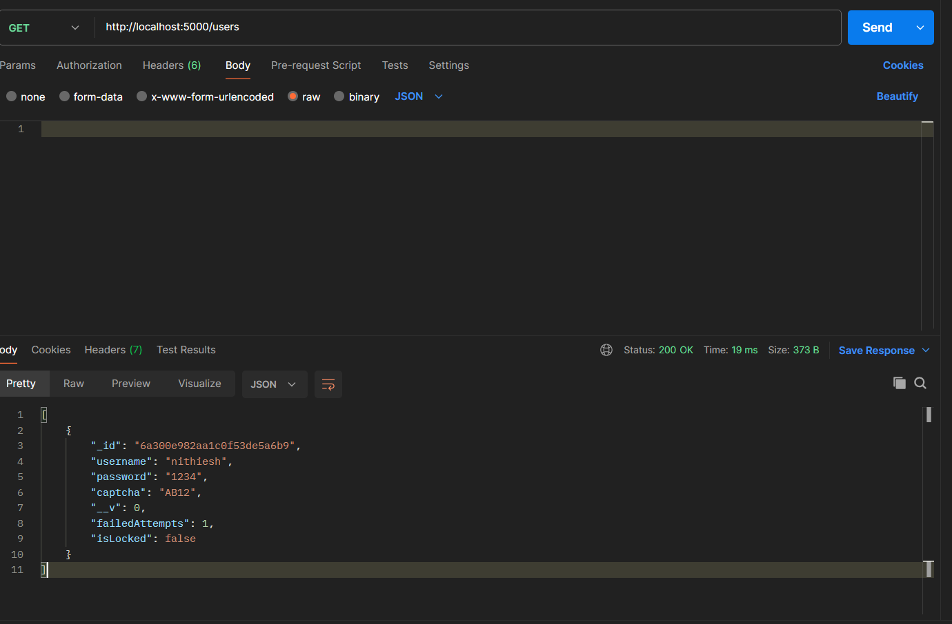
WE SEE ALL THE USERS
UPDATE OPERATOR (PUT API) CODE:
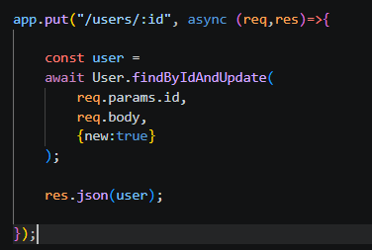

TESTING IT FOR USER NITHIESH USING CORRESPONDING ID TO CHANGE PASSWORD:
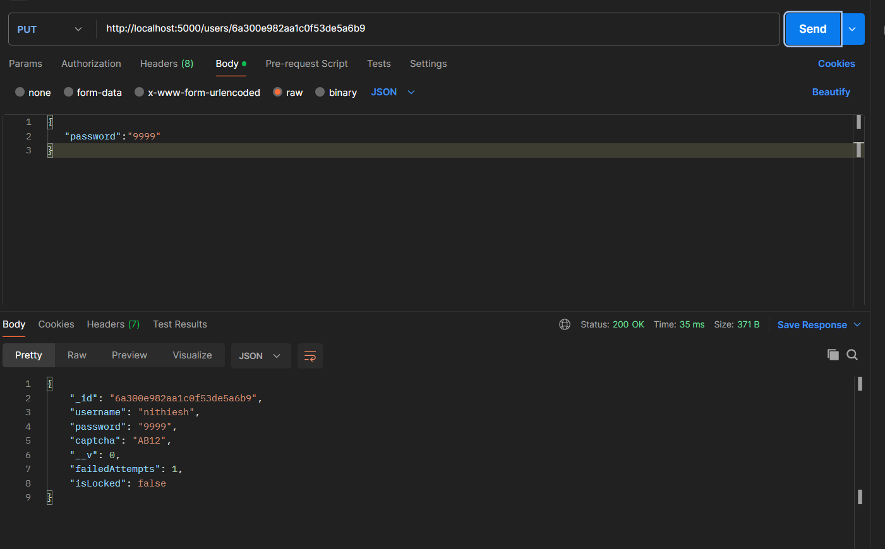
CHECKING THE STATUS IN MONGODB COMPASS AFTER REFRESHING:
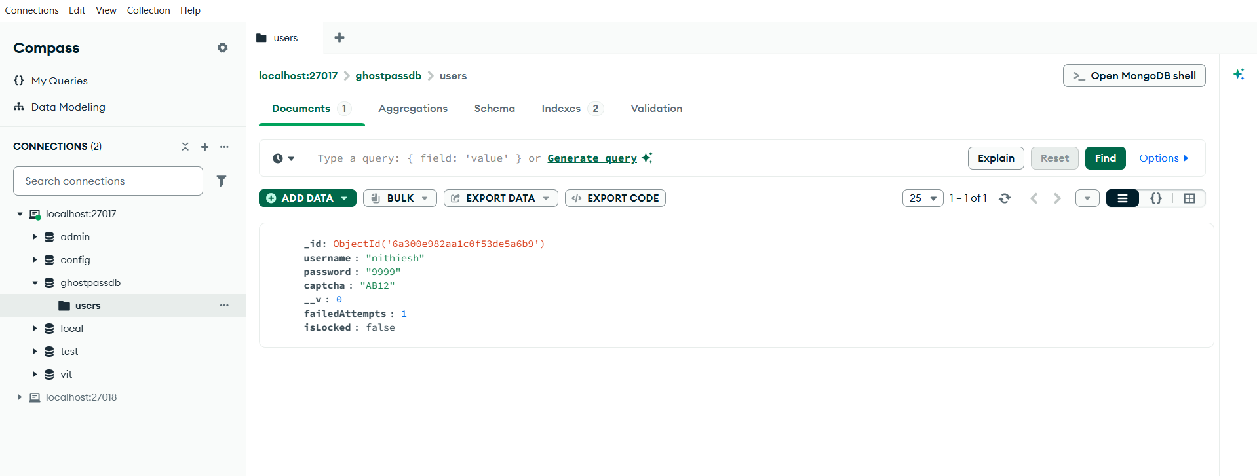

DELETE CODE:
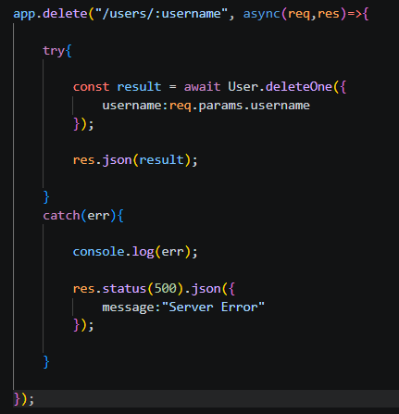
TESTING DELETE USING USERNAME:
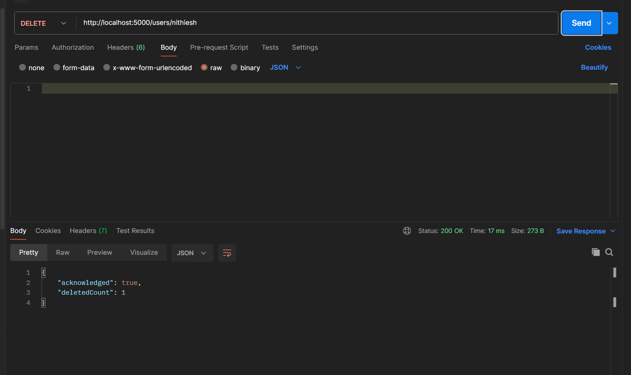

CHECKING MONGODB COMPASS:
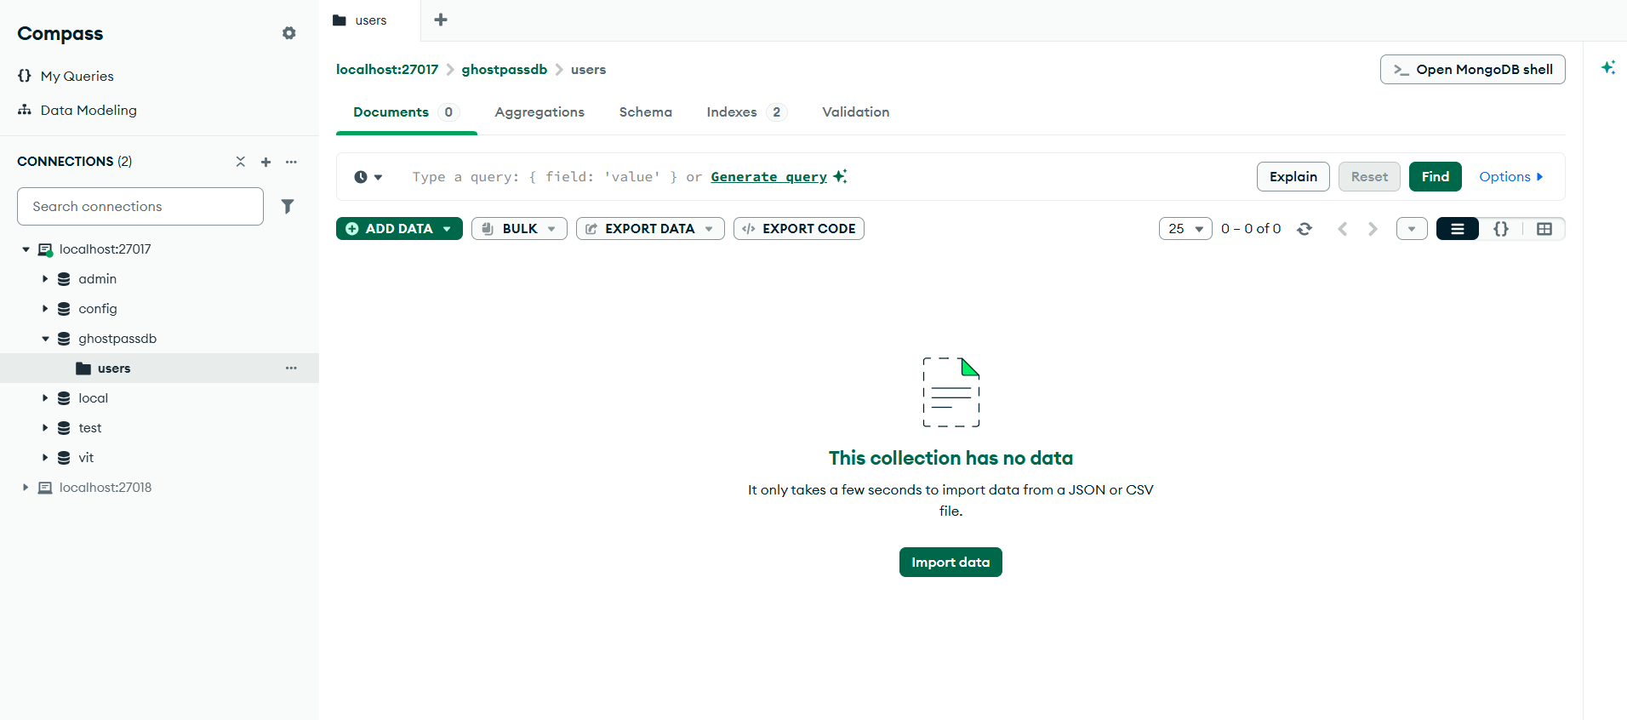

10. Results and Summary
The GhostPass system successfully performs:
- User Registration
- User Management
- CAPTCHA Generation
- Login Authentication
- MongoDB CRUD Operations
- REST API Development
- Database Verification
The system dynamically stores user data in MongoDB and validates login credentials through backend APIs. Random CAPTCHA generation provides an additional security layer during authentication.

GhostPass demonstrates practical implementation of database management, authentication mechanisms, RESTful API development, and MongoDB CRUD operations using Node.js, Express.js, and Mongoose.

11. Future Enhancements
- JWT Authentication
- Password Hashing using bcrypt
- Email Verification
- CAPTCHA Expiry Mechanism
- Role-Based Access Control
- Frontend Dashboard
- Session Management
- Audit Logs

