NAME: NITHIESH KUMAR S S
REGNO: 24BCE1143

PROJECT PROGRESS- 15TH JUNE 2026

SETTING UP PACKAGE JSON:
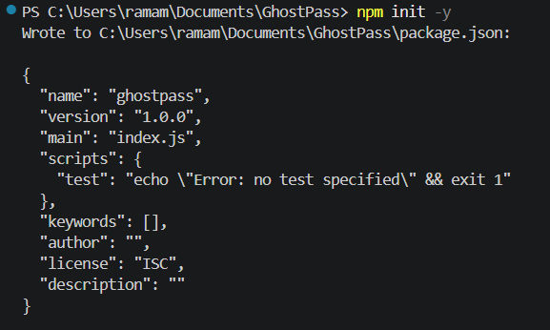
INSTALLING MONGOOSE PACKAGES FOR USING MONGODB:
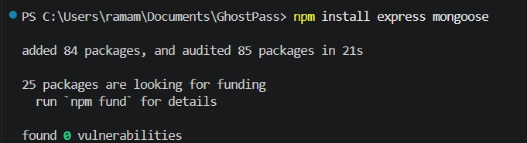
FOLDER STRUCTURE:
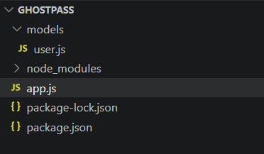
USER.JS CODE:
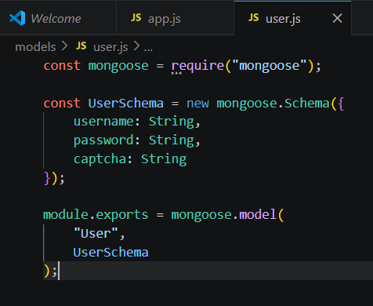
APP.JS CODE INCLUDING ALL APIS:
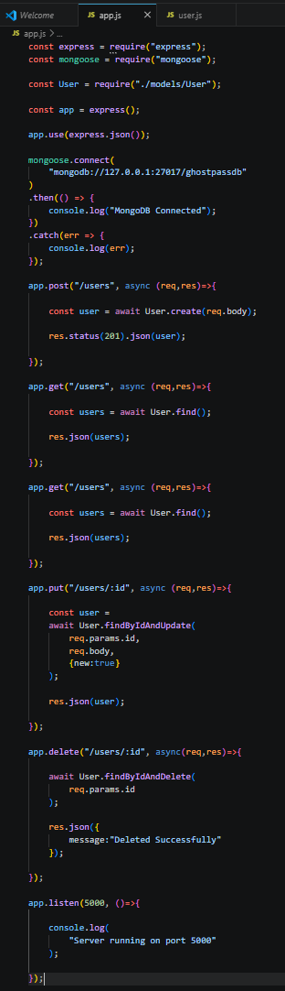
NOTE: POST,GET,PUT,DELETE WERE USED IN APP.JS
AND WE ARE CONNECTING TO 27017 IN MONGODB.

SAVING THE FILES AND RUNNING ON PORT 5000:
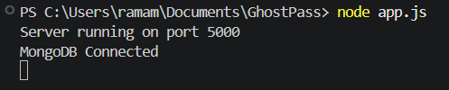

OPENING POSTMAN AND SETTING TO 5000 WHERE OUR BACKEND IS RUNNING AND SETTING TO RAW JSON:
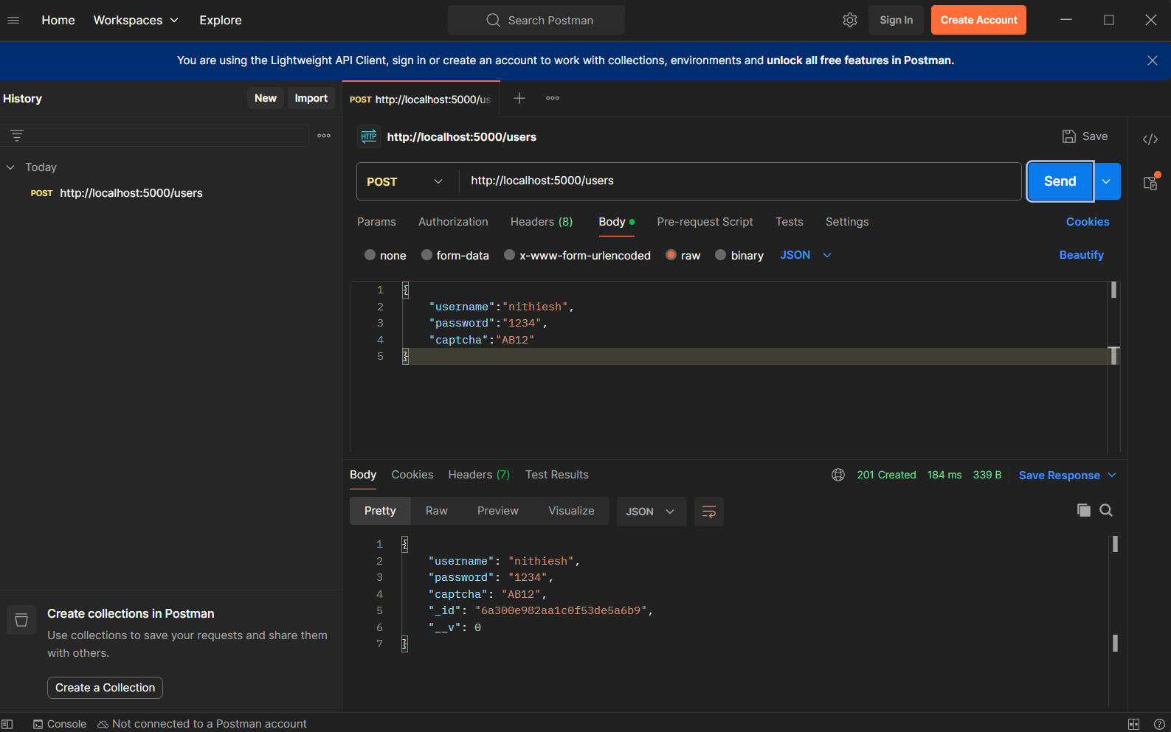

AFTER CLICKING ON SEND AND OPENING MONGODB
COMPASS TO CHECK IF OUR DATABASE IS CREATED:
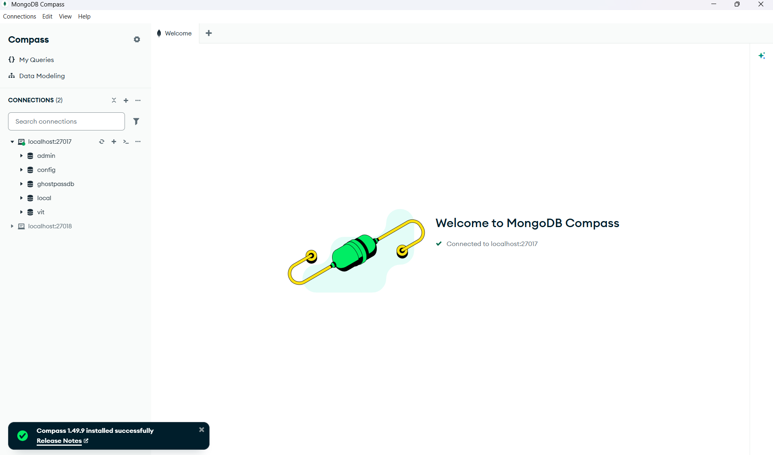

WE SEE GHOSTPASSDB CREATED SUCCESSFULLY.

STRUCTURE:
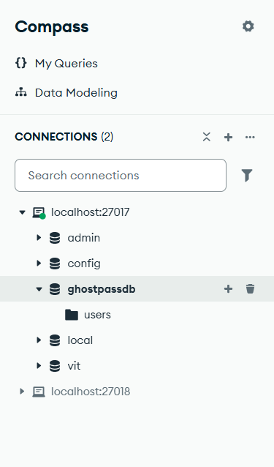

CHECKING WHETHER IF THE DOCUMENT SENT FROM POSTMAN WAS INSERTED SUCCESSFULLY:
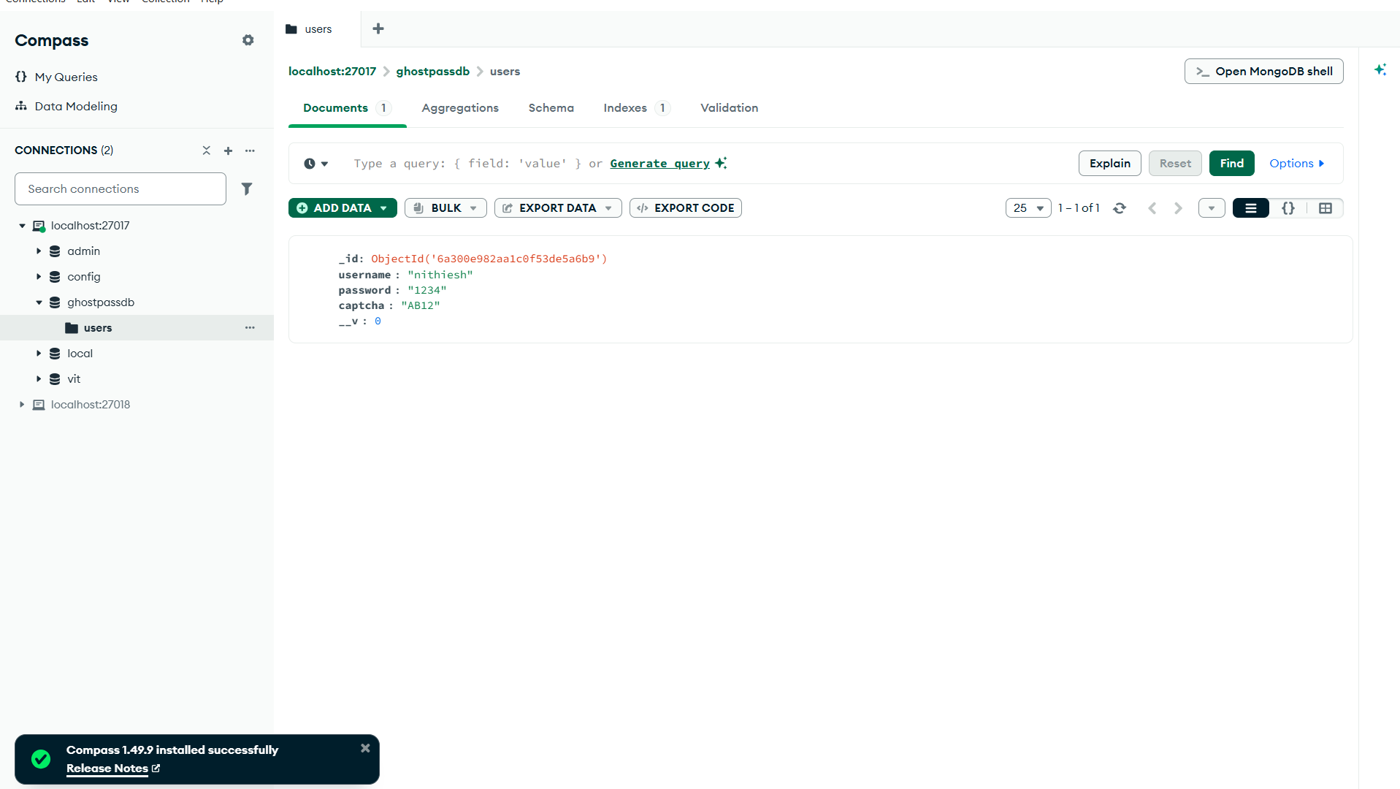

IT HAS BEEN INSERTED SUCCESSFULLY.

