NAME: NITHIESH KUMAR S S
REGNO: 24BCE1143
DATE: 9th June 2026

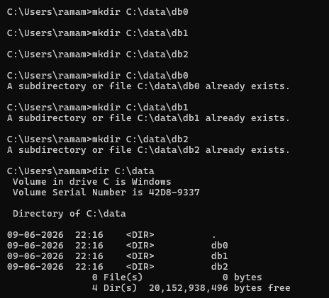

PORTS USED- 27020,27021 AND 27022

PORT 27020:

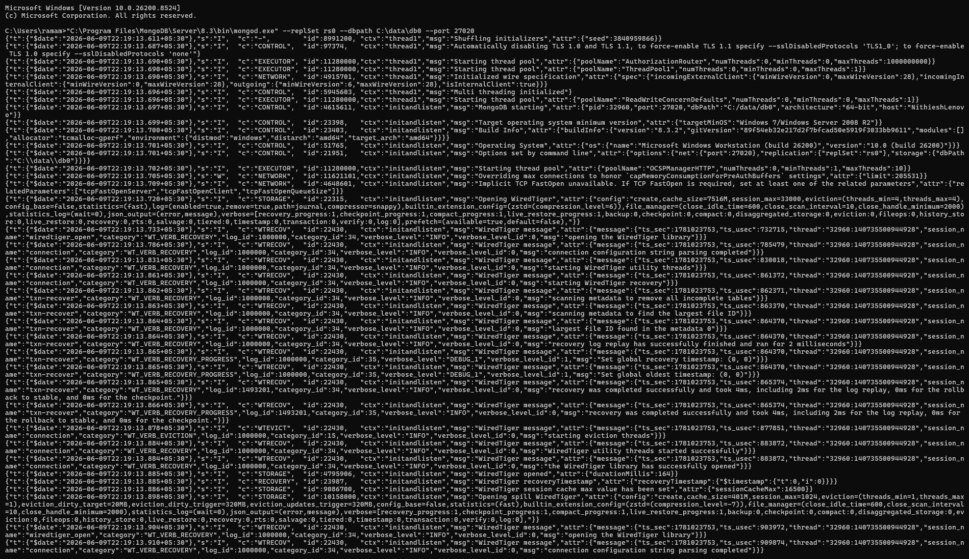

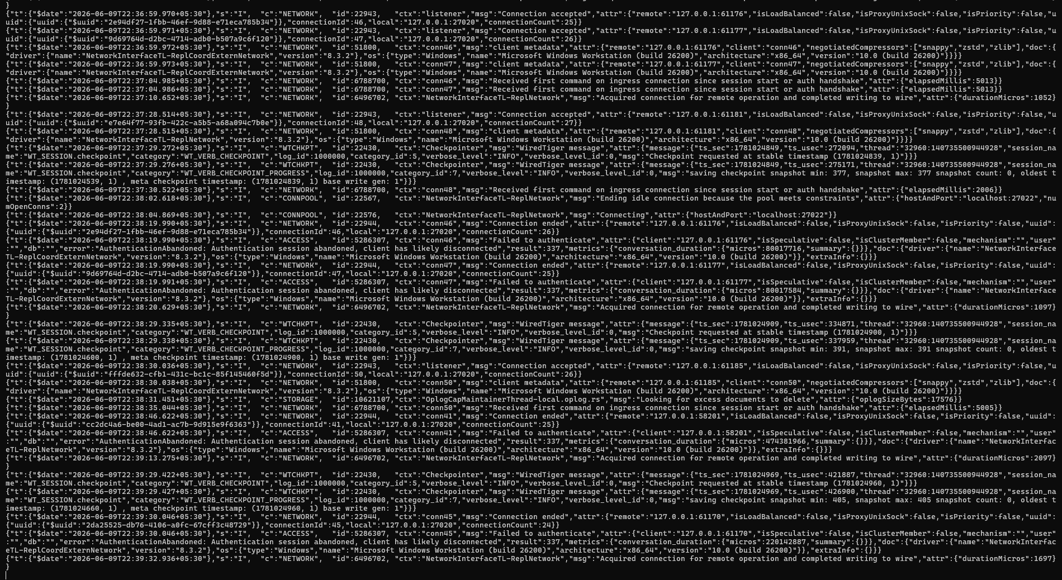

PORT 27021:

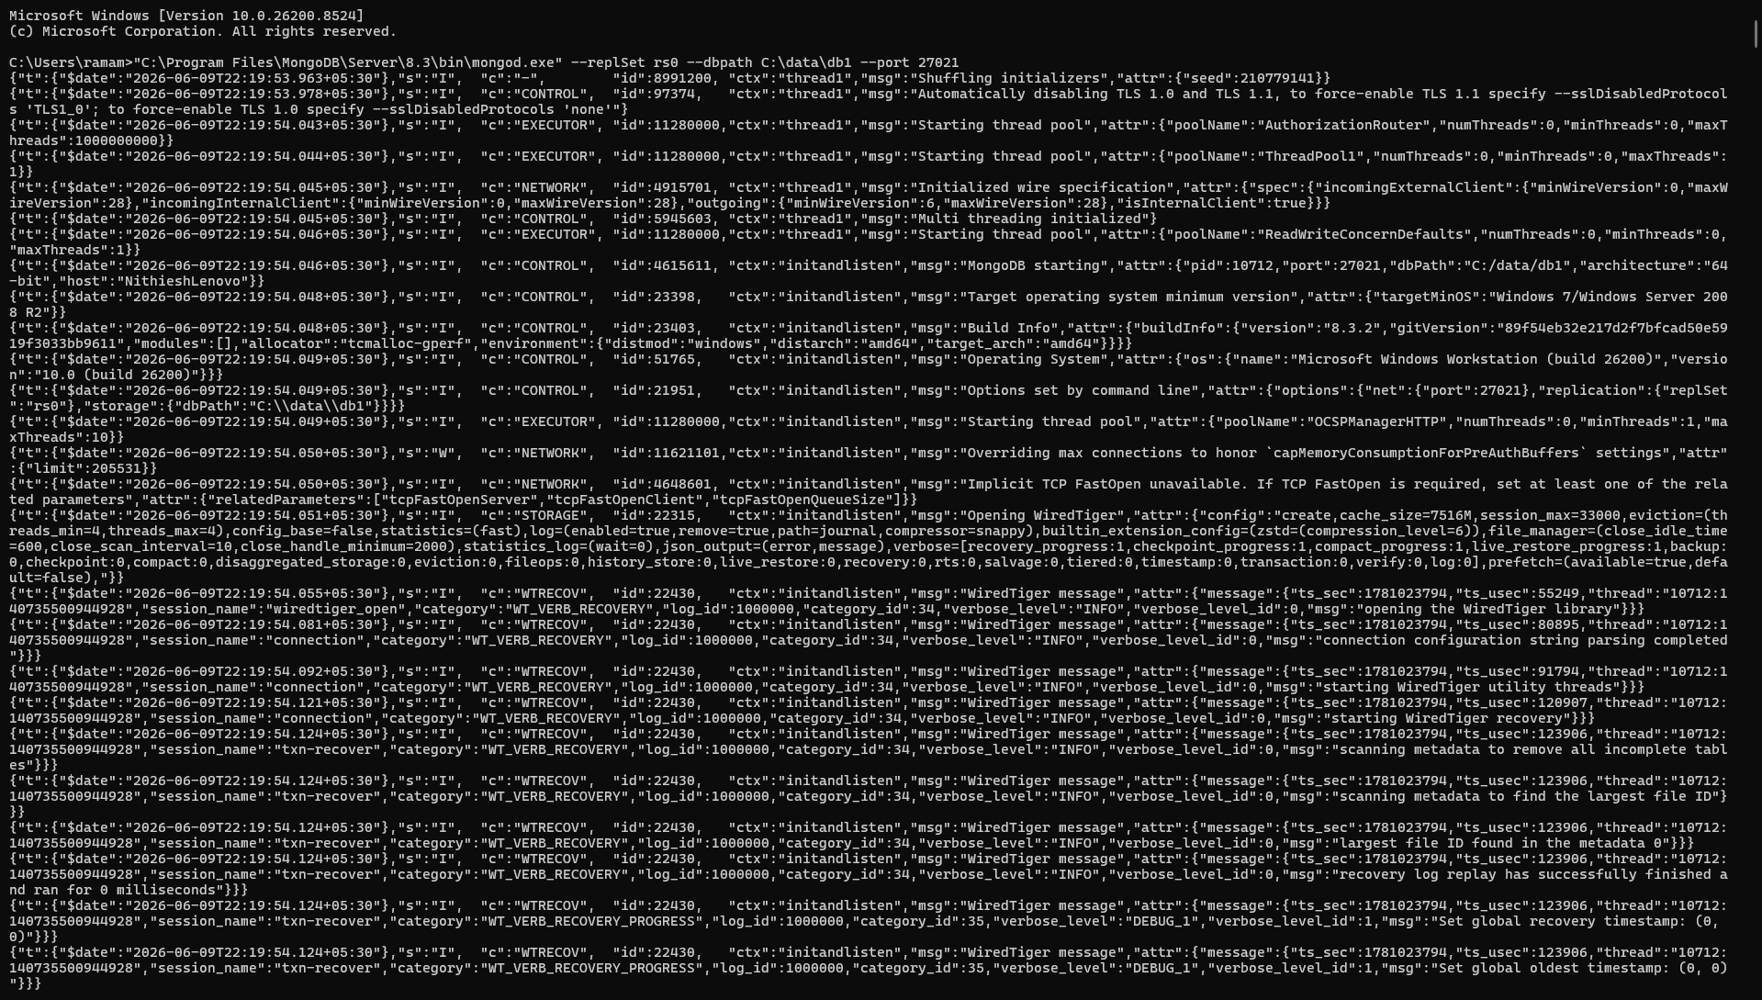

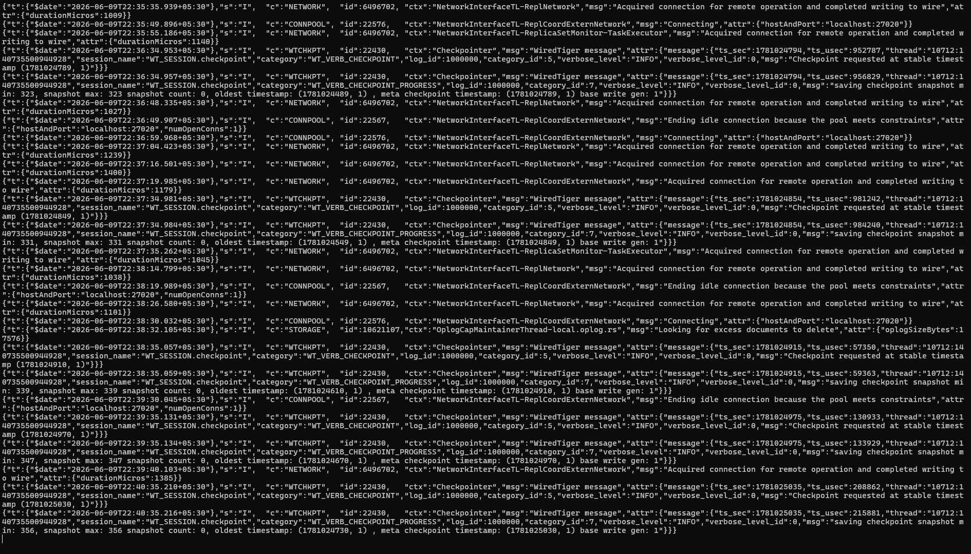

PORT 27022:
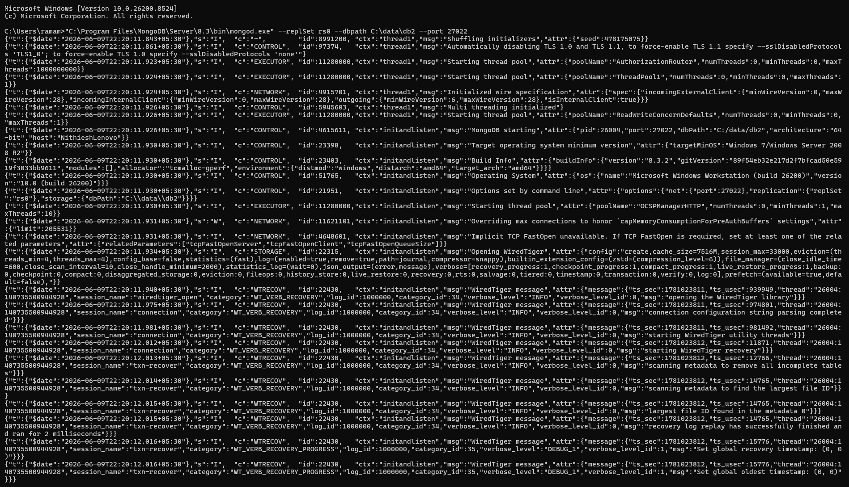

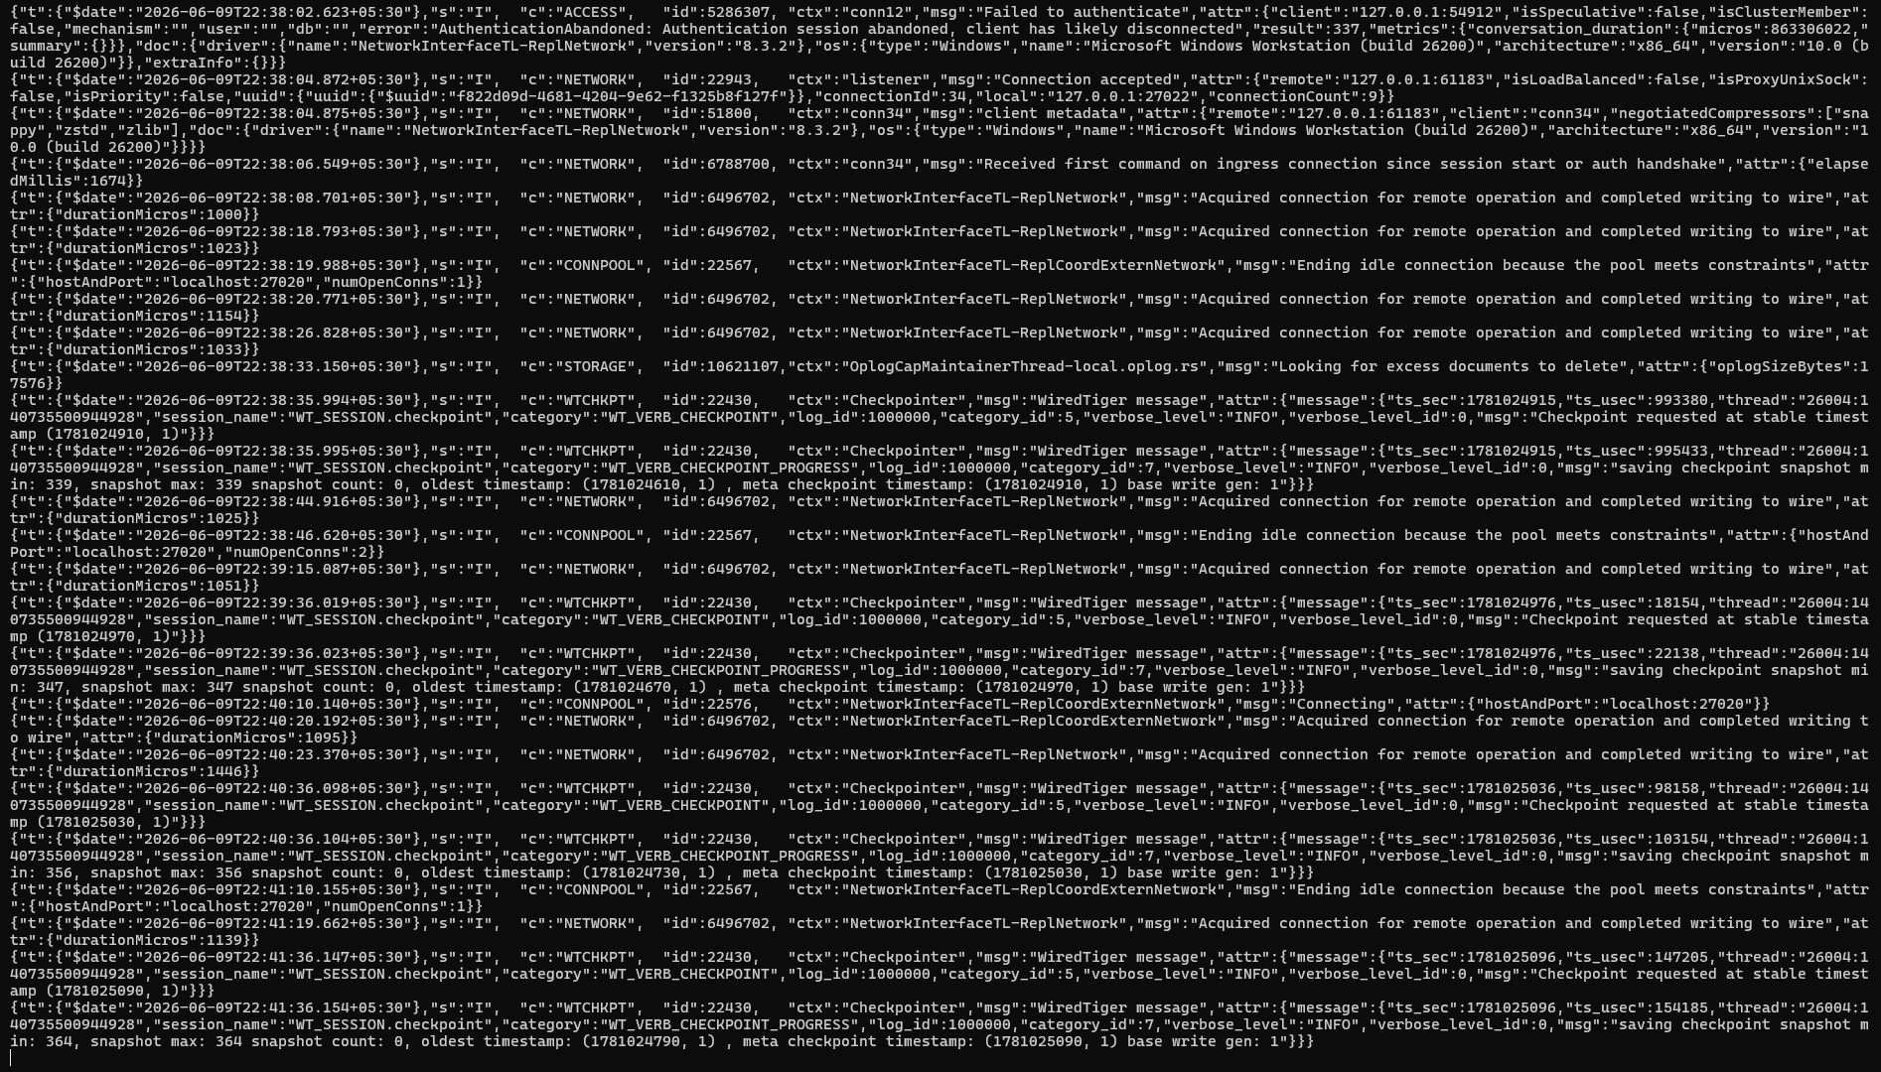

MONGODB TERMINAL FOR PRIMARY PORT 27020:

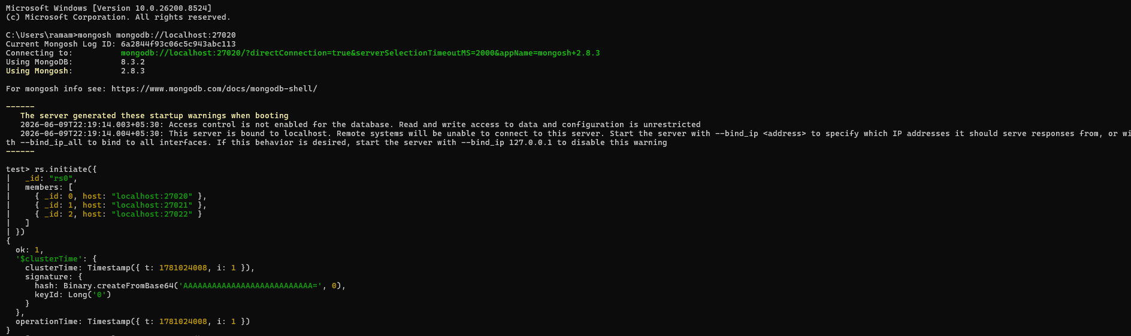

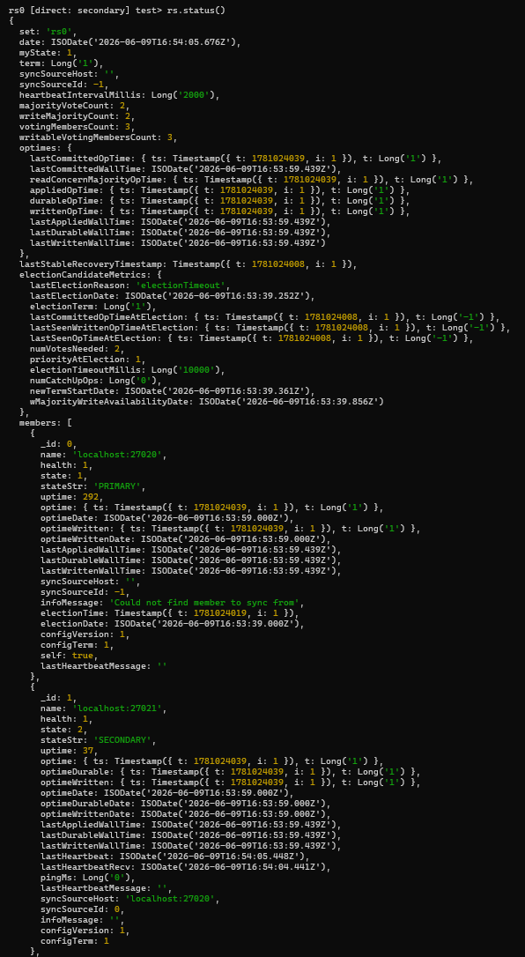
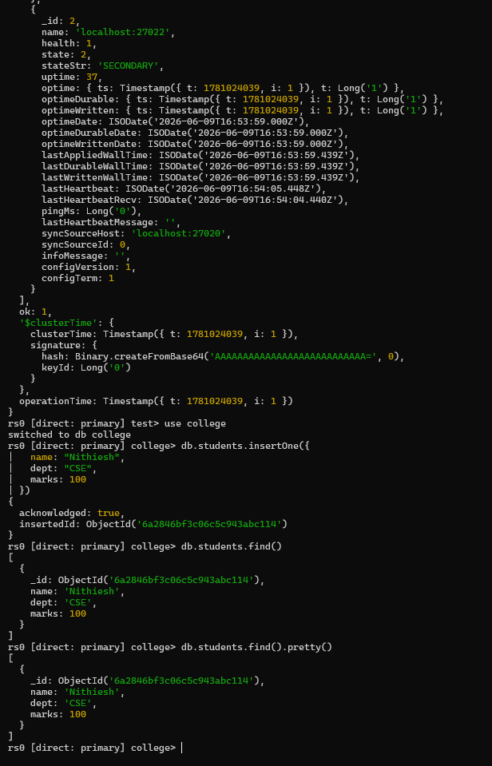
MONGODB TERMINAL FOR SECONDARY PORT 27021:
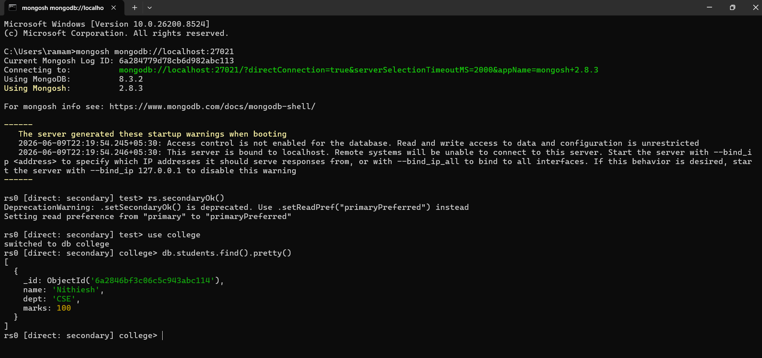

WE SEE DOCUMENT IS REPLICATED IN SECONDARY PORT

