NAME: NITHIESH KUMAR S S

REGNO: 24BCE1143

DATE: 1st June 2026

SCREENSHOTS:

SQL CODE:
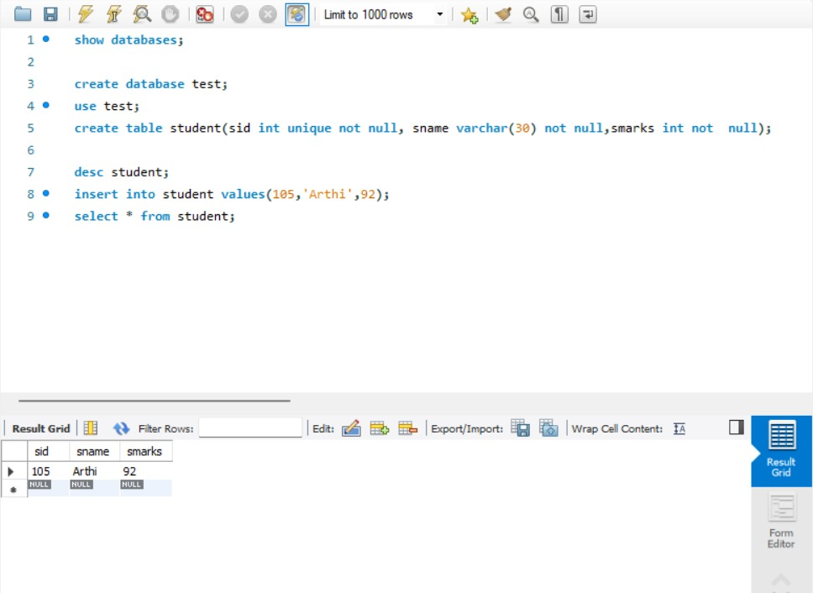

FETCHING THAT USING JAVA:
