**Document Module**

1. **Document Type(Master table)**
2. Create
3. View
4. Edit
5. Delete

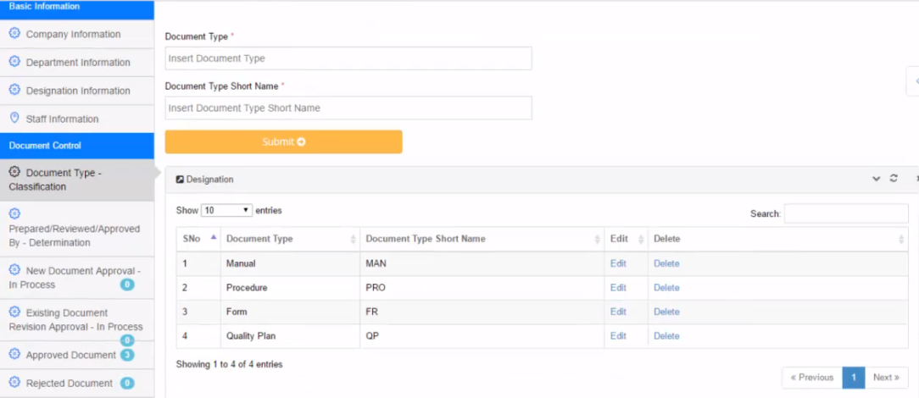

1. **Assign Prepared / Reviewed / Approved person (Master table)**
2. Create
3. View
4. Edit
5. Delete

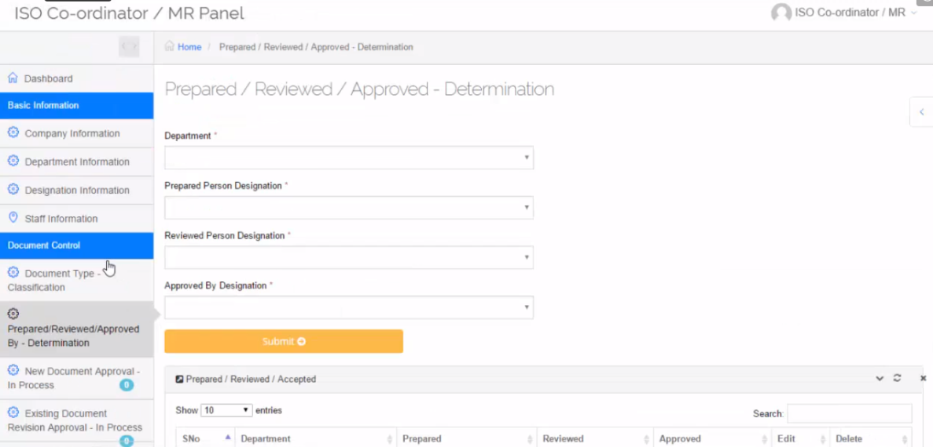

1. **Prepared Person Login:**
2. Upload New Document and also Rename Document with Rev0Draft1 Status added

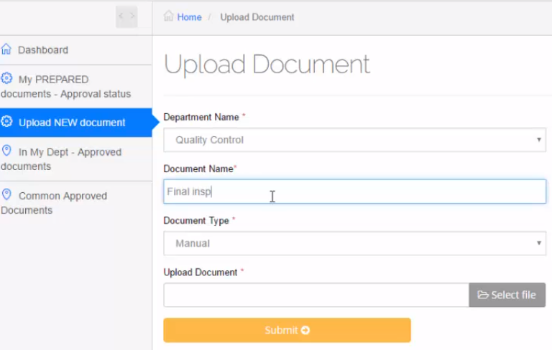

1. View table

Comments and history additionally added and viewed globally.

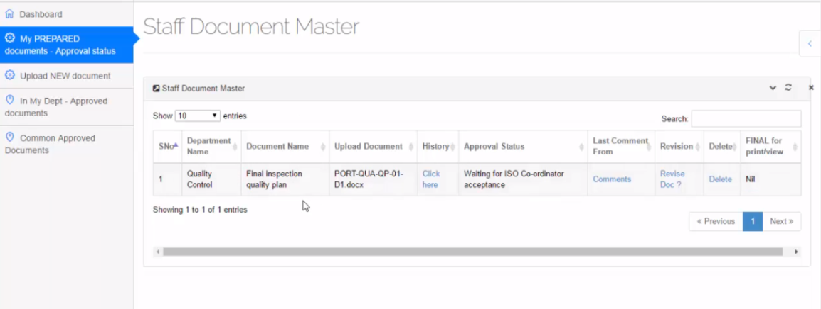

1. History (View history of Document Uploaded)

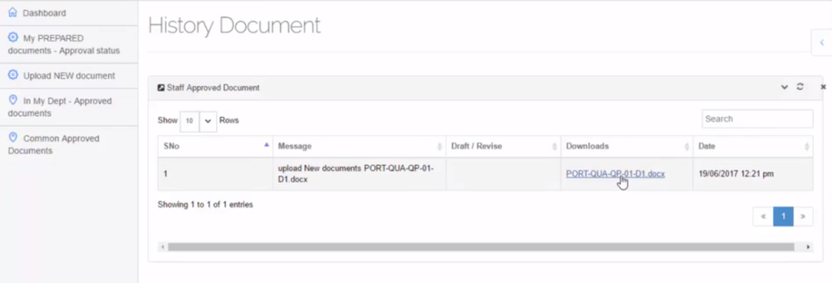

1. Comment (Add and view by all users)

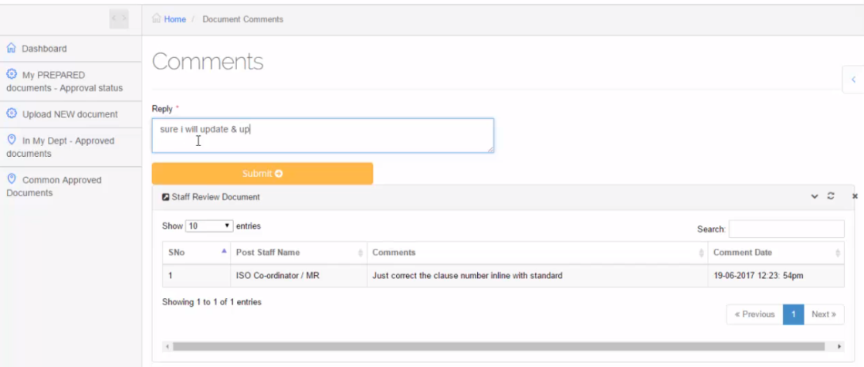

1. Revised document uploaded by Prepared person (rename the Document name and status also changed to Rev0Draft2)

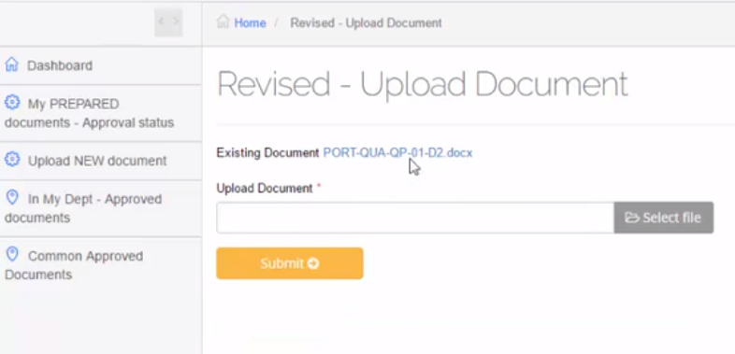

1. **MR Panel Login**
2. Table view
3. Comment
4. History
5. New document approval

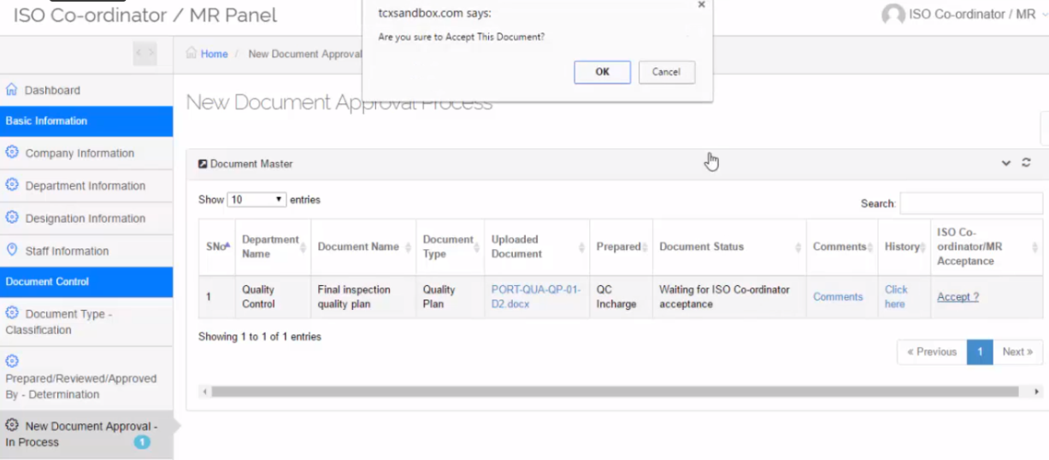

1. **Reviewed person Login**
2. Table view
3. Comment
4. History
5. Reviewed person review the document

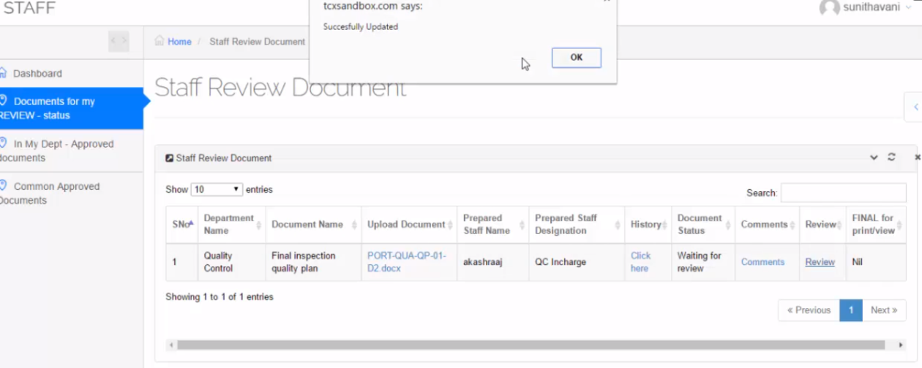

1. **Approved person Login**
2. Table view
3. Comment
4. History
5. Approved person Approve or reject the document. If he reject-> go to prepared person
6. Status and Document name changed to Rev0 and send

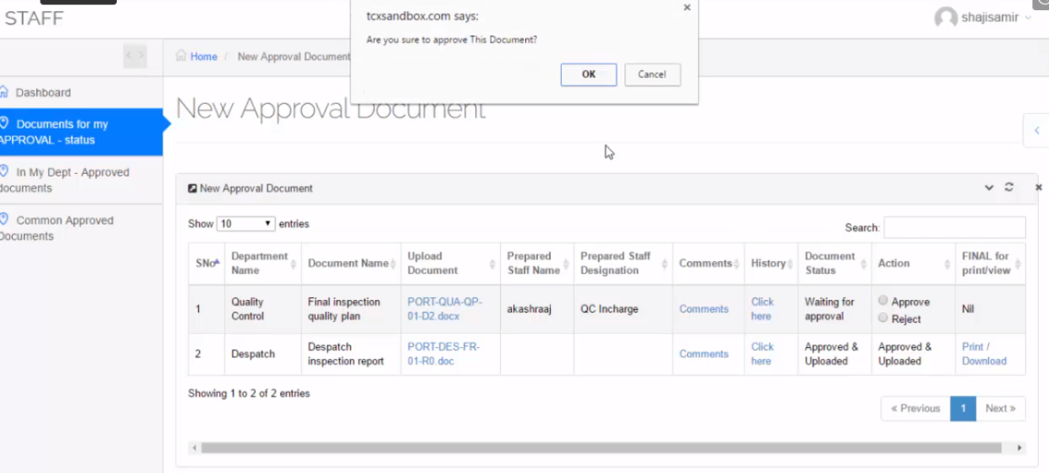

1. **MR Login**
2. Approved document in Approved menu ( In MR login )
3. MR accept the approved document

