Team Turingz — Final Report Skeleton
Group 74 · Hybrid ML + Numerical PDE Solver · who writes what, chapter by chapter

Rules that apply to every chapter
- “N.1 Introduction” first, Summary last. Every figure/table captioned (Figure N.M: …) and cited in the text before it appears.
- Every reference cited; Mendeley + IEEE throughout.
- All result numbers come from docs/report/RESULTS_PACK.md — never retype from memory.
- Bulk code and extra screenshots go to Appendices, cited from the chapters.

Chapter list and owners
Ch | Title | Owner
1 | Introduction (done) | Done
2 | Literature Review (done) | All three
3 | Technology Adapted (done) | Shared
4 | Your Approach — strategy, no diagrams | All three, own module sections
5 | Analysis and Design — all diagrams + contracts | All three, own module sections
6 | Implementation | All three, own module sections
7 | Evaluation and Discussion | All three, own module sections
8 | Conclusion and Further Work | Shared
A–D | Appendices: contributions / code / screenshots / full tables | Each member

Chapter 2 — Literature Review (per-module blocks; shared background written once)
- 2.1 Introduction (required first section — recap Ch1’s three problems, roadmap the sections; no citations)
- 2.2 Background — classical numerical methods and ML surrogates [shared, salvage interim, written ONCE]
  - 2.2.1 Classical numerical methods — FD, spectral, Cole–Hopf lineage. Refs [18]–[29].
  - 2.2.2 ML surrogates — PINN, DeepONet, FNO. Refs [1]–[6].
- 2.3 Module 1 review — Reliability and trust [Sandeepa]
  - 2.3.1 Introduction · 2.3.2 Review of others’ work · 2.3.3 Challenges in existing approaches · 2.3.4 Research gap
  - Refs: failure/extrapolation [7] Wang, [8] Krishnapriyan, [9] Fesser, [10] Zhu, [12] Lu, [13] PDEBench; trust/UQ [14] Psaros, [15] Gopakumar, [16] deep ensembles, [17] conformal.
- 2.4 Module 2 review — Hybrid ML–numerical coupling [Dharmapala]
  - 2.4.1 Introduction · 2.4.2 Review of others’ work · 2.4.3 Challenges · 2.4.4 Research gap
  - Refs: [30] Kochkov, [32] HINTS (Zhang, Nature MI), [11] PDE-Refiner, [31] ANCHOR (arXiv:2512.19643 — closest work, longest treatment), [33] Wu (hybrid reliability).
- 2.5 Module 3 review — Cost-aware control and deployment [Mendis]
  - 2.5.1 Introduction · 2.5.2 Review of others’ work · 2.5.3 Challenges · 2.5.4 Research gap
  - Refs: [34] Hespanha (hysteresis switching), [35] Liberzon, [36] Åström adaptive, [37] Mayne MPC, [38] Peherstorfer multifidelity, [39] Zilberstein anytime, [40] Dean & Boddy, [41] Miettinen / [42] Deb (multi-objective).
  - Gap: no controller takes a TARGET ACCURACY and schedules numerical effort to meet it at low cost; no measured cost/accuracy frontier for a deployed hybrid.
- 2.6 Comparison of approaches (required table)
- 2.7 Consolidated research gap — ties the three per-module gaps together into the project’s single gap
- 2.8 Summary (required last section)
EVIDENCE — Table 2.1 (required, in 2.6 or 2.7): approach | detects failure how | corrects how | target accuracy requestable? | cost measured? Prior rows end No/No; this project Yes/Yes — that table IS the gap statement.
Each module block (2.3–2.5) uses the same four sub-parts: Introduction / Review of others’ work / Challenges / Research gap. This matches the interim and makes each member’s gap unmissable for individual assessment.
Cite ONLY the 42 consolidated references; insert via Mendeley so numbering is by first appearance. ANCHOR = [31], HINTS = [32] (published Nature MI version).

Chapter 3 — Technology Adapted (short; justify, don’t tutorialize)
- 3.1 Introduction · 3.6 Summary (both required)
- 3.2 Benchmark: 1D viscous Burgers, ν = 1/(100π) — shock formation + exact Cole–Hopf reference.
- 3.3 Numerical solvers: Cole–Hopf primary (no time-stepping drift), spectral verifier + corrector, FDM low-fidelity baseline.
- 3.4 ML architectures: PINN per-instance vs FNO/DeepONet amortized — plant the operating-regime distinction here.
- 3.5 Libraries: PyTorch, DeepXDE, neuraloperator, NumPy/SciPy; FastAPI + React for the demo.
EVIDENCE — Figure 3.1: shock-formation illustration (results/eval/3_snapshots.png or regenerate cleaner). Table 3.1: component inventory (solver/model | role | library | key parameter).

Chapter 4 — Your Approach (strategy; NO diagrams, NO result numbers)
- 4.1 Introduction · 4.6 Summary (both required)
- 4.2 Solution overview: users, inputs, outputs, process — more concrete than 1.5; include the modular strategy (three independent modules joined by fixed interfaces, developed against stubs) and the trust → couple → control pipeline as strategy.
- 4.3 M1 approach [Sandeepa]: reference-free signals fused and calibrated into a trust score. What and why, not how.
- 4.4 M2 approach [Dharmapala]: re-anchoring hand-off that preserves continuity. What and why, not how.
- 4.5 M3 approach [Mendis]: an accuracy target mapped to a correction schedule, spent only when trust drops. What and why, not how.
EVIDENCE — Chapter 4 is deliberately light: ONE shared table, otherwise prose.
Table 4.1 (shared, in 4.2): system inputs → outputs. Inputs {initial condition, viscosity, accuracy target} → outputs {solution field, trust signal, cost report}.
NO figures in 4.3–4.5 (all module diagrams go to Ch5). NO code segments. NO result numbers.
Discipline: if a paragraph describes HOW a module is built (architecture, state machine), it belongs in Ch5, not here.

Chapter 5 — Analysis and Design (all diagrams and contracts live here)
- 5.1 Introduction + overall system architecture [shared]
- 5.2 M1 design [Sandeepa]: internal architecture — signal-fusion and calibration design.
- 5.3 M2 design [Dharmapala]: internal architecture — hand-off operator, corrector, switching mechanics.
- 5.4 M3 design [Mendis]: controller state machine, thresholds_for_target (the budget map), deployment runtime run(IC, target) → solution + cost report. One-way latch shipped; hysteresis tested-not-shipped (forward-reference the Ch7 ablation).
- 5.5 Summary (required)
EVIDENCE — Figure 5.1 (REQUIRED by guidelines): top-level architecture, redrawn clean: IC → ML surrogate → [M1 Trust] → [M2 Coupling] → [M3 Control] → solution + cost report (base: docs/architecture/image.png — redraw, don’t paste).
Table 5.1: the three data contracts (Trust / Hybrid rollout / Run-deploy) from the restructured plan.
Figure 5.x [M1]: signal-fusion diagram (base: trust_module_mechanism.png). Figure 5.x [M2]: hand-off sequence diagram. Figure 5.x [M3]: controller decision-flow (base: docs/architecture/module3-architecture.png).
Pseudocode ONLY (3–6 lines) if needed here; real code segments belong in Ch6. NO result numbers.

Chapter 6 — Implementation
- 5.1 Introduction · 5.7 Summary (both required)
- 6.1 Introduction · 6.2 Shared foundation (brief) · 6.3 M1 · 6.4 M2 · 6.5 M3 · 6.6 Integration · 6.7 Summary.
EVIDENCE for 6.5 (Mendis) — Listing: AdaptiveController.decide(), the real ~10 lines. Listing: thresholds_for_target, both lines INCLUDING the 0.58 clip (saturation shown here, discussed in 7.5.4).
Runtime step loop as short pseudocode; the timed-frontier protocol in prose (warm-up, per-IC timing, mean/std over 10 ICs).
One paragraph each for _ablation_switching.py, _pinn_regime.py, _run_full.py with their one-line reproduce commands.
Figure: ONE demo screenshot here (Cost control — Three-way race, light mode); all other screenshots → Appendix C.
6.6: quote the M2 conformance check result (10/10) in one line.

Chapter 7 — Evaluation and Discussion (numbers only from the Results Pack)
- 7.1 Introduction (restate the evaluation questions) · 7.8 Summary (both required)
- 7.2 Setup + Table 7.1 (machine, repeats, 10 ICs, 200 steps, rel-L2). State ONCE: timings are session-dependent; errors, hit-rates and correction counts are deterministic.
- 7.3 M1 results [Sandeepa]: Figure = step11_coarse_detector/coarse_vs_residual.png (0.999 vs 0.683) + own calibration/ROC figures. Attribution: M3 prototyped the concept, M1 productionised it.
- 7.4 M2 results [Dharmapala]: pick 3–4 from results/module2/figures/ (fig1_error_over_time, handoff_viability_gate, restart_safety_boundary…).
- 7.5 M3 results [Mendis]:
  - 7.5.1 Full-system frontier: Table = Pack T1. Figure: REGENERATE the frontier plot from timed_cost_result_m2.json — the existing step9d/timed_pareto.png predates the rerun.
  - 7.5.2 Switching ablation: Table = condensed T2 (policies at targets 0.3 / 0.05 / 0.01), full table → Appendix D. Figure (generate): hit-rate vs target per policy — hardcoded FLAT vs adaptive RESPONDS.
  - 7.5.3 Operating regime: Tables = T3 (PINN) + T5 (DeepONet). Figure (generate): FNO vs DeepONet frontiers, each normalised by its own session’s numerical baseline (numerical = 1.0 line).
  - 7.5.4 Limitations as findings: 3.00% floor; knob saturation below target ≈0.029; hysteresis unnecessary (latch shipped); wall-clock noise → corrections are the controlled variable.
- 7.6 Robustness/OOD [shared]: if using results/deployment/2_cost_accuracy.png or 4_amortization.png, verify against Pack T4 first.
- 7.7 Discussion (required): vs ANCHOR — proactive budget-driven vs reactive fixed threshold. Revisit Table 2.1 with a “this project (measured)” row.

Chapter 8 — Conclusion and Further Work
- 7.1 Introduction · 7.5 Summary (both required)
- 8.1 Introduction · 8.2 Conclusions per objective O1–O5 (each → where proven; no new numbers) · 8.3 Limitations: one PDE, 1D, single-machine timing, 3% floor · 8.4 Further work: learned controller (declared optional stretch), more PDEs, 2D, lower-floor monitor · 8.5 Summary.

Appendices
- A: Individual Contribution × 3 (one page each; Mendis: six plan components → what exists).
- B: Code listings (controller.py complete; integrate.py + _ablation_switching.py excerpts; M1/M2 equivalents).
- C: Demo screenshots — all pages (Overview, solvers, Reliability, Robustness, Cost analysis, Trust, Coupling, Cost control × 3 tabs, Hybrid engine).
- D: Full result tables (complete ablation T2; PINN regime T3; per-IC frontier data).

Figures that must NOT be used (stand-in era / superseded)
- step5_controller/controller.png — synthetic hysteresis demo, cut from the story.
- step7_pareto/pareto.png and step8_robustness/adaptive_vs_fixed.png — the stand-in 0.0-vs-8.6 era, superseded by the measured ablation.
- step9_integration / step9b dry-run PNGs and step10_demo/demo_preview.png — stand-in era.
- step9d PNGs (timed_pareto, coarse_frontier) — real but predate the rerun; regenerate before use.

Report-ready figures (embedded below — also in docs/report/figures/)
- Built from the current JSONs by docs/report/build_figures.py; re-run that script after any experiment re-run. Copy an image straight from here or use the file. Distinct markers/line styles per series, so they survive grayscale printing.
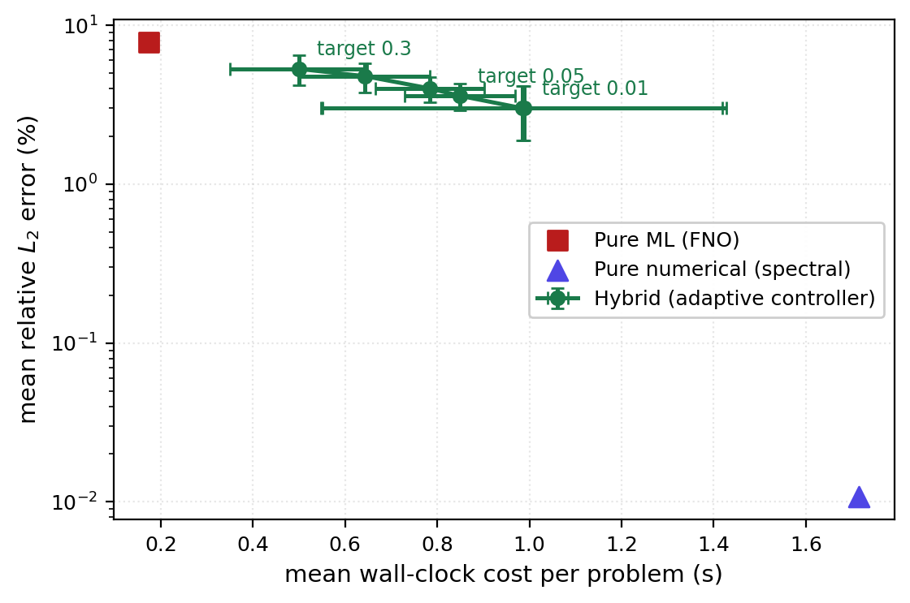
Figure 6.1: Measured cost–accuracy frontier of the hybrid against pure-ML and pure-numerical baselines (10 test ICs, mean ± std). Section 6.5.1.
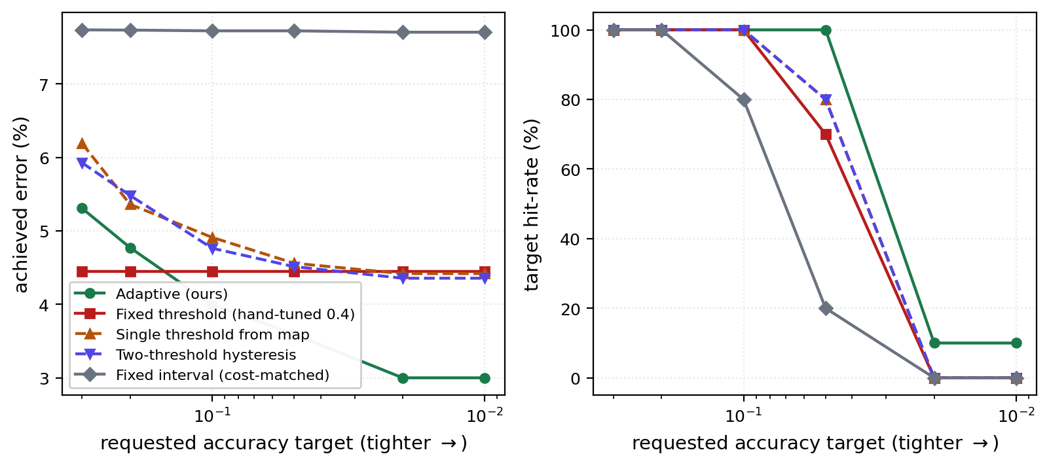
Figure 6.2: Achieved error (left) and target hit-rate (right) versus requested accuracy for five switching policies. The hand-tuned fixed threshold is flat; the adaptive controller responds. Section 6.5.2.
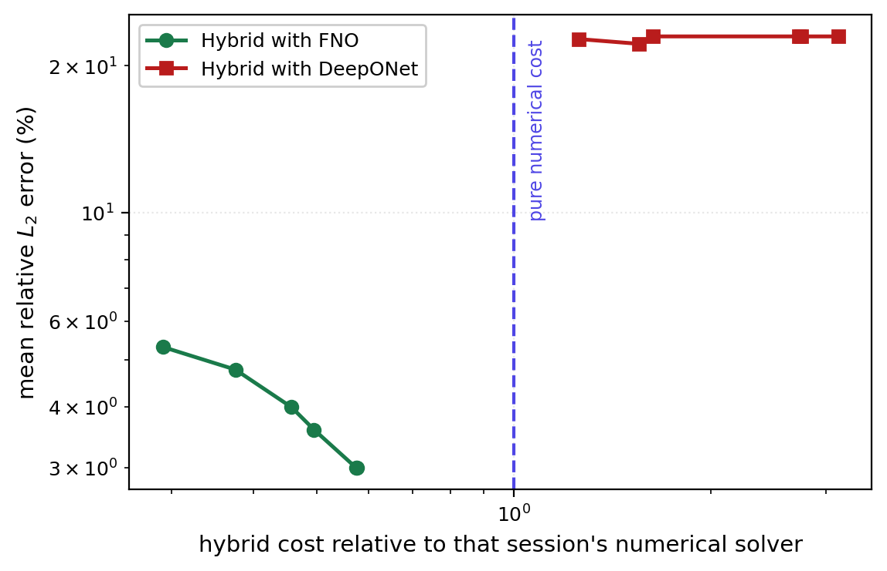
Figure 6.3: Operating regime — FNO and DeepONet hybrid frontiers, each normalised by its own session's numerical cost. FNO sits below the numerical-cost line; DeepONet is dominated. Section 6.5.3.
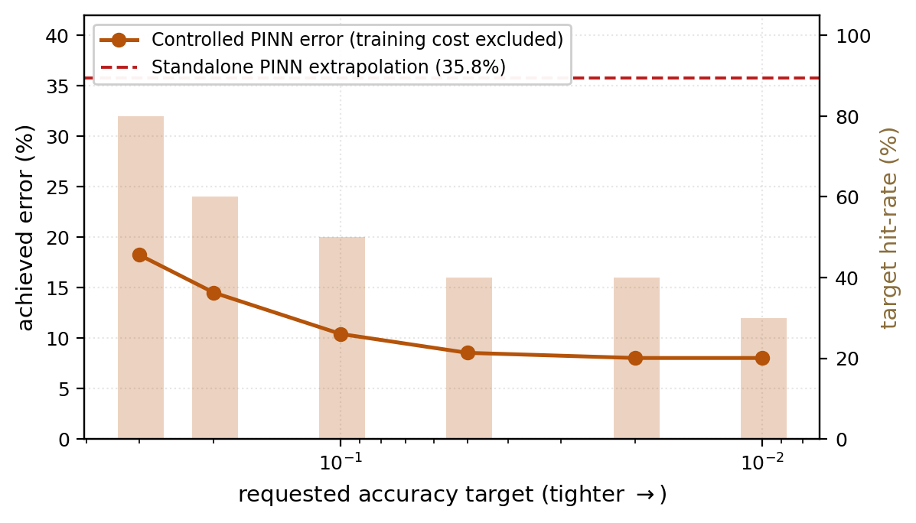
Figure 6.4: Controlled PINN error and hit-rate versus requested accuracy, against standalone PINN extrapolation (35.8%). The controller works; PINN is excluded by deployment cost. Section 6.5.3.

