Team Turingz — Final Report Skeleton
Group 74 · Hybrid ML + Numerical PDE Solver · who writes what, chapter by chapter

Rules that apply to every chapter
- “N.1 Introduction” first, Summary last. Every figure/table captioned (Figure N.M: …) and cited in the text before it appears.
- Every reference cited; Mendeley + IEEE throughout.
- All result numbers come from docs/report/RESULTS_PACK.md — never retype from memory.
- Bulk code and extra screenshots go to Appendices, cited from the chapters.

Chapter list and owners
Ch | Title | Owner
1 | Introduction (done) | Done
2 | Literature Review (done) | All three
3 | Technology Adapted (done) | Shared
4 | Your Approach — strategy, no diagrams | All three, own module sections
5 | Analysis and Design — all diagrams + contracts | All three, own module sections
6 | Implementation | All three, own module sections
7 | Evaluation and Discussion | All three, own module sections
8 | Conclusion and Further Work | Shared
A–D | Appendices: contributions / code / screenshots / full tables | Each member

Chapter 2 — Literature Review (per-module blocks; shared background written once)
- 2.1 Introduction (required first section — recap Ch1’s three problems, roadmap the sections; no citations)
- 2.2 Background — classical numerical methods and ML surrogates [shared, salvage interim, written ONCE]
  - 2.2.1 Classical numerical methods — FD, spectral, Cole–Hopf lineage. Refs [18]–[29].
  - 2.2.2 ML surrogates — PINN, DeepONet, FNO. Refs [1]–[6].
- 2.3 Module 1 review — Reliability and trust [Sandeepa]
  - 2.3.1 Introduction · 2.3.2 Review of others’ work · 2.3.3 Challenges in existing approaches · 2.3.4 Research gap
  - Refs: failure/extrapolation [7] Wang, [8] Krishnapriyan, [9] Fesser, [10] Zhu, [12] Lu, [13] PDEBench; trust/UQ [14] Psaros, [15] Gopakumar, [16] deep ensembles, [17] conformal.
- 2.4 Module 2 review — Hybrid ML–numerical coupling [Dharmapala]
  - 2.4.1 Introduction · 2.4.2 Review of others’ work · 2.4.3 Challenges · 2.4.4 Research gap
  - Refs: [30] Kochkov, [32] HINTS (Zhang, Nature MI), [11] PDE-Refiner, [31] ANCHOR (arXiv:2512.19643 — closest work, longest treatment), [33] Wu (hybrid reliability).
- 2.5 Module 3 review — Cost-aware control and deployment [Mendis]
  - 2.5.1 Introduction · 2.5.2 Review of others’ work · 2.5.3 Challenges · 2.5.4 Research gap
  - Refs: [34] Hespanha (hysteresis switching), [35] Liberzon, [36] Åström adaptive, [37] Mayne MPC, [38] Peherstorfer multifidelity, [39] Zilberstein anytime, [40] Dean & Boddy, [41] Miettinen / [42] Deb (multi-objective).
  - Gap: no controller takes a TARGET ACCURACY and schedules numerical effort to meet it at low cost; no measured cost/accuracy frontier for a deployed hybrid.
- 2.6 Comparison of approaches (required table)
- 2.7 Consolidated research gap — ties the three per-module gaps together into the project’s single gap
- 2.8 Summary (required last section)
EVIDENCE — Table 2.1 (required, in 2.6 or 2.7): approach | detects failure how | corrects how | target accuracy requestable? | cost measured? Prior rows end No/No; this project Yes/Yes — that table IS the gap statement.
Each module block (2.3–2.5) uses the same four sub-parts: Introduction / Review of others’ work / Challenges / Research gap. This matches the interim and makes each member’s gap unmissable for individual assessment.
Cite ONLY the 42 consolidated references; insert via Mendeley so numbering is by first appearance. ANCHOR = [31], HINTS = [32] (published Nature MI version).

Chapter 3 — Technology Adapted (short; justify, don’t tutorialize)
- 3.1 Introduction · 3.6 Summary (both required)
- 3.2 Benchmark: 1D viscous Burgers, ν = 1/(100π) — shock formation + exact Cole–Hopf reference.
- 3.3 Numerical solvers: Cole–Hopf primary (no time-stepping drift), spectral verifier + corrector, FDM low-fidelity baseline.
- 3.4 ML architectures: PINN per-instance vs FNO/DeepONet amortized — plant the operating-regime distinction here.
- 3.5 Libraries: PyTorch, DeepXDE, neuraloperator, NumPy/SciPy; FastAPI + React for the demo.
EVIDENCE — Figure 3.1: shock-formation illustration (results/eval/3_snapshots.png or regenerate cleaner). Table 3.1: component inventory (solver/model | role | library | key parameter).

Chapter 4 — Your Approach (strategy; NO diagrams, NO result numbers)
- 4.1 Introduction · 4.6 Summary (both required)
- 4.2 Solution overview: users, inputs, outputs, process — more concrete than 1.5; include the modular strategy (three independent modules joined by fixed interfaces, developed against stubs) and the trust → couple → control pipeline as strategy.
- 4.3 M1 approach [Sandeepa]: reference-free signals fused and calibrated into a trust score. What and why, not how.
- 4.4 M2 approach [Dharmapala]: re-anchoring hand-off that preserves continuity. What and why, not how.
- 4.5 M3 approach [Mendis]: an accuracy target mapped to a correction schedule, spent only when trust drops. What and why, not how.
EVIDENCE — Chapter 4 is deliberately light: ONE shared table, otherwise prose.
Table 4.1 (shared, in 4.2): system inputs → outputs. Inputs {initial condition, viscosity, accuracy target} → outputs {solution field, trust signal, cost report}.
NO figures in 4.3–4.5 (all module diagrams go to Ch5). NO code segments. NO result numbers.
Discipline: if a paragraph describes HOW a module is built (architecture, state machine), it belongs in Ch5, not here.

Chapter 5 — Analysis and Design (architecture, WHAT + interactions, diagrams; NO code, NO hyperparameters, NO result numbers)
- 5.1 Introduction + overall system architecture [shared]
  - Figure 5.1 (REQUIRED by guidelines): top-level design — IC → ML surrogate → [M1 Trust] → [M2 Coupling] → [M3 Control] → solution + cost report. Describe WHAT each module does and how it interacts.
  - Table 5.1: the three data contracts (Trust / Hybrid rollout / Run-deploy).
- 5.2 Module 1 design [Sandeepa] — 5.2.1 Overview · 5.2.2 Design architecture (signal-fusion + calibration design; Figure: fusion diagram, base trust_module_mechanism.png).
- 5.3 Module 2 design [Dharmapala] — 5.3.1 Overview · 5.3.2 Design architecture (hand-off operator, corrector, switching mechanics; Figure: hand-off sequence diagram).
- 5.4 Module 3 design [Mendis] — 5.4.1 Overview · 5.4.2 Design architecture: controller as a state machine (Figure 5.x: decision flow, base docs/architecture/module3-architecture.png); thresholds_for_target as the accuracy-budget MAP (concept, not code); deployment runtime run(IC, target) → solution + cost report. One-way latch shipped; hysteresis implemented and tested-not-shipped (forward-reference the Ch7 ablation).
- 5.5 Summary (required).
EVIDENCE — Figure 5.1 (required top-level diagram) + Table 5.1 (data contracts) in 5.1. One architecture figure per module in its 5.x.2. All figures captioned (Figure 5.M) and cited in text before they appear.
Each module block uses the same two sub-parts: 5.x.1 Overview / 5.x.2 Design architecture (matches DeepThinkers and the guideline's per-module description).
DISCIPLINE — do NOT repeat the DeepThinkers mistake: their Design chapter was padded with training hyperparameters, model dimensions and code. That is Implementation (Ch6). Chapter 5 stays at architecture / WHAT / interactions / diagrams. If a paragraph gives a batch size, an epoch count, a learning rate, or a code listing, it belongs in Ch6.
Pseudocode is acceptable only if it clarifies a design decision (3–6 lines). Real code and all numbers → Ch6 / Ch7.

Chapter 6 — Implementation (code segments live here; NO result numbers)
- 6.1 Introduction — recap the Ch5 design; state the software/hardware environment · 6.7 Summary (both required).
- 6.2 Shared foundation — dataset generation and model training [shared]: ground-truth pipeline (Cole–Hopf reference, spectral, FDM), IC family, train/test split (t∈[0,1] train, [1,2] held out), brief ML training. Infrastructure.
- 6.3 Module 1 implementation [Sandeepa] — signals, fusion, calibration, coarse-reference check; code segments; consistent with 5.3.
- 6.4 Module 2 implementation [Dharmapala] — hand-off, corrector, switching; code segments; consistent with 5.4.
- 6.5 Module 3 implementation [Mendis] — mirrors 5.5:
  - 6.5.1 Cost profiler.
  - 6.5.2 Accuracy-budget map — Listing: thresholds_for_target including the clip.
  - 6.5.3 Adaptive controller — Listing: decide() state machine (~10 lines).
  - 6.5.4 Deployment runtime — pseudocode / flowchart of the per-step loop (run(IC, ε) → solution + cost report).
  - 6.5.5 Reproducible experiment drivers — _run_full, _ablation_switching, _pinn_regime: one line + run command each. NO results (Ch7).
  - 6.5.6 Deployment application — FastAPI + React demo; ONE screenshot here, rest to Appendix C.
- 6.6 Integration implementation [shared] — stubs swapped for real modules; conformance check 10/10 in one line; shared-branch story.
DISCIPLINE — Ch6 IS where code goes (Ch5 had none), but code SEGMENTS only; full listings → Appendix B, cited from here. NO result numbers, NO performance figures — those are Ch7. Implementation says HOW it is built, not how well it performs.
Maintain design↔implementation consistency: 6.5's sub-subsections mirror 5.5's four components. Cite every listing/figure in the text before it appears.
Guideline: this chapter may be concise; push bulk source and screenshots to the Appendices.

Chapter 7 — Evaluation and Discussion (numbers only from RESULTS_PACK.md)
- 7.1 Introduction — restate the evaluation questions (plan Table 5) · 7.8 Summary (both required).
- 7.2 Evaluation methodology and metrics [shared] — benchmark, 10 test ICs, train/test split, machine, repeats, protocol; metric definitions (rel-L2 error, target hit-rate, cost/speed-up, detector correlation); Table 7.1 setup. STATE ONCE: timings are machine-dependent, reported from a single session; errors, hit-rates and correction counts are deterministic.
- 7.3 Module 1 results [Sandeepa] — detector correlation 0.999 vs 0.683 (Pack T6) + calibration/ROC. Attribution: M3 prototyped the concept, M1 productionised it.
- 7.4 Module 2 results [Dharmapala] — continuity at hand-over, coupling vs hard switch, viability boundary.
- 7.5 Module 3 results [Mendis]:
  - 7.5.1 Full-system frontier: Pack T1 + figure fig_6_5_1_frontier.
  - 7.5.2 Switching ablation: condensed T2 (full → Appendix D) + fig_6_5_2_ablation; BOTH findings (dominates fixed-interval; matches hand-tuned threshold on the frontier but only mine responds to the target).
  - 7.5.3 Operating regime: T3 (PINN) + T5 (DeepONet) + fig_6_5_3_regime and fig_6_5_3b_pinn; three surrogates, three different precondition failures.
  - 7.5.4 Limitations as findings: 3.00% floor; knob saturation below target ≈0.029; hysteresis unnecessary (latch shipped); wall-clock noise-limited so corrections are the controlled variable.
- 7.6 Robustness / OOD [shared] — in-distribution vs out-of-distribution behaviour.
- 7.7 Discussion — how this differs from existing work [REQUIRED by guideline; DeepThinkers omitted it]: proactive budget-driven vs ANCHOR's reactive fixed threshold; revisit Table 2.1 with a “this project (measured)” row so the Ch2 gap is closed with evidence.
EVIDENCE — the four generated figures (docs/report/figures/) all land in 7.5; the RESULTS_PACK tables become 7.5's tables (condensed in-text, full → Appendix D). The live three-way-race scoreboard screenshot (LIGHT mode) can support 7.5.1 as a 'seen live' visual.
Every number from RESULTS_PACK.md — never retyped. Cite each figure/table before it appears.
7.7 is the guideline-required Discussion DeepThinkers left out — do NOT skip it.

Chapter 8 — Conclusion and Further Work
- 7.1 Introduction · 7.5 Summary (both required)
- 8.1 Introduction · 8.2 Conclusions per objective O1–O5 (each → where proven; no new numbers) · 8.3 Limitations: one PDE, 1D, single-machine timing, 3% floor · 8.4 Further work: learned controller (declared optional stretch), more PDEs, 2D, lower-floor monitor · 8.5 Summary.

Appendices
- A: Individual Contribution × 3 (one page each; Mendis: six plan components → what exists).
- B: Code listings (controller.py complete; integrate.py + _ablation_switching.py excerpts; M1/M2 equivalents).
- C: Demo screenshots — all pages (Overview, solvers, Reliability, Robustness, Cost analysis, Trust, Coupling, Cost control × 3 tabs, Hybrid engine).
- D: Full result tables (complete ablation T2; PINN regime T3; per-IC frontier data).

Figures that must NOT be used (stand-in era / superseded)
- step5_controller/controller.png — synthetic hysteresis demo, cut from the story.
- step7_pareto/pareto.png and step8_robustness/adaptive_vs_fixed.png — the stand-in 0.0-vs-8.6 era, superseded by the measured ablation.
- step9_integration / step9b dry-run PNGs and step10_demo/demo_preview.png — stand-in era.
- step9d PNGs (timed_pareto, coarse_frontier) — real but predate the rerun; regenerate before use.

Report-ready figures (embedded below — also in docs/report/figures/)
- Built from the current JSONs by docs/report/build_figures.py; re-run that script after any experiment re-run. Copy an image straight from here or use the file. Distinct markers/line styles per series, so they survive grayscale printing.
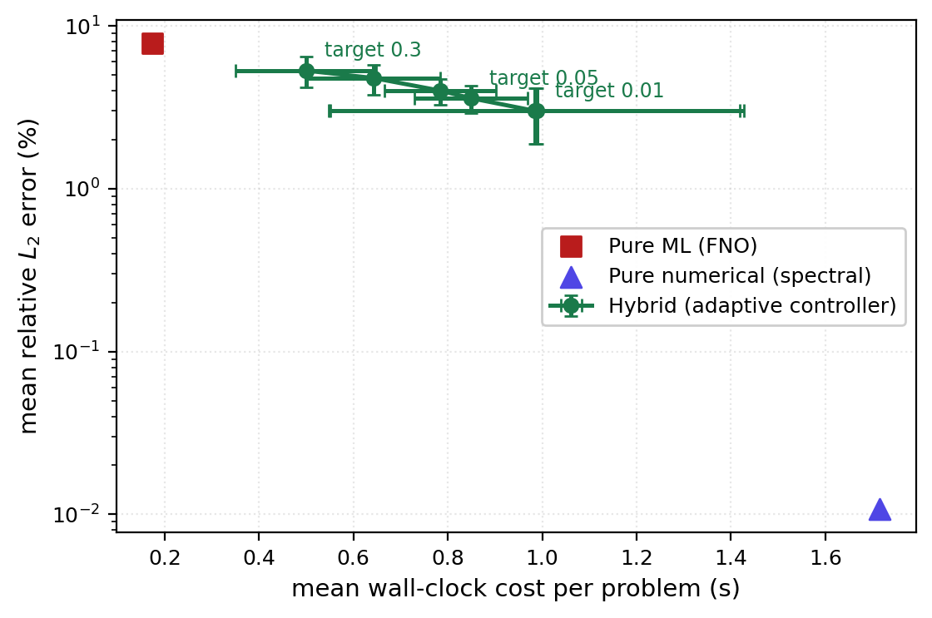
Figure 6.1: Measured cost–accuracy frontier of the hybrid against pure-ML and pure-numerical baselines (10 test ICs, mean ± std). Section 6.5.1.
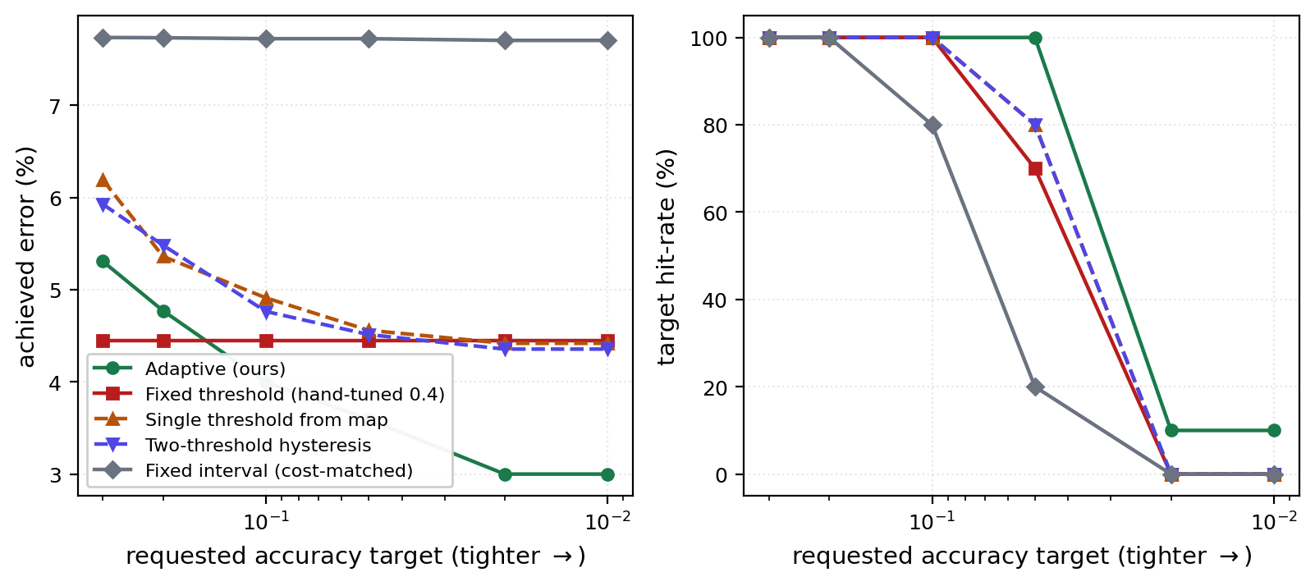
Figure 6.2: Achieved error (left) and target hit-rate (right) versus requested accuracy for five switching policies. The hand-tuned fixed threshold is flat; the adaptive controller responds. Section 6.5.2.
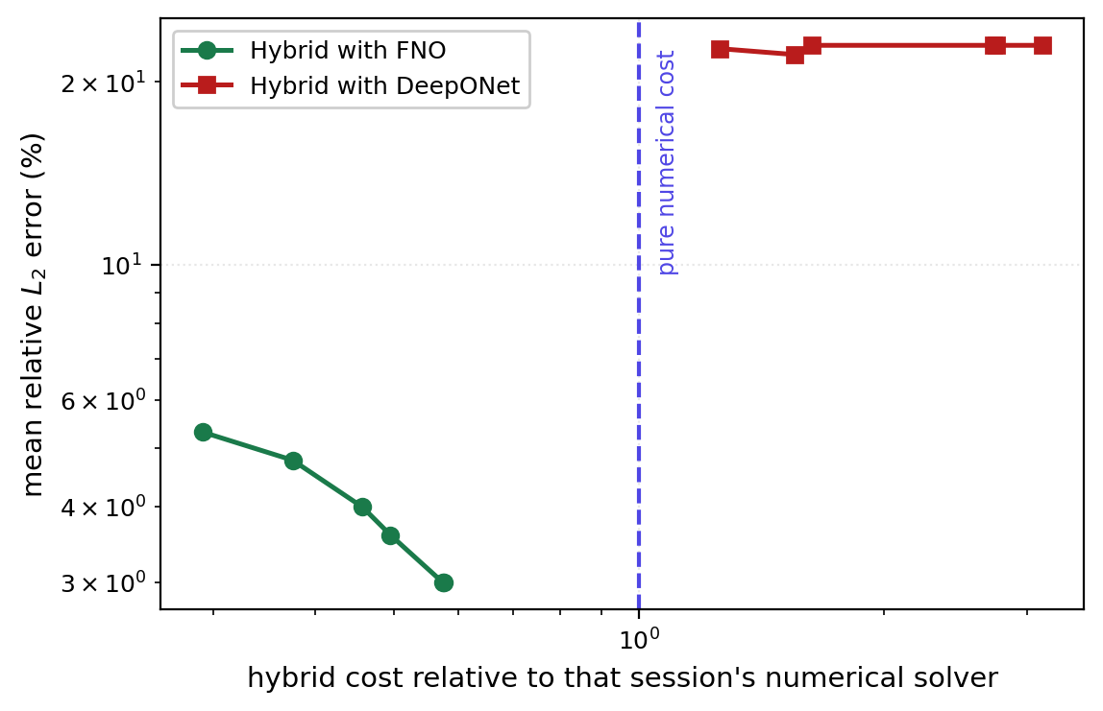
Figure 6.3: Operating regime — FNO and DeepONet hybrid frontiers, each normalised by its own session's numerical cost. FNO sits below the numerical-cost line; DeepONet is dominated. Section 6.5.3.
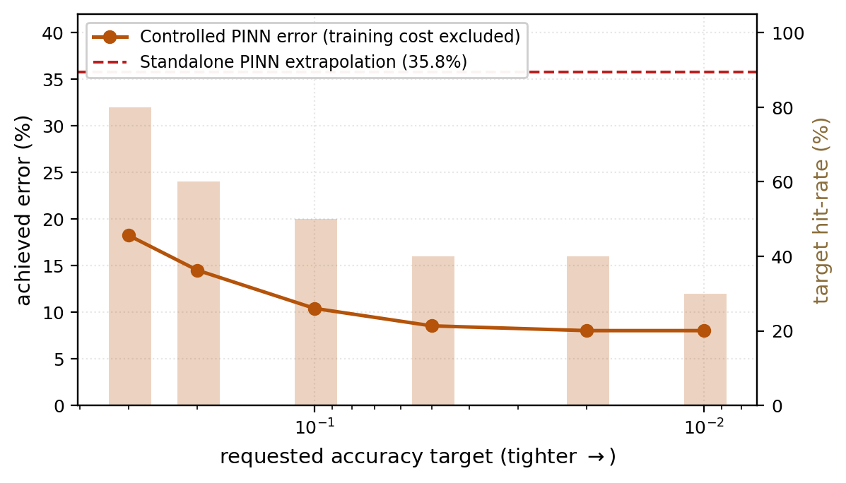
Figure 6.4: Controlled PINN error and hit-rate versus requested accuracy, against standalone PINN extrapolation (35.8%). The controller works; PINN is excluded by deployment cost. Section 6.5.3.

