**Flash an image in Toradex board (apalis imx6)**

**NOTE:** Installation software and file required.

1. Ubuntu Software(Linux).

* Link to download VMWARE: <https://www.vmware.com/in/products/workstation-player/workstation-player-evaluation.html>
* Link to download ubuntu os: <https://ubuntu.com/download/desktop>

1. Toradex Easy installer (apalis imx6).
2. Image for apalis imx6 (download the suitable version).

**STEP 1:**

Download the apalis imx6 easy installer in **Ubuntu (Linux).**

Link: <https://toradex3.rssing.com/chan-59520323/article476.html>

**STEP 2:**

Files -> downloads -> unzip the downloaded file -> right click -> open in terminal.

**STEP 3:**

**In Terminal enter the following commands:**

1. Sudo apt install putty.
2. dmesg |grep tty (permission denied means put the below command).
3. Sudo sysctl kernal.dmesg_restrict=0.
4. dmesg |grep tty

* Check ttyUSB0 is connected.

1. Sudo putty

* Change **ttyUSB0** and 115200.
* Saved Sensor -> select **ttyUSB0** -> Load -> OK.

**STEP 4:**

**New Putty terminal will be open**

1. Give enter and login as **root.**
2. **reboot.**
3. **bmode usb**

**STEP 5:**

**Open one new terminal**

1. Run the downloaded file

* ./recovery-linux.sh

Note: if permission denied means give **chmode +x recovery-linux.sh** command.

Then In display will see the below slide.

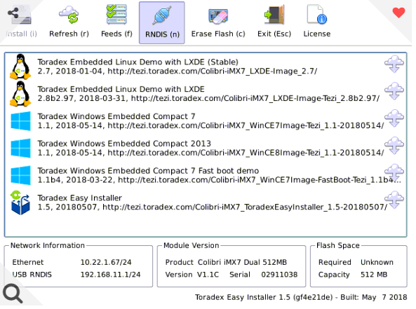

**STEP 6:**

Download the apalix imx6 (any version ex:6.5.1) image in pendrive.

Link to download the image: <https://developer.toradex.com/linux-bsp/application-development/gui/partner-demo-image-qt-for-device-creation-boot-to-qt/#deployoverthenetwork>.

Flash the image by

1. In **Mass storage** -> select the image
2. Give **Install.**

**STEP 7:**

Reset the board then the new Version will be updated in the Board.