**RELEVANT SCREENSHOTS**

UI of stopwatch

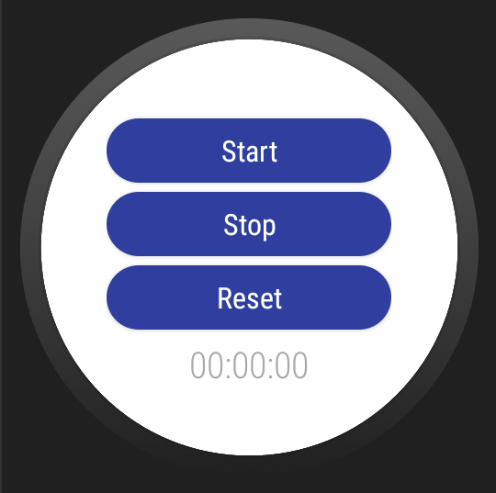

Starting stopwatch

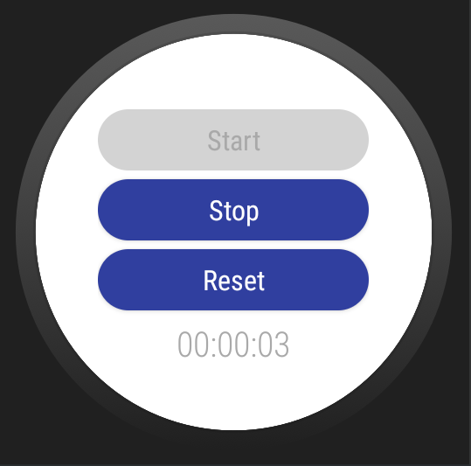

Stopping stopwatch

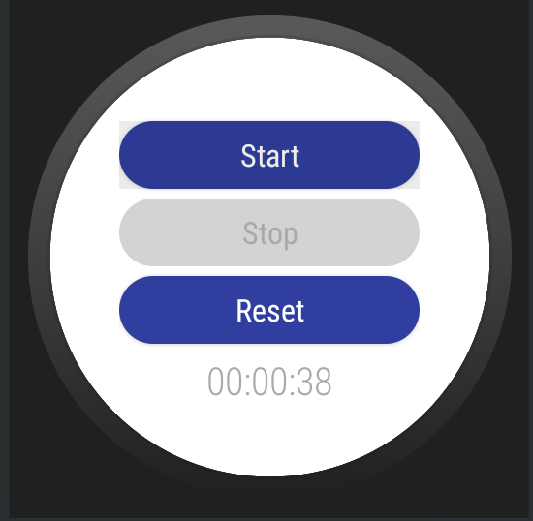

Resetting stopwatch

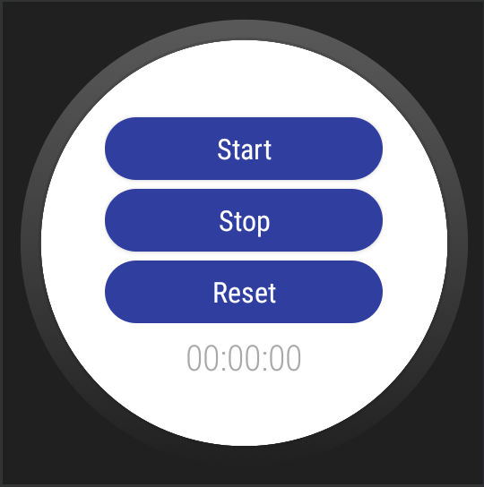

**Commented Java code**

MainActivity.java

package com.example.nithinthomasninanassignment1;

import android.os.Bundle;

import android.os.SystemClock;

import android.view.View;

import androidx.appcompat.app.AppCompatActivity;

import androidx.core.content.ContextCompat;

import com.example.nithinthomasninanassignment1.databinding.ActivityMainBinding;

//the main activity class

public class MainActivity extends AppCompatActivity implements View.OnClickListener {

ActivityMainBinding activityMainBinding;

//setting default value to stopwatch

private int timer = 0;

@Override

protected void onCreate(Bundle savedInstanceState) {

super.onCreate(savedInstanceState);

activityMainBinding = ActivityMainBinding.inflate(getLayoutInflater());

View view = activityMainBinding.getRoot();

setContentView(view);

initializeChronometer();

setListeners();

}

//initializing the stopwatch

private void initializeChronometer() {

//setting the format of stopwatch to 00:00:00

activityMainBinding.chronometer.setFormat("00:%s");

activityMainBinding.chronometer.setBase(SystemClock.elapsedRealtime());

}

//setting the listeners

private void setListeners() {

activityMainBinding.btnStart.setOnClickListener(this);

activityMainBinding.btnStop.setOnClickListener(this);

activityMainBinding.btnReset.setOnClickListener(this);

}

//button click functionalities

@Override

public void onClick(View v) {

if (v.getId() == R.id.btnStart) {

//start the timer

startTimer();

} else if (v.getId() == R.id.btnStop) {

//stop the timer

stopTimer();

} else if (v.getId() == R.id.btnReset) {

//reset the timer

resetTimer();

}

}

private void startTimer() {

//disabling start button

activityMainBinding.btnStart.setEnabled(false);

activityMainBinding.btnStop.setEnabled(true);

activityMainBinding.btnReset.setEnabled(true);

//setting background to buttons

activityMainBinding.btnStart.setBackground(ContextCompat.getDrawable(this, R.drawable.curved_bg_grey));

activityMainBinding.btnStop.setBackground(ContextCompat.getDrawable(this, R.drawable.curved_bg_blue));

activityMainBinding.btnReset.setBackground(ContextCompat.getDrawable(this, R.drawable.curved_bg_blue));

activityMainBinding.btnStart.setTextColor(ContextCompat.getColor(this, R.color.dark_grey));

//changing button text when clicked

activityMainBinding.btnStop.setTextColor(ContextCompat.getColor(this, R.color.white));

activityMainBinding.btnReset.setTextColor(ContextCompat.getColor(this, R.color.white));

if (timer == 0) {

//starting the stopwatch

activityMainBinding.chronometer.start();

timer = 1;

}

}

private void stopTimer() {

//disabling stop button

activityMainBinding.btnStart.setEnabled(true);

activityMainBinding.btnStop.setEnabled(false);

activityMainBinding.btnReset.setEnabled(true);

activityMainBinding.btnStart.setBackground(ContextCompat.getDrawable(this, R.drawable.curved_bg_blue));

activityMainBinding.btnStop.setBackground(ContextCompat.getDrawable(this, R.drawable.curved_bg_grey));

activityMainBinding.btnReset.setBackground(ContextCompat.getDrawable(this, R.drawable.curved_bg_blue));

activityMainBinding.btnStart.setTextColor(ContextCompat.getColor(this, R.color.white));

activityMainBinding.btnStop.setTextColor(ContextCompat.getColor(this, R.color.dark_grey));

activityMainBinding.btnReset.setTextColor(ContextCompat.getColor(this, R.color.white));

if (timer == 1) {

//stopping the stopwatch

activityMainBinding.chronometer.stop();

timer = 0;

}

}

private void resetTimer() {

//disabling reset button

activityMainBinding.btnStart.setEnabled(true);

activityMainBinding.btnStop.setEnabled(true);

activityMainBinding.btnReset.setEnabled(false);

activityMainBinding.btnStart.setBackground(ContextCompat.getDrawable(this, R.drawable.curved_bg_blue));

activityMainBinding.btnReset.setBackground(ContextCompat.getDrawable(this, R.drawable.curved_bg_blue));

activityMainBinding.btnStop.setBackground(ContextCompat.getDrawable(this, R.drawable.curved_bg_blue));

activityMainBinding.btnStart.setTextColor(ContextCompat.getColor(this, R.color.white));

activityMainBinding.btnStop.setTextColor(ContextCompat.getColor(this, R.color.white));

activityMainBinding.btnReset.setTextColor(ContextCompat.getColor(this, R.color.white));

//resetting the stopwatch

activityMainBinding.chronometer.setBase(SystemClock.elapsedRealtime());

}

}