Multimodal Crime / Incident Report Analyzer
Project Report
AI for Engineers — Group Assignment
GITHUB Repo : https://github.com/AdithyaReddyGeeda/Multimodal-Crime-Incident-Report-Analyzer.git
Contributions
Name | Role | Contributions
Adithya Reddy Geeda | Lead | Audio module, Image module, Video module, Integration, React dashboard, Pipeline architecture, Project setup & GitHub
Vidya Cheekuri | Lead | Document module (PDF extraction, section splitting, OCR), Dashboard sync, Dashboard components (IncidentModal, StatsBar, App)
Meghansh | Contributor | Text analyst module (NLP pipeline, sentiment analysis, topic classification)
Tamjida | Contributor | Project documentation and README

1. Background and Problem Statement
A city emergency response department faces a critical challenge: hundreds of daily incidents are reported through vastly different channels — emergency audio calls, written police reports, CCTV surveillance footage, scene photographs, and social media posts. Human analysts manually reviewing all this information introduces delays and errors that can cost lives.

This project builds an AI-powered Multimodal Incident Analyzer that automatically ingests five types of unstructured data, applies specialised AI models to each, extracts structured fields, and merges everything into a unified incident dataset accessible through an interactive dashboard.

2. AI Pipeline Architecture

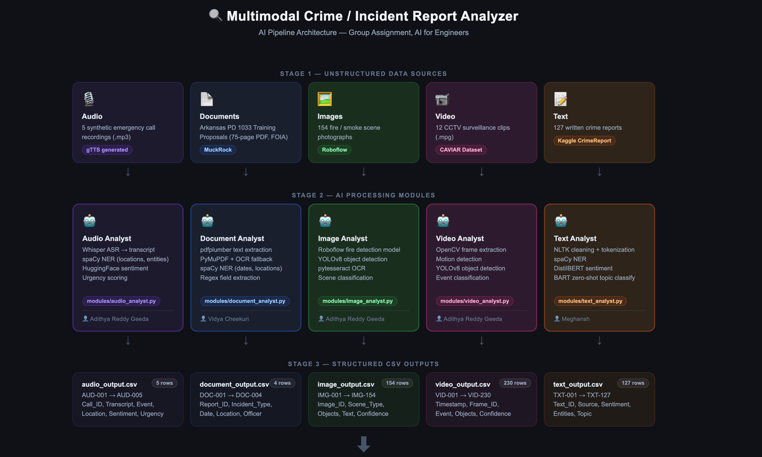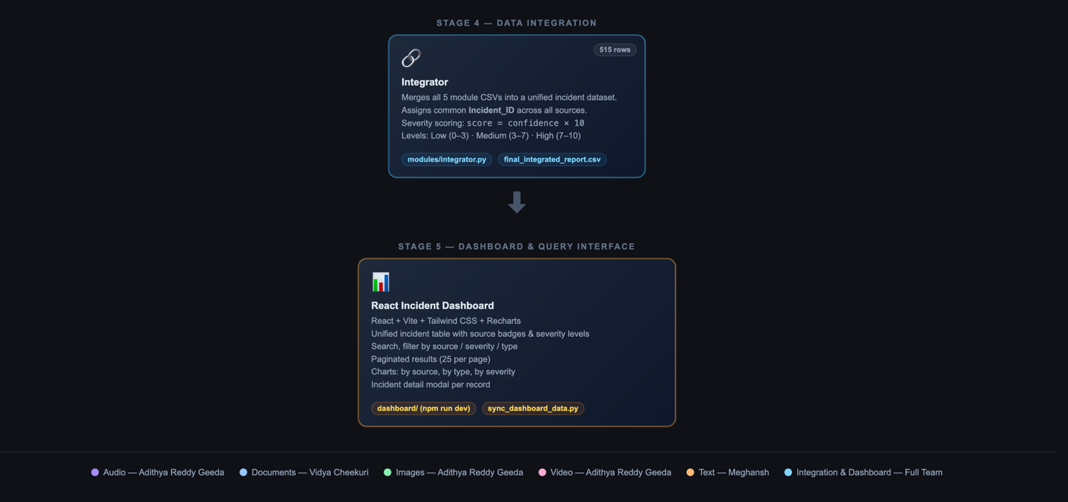

The system is organised as a five-stage pipeline:

# | Stage | Description
1 | Unstructured Data Ingestion | Audio files, PDFs, images, video clips, and text posts are loaded from data/
2 | AI Processing per Modality | Each module runs its AI model on its specific data type
3 | Information Extraction | Key fields (event, location, time, entities, sentiment) are extracted
4 | Structured Dataset Generation | All outputs are merged into final_integrated_report.csv
5 | Dashboard / Query System | React dashboard visualises and filters the unified incident data

The pipeline is orchestrated by main.py and can be executed end-to-end with a single command. A sync script (sync_dashboard_data.py) exports the CSVs to JavaScript data files consumed by the React dashboard.

3.1 Audio Analyst
The Audio Analyst processes emergency call recordings and converts spoken content into structured incident data.
- Dataset: 5 synthetic MP3 audio files generated with gTTS, simulating emergency 911 calls covering fire, theft, assault, traffic accident, and public disturbance scenarios.
- Transcription: OpenAI Whisper (local, base model) transcribes each audio file. Transcripts are saved to data/audio/transcripts.csv.
- NLP Pipeline: spaCy en_core_web_sm performs Named Entity Recognition to extract locations and named entities. HuggingFace distilbert-base-uncased-finetuned-sst-2-english classifies sentiment (POSITIVE/NEGATIVE/NEUTRAL).
- Urgency Scoring: A heuristic scoring function assigns a 0–1 urgency score based on presence of distress keywords (fire, trapped, shot, etc.).
- Output: outputs/audio_output.csv — 5 rows, columns: Incident_ID, Call_ID, Transcript, Extracted_Event, Location, Sentiment, Urgency_Score.

3.2 Document Analyst
The Document Analyst extracts structured information from PDF police and administrative documents.
- Dataset: Arkansas Police Department 1033 Training Plan Proposals — a 75-page FOIA-released PDF obtained via MuckRock (muckrock.com). The document contains training proposals submitted by four Arkansas police departments for MRAP (Mine Resistant Ambush Protected) vehicle operations.
- Text Extraction: pdfplumber is the primary extraction library, with PyMuPDF (fitz) as a fallback. For scanned pages, pytesseract OCR is applied via pdf2image conversion.
- Section Splitting: The module detects department section boundaries by identifying cover letter patterns (“To: Whom it may Concern”) and department name headers. Each department submission becomes a separate row.
- NLP Pipeline: spaCy NER extracts dates, locations, and person names. Regex patterns identify incident/document types, officer names, suspect descriptions, and outcomes.
- Output: outputs/document_output.csv — 4 rows (Fort Smith PD, Hot Springs PD, Jacksonville AR PD, Lonoke County Sheriff), columns: Incident_ID, Report_ID, Incident_Type, Date, Location, Officer, Summary, Suspect_Description, Outcome.

3.3 Image Analyst
The Image Analyst analyses scene photographs to detect objects of interest and classify incident types.
- Dataset: 154 fire and smoke scene images from the Roboflow Fire Detection Dataset (workspace: leilamegdiche, project: fire-detection-rsqrr, version 1). Images are stored in fire-detection.v1i.yolov8/test/images/.
- Object Detection: The Roboflow hosted inference API provides fire/smoke detection at 85.4% mAP. YOLOv8n (yolov8n.pt) is used as a fallback for general object detection.
- Classes Detected: fire, smoke, light, no-fire.
- OCR: pytesseract is run on each image to extract any visible text (license plates, street signs, banners).
- Output: outputs/image_output.csv — 154 rows, columns: Incident_ID, Image_ID, Scene_Type, Objects_Detected, Text_Extracted, Confidence_Score.

3.4 Video Analyst
The Video Analyst processes CCTV footage to detect abnormal activities and produce a timestamped event log.
- Dataset: 12 CAVIAR CCTV surveillance clips (.mpg) from the University of Edinburgh CAVIAR dataset. Scenarios include Browse, Fight_Chase, Fight_OneManDown, LeftBag, Meet_Split, Walk, Rest_InChair, and Shop scenarios.
- Frame Extraction: OpenCV extracts frames at regular intervals from each video clip.
- Motion Detection: Frame differencing detects frames with significant motion, filtering static background frames.
- Object Detection: YOLOv8 runs inference on each motion-flagged frame to detect and classify objects (person, bag, vehicle, etc.).
- Event Classification: Detected objects and motion patterns are mapped to incident categories (fighting, abandoned object, collapse, normal movement).
- Output: outputs/video_output.csv — 230 rows, columns: Incident_ID, Timestamp, Frame_ID, Event_Detected, Objects, Confidence.

3.5 Text Analyst
The Text Analyst processes written crime reports and social media text to extract structured incident information.
- Dataset: 127 crime reports from the Kaggle CrimeReport dataset (data/Text/CrimeReport.txt). Reports cover robbery, assault, theft, vandalism, and other crime types.
- Preprocessing: NLTK handles text cleaning, stopword removal, and tokenization.
- NER: spaCy en_core_web_sm extracts named entities — persons, organisations, locations, and dates.
- Sentiment Analysis: HuggingFace distilbert-base-uncased-finetuned-sst-2-english classifies each report as POSITIVE, NEGATIVE, or NEUTRAL with a confidence score.
- Topic Classification: facebook/bart-large-mnli performs zero-shot classification across categories: robbery/theft, assault/violence, fire/arson, traffic accident, public disturbance.
- Output: outputs/text_output.csv — 127 rows, columns: Incident_ID, Text_ID, Source, Raw_Text, Sentiment, Sentiment_Score, Entities, Topic.
4. Final Integration
The integration module (modules/integrator.py) merges all five module outputs into a single unified dataset using pandas. The process follows the four steps specified in the assignment brief:
- Step 1 — Common ID: Each module assigns a prefixed Incident_ID (AUD-, DOC-, IMG-, VID-, TXT-) to ensure uniqueness across sources.
- Step 2 — Merge: All five DataFrames are concatenated and mapped to a common schema.
- Step 3 — Missing Values: Where a modality has no data for a given field (e.g., no Officer field in image data), the cell is filled with N/A.
- Step 4 — Severity Classification: A severity score is computed as confidence/urgency × 10 (0–10 scale). Scores 0–3 = Low, 3–7 = Medium, 7–10 = High. Document entries use a keyword-based urgency weight.

Final output: outputs/final_integrated_report.csv with 515 total incidents.
Incident_ID | Source | Type | Location | Confidence/Urgency | Severity_Score | Severity_Level
AUD-001 | Audio | fire / arson | Downtown Ave | 0.91 | 9.1 | High
DOC-001 | Document | admin / training | Fort Smith PD | 0.50 | 5.0 | Medium
IMG-034 | Image | fire scene | N/A | 0.94 | 9.4 | High
VID-003 | Video | person collapsing | N/A | 0.88 | 8.8 | High
TXT-112 | Text | robbery/theft | Oak Street | 0.76 | 7.6 | High

5. Dashboard
The interactive React dashboard (dashboard/) provides a unified interface for exploring and filtering the integrated incident dataset. It is built with Vite, Tailwind CSS, and Recharts, and runs locally with npm run dev.
- Unified incident table with source badges (Audio = blue, Document = indigo, Image = green, Video = purple, Text = orange) and severity badges (High = red, Medium = yellow, Low = green).
- Search bar and filter controls for source, severity level, and incident type.
- Paginated results at 25 rows per page.
- Charts showing incident distribution by source, by incident type, and by severity level.
- Incident detail modal showing all extracted fields for a selected record.
- Data is synced from the output CSVs via sync_dashboard_data.py, which writes JavaScript data files to dashboard/src/data/.

6. Tools and Datasets Summary
Module | Dataset | AI Tools | Rows Out | ID Range
Audio Analyst | 5 MP3 files (gTTS synthetic 911 calls) | Whisper ASR, spaCy NER, HuggingFace DistilBERT | 5 rows | AUD-001 to AUD-005
Document Analyst | Arkansas PD 1033 Training Proposals PDF (75 pages, FOIA released via MuckRock) | pdfplumber, PyMuPDF, pytesseract OCR, spaCy NER | 4 rows | DOC-001 to DOC-004
Image Analyst | 154 fire/smoke images from Roboflow Fire Detection Dataset v1 | Roboflow hosted model (85.4% mAP), YOLOv8n, pytesseract OCR | 154 rows | IMG-001 to IMG-154
Video Analyst | 12 CAVIAR CCTV surveillance clips (.mpg) | OpenCV frame extraction, motion detection, YOLOv8 object detection | 230 rows | VID-001 to VID-230
Text Analyst | 127 crime reports from Kaggle CrimeReport dataset | NLTK, spaCy NER, DistilBERT sentiment, BART zero-shot topic classification | 127 rows | TXT-001 to TXT-127
Integration | All 5 CSVs | pandas merge/concat | 515 rows | Mixed

