**LED control using push button**

* **CODE**

#include "stm32f4xx_hal.h"

void Init_Pushbutton(void);

void Init_leds(void);

int main(void)

{

void Init_Pushbutton();

void Init_leds();

while(1)

{

if(HAL_GPIO_ReadPin(GPIOA,GPIO_PIN_0))

{

HAL_GPIO_WritePin(GPIOD,GPIO_PIN_12|GPIO_PIN_13|GPIO_PIN_14|GPIO_PIN_15,GPIO_PIN_SET);

}

else

HAL_GPIO_WritePin(GPIOD,GPIO_PIN_12|GPIO_PIN_13|GPIO_PIN_14|GPIO_PIN_15,GPIO_PIN_RESET);

}

}

void Init_Pushbutton(void){

__HAL_RCC_GPIOA_CLK_ENABLE();

GPIO_InitTypeDef pushbutton;

pushbutton.Pin = GPIO_PIN_0;

pushbutton.Mode = GPIO_MODE_INPUT;

pushbutton.Pull = GPIO_NOPULL;

HAL_GPIO_Init(GPIOA, &pushbutton);

}

void Init_leds(void){

__HAL_RCC_GPIOD_CLK_ENABLE();

GPIO_InitTypeDef ledpins;

ledpins.Pin = GPIO_PIN_12|GPIO_PIN_13|GPIO_PIN_14|GPIO_PIN_15;

ledpins.Mode = GPIO_MODE_OUTPUT_PP;

HAL_GPIO_Init(GPIOD, &ledpins);

}

* Output

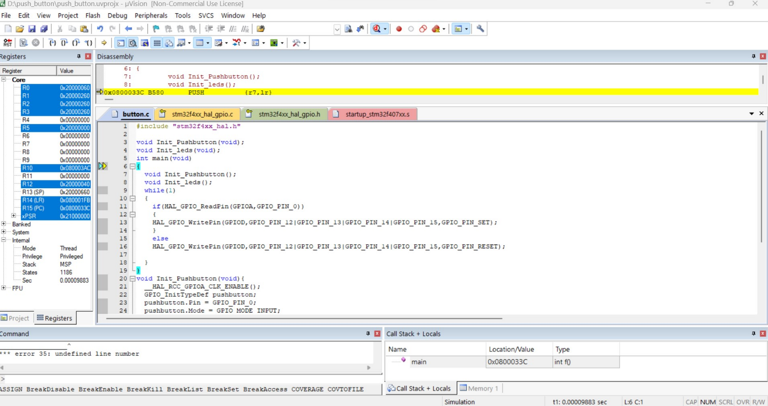

**SEVEN SEGMENT DISPLAY control using push button**

* **CODE**

#include "stm32f4xx_hal.h"

#include "stm32f4xx_hal_gpio.h"

void displayDigit(int digit, int value);

void displayNumber(int number);

int main(void)

{

HAL_Init();

GPIO_InitTypeDef GPIO_InitStruct;

__HAL_RCC_GPIOA_CLK_ENABLE();

__HAL_RCC_GPIOB_CLK_ENABLE();

GPIO_InitStruct.Pin = GPIO_PIN_0 | GPIO_PIN_1 | GPIO_PIN_2 | GPIO_PIN_3;

GPIO_InitStruct.Mode = GPIO_MODE_OUTPUT_PP;

GPIO_InitStruct.Speed = GPIO_SPEED_FREQ_HIGH;

HAL_GPIO_Init(GPIOA, &GPIO_InitStruct);

GPIO_InitStruct.Pin = GPIO_PIN_3 | GPIO_PIN_4 | GPIO_PIN_5 | GPIO_PIN_6| GPIO_PIN_7 | GPIO_PIN_8 | GPIO_PIN_9 | GPIO_PIN_10;

GPIO_InitStruct.Mode = GPIO_MODE_OUTPUT_PP;

GPIO_InitStruct.Speed = GPIO_SPEED_FREQ_HIGH;

HAL_GPIO_Init(GPIOB, &GPIO_InitStruct);

while (1)

{

displayNumber(1234);

HAL_Delay(1000);

displayNumber(5678);

HAL_Delay(1000);

}

}

void displayDigit(int digit, int value)

{

switch (digit)

{

case 1:

HAL_GPIO_WritePin(GPIOA, GPIO_PIN_0, GPIO_PIN_SET);

break;

case 2:

HAL_GPIO_WritePin(GPIOA, GPIO_PIN_1, GPIO_PIN_SET);

break;

case 3:

HAL_GPIO_WritePin(GPIOA, GPIO_PIN_2, GPIO_PIN_SET);

break;

case 4:

HAL_GPIO_WritePin(GPIOA, GPIO_PIN_3, GPIO_PIN_SET);

break;

}

switch (value)

{

case 0:

HAL_GPIO_WritePin(GPIOB,

GPIO_PIN_3 | GPIO_PIN_4 | GPIO_PIN_5 | GPIO_PIN_6 | GPIO_PIN_7

| GPIO_PIN_8, GPIO_PIN_SET);

HAL_GPIO_WritePin(GPIOB, GPIO_PIN_9 | GPIO_PIN_10, GPIO_PIN_RESET);

break;

case 1:

HAL_GPIO_WritePin(GPIOB, GPIO_PIN_6 | GPIO_PIN_8, GPIO_PIN_SET);

HAL_GPIO_WritePin(GPIOB,

GPIO_PIN_3 | GPIO_PIN_4 | GPIO_PIN_5 | GPIO_PIN_7 | GPIO_PIN_9

| GPIO_PIN_10, GPIO_PIN_RESET);

break;

case 2:

HAL_GPIO_WritePin(GPIOB,

GPIO_PIN_5 | GPIO_PIN_6 | GPIO_PIN_7 | GPIO_PIN_8 | GPIO_PIN_9,

GPIO_PIN_SET);

HAL_GPIO_WritePin(GPIOB, GPIO_PIN_3 | GPIO_PIN_4 | GPIO_PIN_10,

GPIO_PIN_RESET);

break;

case 3:

HAL_GPIO_WritePin(GPIOB,

GPIO_PIN_4 | GPIO_PIN_5 | GPIO_PIN_6 | GPIO_PIN_7 | GPIO_PIN_9,

GPIO_PIN_SET);

HAL_GPIO_WritePin(GPIOB, GPIO_PIN_3 | GPIO_PIN_8 | GPIO_PIN_10,

GPIO_PIN_RESET);

break;

case 4:

HAL_GPIO_WritePin(GPIOB,

GPIO_PIN_3 | GPIO_PIN_6 | GPIO_PIN_7 | GPIO_PIN_9,

GPIO_PIN_SET);

HAL_GPIO_WritePin(GPIOB,

GPIO_PIN_4 | GPIO_PIN_5 | GPIO_PIN_8 | GPIO_PIN_10,

GPIO_PIN_RESET);

break;

case 5:

HAL_GPIO_WritePin(GPIOB,

GPIO_PIN_4 | GPIO_PIN_5 | GPIO_PIN_6 | GPIO_PIN_8 | GPIO_PIN_9,

GPIO_PIN_SET);

HAL_GPIO_WritePin(GPIOB, GPIO_PIN_3 | GPIO_PIN_7 | GPIO_PIN_10,

GPIO_PIN_RESET);

break;

case 6:

HAL_GPIO_WritePin(GPIOB,

GPIO_PIN_4 | GPIO_PIN_5 | GPIO_PIN_6 | GPIO_PIN_7 | GPIO_PIN_8

| GPIO_PIN_9, GPIO_PIN_SET);

HAL_GPIO_WritePin(GPIOB, GPIO_PIN_3 | GPIO_PIN_10, GPIO_PIN_RESET);

break;

case 7:

HAL_GPIO_WritePin(GPIOB,

GPIO_PIN_3 | GPIO_PIN_4 | GPIO_PIN_5 | GPIO_PIN_8,

GPIO_PIN_SET);

HAL_GPIO_WritePin(GPIOB,

GPIO_PIN_6 | GPIO_PIN_7 | GPIO_PIN_9 | GPIO_PIN_10,

GPIO_PIN_RESET);

break;

case 8:

HAL_GPIO_WritePin(GPIOB,

GPIO_PIN_3 | GPIO_PIN_4 | GPIO_PIN_5 | GPIO_PIN_6 | GPIO_PIN_7

| GPIO_PIN_8 | GPIO_PIN_9, GPIO_PIN_SET);

HAL_GPIO_WritePin(GPIOB, GPIO_PIN_10, GPIO_PIN_RESET);

break;

case 9:

HAL_GPIO_WritePin(GPIOB,

GPIO_PIN_3 | GPIO_PIN_4 | GPIO_PIN_5 | GPIO_PIN_6 | GPIO_PIN_8

| GPIO_PIN_9, GPIO_PIN_SET);

HAL_GPIO_WritePin(GPIOB, GPIO_PIN_7 | GPIO_PIN_10, GPIO_PIN_RESET);

break;

}

}

void displayNumber(int number)

{

int digit1 = number / 1000;

int digit2 = (number / 100) % 10;

int digit3 = (number / 10) % 10;

int digit4 = number % 10;

HAL_GPIO_WritePin(GPIOA, GPIO_PIN_0 | GPIO_PIN_1 | GPIO_PIN_2 | GPIO_PIN_3,

GPIO_PIN_RESET);

displayDigit(1, digit1);

HAL_Delay(1);

HAL_GPIO_WritePin(GPIOA, GPIO_PIN_0 | GPIO_PIN_1 | GPIO_PIN_2 | GPIO_PIN_3,

GPIO_PIN_RESET);

displayDigit(2, digit2);

HAL_Delay(1);

HAL_GPIO_WritePin(GPIOA, GPIO_PIN_0 | GPIO_PIN_1 | GPIO_PIN_2 | GPIO_PIN_3,

GPIO_PIN_RESET);

displayDigit(3, digit3);

HAL_Delay(1);

HAL_GPIO_WritePin(GPIOA, GPIO_PIN_0 | GPIO_PIN_1 | GPIO_PIN_2 | GPIO_PIN_3,

GPIO_PIN_RESET);

displayDigit(4, digit4);

HAL_Delay(1);

}

* OUTPUT

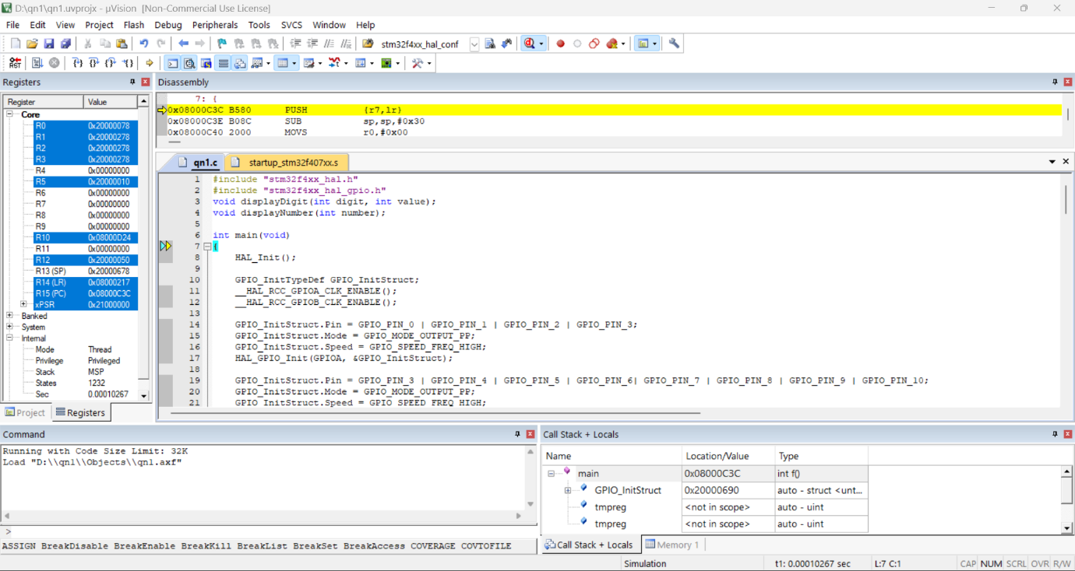

STEPPER MOTOR

* CODE

#include "stm32f4xx.h"

#include "stm32f4xx_hal_gpio.h"

// Define motor control pins

#define STEP_PIN GPIO_PIN_0

#define DIR_PIN GPIO_PIN_1

#define ENABLE_PIN GPIO_PIN_2

// Function to initialize GPIO pins

void GPIO_Init(void) {

GPIO_InitTypeDef GPIO_InitStruct;

__HAL_RCC_GPIOA_CLK_ENABLE();

GPIO_InitStruct.Pin = STEP_PIN | DIR_PIN | ENABLE_PIN;

GPIO_InitStruct.Mode = GPIO_MODE_OUTPUT_PP;

GPIO_InitStruct.Speed = GPIO_SPEED_FREQ_HIGH;

HAL_GPIO_Init(GPIOA, &GPIO_InitStruct);

}

// Function to control the stepper motor

void StepperMotor_Control(uint8_t direction, uint16_t steps, uint16_t delay_ms) {

// Set direction pin

if (direction == 0) {

HAL_GPIO_WritePin(GPIOA, DIR_PIN, GPIO_PIN_RESET);

} else {

HAL_GPIO_WritePin(GPIOA, DIR_PIN, GPIO_PIN_SET);

}

// Enable the motor driver

HAL_GPIO_WritePin(GPIOA, ENABLE_PIN, GPIO_PIN_RESET);

// Perform steps

for (uint16_t i = 0; i < steps; i++) {

// Set step pin high

HAL_GPIO_WritePin(GPIOA, STEP_PIN, GPIO_PIN_SET);

// Delay

HAL_Delay(delay_ms);

// Set step pin low

HAL_GPIO_WritePin(GPIOA, STEP_PIN, GPIO_PIN_RESET);

// Delay

HAL_Delay(delay_ms);

}

// Disable the motor driver

HAL_GPIO_WritePin(GPIOA, ENABLE_PIN, GPIO_PIN_SET);

}

int main(void) {

// Initialize GPIO pins

GPIO_Init();

while (1) {

// Rotate clockwise for 200 steps with a delay of 2ms

StepperMotor_Control(0, 200, 2);

// Delay

HAL_Delay(1000);

// Rotate counter-clockwise for 200 steps with a delay of 2ms

StepperMotor_Control(1, 200, 2);

// Delay

HAL_Delay(1000);

}

}

* OUTPUT

