ChurnPredict: Enhancing Customer Retention
through Predictive Analytics

Bandaru Nithin Kumar
Department of Computer Science and Engineering
Amrita School of Artificial Intelligence, Bengaluru
Amrita Vishwa Vidyapeetham, India
bl.en.u4aid23007@bl.students.amrita.edu

Talusu Sai Swaroop
Department of Computer Science and Engineering
Amrita School of Artificial Intelligence, Bengaluru
Amrita Vishwa Vidyapeetham, India
bl.en.u4aid23051@bl.students.amrita.edu
Dr. Sarada Jayan
Department of Mathematics
Amrita School of Engineering, Bengaluru
Amrita Vishwa Vidyapeetham, India
j_sarada@blr.amrita.edu
Paruchuri Sai
Department of Computer Science and Engineering
Amrita School of Artificial Intelligence, Bengaluru
Amrita Vishwa Vidyapeetham, India
bl.en.u4aid23063@bl.students.amrita.edu

Abstract—One of the customer retention researches is devoted to churning prediction using intricate machine learning models, the Kaggle data repository serves as a source of several datasets on customer characteristics’ including demographics, usage, and active service history which help explain churn behavior. Extended data preprocessing that touches on missing value treatment, scaling outliers, and creating important features makes it sunset for the necessary model building to take place. Various classification algorithms are put to use including support vector machines, random forest, naïve bayes which were imported and developed from scratch, and logistic regression which was also imported and developed from scratch. Of these, the Random Forest classifier was particularly successful, providing an accuracy of 94%, making it therefore useful in the domain of churn prediction. There are further indicators provided in the models that in this case show the difference that hyperparameter tuning and the building of algorithms have on the predictive capabilities and strength of the models. Machine learning and particularly churn prediction are necessary in this work as they provide unique strategies to improve retention. This research provides the missing link for businesses looking to understand how to approach churn in a massively data-driven way and effectively improve customer retention.
Keywords—Churn prediction, Probability, Machine learning

Introduction
Customer retention has now emerged as an important success and growth factor for any organization in today's business environment, particularly in subscription-based industries. One of the biggest problems here is churn or customer attrition. Losing customers impacts the profitability and efficiency of operations directly.[13] Traditionally, organizations have used customer feedback, transaction histories, and manual reviews to identify risks associated with churn. However, these traditional methods are cumbersome, error-prone, and incapable of identifying soft patterns in customer behavior. With the advent of machine learning, firms can predict churn probabilities with higher accuracy and efficiency, allowing for proactive intervention to retain those high-value customers. It is through machine learning algorithms that organizations can process millions of lines of customer data and identify behavioral trends and patterns that may have otherwise escaped attention.
High accuracy in predicting customer churn can be achieved by analyzing features like transaction frequency, account activity, service usage, and demographics using machine learning models. This has transformed the approach from reactive to proactive so that businesses can design personalized retention strategies based on at-risk customers. These models not only benefit the process of decision-making but help in improving customer satisfaction for they address probable causes even before churn happens and subsequently drive customer loyalty and profitability.[14] In this research work, a variety of machine learning models were applied toward the prediction of churn probability - SVM, Random Forest, and Naive Bayes were imported and implemented from scratch, and Logistic Regression was again imported and implemented from scratch. Among them, the best model is Random Forest, achieving an accuracy of 94%.
Its ensemble approach combines the results of multiple decision trees, giving it robustness against overfitting and the ability to easily handle complex datasets. This fits very well with the churn prediction scenario, where the data is usually high-dimensional, with intricate relationships between input features. The dataset for this study was taken from Kaggle, which contains various types of customer attributes that lead to churn behavior. Therefore, extensive preprocessing techniques involved normalization, handling missing values, and feature engineering to ensure that data was ready for model training.[15] Further hyperparameter tuning was also conducted to further optimize the performance of models, thereby making the results more accurate and reliable. These steps thus outline the importance of preparing data and optimizing it to come up with an effective system for churn prediction. By integrating models of machine learning into churn prediction workflows, firms can gain insights that help companies make strategic decisions about strategies to maintain customers. Accuracy in ascertaining a customer is at risk permits organizations to intervene systematically with personalized offers, enhancements in customer care, and participation in engagement strategies.[1]
This approach not only reduces revenue but also retains long-term customer relationships while ensuring competitiveness with the changes in the ever-changing dynamic market landscape. This study underlines the use of machine learning in countering churn, hence showing a fair prospect of its use in transforming customer retention models in various industries.
This section discusses the turnaround aspects of applying machine learning to deal with one of the significant issues of businesses dealing in subscription-based markets: customer churn. Machine learning from customer data identifies behavioral patterns otherwise missed by traditional methods. Instead of reacting to situations, businesses can take proactive retention strategies and prevent instances of churn. By extensive preprocessing and feature engineering, machine learning models enhance decision-making as well as improve customer satisfaction, and encourage long-term loyalty. The integration of these techniques into a churn prediction workflow holds much promise for the eventual revolution in customer retention strategies and in driving sustainable growth.[2]

Related Works
Forbes Makudza performed a detailed credit risk assessment using various machine learning classifiers, including Decision Trees, Random Forests, and Gradient Boosting Machines. They applied these models to benchmark datasets like the German and Australian credit datasets. Their analysis focused on performance metrics such as accuracy, precision, and recall. Results demonstrated that Gradient Boosting achieved the highest accuracy of 89.3%, followed by Random Forest at 87.5% and Decision Trees at 82.4%.
Adeniran et al. analyzed customer churn prediction in telecommunications using machine learning techniques like Decision Trees, Support Vector Machines (SVM), and Ensemble Methods (Random Forests, Gradient Boosting). Their study, applied to telecom datasets, found that Gradient Boosting achieved an accuracy of 84.5%, outperforming SVM (82.3%) and Decision Trees (80.1%). The results highlighted Gradient Boosting's effectiveness in capturing complex non-linear patterns.
Efunniyi et al. explored hybrid machine learning models that combine Principal Component Analysis (PCA) with XGBoost. Applied to customer usage and billing datasets, their model achieved a recall of 87.4% and an accuracy of 85.9%. Their work demonstrated the benefit of dimensionality reduction in improving model performance and computational efficiency.
The contributions in these regions are:
- An Advanced Feature Engineering The paper demonstrates why feature engineering is critical in churn prediction by converting raw customer data into meaningful features, such as transaction frequency, account activity, and usage of services, which are required to improve the accuracy and interpretability of a model.[11]
- A full data preprocessing methodology underlines proper techniques for handling missing values, normalization, and scaling to clean and optimize the dataset presented before its release to the machine learning model, ensuring the output and predictions are accurate and not speculative.
- Hyperparameter Tuning: The study applies the technique of hyperparameter tuning in order to optimize the model's performance in machine learning tasks, showing how changing model parameters can make a huge difference in getting better predictive accuracy and significantly reduce overfitting, meaning more robust models.[12]
- The study allows for the development of proactive retention strategies by integrating the machine learning models into customer retention workflows. Identifying at-risk customers and triggering timely interventions would keep some from churning before it happened.[10]
- Multiple Sources of Data: The research further illustrates how a combination of diverse customer attributes, such as demographics, usage patterns of services, and historical behavior, can be used to create a more comprehensive view of churn behavior. In that way, the model has better capabilities of capturing complex relationships within the data.

Dataset Description

The Customer Churn Records dataset Contains 10,000 entries with 18 distinct features that would provide a very comprehensive view of customer demographics, financial metrics, and behavioral patterns. Among the key demographic variables are Geography, Gender, and Age, which would reveal regional and personal characteristics that may influence the behavior of customers. CreditScore, Balance, and EstimatedSalary are some kind of economic profiles of customers that can tell us about the value of economic behavior. Tenure, NumOfProducts, and IsActiveMember are examples of behavioral data that relate to customer behavior and interaction with products. Lofty information like Satisfaction Score, complaints, Card Type, points earned, and so many more service details have been included in the dataset, where all kinds of analysis are possible, from customer interaction to preference study.

This dataset is best suited for churn prediction and customer segmentation, with Exited as the target variable for identifying customers who will most likely leave the service. The presence of categorical and numerical data guarantees the flexibility to use different analytical approaches, including machine learning. Notably, the dataset is complete with no missing values, thus simplifying preprocessing and enabling seamless modeling. This dataset can enable actionable insights into customer behavior and strategies developed for better retention and engagement through leveraging the diverse set of features available.

Proposed Methodologies
Irrelevant feature removal in this data cleaning process: Removing Surname, and Complain features from CustomerId to make features such as removal of noises hold and bringing back variables by leaving on them the maximum amount with the greatest possibility impact on the results Also it can be observed due to modes' filling up on these columns, there would be little bit biasing coming in terms of data itself. Further steps include data transformation and preprocessing.[9] For example, the normalization technique tends to make features scale-homogeneous and reduce skewness as much as possible. Exploratory Data Analysis was done regarding patterns and insights within data; feature selection methods can help in simplifying the dataset by creating dimensionality without losing important predictors. The dataset was separated into parts of training and testing, ensuring proper evaluation during the development of the model should take place. This merged pipeline ensures that the focus is there on quality and readiness for complex modeling techniques.[3]

Data Cleaning
Refinement was applied to data for its cleanest version to provide it for analysis. It mainly eradicated the redundant attributes. These included attributes such as Customer ID, Row Number, Surname, and Complain as they were contributing less to the aims for making prediction models. Also, filling up missing values for those instances with the help of the mode column, resulted in none lost while keeping up consistency throughout. This systematic cleaning step made it comprehensive and noise-free: the input dataset was suitable for succeeding preprocessing and modeling tasks as a solid ground.[8]

Data Transformation
Encoding categorical variables and scaling numerical features make up the Data Transformation process of the notebook in preparation for data analysis. Categorical columns were detected and transformed by applying Label Encoding to change the text type of data into numbers that could then be compatible with the algorithms being applied by the machine learning process. The standard scaling for the numeric type of data ensured all features would be on a comparable scale, which decreases the effect of outliers. This pre-processing stage therefore resulted in standardizing the data structure making the dataset more amenable to robust modeling and analysis.[4]

Sampling techniques

Before applying any sampling technique, the class imbalance in the dataset was very strong. The class labels were 7,962 of 0 and only 2,038 of 1. For balancing the dataset, the SMOTE-ENN method was applied. Not only was the SMOTE-ENN method synthetically useful but it also removed noisy and borderline examples by applying the ENN. Consequently, the final dataset achieved a balance that was optimal in quality, ascertaining enhanced generalization ability along with fairness in making predictions between classes.[7]

The bar chart titled "Before Balancing" is shown below. There is a high-class imbalance in the dataset. It has about 8,000 samples for Class 1 and 2,000 for Class 0. Due to the large number of samples for Class 1, it might result in biased predictions of the model, since the classifier is most likely to favor the majority class. [17] This, therefore, comes with a bad performance of the minority class. To overcome this, oversampling (such as SMOTE), undersampling, or class-weight adjustment in algorithms can be used for balancing the representation and building better models.
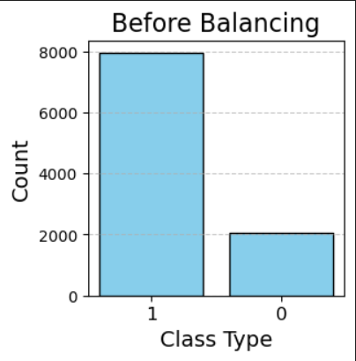
- Before Sampling
The bar chart titled "After Balancing" shows the class distribution of a dataset after applying balancing techniques. Class 0 and Class 1 now nearly have equal representation, where Class 0 has about 6,000 samples, while Class 1 has a little more. This is to ensure that the model can learn well from both classes, which also makes predictions fairer and more reliable, especially for the minority class.
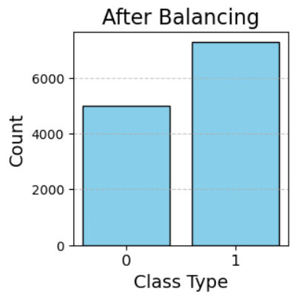
- After Sampling

Exploratory Data Analysis

The bar chart represents the class distribution of the variable IsActiveMember about the target variable Exited. The proportions indicate that for both active and inactive members, the majority were not exited (Exited = 0, in blue), whereas the proportion of exits is lower (Exited = 1, in red). Active members have a slightly lower proportion of exits than inactive members. This therefore indicates that the membership activity status may be a key predictor for customer exit.

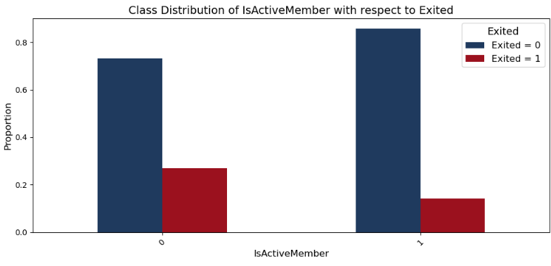
- Class Distribution of IsActiveMember concerning Exited

The given bar chart illustrates the proportion of credit card owners (HasCrCard) about whether or not they exited. According to this graph, more credit card holders tend to be churners if compared with the people without credit cards (Exited = 1 and HasCrCard = 1 compared with Exited = 0 and HasCrCard = 0). It might therefore be that customers' holding of credit cards could influence them to leave.

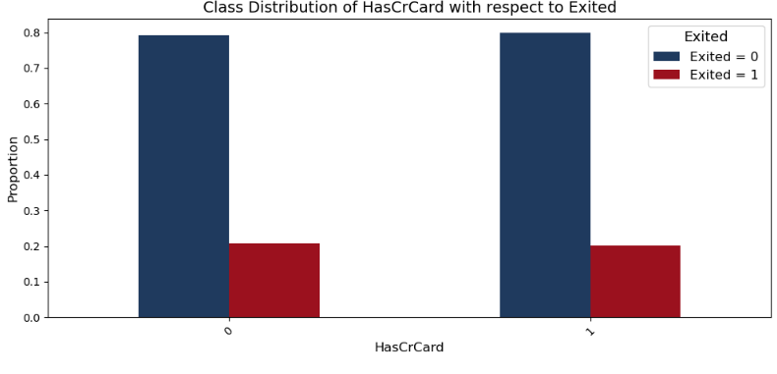
- Class Distribution of HasCrCard concerning Exited

The bar chart shows the distribution of customers across the three different geographic regions, namely France, Germany, and Spain, about their churn status, Exited. It seems that Spain has the highest proportion of churned customers in comparison with France and Germany. Likely, the geographical location does not have much of an influence on determining customer churn.

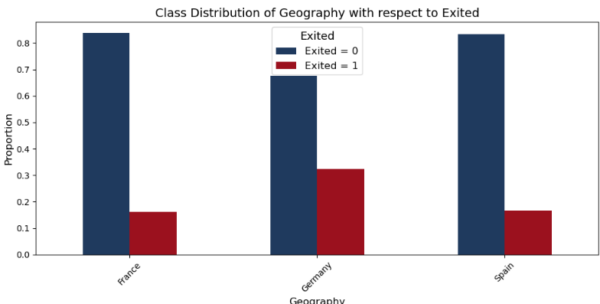
- Class Distribution of Geography concerning Exited

The correlation matrix is pretty complex with the interdependency of different factors causing customer churning as follows: There are two features that are moderately correlated in a positive way like "Tenure" versus "Balance," indicating older customers tend to hold the balance in higher amounts. Yet there are other weak negative dependencies such as "Age" versus "Exited," indicating somehow that younger customers are attracted to churn.
However, most of these features show little correlation between them, suggesting they are relatively independent and probably will provide unique insight into this churn phenomenon. Further analysis and modeling would be needed to tease out the more detailed relationships between these variables and their impact on customer retention strategies.
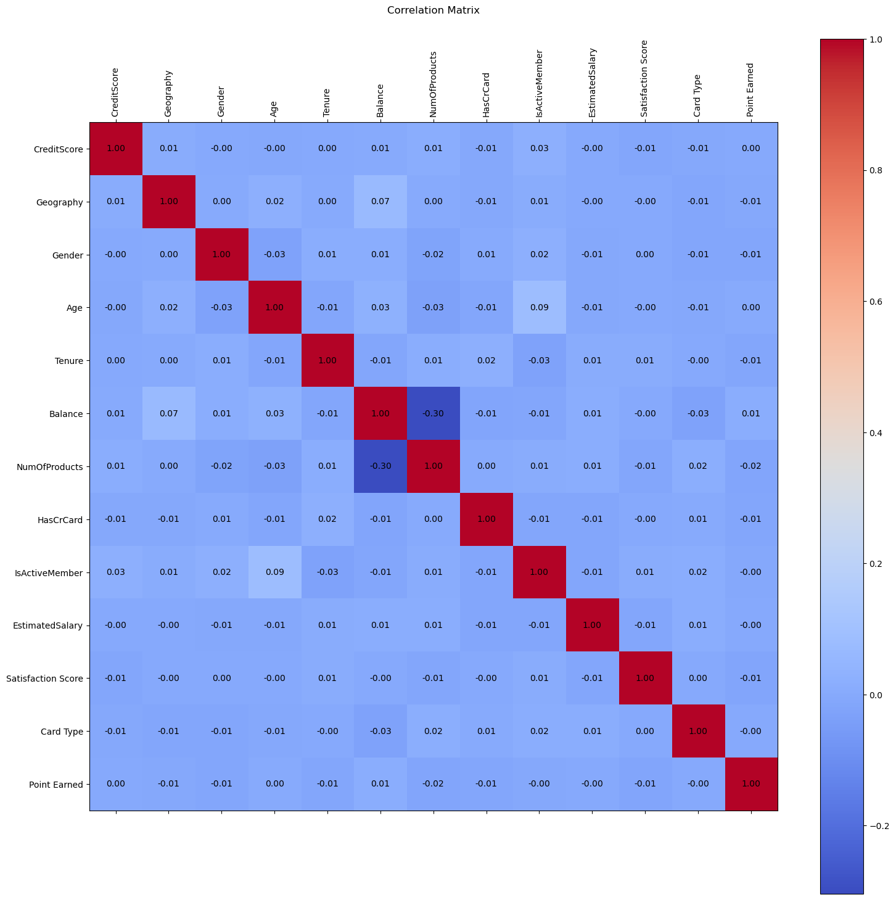
- Correlation Matrix

Feature Ranking
To calculate the feature importance scores, the Random Forest algorithm was employed. This indicated which variables were most influential in making predictions regarding churned customers, thus screening features of great importance for classifying churn.

Splitting Data
The Random Forest algorithm was employed to generate feature importance scores, with the identification of the most influencing variables toward determining customer churn. Analysis by this method identifies key attributes contributing to high-impact churn classifications, helping to tailor specific approaches to understanding and addressing the associated customer retention challenges.

Training& Testing
We used various machine learning algorithms during the training and testing phases, including SVM, Random Forest, Naive Bayes, and Logistic Regression. These models were trained on the data set to learn patterns and relationships that could predict churn probabilities.[16] For SVM, we have optimized the kernel function to help the algorithm deal with the non-linear decision boundary in the data. Applying the Random Forest algorithm has deployed an ensemble of decision trees so that overfitting will be reduced and, hence, the prediction would improve. For the Naive Bayes classifier, independence of features is assumed; hence, we train them to evaluate the likelihood of churn over the provided features. Logistic Regression, trained on gradient descent, gave a linear model based on feature coefficients to evaluate the probability of churn. Each model was cross-validated to see how well they predict by comparing metrics such as accuracy, precision, recall, and F1-score to decide which performed well in predicting customer churn.[5]

Results
- Results
Model | F1- | Score | Accuracy
Logistic Regression | 0.78 | 0.79 | 0.79
SVM | 0.90 | 0.93 | 0.92
Naïve Bayes | 0.78 | 0.86 | 0.83
Random Forest | 0.93 | 0.95 | 0.94

With the highest F1-score of 0.93, an accuracy of 0.94, and a score of 0.95, Random Forest outperforms other machine learning models used in churning prediction. The model has shown its robustness and very effective predictive ability. Another reliable option available is Support Vector Machines (SVM) which ranks second with an F1 score of 0.90, an accuracy of 0.92, and a score of 0.93. In contrast, Naïve Bayes and Logistic Regression both have an F1-score of 0.78, though their accuracy is not the same, with Logistic Regression scoring 0.79, and Naïve Bayes with 0.83. That means that ensemble approaches, like the Random Forest, perform better on this task of classification.[6]

Conclusion
Predictive usage of machine learning helps early detection of potential churn and retention through targeted efforts to keep customers. Insights about customer patterns and trends will help address customer churn proactively. The goal of reducing marketing costs along with enhancing operational efficiency leads banks towards using their resources better, resulting in greater customer satisfaction.

Acknowledgment

We thank Amrita Vishwa Vidyapeetham for affording the resources and infrastructure that facilitated this work. Innumerable thanks to our guide, Sarada mam, for their invaluable guidance, encouragement, and constructive criticism along the way of this work. We also acknowledge all the support and insights gained from our colleagues, peers, and collaborators, as that has greatly contributed to its refinement. We thank our family and friends for their unconditional support while we were on this mission.

References
- Lu, N., Lin, H., Lu, J., & Zhang, G. (2012). A customer churn prediction model in the telecom industry using boosting. IEEE Transactions on Industrial Informatics, 10(2), 1659-1665.
- Au, W. H., Chan, K. C., & Yao, X. (2003). A novel evolutionary data mining algorithm with applications to churn prediction. IEEE transactions on evolutionary computation, 7(6), 532-545.
- Shaaban, E., Helmy, Y., Khedr, A., & Nasr, M. (2012). A proposed churn prediction model. International Journal of Engineering Research and Applications, 2(4), 693-697.
- Verbraken, T., Verbeke, W., & Baesens, B. (2012). A novel profit maximizing metric for measuring classification performance of customer churn prediction models. IEEE transactions on knowledge and data engineering, 25(5), 961-973.
- Amin, A., Anwar, S., Adnan, A., Nawaz, M., Alawfi, K., Hussain, A., & Huang, K. (2017). Customer churn prediction in the telecommunication sector using a rough set approach. Neurocomputing, 237, 242-254.
- Qian, Z., Jiang, W., & Tsui, K. L. (2006). Churn detection via customer profile modeling. International Journal of Production Research, 44(14), 2913-2933.
- Saran Kumar, A., & Chandrakala, D. (2016). A survey on customer churn prediction using machine learning techniques. International Journal of Computer Applications, 975, 8887.
- Ahmad, A. K., Jafar, A., & Aljoumaa, K. (2019). Customer churn prediction in telecom using machine learning in the big data platform. Journal of Big Data, 6(1), 1-24.
- Lalwani, P., Mishra, M. K., Chadha, J. S., & Sethi, P. (2022). Customer churn prediction system: a machine learning approach. Computing, 104(2), 271-294.
- Sai, B. K., & Sasikala, T. (2019, April). Predictive analysis and modeling of customer churn in telecom using machine learning technique. In 2019 3rd International Conference on Trends in Electronics and Informatics (ICOEI) (pp. 6-11). IEEE.
- Kumar, M. R., Priyanga, S., Anusha, J. S., Chatiyode, V., Santiago, J., & Chaudhary, D. (2024, July). Enhancing Telecommunications Customer Retention: A Deep Learning Approach Using LSTM for Predictive Churn Analysis. In 2024 International Conference on Data Science and Network Security (ICDSNS) (pp. 01-07). IEEE.
- Tiwari, U., Ashwani, S., Tripathy, A. J., & Kumar, K. D. (2024, February). A Two-Stage Ensemble Approach for Analysis of Optimizing Customer Churn with Lime Interpretability. In 2024 IEEE International Conference on Computing, Power and Communication Technologies (IC2PCT) (Vol. 5, pp. 1540-1545). IEEE.
- Poojitha, D., Darak, T., Samaddar, U., & Venugopal, M. (2024, June). Machine Learning Strategies for Telecom Churn Prediction. In 2024 15th International Conference on Computing Communication and Networking Technologies (ICCCNT) (pp. 1-6). IEEE.
- Sandhya, N., Samuel, P., & Chacko, M. (2019). Feature intersection for agent-based customer churn prediction. Data Technologies and Applications, 53(3), 318-332.
- Lalitha, S., Gupta, T. S., Thelu, A., Reddy, V. K., & Reddy, V. C. (2024, June). Predictive Modeling for Real-Time Customer Lifetime Value. In 2024 15th International Conference on Computing Communication and Networking Technologies (ICCCNT) (pp. 1-6). IEEE.
- Qureshi, S. A., Rehman, A. S., Qamar, A. M., Kamal, A., & Rehman, A. (2013, September). Telecommunication subscribers' churn prediction model using machine learning. In Eighth International Conference on Digital Information Management (ICDIM 2013) (pp. 131-136). IEEE.
- Ullah, I., Raza, B., Malik, A. K., Imran, M., Islam, S. U., & Kim, S. W. (2019). A churn prediction model using random forest: analysis of machine learning techniques for churn prediction and factor identification in the telecom sector. IEEE Access, 7, 60134-60149.

https://www.kaggle.com/datasets/radheshyamkollipara/bank-customer-churn/data

