# **NEXT-STEP-SYSTEM**

**AED Final Project Proposal**

Group 46: Samruddhi Sawant, Nithin Menezes, Snehal Shinde.

Approved By: TA- Renuka Alakunta

**Problem Statement:-**

* In many orphan trusts and child care organizations, limited personnel and manual processes hinder efficient service delivery and resource management. Overwhelmed staff struggle with monitoring, reporting, and addressing the needs of orphans, while the absence of an integrated system impedes data-driven decisions. A comprehensive orphan trust management system can streamline operations, reduce workload, improve resource allocation, and enable real-time progress tracking, empowering staff and management to deliver better outcomes for children and the organization.

**Challenges:-**

1. **Limited Workforce and High Workload:**

* Orphan trusts often operate with a small number of supervisors, caregivers, and support staff who manage large numbers of children.
* Overworked staff struggle to provide personalized attention to children, leading to a decline in the quality of care.

1. **Resource Constraints and Budget Limitations:**

* Insufficient funding affects the ability to provide adequate food, clothing, education, healthcare, and other essentials for children.
* Limited budgets also restrict hiring additional staff or implementing advanced systems to improve operations.

1. **Manual Processes and Inefficiencies:**

* Reliance on paper-based systems or basic digital tools for record-keeping, reporting, and resource management results in inefficiencies.
* Manual tasks, such as attendance tracking, inventory management, and progress monitoring, are time-consuming and prone to errors.

1. **Challenges in Monitoring and Reporting:**

* Supervisors find it difficult to track children’s progress, staff performance, and program outcomes due to the lack of a centralized system.
* Inconsistent or incomplete reporting hampers the ability to assess needs and address issues effectively.

1. **Fragmented Data Management:**

* Data related to children’s health, education, and welfare is often scattered across different systems or locations, leading to duplication and difficulty in retrieval.
* This disorganization hinders effective decision-making and impacts the delivery of timely support.

**Solutions:-**

1. **Limited Workforce and High Workload:**

Automate routine tasks like attendance tracking and scheduling using a centralized system to reduce manual effort. Introduce volunteer programs and NGO partnerships to supplement staff and share the workload.

1. **Resource Constraints and Budget Limitations:**

Develop crowdfunding campaigns and apply for grants to secure additional funding. Implement cost-effective technologies and efficient resource management practices to maximize impact.

1. **Manual Processes and Inefficiencies:**

Transition to digital tools for record-keeping and reporting to save time and reduce errors.

Implement task management software to streamline daily operations and workflows.

1. **Challenges in Monitoring and Reporting:**

Use a centralized database for real-time tracking of children’s progress and staff activities.

Automate report generation for insights into key performance metrics and program outcomes.

1. **Fragmented Data Management:**

Consolidate all records into a secure, centralized platform to ensure consistency and accessibility. Introduce data categorization and tagging to facilitate quick retrieval and analysis.

**High-Level-Component-Diagram:-**

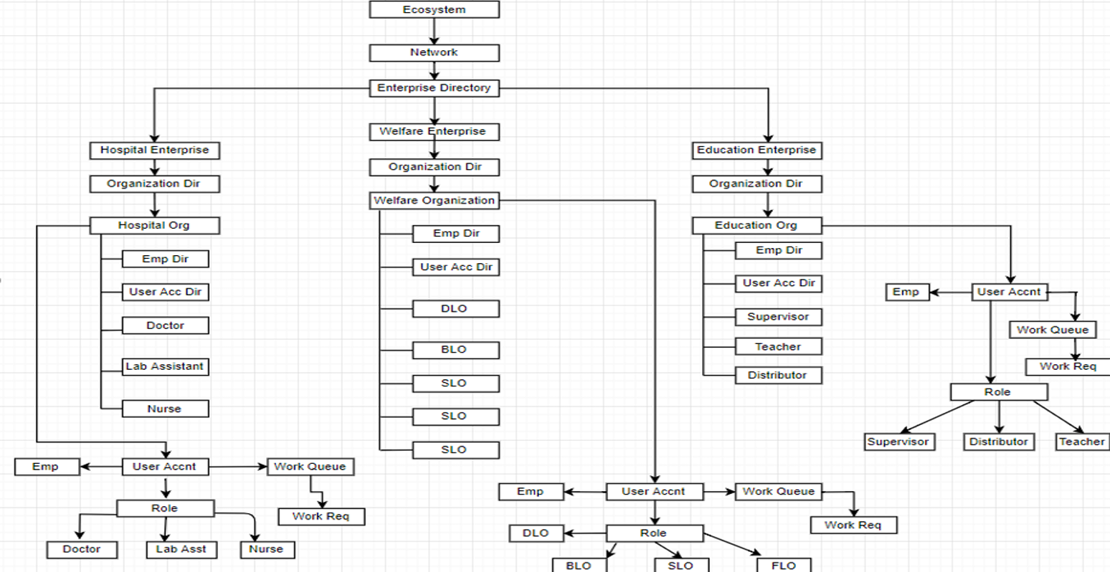

**Enterprises:-**

* Education Enterprise
* Hospital Enterprise
* Welfare Enterprise
* Admin Enterprise

**Organizations:-**

* Education Organization
* Hospital Organization
* Welfare Organization
* Welfare BLO Organization
* Welfare DLO Organization
* Welfare FLO Organization
* Welfare SLO Organization

**Roles:-**

* Welfare BLO Role
* Welfare FLO Role
* Welfare DLO Role
* Welfare SLO Role
* Education Teacher Role
* Education Supervisor Role
* Education Distributor Role
* Hospital Nurse Role
* Hospital Doctor Role
* Hospital Lab Assistant Role

**Use Cases:-**

1. **Child Profile Management**Staff can manage comprehensive profiles for each child, including personal details, health records, and education progress, ensuring all relevant information is centralized and easily accessible.
2. **Resource and Inventory Management**Enables tracking and allocation of resources such as food, clothing, and medical supplies to ensure availability and proper usage across the organization.
3. **Workload Management and Task Assignment**Supervisors can assign tasks to staff members, monitor their progress, and balance workloads to optimize productivity and service delivery.
4. **Attendance Monitoring**Facilitates daily tracking of attendance for children and staff, helping in planning and ensuring accountability across all activities.
5. **Progress Reporting and Analytics**Generates detailed reports on various aspects such as child development, staff performance, and resource utilization, supporting data-driven decision-making.
6. **Communication and Alerts**Provides a platform for real-time communication between staff, supervisors, and administrators, ensuring updates and alerts are delivered effectively.
7. **Demand-Supply Tracking**Helps log resource demands at field levels and aligns them with supply data to enable efficient allocation and minimize shortages.
8. **Performance Monitoring**Allows supervisors to evaluate staff performance based on predefined metrics, ensuring accountability and identifying areas for improvement.