**MINI PROJECT REPORT ON**

**HOSPITAL MANAGEMENT SYSTEM**

**T. E. Computer Engineering** Under the guidance of

**Mrs VARSHA NAGPURKAR**

By

**Nithin Menezes 58**

**Subhashkumar 63**



Department of Computer Engineering

St. Francis Institute of Technology

(Engineering College) University of Mumbai

2020-2021

**CERTIFICATE**

This to certify that the Mini Project report on Flight Management System has been carried out by **Name of the Student** (TE/Branch/Roll No), who is a bonafide student of St. Francis Institute of Technology, Mumbai in partial fulfillment of the requirement of T. E. degree in Computer Engineering at St. Francis Institute of Technology, Mumbai, India. It is also certified that this work has not been presented anywhere else for award of any other degree or diploma prior to this.

**Project Incharge:**

**Mrs Varsha Nagpurkar**

**Internal Examiner External Examiner**

**_________________________ __________________________**

# INDEX

|  |  |  |
| --- | --- | --- |
| **SR.No** | **Title** | **Page No** |
| 1) | Introduction | 4 |
| 2) | System Requirements Specification | 8 |
| 3) | System Environment | 11 |
| 4) | System Design | 15 |
| 5) | Conclusion | 18 |
| 6) | Screen -Shots | 19 |

INTRODUCTION

## Project objective:

The objective of this project is to create a hospital management database that stores details about the different patients, doctors, booking appointment, bed allotment, admin and also manages the payment of the hospital. First the User has to login as a user or the admin. The admin can change all the details related to the hospital i.e. the admin has the power to add different patients. The passenger can book appointment of the respective doctors of their choice. Before booking a appointment, the user has to enter their personal details such as their mobile no., name, address, date of birth etc. After filling up their personal details they can proceed to book a appointment. Later after completing the appointment user will get all the details related to their appointment and doctor.

The software has been developed using the most powerful and secured backend MySQL and PHP is used for processing the data.The Designing of this Website is done with the help of HTML,CSS and Javascript.

## Features of the system

This system will be performing the following tasks:

(a) The system will provide an interface to login and register to the user and admin.

(b) User can check the availability of bed allotment.

(c) User can book appointment of any doctor of his choice.

(d) User can Make Payments for their checkups.

(e) User can also cancel their appointment.

# PROBLEM STATEMENT

The hospital management database stores details about the different user ,admin, appointment bookings doctors and also manages payment of the hospital. The admin can change details of doctors appointments bills. The admin has power to change details of appointment doctors etc. The passengers can book appointment of their choice of doctors. . Before booking a appointment, the passenger has to enter their personal details such as their mobile no., name, address, date of birth etc. After filing up their personal details they can proceed to book a appointment. Later after completing the booking of appointment process the passenger will get all the details related to appointment and doctors.

This ER(Entity Relationship) Diagram represents the model of Hospital Management System Entity. The Entity Relationship diagram shows all visual instrument of database tables and the relations between Patients, Nurses, Hospitals ,Medicines etc. The main entities of the Hospital Management System are Hospitals, Patient, Doctors, Appointments and Medicines.

First the person will login by his/her login_id, login_role_id, login_username, etc.If the person does not have a login_id,they can create a user_id, all such options come under user entity, so the Login is a weak entity. The user has their Roles and permission because of which they come into picture. Now all this come under appointment of the person which is directly binded to the Manage relationship along with the hospital entity which will contain the hospital details. The doctors entity consist of details of the doctor including attributes like their id no, name, email id,pass and also their mobile no. The medicine entity is a weak entity connected to the weak realationship under the hospital entity because it will depend upon the person whether he wants to order the medicines so that we can keep a stock of that. The patient entity will come under the manage relationship where the patient can fill the mobile no., email id, name, address, etc.

The Multivalued attributes are given for email id and phone no. because a single person can have more than one email id or phone no. For user id, login id etc primary key is necessary to select only one key as a unique identifier of an entity.

**The above Problem Statement can be represented by the following ER diagram:**

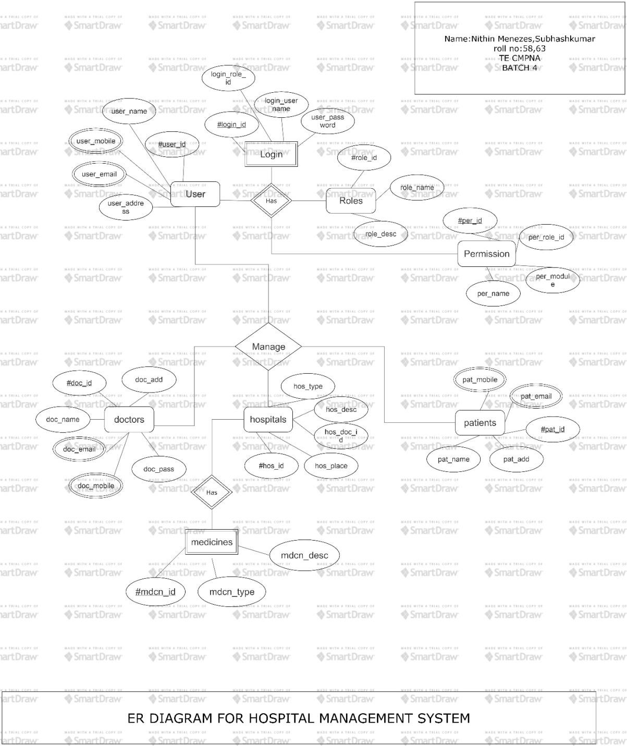

**USE CASE DIAGRAM**

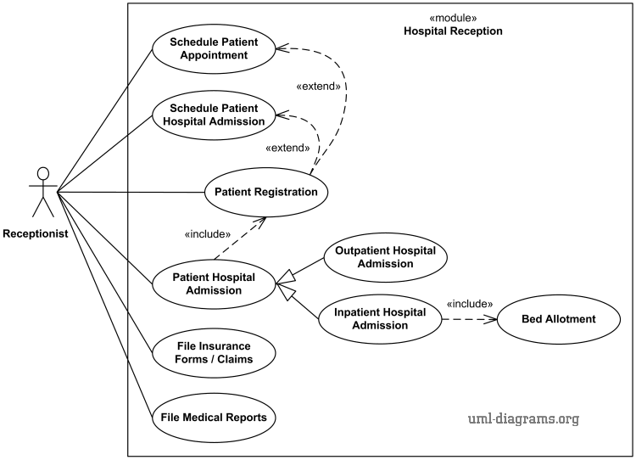

# SYSTEM REQUIREMENT SPECIFICATIONS :

Software requirement specification abbreviated as SRS is a means of translating the idea of files into a formal document. The main features of SRS include: ⮚ Establishing the basis for an agreement between the client and the developer. ⮚ Producing a reference for validation of the final product. SRS assist clients in determining if the software meets the requirements.

Mainly there are six requirements which an SRS must satisfy.

(a) It should specify the external behaviour.

(b) It should specify the constraints.

(c) It should be easy to change.

(d) It should be a reference tool.

(e) It should record throughout the lifecycle.

(f) It should have the capacity of expectation of an undesired event.

Usually we come across three types of requirement specification

(a) Software Requirements

(b) User Interface Requirements

(c) Database Requirements

## ❖ Software Requirements

Technically the system will run on any OS having Web Browser.

(a) Development Tools: Front End: HTML , CSS,JAVASCRIPT Back End : PHP,MySQL

(b) Operating System: Windows 10

(c) Web server: XAMPP

## ❖ User Interface Requirements

The user of the proposed system requires that the developed software should be user friendly, have security access, and ensure the privacy of the administrator and produce results in timely manner. The users are not frequently exposed to the mail system, so the system interface to the user must be simple and understandable. The web pages must be user-friendly and must be in an easy-to-use style. The user must be able to easily switch among various I/O screens. The product is well designed so that it can be used easily by the users who are novices to the system.

The user interface should be as interactive as possible. A user- friendly interface must be provided so that the user can easily interact with the system and comprehend things in a quicker and easier way. The system must provide reliable and up-to-date information.

The application should be efficient so that the user does not spend much time in searching. Consistency will increase the confidence of the user in the reliability of the application. The user must be limited with a small set of operations to achieve the result. The application should be visually and conceptually clear. .

## ❖ Database Requirements

* 1. Client/Server system
     1. The term client/server refers primarily to an architecture or logical division of responsibilities, the client is the application (also known as the front-end), and the server is the DBMS (also known as the back-end).
     2. Our project works on the Client/Server model. All the data is stored in a central server a can be accessed by the client from the GUI.
     3. The client can access and alter the data in the server side with the right credentials.
  2. Database Design is a collection of processes that facilitate the designing, development, implementation and maintenance of enterprise data management systems. Database designing is crucial to a high performance database system. Apart from improving the performance, properly designed databases are easy to maintain, improve data consistency and are cost effective in terms of disk storage space.

# IMPLEMENTATION

## Database Connectivity

Database Connectivity

A Database connection is a facility in computer science that allows client software to talk to database server software, whether on the same machine or not. A connection is required to send commands and receive answers, usually in the form of a result set. Connections are a key concept in data-centric programming. Since some DBMS engines require considerable time to connect, connection pooling was invented to improve performance. No command can be performed against a database without an "open and available" connection to it.

1. **Functional Requirements** 
   1. The various functional requirements of the system can be summarized as:-
      1. A homepage that is user friendly and ambiguous.
      2. It is easy to sign in a user in his page.
      3. User can easily send mails to different uses in an office.
      4. User can easily view the inward mails and local mails.
      5. User can easily remove the mails from his inbox.
      6. Attractions.
      7. SPECIALITIES.
2. **Non-Functional Requirements**

Non-functional requirements define the system properties and constraints that arise through user needs, because of the budgeted constraints or organizational policies, or because of the need for interoperability with other software or due to the external factors such as safety regulations, privacy registrations and so on.

1. **Other Requirements**
2. Performance Requirements

(a) The database should be centralized and secure.

(b) The system should be user friendly and easily accessible

(c) The system must be reliable.

1. Design Requirements

The main objectives of input design are:

(a) Controlling the amount of input

(b) Keeping the process simple.

(c) The best thing in the input design is to achieve all the objectives mentioned in the simplest manner possible.

The main objectives of output design are:

(a) Identifying the specific outputs.

(b) Creating reports for displaying and storing information.

**SYSTEM ENVIRONMENT:**

1. **Hardware Requirements**
   1. I/O devices
      1. Monitor
      2. Keyboard
   2. Modern Computer with Modern Web Browser
   3. Internet Connection
2. **Software Requirements**
   1. Development Tools:
      * 1. Front End : HTML,CSS,JAVASCRIPT,JQUERY, BOOTSTRAP
        2. Back End : PHP, MySQL
   2. Operating System : Windows 10
   3. Web server : XAMPP
   4. Package Manager: Composer - It is an application-level package manager for the PHP
3. **Windows 10**

Windows 10 is a Microsoft operating system for personal computers, tablets, embedded devices and internet of things devices.

Microsoft released Windows 10 in July 2015 as a follow-up to Windows 8. The company has said it will update Windows 10 continuously, rather than release a new, full-fledged operating system as a successor.

Anyone adopting Windows 10 can upgrade legacy machines directly from Windows 7 or Windows 8 to Windows 10 without re-imaging or performing intrusive and time-consuming system wipes and upgrade procedures. To upgrade from a previous version of Windows 10, IT or users run the Windows 10 OS installer, which transfers any applications and software on the previous OS, as well as settings and preferences over to Windows 10. Organizations and users can pick and choose how they will patch and update Windows 10. IT or users can access a Windows 10 upgrade through the Windows Update Assistant to manually begin an upgrade or wait for Windows Update to offer an upgrade when it is set to run.

Windows 10 features built-in capabilities that allow corporate IT departments to use mobile device management (MDM) software to secure and control devices running the operating system. In addition, organizations can use traditional desktop management software such as Microsoft System Center Configuration Manager.

Windows 10 Mobile is a version of the operating system Microsoft designed specifically for smartphones.

1. **MySQL Server**

XAMPP is the title used for a compilation of free software. The name is an acronym, with each letter representing one of the five key components. The software packet contains the web server Apache, the relational database management system MySQL (or MariaDB), and the scripting languages Perl and PHP. The initial X stands for the operating systems that it works with: Linux, Windows, and Mac OS X.

* **Apache:** ihe open source web server Apache is the most widely used server worldwide for delivery of web content. The server application is made available as a free software by the Apache Software Foundation.
* **MySQL/MariaDB:** in MySQL, XAMPP contains one of the most popular relational database management systems in the world. In combination with the web server Apache and the scripting language PHP, MySQL offers data storage for web services. Current XAMPP versions have replaced MySQL with MariaDB (a community-developed fork of the MySQL project, made by the original developers).
* **PHP:** the server-side programming language [PHP](https://www.ionos.com/digitalguide/websites/website-creation/learn-php-our-all-encompassing-php-tutorial-for-beginners/) enables users to create dynamic websites or applications. PHP can be installed on all platforms and supports a number of diverse database systems.
* **Perl:** the scripting language Perl is used in system administration, web development, and network programming. Like PHP, Perl also enables users to program dynamic web applications.

Alongside these core components, this free-to-use Apache distribution contains some other useful tools, which vary depending on your operating system. These tools include the mail server Mercury, the database administration tool phpMyAdmin, the web analytics software solutions Webalizer, OpenSSL, and Apache Tomcat, and the FTP servers FileZilla or ProFTPd.

1. **Java Script**

JavaScript is a script based programming language that supports the development of both server and client components of web based applications. On client side it can be used to write programs that are executed by a web browser within the context of web page. On server side it can be used to write web server programs that can process information submitted by the web browser and update browser display accordingly.

Features of JavaScript:

(a) Much of JavaScript’s syntax and some of its semantics are adopted from c and c++. Support for basic mathematics and logic and a step by step execution model are fundamental to JavaScript.

(b) JavaScript is an interpreted language.

(c) Regular expressions are a prominent feature of JavaScript. These allow strings to be matched to a certain pattern and empower JavaScript significantly as a tool for manipulating text content of web pages.

(d) Functions are treated as first class objects, which frequently make code concise and elegant.

(e) JavaScript is well designed for object-oriented programming. Objects are at the root of JavaScript’s data manipulation model.

(f) JavaScript objects are associative arrays. The strings that index the properties and methods of an object can be constructed at runtime.

1. **Hypertext Markup Language (Html)**

Html, short for hypertext markup language, is the predominant markup language for the creation of web pages. It provides a means to describe the structure of text-based information in a document — by denoting certain text as headings, paragraphs, lists, and so on — and to supplement that text with interactive forms, embedded images, and other objects. Html is written in the form of labels (known as tags), surrounded by less-than (<) and greater-than signs (>). Html can include embedded scripting language code which can affect the behavior of web browsers and other html processors.

Html was originally developed by Timberners-lee while at CERN, and popularized by the mosaic browser developed at ncsa. During the course of the 1990s it has blossomed with the explosive growth of the web. During this time, html has been extended in a number of ways. The web depends on web page authors and vendors sharing the same conventions for html. This has motivated joint work on specifications for html.

Website is a collection of pages, publications and documents that receive on web server. While these bags publications and a document as a formatted in any single format. You should use html for home page and all primary pages and the site.

An Html code is essentially a set of instructions given to a web browser for formatting and layout of web page. Html does not actually tell a computer how the web page will look to a visitor rather that you use html to compose the page to specify all the elements that appear on the page-the text, graphics, horizontal rule, heading division and so on. In addition we use html to tell a computer what color to use where and to indicate the relative size and font of text.

1. **Cascading Style Sheets (CSS)**

Cascading Style Sheets (CSS) is a style sheet language used for describing the presentation of a document written in a markup language such as HTML.CSS is a cornerstone technology of the World Wide Web, alongside HTML and JavaScript.

CSS is designed to enable the separation of presentation and content, including layout, colors, and fonts. This separation can improve content accessibility, provide more flexibility and control in the specification of presentation characteristics, enable multiple web pages to share formatting by specifying the relevant CSS in a separate .css file which reduces complexity and repetition in the structural content as well as enabling the .css file to be cached to improve the page load speed between the pages that share the file and its formatting.

Separation of formatting and content also makes it possible to present the same markup page in different styles for different rendering methods, such as on-screen, in print, by voice (via speech-based browser or screen reader), and on Braille-based tactile devices. CSS also has rules for alternate formatting if the content is accessed on a mobile device.

The name cascading comes from the specified priority scheme to determine which style rule applies if more than one rule matches a particular element. This cascading priority scheme is predictable.

**SYSTEM DESIGN:**

Databases are the storehouses of data used in the software systems. The data is stored in tables inside the database. Several tables are created for the manipulation of the data for the system. Two essential settings for a database are

* Primary Key- the field that is unique for all the record occurrences.
* Foreign Key-the field used to set relation between tables.

Normalization is a technique to avoid redundancy in the tables.

**ADMIN**

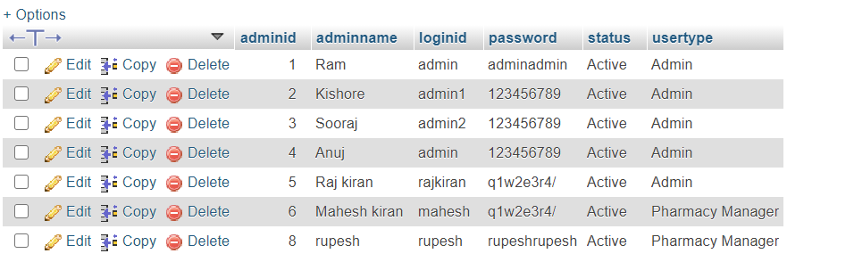

**APPOINTMENT**

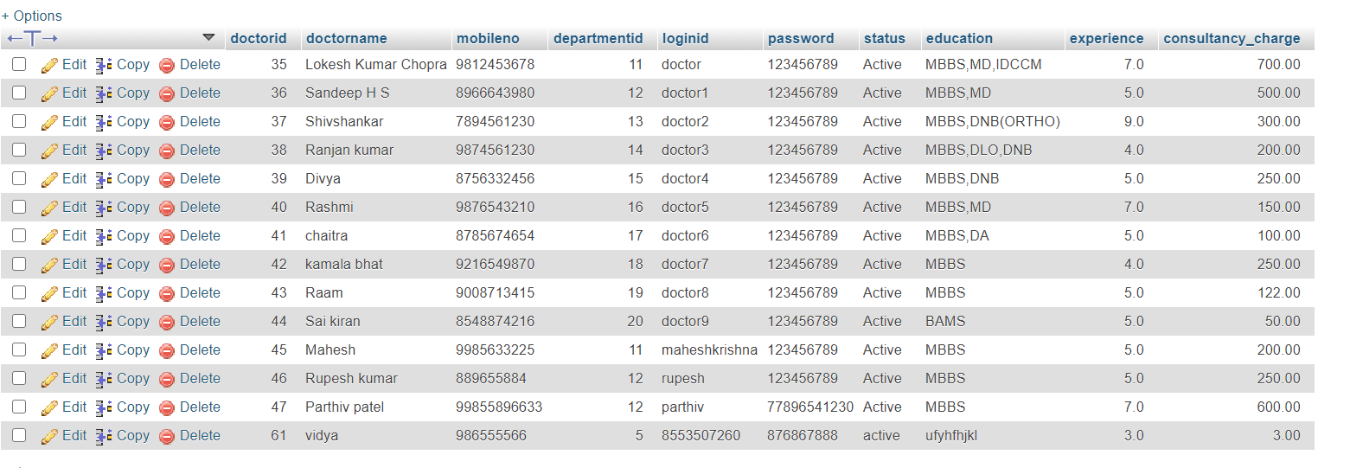

**TREATMENT**

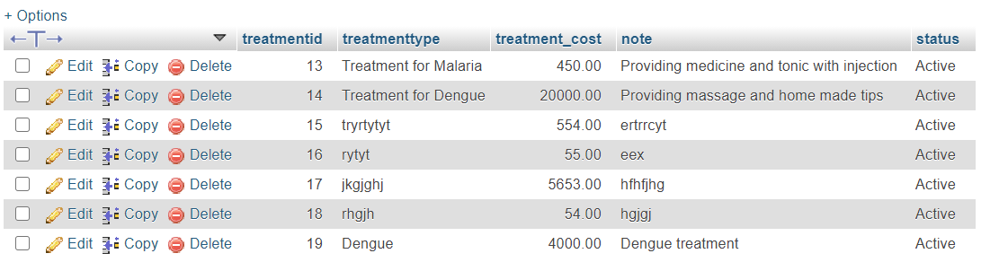

**SERVICE TYPE**

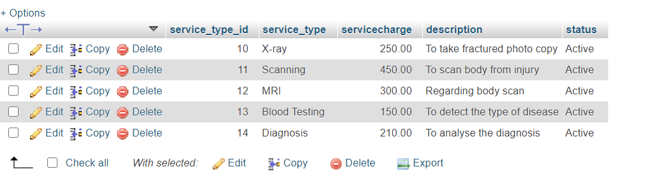

**MEDICINE**

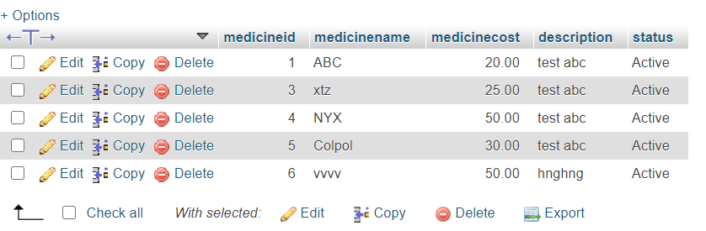

**APPOINTMENT**

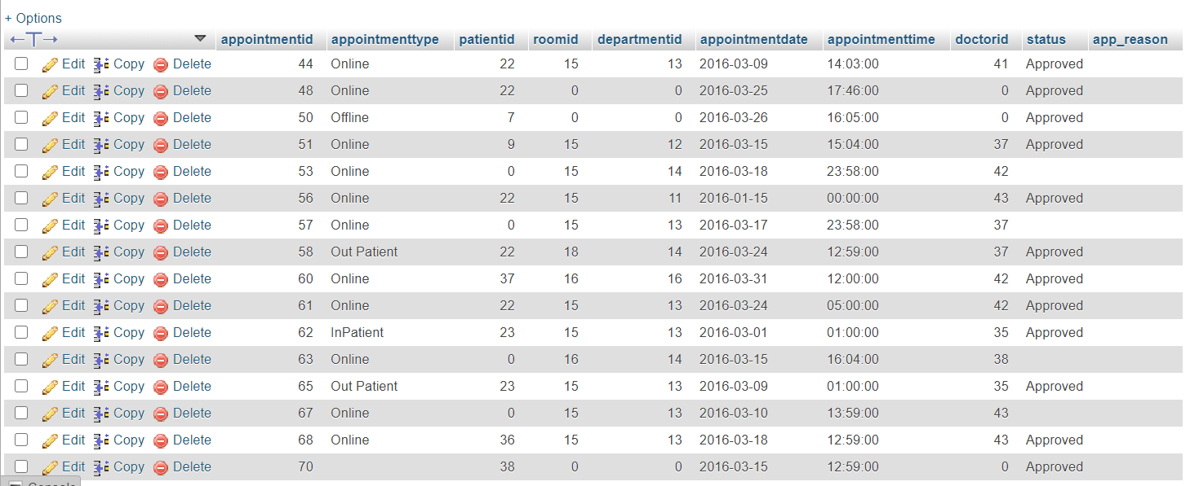

.

## CONCLUSION:

## Conclusion

The project Hospital Management System (HMS) is for computerizing the working in a hospital. The software takes care of all the requirements of an average hospital and is capable to provide easy and effective storage of information related to patients that come up to the hospital.

* It generates test reports; provide prescription details including various tests, check-up and medicines prescribed to patient and doctor. It also provides injection details and billing facility.•
* The system also provides the facility of backup as per the requirement.

## Future scope

Being a challenging role, hospital management graduates can enter into this profession from any of the levels right from middle level management to the top level of the company and hence the scope gets increased. Also as management in the healthcare sector is highly taken care of after direct medical services provided to the patients, the professionals have good opportunity to expand their career with diversification intra and inter institutes.  
Because of entrance of private players in the market, who provide quality health care services at low cost, the experienced and deserving candidates are taken in hands for a particular position. On the other side with increasing efforts of the government, the rural and urban health care is also gaining its importance and graduates in this field have more chances of getting employment

## SCREEN SHOTS

Home page

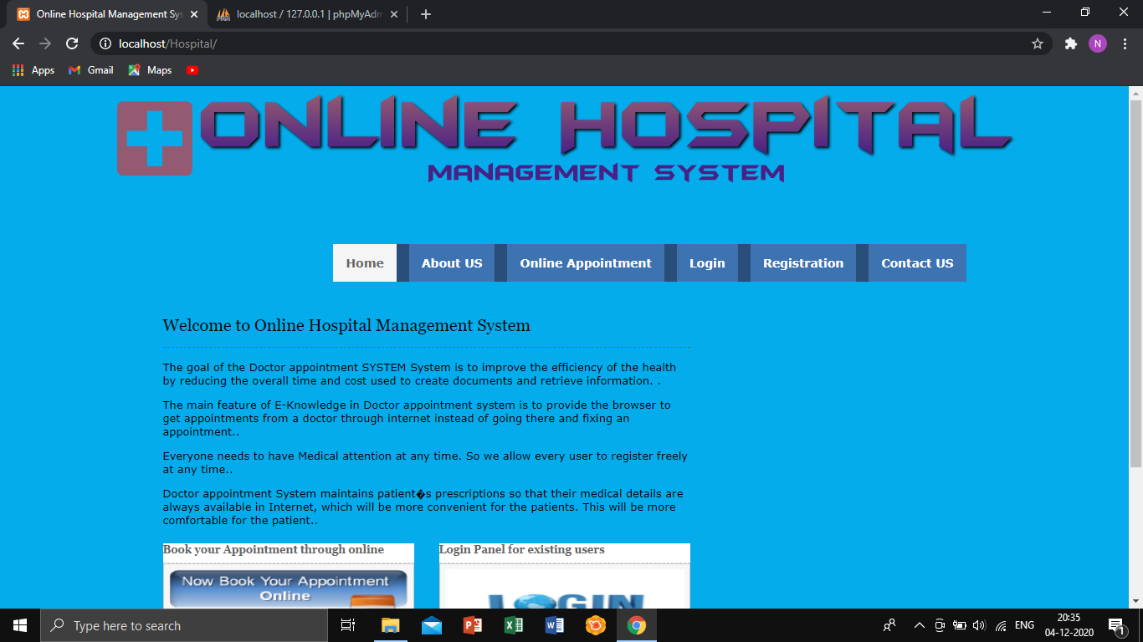

There will be a short summary regarding our hospital, what are its speciality and the facilities we provide to the society.

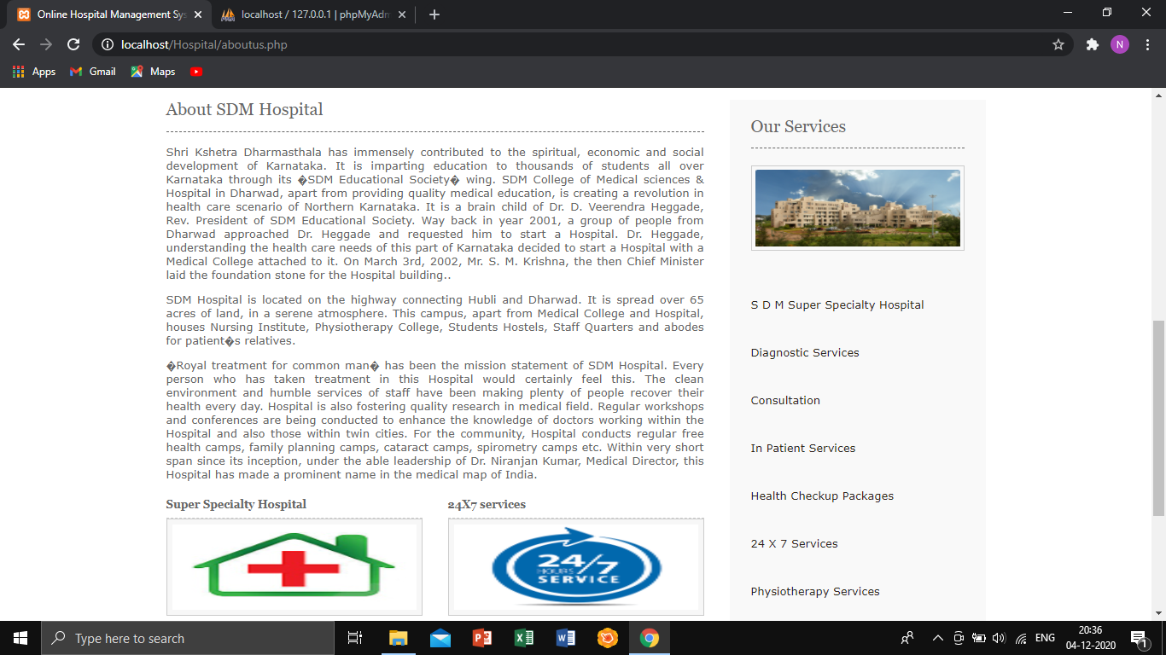

Under online appointment, the patient can fill the necessary details and book their appointments.

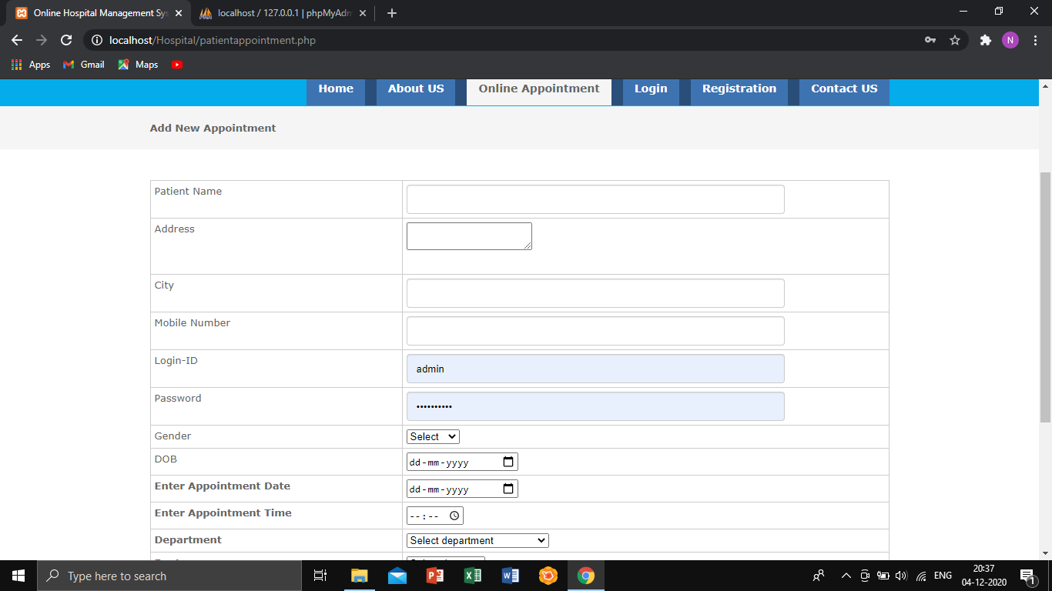

Under Registration, if a person does not have a Login ID, he/she can register and create a new login ID

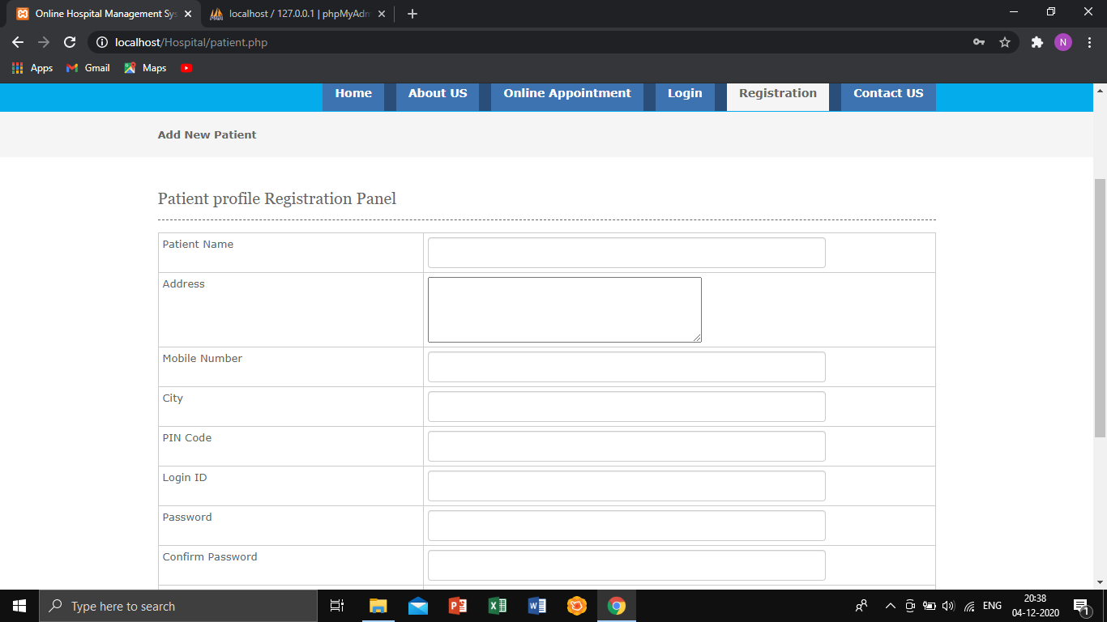

If a person has any queries or wants to give any feedback they can text or contact us

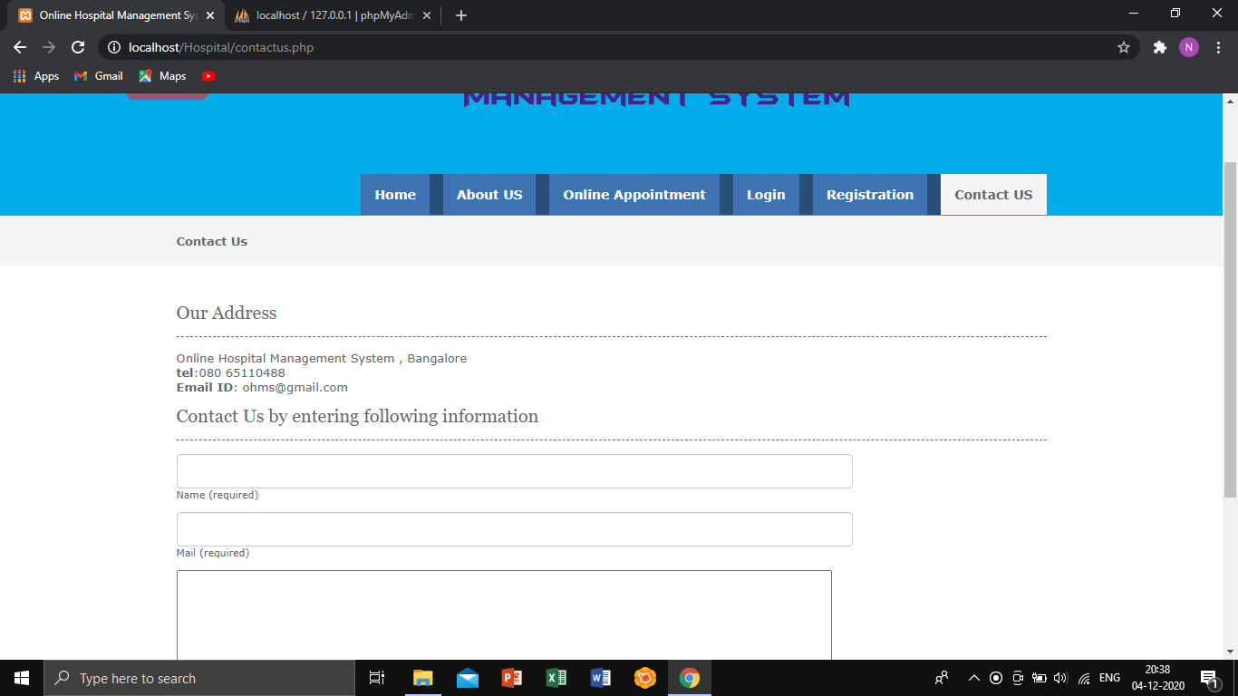

**PATIENT LOGIN PAGE:**  
After registration the person can login under the Patient Login panel.

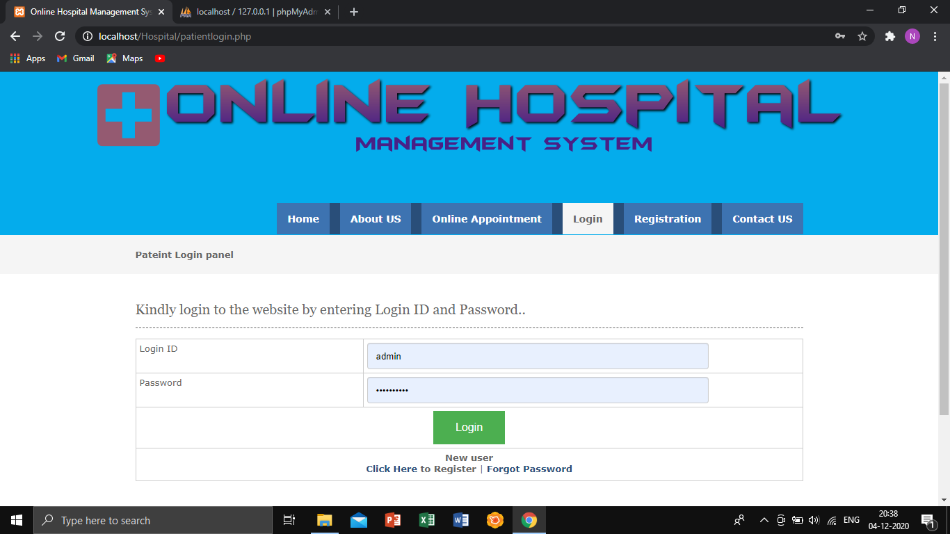

After that the Patient will be able to see the following account details.

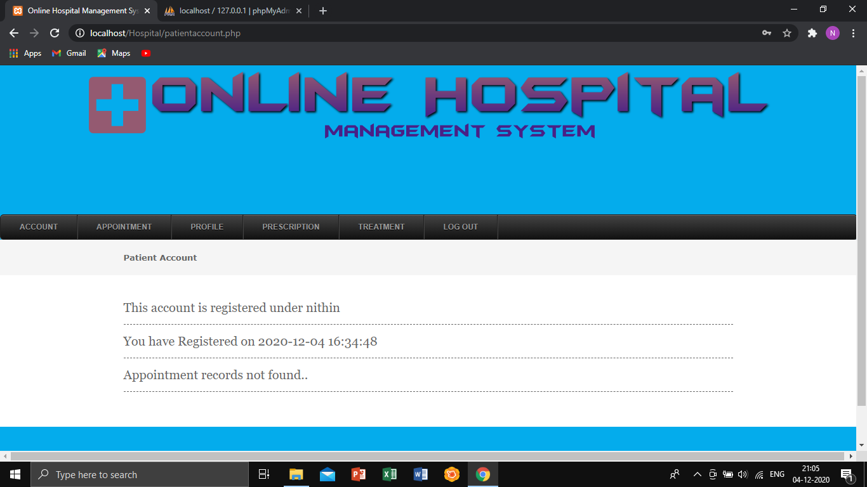

Under appointment a person can add or view his/her appointment.

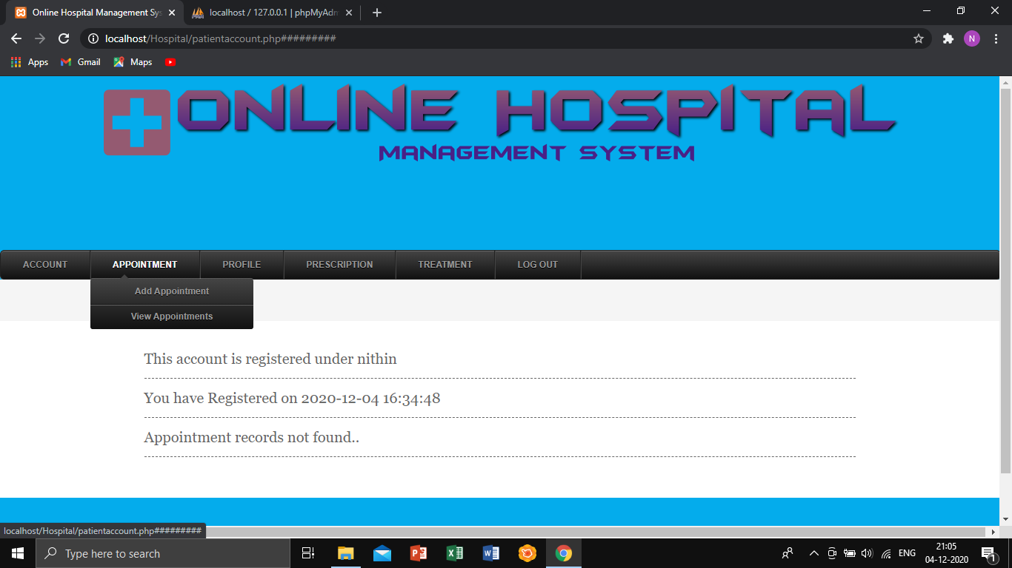

For security reasons a person can change their profile details and also their password.

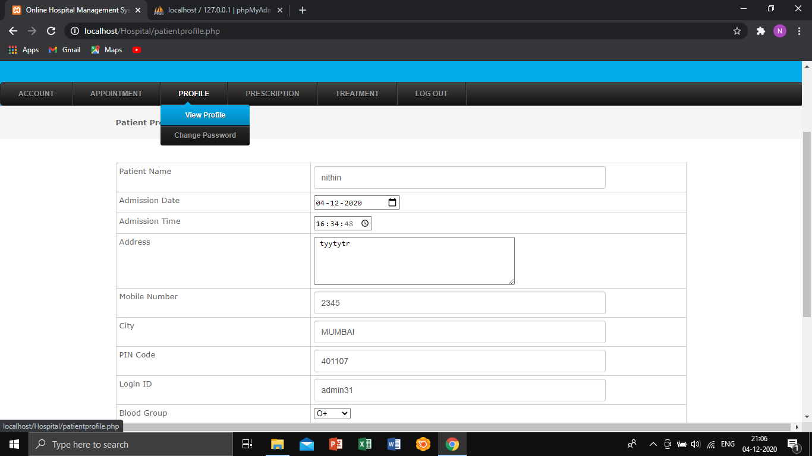

**ADMIN LOGIN PAGE:**  
In this page the receptionist can login under this panel.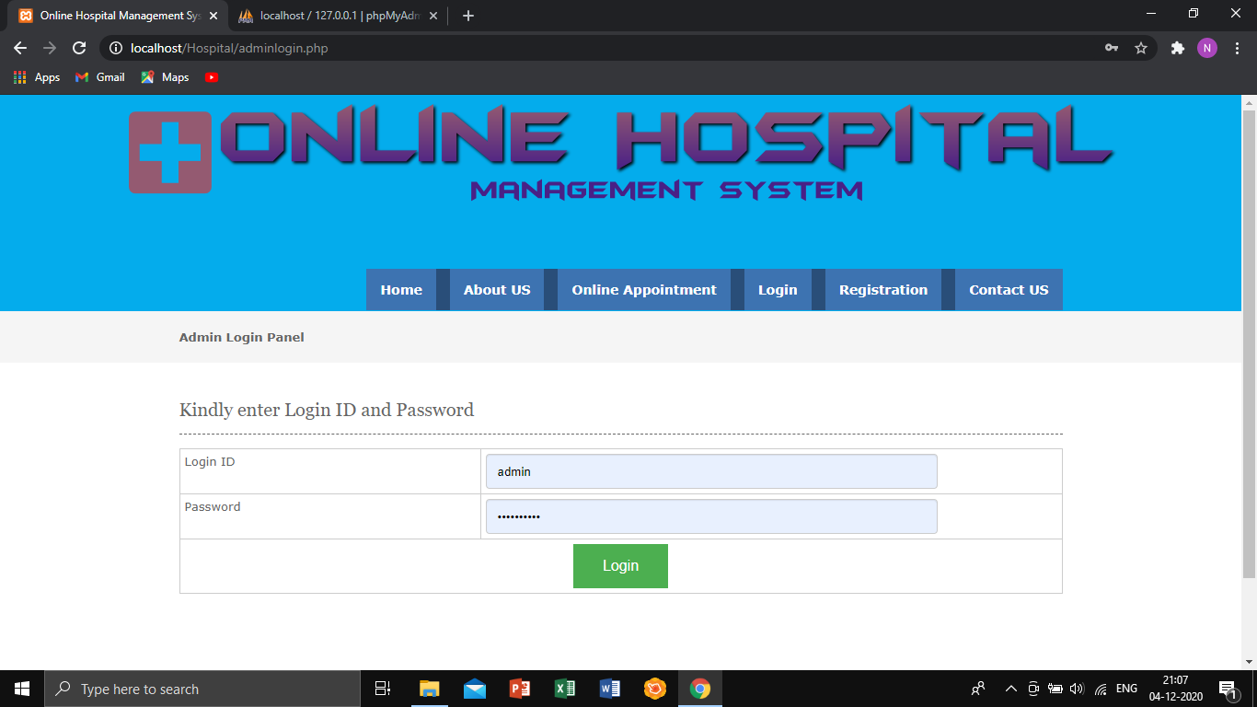

The admin can view their profile details, they can also change their password and add new admin.

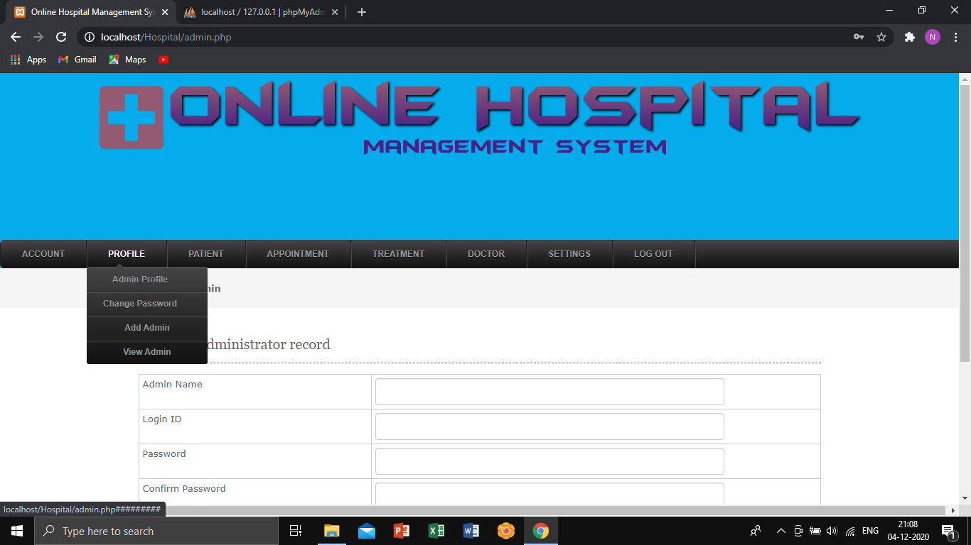

The admin can add patient details and view patient records.

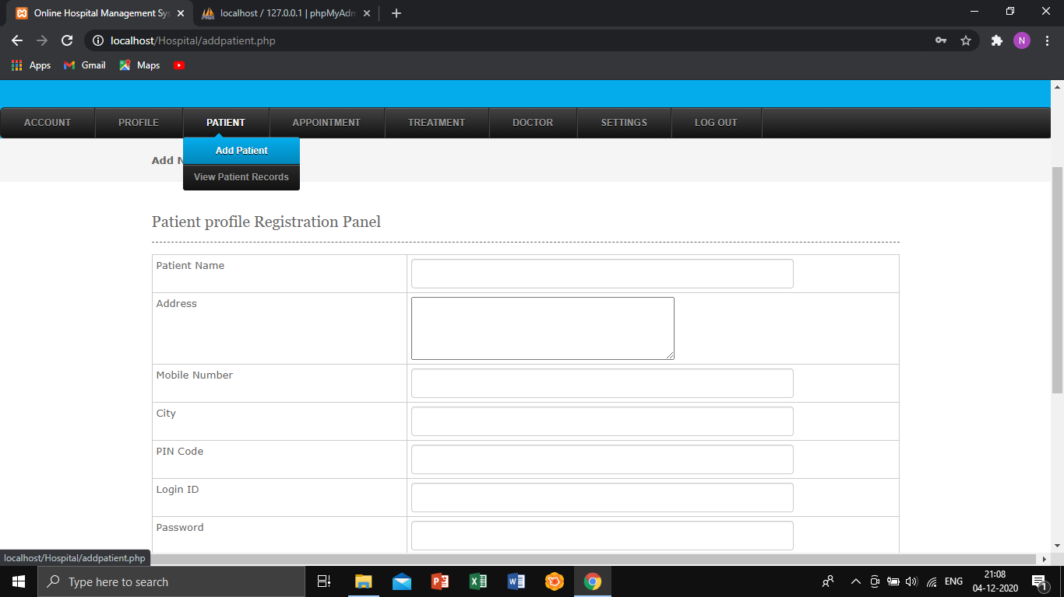

The admin can view  
1) treatment records

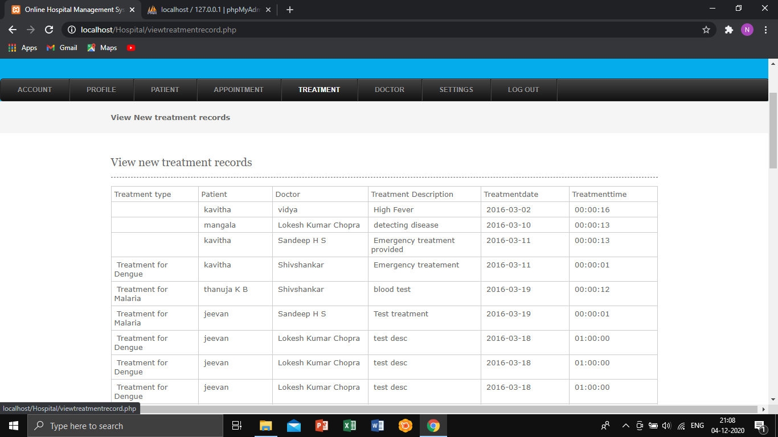

2) Can also add and view doctor timings

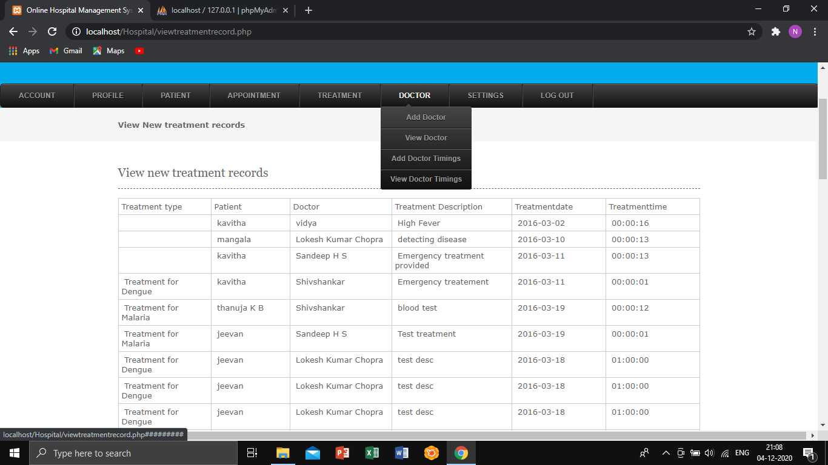

3) Add and view Treatments and medicines

