Claim Document Classifier
Full Technical Report and Handover Guide
Author: Nithin Pullanivalappil Joshy (Student ID 60781653)
Programme: Master of Information Systems Management, Macquarie University (COMP8851 internship)
Company / supervisor: Truuth / Johnson Rouslie Junior
Date: 23 October 2026
Audience: Anyone picking up this project after me. It is written so that you can run, test, extend and evaluate the classifier without having to ask.
Code repository: https://github.com/nithin41998-boop/Claim-Document-Classifier
Scope: This report covers the claim document classifier only. The Image Dimension Check is a separate project with its own report.

1. Summary
The classifier sorts insurance-claim attachments (photos, scans, letters, invoices, reports) into Truuth's established claim-document categories. It sends each image to a vision-capable language model together with the full list of categories and a description of each, and the model returns the single best-matching category, or 'Unclassified' if nothing fits. A shell script runs this over a whole folder, copies the files into one folder per category, groups files that look like pages or sides of the same document, and writes a summary CSV and a token (cost) summary.
There is no hand-built rules engine. All the 'knowledge' is in two places: the category list with descriptions (categories_with_descriptions.txt) and the rules in the prompt (classify_claim_document.py). Most improvements so far came from fixing descriptions and prompt rules, not code.
Where it stands: on a 139-document test set it classified 137 correctly (98.6%), and on the 184 readable documents of the Discovery dataset it classified 179 correctly. Both runs cost well under one cent per document. The five Discovery misses were four rear-corner car photos (no matching category existed) and one screenshot that fits no category. Front and rear vehicle categories were added on 23 October 2026 and the rear photos now classify correctly. What is NOT done is automated, ground-truth accuracy measurement, testing of the front category, handling of multi-page PDFs and sub-folders, and several robustness improvements. Section 11 lists the remaining work in priority order.

2. Hypotheses
These are the hypotheses the project was built to test. They are taken from the project's earlier status and testing reports, and are written as testable statements so a successor can confirm or reject them with data.
# | Hypothesis | How it is tested | Status
H1 | A vision-capable language model, given Truuth's actual category list with authoritative descriptions, can classify a wide variety of real insurance-claim attachments into the correct category without a hand-built rules engine. | Run batches of real documents; check every result against the document's actual content (text or image), never its filename. | Supported: 98.6% on 139 documents, 179 of 184 readable Discovery documents. The 'correct' judgement was made by hand.
H2 | Grouping files by a shared base file name reconstructs multi-page or multi-sided documents submitted as separate images. | Synthetic front/back pairs; real folders with known pairs. | Works on synthetic pairs. Not validated on real data, and it has a known false-grouping risk (Section 9).
H3 | A low-cost model (GPT-5.6 Luna) can match or beat Claude Haiku 4.5 on this taxonomy at lower cost, provided the integration allows for the model's hidden reasoning tokens. | Re-run the same test batches after migration and compare accuracy and token cost. | Supported: 43 of 43 correct after migration (the earlier Haiku round: 12 of 42 hand-checked, all correct). A formal side-by-side on identical documents was not done.
H4 | Accuracy holds when the number of categories and the variety of documents grows. | Large, varied dataset covering most categories. | Partly supported: 103 of 106 categories were exercised in the 139-document set. Three categories had no test document. Unicode is one (it also has no description); the other two should be identified from the category list and the test set.
H5 | Where results are wrong, the cause is usually the category list or prompt (a missing category, overlapping descriptions) and not the model. | Investigate every error against the real document. | Supported so far: most errors were category-list defects, including the missing front and rear vehicle categories.

Because a language model can answer differently on repeated runs, a single correct result is not proof that a fix works. Re-run any changed case several times (see Section 10).

3. Repository and File Map
GitHub repository (branch main): https://github.com/nithin41998-boop/Claim-Document-Classifier
File | What it does
classify_claim_document.py | Classifies ONE image. Loads the categories and descriptions, builds the prompt, calls Luna, validates the answer and prints one line: the category name or Unclassified.
categories_with_descriptions.txt | The category list used for classification: category name, a real tab character, then a description. If this file is missing the classifier falls back to categories.txt (names only, which is less accurate). 108 lines.
categories.txt | Plain list of category names, one per line. The shell script requires this file to exist; the classifier uses it as the fallback. Keep it identical in names and order to the descriptions file.
classify_claims_folder.sh | Batch driver: classifies every file in a folder, groups likely related files, copies results into per-category folders, writes summary.csv and a token summary.
.gitignore | Keeps output folders, logs, CSVs, images, PDFs, .env and Windows Zone.Identifier files out of version control, so client documents and keys are never committed.

There is no README, requirements file or test set in the repository. Client test documents are deliberately not stored in it. Adding a README is a task in Section 11.

4. Setup and How to Run

4.1 Environment
Developed and tested in Ubuntu on WSL. You need:
- Python 3 with opencv-python, numpy and openai (for example: pip install opencv-python numpy openai --break-system-packages).
- poppler-utils (provides pdftoppm, used to turn the first page of a PDF into an image).
- Access to the model through AWS Bedrock's OpenAI-compatible endpoint. Two environment variables must be set in the SAME terminal you run the script from: OPENAI_API_KEY (a Bedrock API key, which starts with ABSK and is about 132 characters long) and OPENAI_BASE_URL = https://bedrock-runtime.ap-southeast-2.amazonaws.com/openai/v1. The model id is global.openai.gpt-5.6-luna.
A Bedrock key used without the Bedrock base URL is sent to OpenAI and rejected, and a placeholder such as '<your key>' gives 'Invalid API Key format'. Check the key without printing it: echo "Starts with: ${OPENAI_API_KEY:0:4} Length: ${#OPENAI_API_KEY}" should show ABSK and about 132. Never paste the key into chat, tickets, documents or Git.

4.2 Running
One image (use this first whenever something looks wrong; it shows errors on screen):
cd ~/claims-classifier
DEBUG_LABEL=1 python3 classify_claim_document.py "/path/to/image.jpg"

Whole folder (JPG, JPEG, PNG and PDF directly inside the folder; sub-folders are not searched):
./classify_claims_folder.sh -d <input_folder> -o <output_folder>

Windows folders are reached in WSL as /mnt/c/Users/<name>/... (for example C:\Users\nithi\OneDrive\Desktop becomes /mnt/c/Users/nithi/OneDrive/Desktop). Quote any path that contains spaces.

4.3 Output
Output | Contents
<output>/<Category name>/ | Copies of the files classified into that category. Characters not allowed in folder names are replaced by a dash. Files that were judged to belong together are placed in a sub-folder named by their Group ID.
<output>/summary.csv | Original Filename, Category, Group ID for every file.
<output>/token_usage.log | One 'input,output' token pair per model call (including retries). The script totals these at the end for cost estimation.
Terminal summary | Files processed, location of the CSV and folders, total input and output tokens.

Cost check: Luna was priced at $0.20 per million input tokens and $1.20 per million output tokens (Global Cross-Region rates used in the earlier cost calculations; confirm current rates before quoting). cost = input x 0.20/1,000,000 + output x 1.20/1,000,000.

5. Architecture and Workflow
Figure 1 shows the batch script. Figure 2 shows what happens inside classify_claim_document.py for one image.
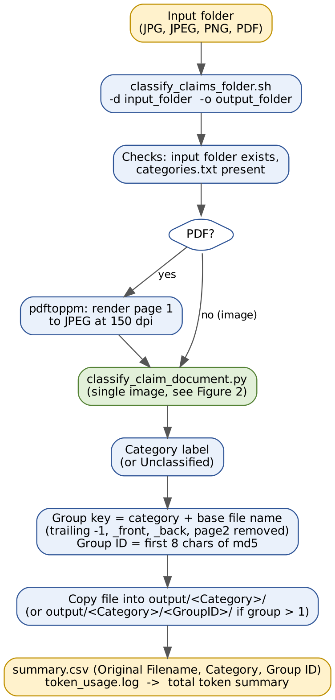
Figure 1: Batch workflow (classify_claims_folder.sh)

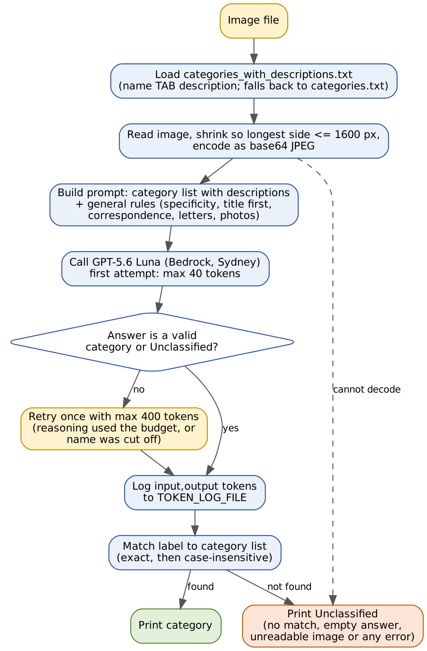
Figure 2: Single-image classification (classify_claim_document.py)
Colour key: blue = processing step, yellow = input/output or retry, green = classifier call or successful result, orange = Unclassified outcome.
Design rule: a closed list. The model must answer with one of the listed names. Anything else is treated as Unclassified, so a new kind of document is never silently forced into a wrong category and never invents a new label.

6. How Each Part Works

6.1 The category list
The taxonomy comes from Truuth's own spreadsheet (Truuth_Claims_Documents.xlsx). 97 unique names were extracted, a duplicate ('Drivers License details', same document type as 'Drivers License') was removed, and a second spreadsheet supplied real descriptions for 95 of them. Ten categories not in Truuth's list were added so that out-of-scope documents have somewhere sensible to go (Insurance Claim, Lottery Win, Tax Notice, Package Delivery Notice, Visa Approval, System Security Alert, Job Offer Letter, Charitable Donation Request, Claim approval, Claim Form/application). That gave 106 categories. Two new categories were added on 23 October 2026 (Photo of the front of the vehicle and Photo of the rear of the vehicle), giving 108.
Spelling in the list matches Truuth's source, including 'Asessement photos' and 'Doctor certifcates'. The classifier compares names exactly, so do not correct spelling in one place only. Any rename must be made in both category files and in anything downstream that uses the names.
Each description says what the category covers and, where categories overlap, which one to use instead. The descriptions matter more than anything else in the project: rewriting a description is the usual fix for a wrong result.

6.2 The prompt (classify_claim_document.py)
The prompt contains the category list ('- Name: description') followed by general rules. The rules are:
- Answer with only the exact category name, nothing else.
- Prefer the category that most specifically describes what the document is (its subject, sender or purpose) over one based on tone or urgency.
- A clear title, header or status field (for example 'CLAIM APPROVAL') outranks other details in the body.
- Correspondence categories (Client, Broker, Assessor, Investigator, Moderator, Salvage, Sasria, Ombudsman) are chosen by who the document is addressed to or sent from, not by other parties named inside it.
- A letter or email counts as correspondence only if it replies to or references an earlier message from that party. A letter that starts something (an authorisation, a quote, a settlement or release offer, an instruction) goes to its purpose-based category, such as Authorisation letter, Assessed quote or Release Offer.
- For photos, a specific photo category (front or rear end of the vehicle, scratch/dent facing a direction, the complete damaged panel, forced-entry damage, damage for digital assessment) beats a generic one such as Photos from clients or Asessement photos.
- If nothing fits, answer exactly: Unclassified.

6.3 Calling the model and handling reasoning tokens
The image is read, shrunk so its longest side is at most 1600 pixels (1024 was too small for telling vehicle sides apart), and sent as a base64 JPEG. GPT-5.6 Luna is a reasoning model: part of its output budget can be spent on hidden reasoning, leaving nothing visible. The first call therefore allows only 40 output tokens (cheap, enough for almost every answer). If the answer is empty, or is not a valid category name (it may have been cut off part-way through a long name), the call is repeated once with 400 tokens. Both calls' token counts are logged. The newer API parameter max_completion_tokens must be used; max_tokens is rejected by this model.
The answer is then matched to the list: an exact match, then a case-insensitive match, otherwise Unclassified. Any error (unreadable image, authentication or network failure) also prints Unclassified and writes the reason to stderr.

6.4 Batch script and grouping
For each JPG, JPEG, PNG or PDF directly in the input folder the script classifies the file (PDFs are rendered to a JPEG of page 1 at 150 dpi first), then forms a group key from the category plus the file's base name with trailing markers removed (-1, _2, _front, _back, page2, p3 and any trailing digits). The Group ID is the first 8 characters of an MD5 of that key. After all files are done, files whose group has more than one member are copied into <category>/<GroupID>/ and the rest directly into <category>/. Grouping is by file name only; nothing looks at the images themselves.
Important: the script sends classifier errors to /dev/null (2>/dev/null) and turns an empty result into Unclassified. A setup problem therefore makes EVERY file look Unclassified with no message. Always test one file by hand first.

7. What Has Been Done
- Built a standalone classifier and folder-sorting tool, kept entirely separate from the identity-document dimension check.
- Extracted Truuth's taxonomy, merged real descriptions, removed one duplicate, and added ten out-of-scope categories (106 categories); later added front and rear vehicle photo categories (108).
- Implemented filename-based grouping and the per-category output structure, validated on synthetic front/back pairs.
- Added rules for titles over body text, for specificity over tone, and for letters versus correspondence, each from a concrete misclassification.
- Migrated from Claude Haiku 4.5 (Bedrock Messages API) to GPT-5.6 Luna (Bedrock OpenAI-compatible endpoint), including parameter changes and token-usage logging.
- Found and fixed the reasoning-token defect (empty answers reported as Unclassified) with a retry-only-when-needed pattern, and a second defect where a cut-off category name skipped the retry.
- Fixed category-list defects: four correspondence categories whose descriptions had been merged into their names, and a category with no description. Rewrote overlapping pairs so each says when to use the other (Saps report and A1 report; Itemised invoice and Repairer's invoice; Signed AOL and Signed Release; Proof of forcible entry and Photos from clients).
- Improved left/right vehicle photo handling: a headlight/taillight rule, image size raised from 1024 to 1600 px, and the complete-panel category changed so it no longer takes photos whose side can be determined.
- Ran four test rounds (Section 8) and wrote test reports; added token and cost reporting.
- Pushed the code to its own GitHub repository with a .gitignore that keeps client data and keys out.
- 23 October 2026: added 'Photo of the front of the vehicle' and 'Photo of the rear of the vehicle' (names and descriptions in both category files, plus the prompt's photo rule). The descriptions were widened to include corner and angled close-ups, with damage allowed. Pushed to GitHub (commits 085e781 and f3e9978).

8. Test Results
Round | Documents | Result | Notes
1 (Haiku 4.5) | 42 | All processed; 12 hand-checked, all correct | 30 of 42 never hand-checked. 106-category list, but the batch covered only a fraction of it.
2 (Luna) | 43 | 43 of 43 correct | Included one document correctly left Unclassified (an internal email). Two earlier failures retested five times each and fixed.
3 (Luna, 139-document set) | 139 | 137 correct (98.6%) | 103 of 106 categories covered. Two misses (Release Offer; Repairer's invoice) were fixed and confirmed on the real files. 563,820 input and 4,203 output tokens; $0.1178; about $0.00085 per document.
4 (Luna, Discovery dataset) | 294 supplied; 184 readable | 179 of 184 correct | 110 files could not be opened and were excluded. 1,485,170 input and 28,466 output tokens; $0.331193; about $0.0018 per readable document ($0.0011 if divided over all 294).

8.1 The five Discovery misses
- Four close-up photos of rear-corner car damage. No category existed for the back or front of a vehicle, so results varied between left, right and Unclassified. Fixed by the two new categories (below).
- One screenshot of an HP Support web page. It fits no category; guidance from Truuth on where it belongs is still outstanding.

8.2 Front and rear category check (23 October 2026)
Five rear-end photos from the Discovery set (three silver Mazda rear-corner shots with scratches and a dent, and two white-car shots showing the taillight, bumper and number plate) were run through the updated classifier. Nithin ran them and reported that all five classified correctly; the printed output for one of them (P000 BumperMisalignedChat.jpg) was 'Photo of the rear of the vehicle'. The photos were run once each, not repeated, and the front category has not been tested because no front photo was available.

8.3 What the testing does and does not show
- 'Correct' was judged by a person looking at each document. There is no ground-truth label file, so no automated accuracy or confusion matrix exists yet.
- In the Discovery run, 110 of 294 files were unreadable, so that result covers the 184 readable files (63%) only.
- Model answers can vary between runs, especially for photos. A fix needs several repeat runs before it is trusted.

9. Known Limitations
- No ground-truth labels or automated accuracy measurement; every check so far was manual.
- Unicode has no description and no test document; two further categories also lack test documents.
- The HP Support screenshot (and similar non-claim images) has no category and ends up Unclassified or in the wrong place.
- The front category is untested. The rear and front descriptions overlap with the 'facing left/right' descriptions, which say that visible taillights or headlights decide the side. The five rear photos passed, but other rear-corner photos may still be sent to left or right. Re-test whenever any vehicle-photo description changes.
- Left/right classification of vehicle photos is not fully stable across repeated runs.
- The batch script hides classifier errors, so a setup fault makes every file Unclassified silently.
- Grouping uses file names only. Because trailing digits are stripped, unrelated files in the same category with similar numbered names (for example camera photos taken the same day) can be grouped together, and a real front and back with unrelated names are not grouped. The Discovery file names are random IDs, so grouping there is meaningless.
- Only the first page of a PDF is classified, and only files directly in the input folder are processed (no sub-folders).
- There is no confidence score, so a lucky wrong answer and a solid right answer look the same.
- Each call sends the whole category list with descriptions (about 8,000 input tokens per call in the Discovery run), so cost grows with the size of the list.
- Files are processed one at a time, with no handling of rate limits and no parallelism, which will be slow for large batches.
- The retry makes at most one extra call; if that also fails the file is Unclassified.
- There is no README, requirements file or automated test suite.

10. Troubleshooting and Gotchas
Symptom | Cause and fix
Every file Unclassified | Almost always environment, not the model. Run classify_claim_document.py on ONE image directly; the error appears on screen. Common causes below.
401 'Invalid API Key format: Base64 decoding failed' or 'Must start with pre-defined prefix' | The key variable holds a placeholder or the wrong key. Check with the echo command in 4.1: it should start with ABSK and be about 132 characters. Set the key with: read -s -p "Paste key and press Enter: " OPENAI_API_KEY; echo; export OPENAI_API_KEY
401 invalid key after the format is right | Temporary key expired. Create a new Bedrock API key in region ap-southeast-2.
'Missing credentials' | OPENAI_API_KEY is not set in this terminal. Variables set in one window do not exist in another.
Key is valid but requests are rejected as if sent to OpenAI | OPENAI_BASE_URL is not set to the Bedrock endpoint.
'unsupported parameter: max_tokens' | Use max_completion_tokens for this model.
Empty or cut-off answers | Reasoning used the output budget or a long name was truncated. The retry covers this. If it persists, increase the 400-token retry.
A category is never returned | Check that its name is identical in both files, the separator in categories_with_descriptions.txt is a real tab, and the description does not contain the name of another category by mistake.
Windows Zone.Identifier files appear | Created when files are copied from Windows into WSL. They are ignored by .gitignore and can be deleted.
Many files Unclassified in a client dataset | Check that the files open at all. 110 of 294 Discovery files were unreadable, and the script reports them as Unclassified without saying why.
Same photo gives different answers | Normal variation. Repeat 3 to 5 times; if still inconsistent, fix the descriptions of the competing categories.

11. Future Work (Priority Order)
# | Task | Detail / done when
1 | Build ground truth and an automatic scorer | Create a CSV of filename and correct category for the test documents (the 139 set and the readable Discovery files). Write a script that compares summary.csv with it and prints accuracy per category and a confusion matrix. Done when accuracy can be re-measured with one command after any change.
2 | Make the batch script show errors | Remove 2>/dev/null or write stderr to an errors.log, and stop turning an empty result silently into Unclassified. Add an upfront check that the key and base URL are set and a one-file self-test.
3 | Test front and rear thoroughly | Run the front category on real front-end photos. Re-run the rear photos several times each and the earlier left/right photos to check nothing regressed. Done when all are stable on repeated runs.
4 | Resolve overlap with the facing-direction categories | Decide with Truuth what a rear-corner photo with visible taillights should be. Make the left/right, complete-panel, rear and front descriptions say consistently which wins.
5 | Handle the unreadable and out-of-scope files | Ask Discovery for readable copies of the 110 files. Agree with Truuth where the HP Support screenshot and similar non-claim images belong, or add an explicit 'Not a claim document' category.
6 | Cover the remaining categories | Source or build test documents for Unicode and the two other uncovered categories; write a description for Unicode.
7 | Review the category list with Truuth | Confirm names (including the spelling variants), remove or merge overlapping categories, and check the ten added categories are wanted.
8 | Add a confidence or review flag | For example, ask the model for its second-best category or a confidence, or run twice and flag disagreement, so uncertain files go to a human.
9 | Reduce cost and latency | The prompt sends every description on every call. Options: prompt caching if the endpoint supports it; shorter descriptions; a two-stage approach (broad group first, then the categories within it); parallel calls with rate-limit handling.
10 | Better grouping | Group by content (same document number, name or layout) or at least by a stricter file-name rule. Add a test with unrelated numbered photos.
11 | PDFs and folders | Classify every page of a PDF (or the first few) and combine, and add an option to recurse through sub-folders.
12 | Formal comparison of models | Run the same documents through Haiku and Luna (and any new model) and compare accuracy and cost on identical data.
13 | Documentation and packaging | Add a README, requirements.txt, an install script and a small automated test that runs the five vehicle photos and a few documents of each key type.
14 | Plan integration | Decide how Truuth would call this: batch tool, service or module, and what confidence and audit information it must return.

12. How to Add or Change a Category
- Choose the exact name. Check that no existing name is a near duplicate.
- Add one line to categories.txt, and one line to categories_with_descriptions.txt: name, a real tab, then the description. Keep the order the same in both files.
- Write the description around what is visible or printed on the document and how it differs from the closest existing category. Edit that neighbour's description too, so each points at the other.
- Run the real examples that should land in it, and the examples that should not, 3 to 5 times each. Record results.
- Re-run the full test sets to check no other category regressed.
- Commit and push. Never commit client documents, outputs or keys.

13. Suggested First Week for a New Owner
- Clone the repository, install the tools in 4.1, set the two environment variables, and classify one image directly.
- Run the batch on a small folder of mixed documents. Open summary.csv and the category folders and token_usage.log.
- Read classify_claim_document.py (about 160 lines) and the descriptions for the overlapping categories.
- Do Section 11 task 1 (ground truth and scorer) first, because every later change needs it to prove it helped.
- Then do task 2 (visible errors) and task 3 (front and rear tests).

14. References and Sources
- Truuth_Claims_Documents.xlsx and the second description spreadsheet supplied by Truuth: source of the category list and descriptions.
- Claim Document Classifier status and test reports: Status report (1-4 September 2026), Testing Round 1, Testing Round 2 (Luna migration), Week 9 internship report (139-document set and Discovery run).
- AWS Bedrock OpenAI-compatible API documentation; OpenAI Chat Completions API (max_completion_tokens and reasoning models).
- Poppler (pdftoppm) and OpenCV documentation.
Code: https://github.com/nithin41998-boop/Claim-Document-Classifier

