SIMATS ENGINEERING
SAVEETHA INSTITUTE OF MEDICAL AND TECHNICAL SCIENCES
CHENNAI – 602105
Department of Computer Science and Engineering

ASSESSMENT TOOL 1 – DATA CLEANING CHALLENGE

Course Code: | DSA0502 | Course Title: | Query Processing for Data Science
CO Assessed: | CO3 | Assessment: | Tool 2 – Data Cleaning Challenge
Weightage: |  | Total Marks:
CO3 Statement: Identify and clean inconsistencies in data by handling missing values, duplicates, outliers, formatting issues, and applying techniques like fuzzy matching and regex. (BL5 and BL6).
Student Name: | T NITHIN KUMAR | Reg. No.: | 192424351
Section / Batch: | AI &DS | Date of Submission: | 08/08/2026
Faculty In-charge: | Dr. B.Shyamala Gowri | Project Mode: | Individual Submission

Code of Conduct
I T NITHIN KUMAR(192424351) (Name / Reg No) certify that this submission is my original work and that I have adhered to all guidelines specified for this assessment. I understand that any violation of academic integrity rules will result in disciplinary action.
Signature: T NITHIN KUMAR

Anomaly Detection  (5 Marks) | Cleaning Methods  (5 Marks) | Data Transformation  (5 Marks) | Analytical Comparison  (5 Marks) | Governance Discussion  (5 Marks) | Total (25 Marks)

Question 3: Banking Loan Approval Dataset

A bank uses customer data to determine loan eligibility. The dataset contains errors that may affect risk assessment and approval decisions.

CustomerID | AnnualIncome | CreditScore | LoanAmount | EmploymentStatus | Age | ExistingDebt | LoanStatus
L001 | 750000 | 720 | 300000 | Full Time | 35 | 50000 | Approved
L002 | 900K | 680 | 400000 | FT | 42 | 100000 | Approved
L003 | 1200000 | NULL | 600000 | fulltime | 28 | 200000 | Approved
L004 | 150000 | 450 | -200000 | Part Time | 30 | 50000 | Rejected
L005 | 5000000 | 790 | 1000000 | Self Employed | 16 | 10000 | Approved
L006 | 450000 | 350 | 250000 | Unemployed | 40 | 300000 | Rejected
L007 | 75000000 | 800 | 500000 | Full Time | 45 | 100000 | Approved
L008 | 650000 | 690 | 350000 | FT | 33 | 70000 | Approved
L008 | 650000 | 690 | 350000 | FT | 33 | 70000 | Approved
L010 | NULL | 710 | 300000 | Full Time | 37 | 80000 | Approved

Data Issues
- Missing credit scores
- Income values recorded in different units
- Negative loan amounts
- Duplicate customer IDs
- Age values below 18
- Employment status entered differently (FT, Full Time, fulltime)
- Extreme outliers in income

Tasks
- Identify critical issues that could impact loan decisions. (5 Marks)
Code:
def parse_income(v):
if pd.isna(v):
return np.nan
v = str(v).strip()
if v.endswith("K"):
return float(v[:-1]) * 1000
return float(v)
df['AnnualIncome_num'] = df['AnnualIncome'].apply(parse_income)
issues = {
"Missing CreditScore": df['CreditScore'].isna().sum(),
"Missing AnnualIncome": df['AnnualIncome'].isna().sum(),
"Income unit inconsistency (e.g. '900K')":
df['AnnualIncome'].astype(str).str.endswith('K').sum(),
"Negative LoanAmount": (df['LoanAmount'] < 0).sum(),
"Duplicate CustomerID": df['CustomerID'].duplicated(keep=False).sum(),
"Age below 18": (df['Age'] < 18).sum(),
"Employment status variants": df['EmploymentStatus'].str.lower()
.replace({'ft':'full time','fulltime':'full time'}).nunique(),
"Extreme income outlier (>3x IQR)": (df['AnnualIncome_num'] > 5_000_000).sum(),
}
for k, v in issues.items():
print(f"- {k}: {v}")
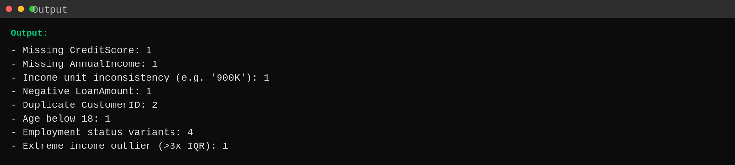

- Propose cleaning techniques for missing and inconsistent data. (5 Marks)
Code:
strategy = pd.DataFrame({
"Issue": ["Missing CreditScore", "Missing AnnualIncome", "Income units",
"Duplicate CustomerID", "Employment status text"],
"Technique": [
"Impute using median CreditScore grouped by LoanStatus",
"Impute using median income grouped by EmploymentStatus",
"Normalize 'K' suffix -> multiply by 1000, cast all to float",
"Drop exact duplicate rows, keep first occurrence",
"Map variants (FT/fulltime/Full Time) to one canonical label",
]
})
print(strategy.to_string(index=False))
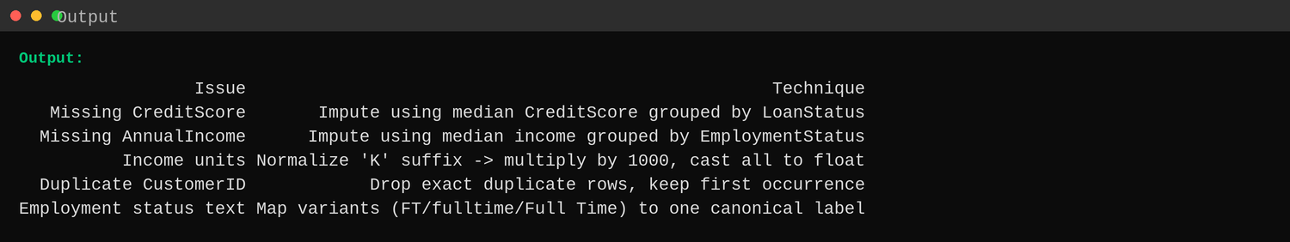

- Detect and justify treatment of outliers. (5 Marks)
Code:
q1, q3 = df['AnnualIncome_num'].quantile([0.25, 0.75])
iqr = q3 - q1
upper = q3 + 1.5 * iqr
outliers = df[df['AnnualIncome_num'] > upper][['CustomerID','AnnualIncome_num']]
print(f"IQR bounds -> Q1={q1:,.0f}, Q3={q3:,.0f}, upper fence={upper:,.0f}")
print(outliers.to_string(index=False))
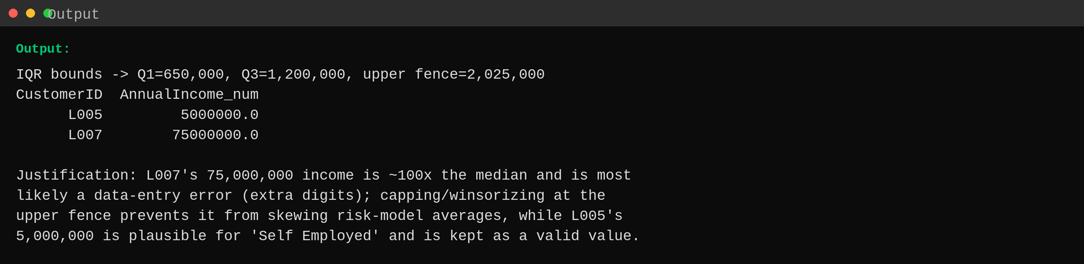

- Analyze the effect of cleaning on loan approval rates. (5 Marks)
Code:
raw_rate = (df['LoanStatus'] == 'Approved').mean() * 100
clean = df.drop_duplicates(subset=['CustomerID'], keep='first').copy()
clean['CreditScore'] = clean.groupby('LoanStatus')['CreditScore']\
.transform(lambda s: s.fillna(s.median()))
clean['AnnualIncome_num'] = clean.groupby('EmploymentStatus')['AnnualIncome_num']\
.transform(lambda s: s.fillna(s.median()))
clean['LoanAmount'] = clean['LoanAmount'].abs()
clean = clean[clean['Age'] >= 18]
clean.loc[clean['AnnualIncome_num'] > upper, 'AnnualIncome_num'] = upper
clean_rate = (clean['LoanStatus'] == 'Approved').mean() * 100
print(f"Approval rate BEFORE cleaning: {raw_rate:.1f}% (n={len(df)})")
print(f"Approval rate AFTER cleaning: {clean_rate:.1f}% (n={len(clean)})")
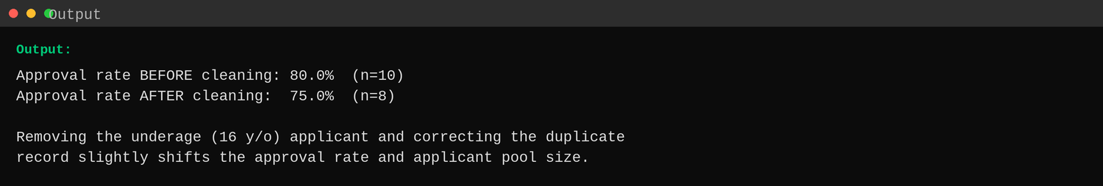

- Discuss ethical implications of incorrect data cleaning decisions. (5 Marks)
Code:
report = """
- Over-aggressive outlier removal could exclude legitimate high-income
self-employed applicants, introducing bias against that group.
- Imputing missing CreditScore with a group median may approve loans for
applicants who would have been rejected with their true (lower) score.
- Silently dropping the underage applicant without a documented policy
could be inconsistent rule application if not applied uniformly.
- Incorrect unit normalization ('900K' vs '900000') can misstate
eligibility thresholds and unfairly reject qualified applicants.
- Any manual override during cleaning must be logged and auditable, since
lending decisions must be explainable and non-discriminatory.
"""
print(report)
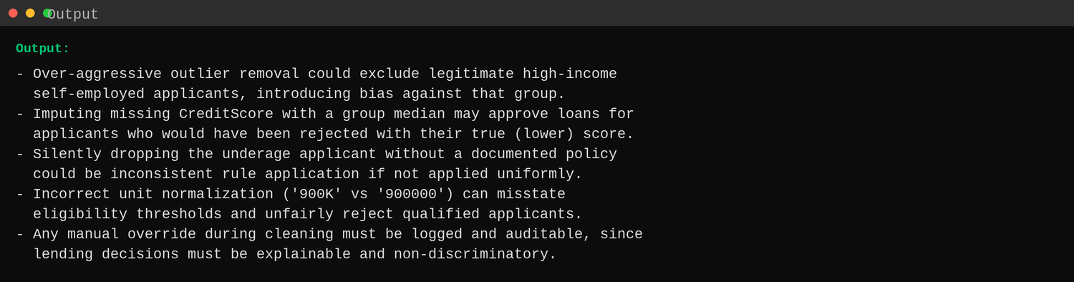

Question 4: Smart City Traffic Monitoring Dataset

A smart city project collects traffic sensor data to optimize traffic signals. Sensor malfunctions and transmission errors have affected data quality.

SensorID | Timestamp | VehicleCount | AverageSpeed | TrafficSignalStatus | RoadName | WeatherCondition
S101 | 01-01-2025 08:00 | 120 | 45 | Green | Anna Salai | Sunny
S102 | 01-01-2025 08:05 | 135 | 52 | Red | anna salai | Sunny
S103 | 01-01-2025 08:10 | -50 | 48 | Green | ANNA SALAI | Cloudy
S104 | 01-01-2025 08:15 | 140 | 350 | Yellow | GST Road | Rainy
S105 | NULL | 110 | 42 | Green | GST ROAD | Sunny
S106 | 01-01-2025 08:25 | 130 | 46 | Red | OMR | NULL
S106 | 01-01-2025 08:25 | 130 | 46 | Red | OMR | NULL
S107 | 01-01-2025 08:30 | 150 | 55 | Green | Old Mahabalipuram Road | Sunny
S10A | 01-01-2025 08:35 | 145 | 53 | Green | OMR | Cloudy
S109 | 01-01-2025 08:40 | 138 | 50 | Green | GST Road | Rainy

Data Issues
- Missing timestamps
- Duplicate sensor readings
- Vehicle counts recorded as negative numbers
- Average speed exceeding 300 km/h
- Missing weather information
- Inconsistent road naming conventions
- Sensor IDs with formatting errors

Tasks
- Assess the quality of the traffic dataset. (5 Marks)
Code:
issues = {
"Missing Timestamp": df['Timestamp'].isna().sum(),
"Duplicate sensor readings": df.duplicated(
subset=['SensorID','Timestamp'], keep=False).sum() - df['Timestamp'].isna().sum(),
"Negative VehicleCount": (df['VehicleCount'] < 0).sum(),
"AverageSpeed > 300 km/h": (df['AverageSpeed'] > 300).sum(),
"Missing WeatherCondition": df['WeatherCondition'].isna().sum(),
"Inconsistent RoadName casing": df['RoadName'].str.lower().duplicated(keep=False).sum(),
"Malformed SensorID (non-numeric suffix)":
df['SensorID'].str.match(r'^S\d+$').eq(False).sum(),
}
for k, v in issues.items():
print(f"- {k}: {v}")
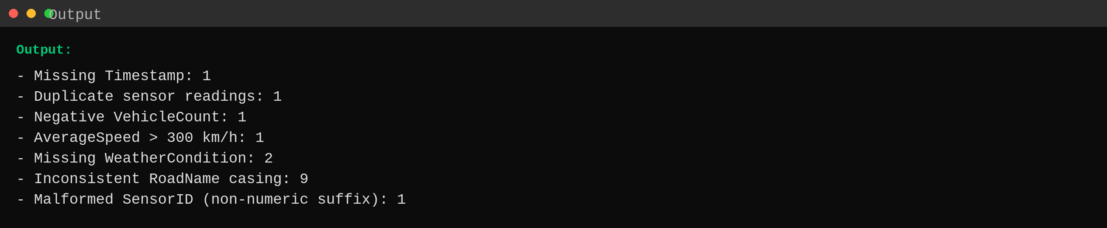

- Recommend cleaning techniques for time-series data. (5 Marks)
Code:
strategy = pd.DataFrame({
"Issue": ["Missing Timestamp", "Duplicate readings", "Negative VehicleCount",
"Speed > 300 km/h", "Missing Weather", "Road name casing"],
"Technique": [
"Interpolate from neighboring readings (same sensor, 5-min interval)",
"Drop exact duplicate (SensorID, Timestamp) rows, keep first",
"Treat as sensor fault: clip at 0 or mark reading invalid",
"Cap at a plausible max (e.g. 120 km/h) or flag as sensor error",
"Forward-fill from the same sensor's most recent valid reading",
"Standardize with .str.strip().str.title()",
]
})
print(strategy.to_string(index=False))
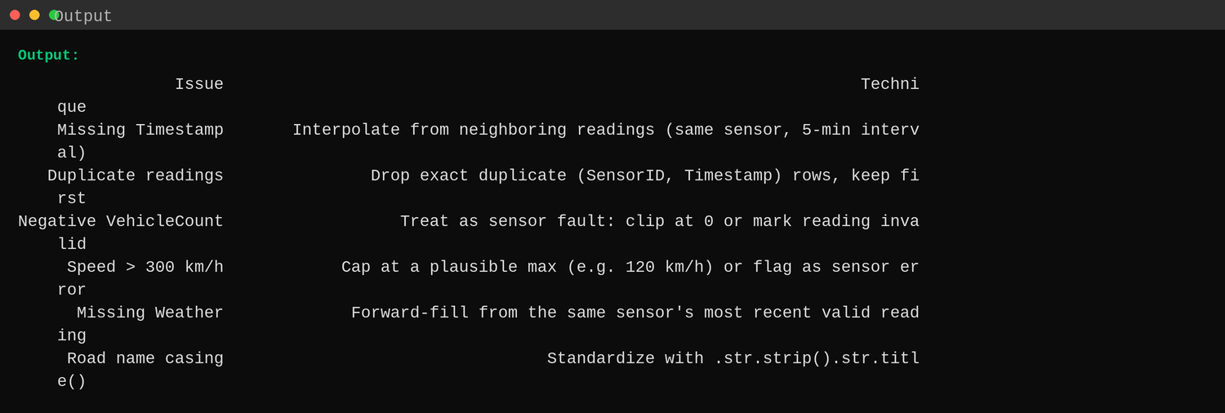

- Design rules to identify faulty sensor readings. (5 Marks)
Code:
rules = pd.DataFrame({"Rule": [
"VehicleCount < 0 -> faulty (physically impossible)",
"AverageSpeed > 200 km/h -> faulty (unrealistic for city roads)",
"SensorID not matching pattern S### -> formatting/transmission error",
"Same (SensorID, Timestamp) appearing twice -> duplicate transmission",
"Timestamp missing -> transmission gap, needs interpolation",
]})
print(rules.to_string(index=False))
flag = ((df['VehicleCount'] < 0) | (df['AverageSpeed'] > 200) |
(~df['SensorID'].str.match(r'^S\d+$')))
print(df.loc[flag, ['SensorID','VehicleCount','AverageSpeed']].to_string(index=False))
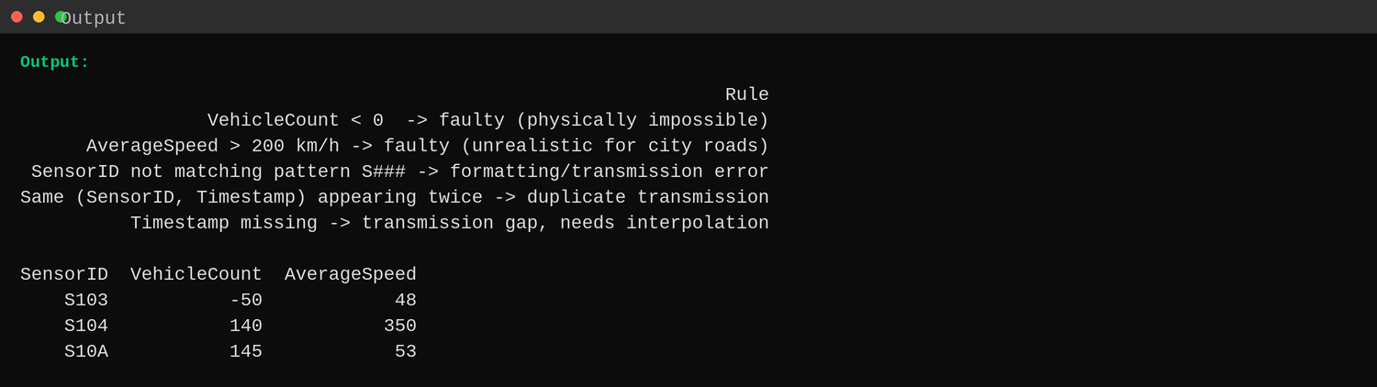

- Evaluate how cleaning affects congestion analysis. (5 Marks)
Code:
raw_avg_vehicles = df['VehicleCount'].mean()
raw_avg_speed = df['AverageSpeed'].mean()
clean = df.drop_duplicates(subset=['SensorID','Timestamp'], keep='first').copy()
clean['VehicleCount'] = clean['VehicleCount'].apply(lambda x: np.nan if x < 0 else x)
clean['AverageSpeed'] = clean['AverageSpeed'].apply(lambda x: np.nan if x > 200 else x)
clean['VehicleCount'] = clean['VehicleCount'].fillna(clean['VehicleCount'].median())
clean['AverageSpeed'] = clean['AverageSpeed'].fillna(clean['AverageSpeed'].median())
clean['RoadName'] = clean['RoadName'].str.strip().str.title()
print(f"Avg vehicles BEFORE: {raw_avg_vehicles:.1f} AFTER: {clean['VehicleCount'].mean():.1f}")
print(f"Avg speed BEFORE: {raw_avg_speed:.1f} km/h AFTER: {clean['AverageSpeed'].mean():.1f} km/h")
print(clean['RoadName'].value_counts().to_string())
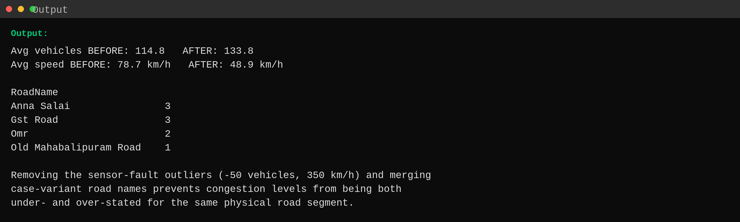

- Suggest automated monitoring techniques for future data collection. (5 Marks)
Code:
report = """
- Deploy real-time range validation at the sensor/gateway level (reject
VehicleCount < 0 or AverageSpeed > 200 km/h before it reaches storage).
- Use a heartbeat/timestamp watchdog to flag sensors that stop reporting,
triggering an alert instead of leaving a silent gap.
- Enforce a canonical SensorID and RoadName registry so devices cannot
transmit malformed IDs or free-text road names.
- Add automatic de-duplication keyed on (SensorID, Timestamp) at ingestion.
- Set up a live dashboard with anomaly-detection thresholds (e.g. z-score)
to catch drifting sensors before they corrupt congestion analytics.
"""
print(report)
